Supplementary Information: Integrated Magnetless Passive Broadband Faraday Isolator

Jerome Lapointe^{1*}, Cedrik Coia² and Réal Vallée¹

¹Centre d'optique, photonique et laser, 2375 Rue de la Terrasse, Université Laval, G1V 0A6, Canada
²AEPONYX Inc., Montréal, QC H3C 4J9, Canada

S1 Additional details on the laser writing process

The BIG crystal we have used induces a Faraday rotation of -93°/mm at the wavelength of 1550 nm resulting in 45° rotation, for a 480 μm thick slab. Now, because of the rather limited working distance of the focusing objective, long waveguides (few millimeters or more) are usually inscribed perpendicular to the laser beam (transverse writing, see Fig. 2b of the main manuscript). Indeed, the maximum waveguide length achievable using longitudinal writing (laser beam parallel to the waveguide, see Fig. 2b of the main manuscript) is of the order of the working distance of the focusing objective which is equal to 1.4 mm in our case. However, the entrance and exit of the waveguide inscribed using the transverse writing must be carefully cut and polished due to the well-known detrimental side effects [S1-S4]. Indeed, when the beam is focalized near both ends of the slab, a part of the beam enters the slab from the side instead of the top surface, resulting in different laser focal spot positions. This highly complicates the BIG waveguide fabrication since post processing of the facets must be avoided in order to maintain the length of BIG which precisely rotate the polarization by 45°. Therefore, longitudinal writing is the preferred choice in our case, considering the geometry of the BIG slab.
When attempting to inscribe waveguides in solids, the laser-induced modification of the material will result in refractive index changes that can be either positive or negative. Since we have found that the laser-induced modification alters the Faraday rotation, a depressed cladding waveguide (DCW) should be laser inscribed rather than the direct laser inscription of a waveguide core. Writing the cladding therefore ensures that the cores are left unaltered, hence still endowed with the remnant magnetization required for Faraday rotation. Laser inscription of DCWs is based on negative type I (smooth modification) or type III (damage) index change. Type III should be avoided since it produces waveguides with high propagation loss due to the waveguide interface roughness [S5] and affects the robustness of the material. Therefore, single laser scan tests were performed to achieve a smooth Type I negative refractive index change in BIG.
We found that the type I laser-induced modification window in BIG is very narrow and highly dependent on the writing depth. In fact, the high refractive index of BIG (n = 2.327 at 1310 nm [S6]) induces strong spherical aberrations which significantly elongate the focal spots as depth increases. As shown in Fig. S1, the height of the focal spot can lie anywhere between a few microns and about 70 µm. The vertically elongated traces in Fig. S1a,b,c are the cross-sectional views of 2 mm-long straight lines inscribed at different depths (as illustrated in the top right inset of Fig. S1), at a scan speed of 0.5 mm/s, using an objective lens of 100× and 0.85 NA, equipped with a correction collar for spherical aberration correction. Fig. S1a shows laser traces with the correction collar set to 0 µm (no spherical aberration correction). The trace at the top is the one closest to the surface where it was still possible to write without ablating it. It was written using a laser power of 240 µW (pulse energy of 240 nJ at a repetition rate of 1 kHz). Using a slightly lower power resulted in no material modification while slightly larger powers quickly resulted in surface ablation.
In order to inscribe DCWs as shown in Fig. 2b of the main manuscript, a multiscan technique was required to effectively fill the cladding area with a negative refractive index change (Δn < 0). Using an unaberrated (shortest) laser focal spot, obtained at a specific depth corresponding approximately to the correction collar value, see the white arrow in Fig. S1b, the multiscan technique only resulted in damaging the material. Moreover, using this unaberrated laser spot, it would take a very long time to inscribe the entire waveguide. Also note that vertically elongated laser spots are beneficial to smooth out the refractive index change, and this contributes to reducing the lower propagation losses (see ref. [S7] for a similar effect in transvers writing). Indeed, as illustrated in Fig. S1d,e,f, circular laser spots need to be much closely packed together to form a smooth waveguide interface. Even when separated by only 1 µm, the 2.5 µm × 5 µm laser spots still produce roughness (see Fig. S1e) whilst 10 times longer (2.5 µm × 50 µm) laser spots do not produce any observable roughness even when separated by 8 µm (see Fig. S1f). Since small laser spots are not a practical option, 11 different correction collar positions (from 0 to 750 µm) were tried to inscribe traces at all depth (from 0 to 480 µm) inside the BIG slabs in order to obtain the most homogenously elongated laser spot through the entire thickness. As shown in Fig. S1c, the best results were obtained with a correction collar of 525 µm which produced elongated laser spots through the whole thickness of the slabs. Larger values resulted in very week modification at the top surface and smaller values resulted in ablation at the bottom surface due to the unaberrated laser spot at that depth which is close to 480 µm. The best scenario would be to find a highly uniform and elongated spot at every depth, similar to the one in the white dashed square in Fig. S1a. Moreover, the laser power could be slightly modified as a function of the depth to optimize the refractive index change. Accordingly, the automated actuation of both the correction collar and the pulse energy during the whole waveguide fabrication could be considered as a promising approach to the effective industrialization of the process.

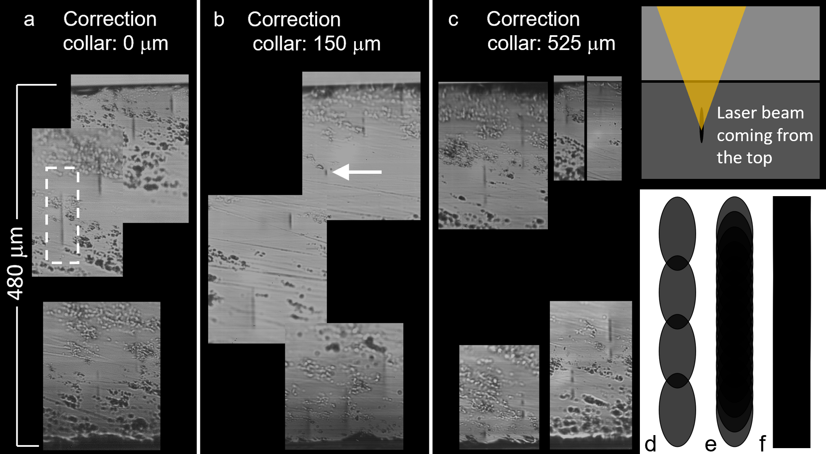
Fig. S1 | Cross-sectional views of straight laser tracks at different depth in BIG using a focusing objective with a correction collar set to a) 0 µm, b) 150 µm and c) 525 µm. The top right inset illustrates how the laser tracks are inscribed. Drawings of 2.5 µm × 5 µm laser spots distanced by d) 4 µm and e) by 1 µm. f) 2.5 µm × 50 µm laser spots distanced by 8 µm, illustrating the smooth waveguide interface.

In order to obtain low optical losses, the laser written cladding of the DCWs should be uniform and thick enough to provide sufficient confinement to the light mode. As illustrated in Fig. 2c of the main manuscript, using the multiscan technique, the focalized laser beam is inevitably affected by the previously written lines. The more lines written, the more the focused laser is scattered and the focal spot is modified, especially when multiple cladding layers are written. Here we define a cladding layer as a tubular structure characterized by a wall thickness that corresponds to the dimensions of a single laser track. Note that only one cladding layer has been previously reported using the longitudinal writing [S1,S3,S4], which limits the efficiency of the light confinement due to the small thickness of the waveguide cladding. Indeed, for a similar multiscan technique yet using transverse laser writing (see Fig. 2b of the main manuscript), the reported lowest loss waveguides have multiple cladding layers [S5,S8,S9]. Using this technique, the waveguide propagation losses are mostly attributed to the waveguide interface roughness, as it can be seen in the inset of Fig. 2c of the main manuscript.
In addition, each time a line is started and completed, it inevitably induces a non-uniform region as the scan speed increases or decreases, and if the speed is brought to zero, a larger spot of accumulated energy is formed. Note that these defects are not observed in the inset of Fig. 2c of the main manuscript since both ends of the waveguide were cut and polished. Therefore, a constant laser scan speed must be used during the whole waveguide fabrication process. Helical writing partially solves this problem. A single helix path involves only one beginning and one end of laser writing, allowing the scanning speed to remain constant over the whole writing process. A cross-sectional view of a waveguide that was laser written using a helix path is shown in the inset in Fig. 2d of the main manuscript, emphasizing the waveguide quality improvement, while a small defect caused by the end of the laser inscription is still visible (in the lower right corner). While this thin cladding weakly confines the light, the focused laser beam is inevitably affected by the previously written helices in a multi-layered configuration that produces a thicker cladding.
In order to optimize the laser writing parameters, the measurement of the refractive index profiles of the laser-induced material modification was very useful. Fig. S2 presents the radial refractive index profile of the waveguide shown in Fig. 2g of the main manuscript measured with a microscope equipped with a wavefront sensor. The waveguide was inscribed with a programmed inner diameter of 14 μm. However, as shown in Fig. S2, the effect of the laser (spot size and accumulation due to overlapping laser scans) extends to a diameter of the order of 10 μm, which explains its efficient coupling with a smf-28 fiber with a core diameter of 8.2 μm (FWHM). See Methods for more details on the refractive index profile measurements.
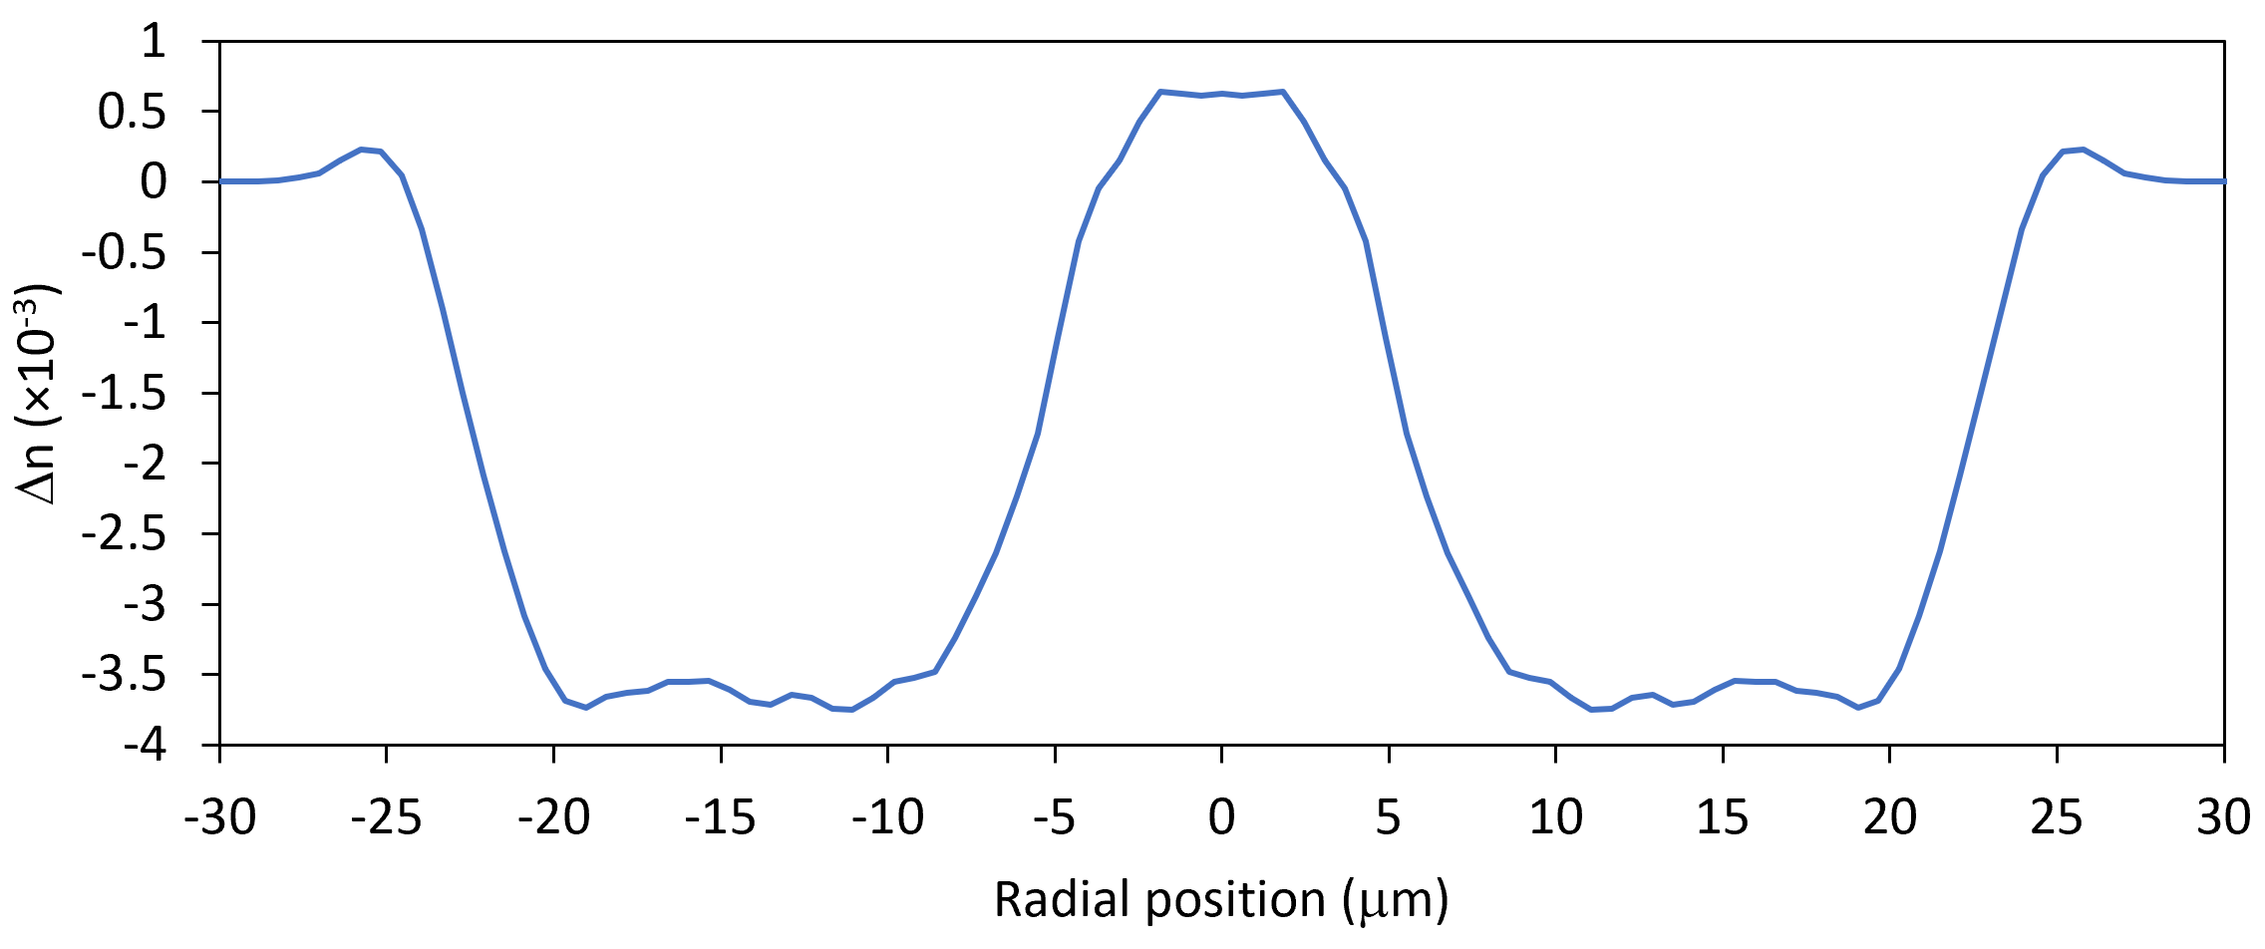
Fig. S2 | Radial refractive index profile at around 1000 nm of our 0.14 dB loss laser-inscribed waveguide. The waveguide was obtained using a laser inscription with programmed inner and outer diameters of 14 and 50 μm.

S2 Additional details on the laser writing parameter limitations

The laser scan speed is limited by the performance of the motorized stages, namely its stability. The radii of curvature required to laser inscribe the inner part of the cladding are smaller than 10 µm. Beyond 0.5 mm/s, the shape of the waveguide is no longer perfectly circular. The precision and reduced weight of the piezo nano-positioning stages used in this project were key in increasing the laser scan speed while maintaining a circular waveguide shape.
When it comes to laser track spacing, there is a trade-off between the high laser track density (providing high Δn and uniformity) and the manufacturing time. Since the horizontal size of the laser spot is small (about 4 µm), the horizontal laser track spacing must be small to maintain waveguide uniformity. We found that 0.5 µm is about the maximum allowable spacing. Using this horizontal track spacing, we found that a vertical track spacing must be greater than about 6 µm to avoid stress induced cracks, depending on the other laser writing parameters. Whilst the fabrication of the whole Faraday rotator waveguide takes less than 10 minutes using these conditions, the throughput could be increased using longer vertical laser track spacings at the cost of a resulting slightly lower Δn. While we expect uniformity to be maintained, further investigation of optical losses should be performed using longer vertical track spacing.

References
[S1] Caulier, O., Le Coq, D., Bychkov, E., & Masselin, P. Direct laser writing of buried waveguide in As 2 S 3 glass using a helical sample translation. Opt. Lett. 38, 4212-4215 (2013).
[S2] Lapointe, J., Bérubé, J. P., Pouliot, S., & Vallée, R. Control and enhancement of photo-induced refractive index modifications in fused silica. OSA Contin. 3, 2851-2862 (2020).
[S3] Peng, Y. P., Zou, X., Bai, Z., Leng, Y., Jiang, B., Jiang, X., & Zhang, L. Mid-infrared laser emission from Cr: ZnS channel waveguide fabricated by femtosecond laser helical writing. Sci. Rep. 5, 18365 (2015).
[S4] Salamu, G., Jipa, F., Zamfirescu, M., & Pavel, N. Cladding waveguides realized in Nd: YAG ceramic by direct femtosecond-laser writing with a helical movement technique. Opt. Mater. Express 4, 790-797 (2014).
[S5] Lapointe, J., Dupont, A., Pouliot, S., Guérineau, T., Lafreniere-Greig, J., Messaddeq, Y., & Vallée, R. Laser writing of 3D waveguides up to long-wave infrared: sensing and high refractive index contrast challenges. In Laser Applications in Microelectronic and Optoelectronic Manufacturing (LAMOM) XXVII 11988, 78-93 (SPIE, 2022).
[S6] Magneto-Optic LPE Garnet Faraday Rotator Crystals. II-VI, inc. https://ii-vi.com/product/magneto-optic-lpe-garnet-faraday-rotator-crystals/ (2023)
[S7] Lapointe, J., & Kashyap, R. A simple technique to overcome self-focusing, filamentation, supercontinuum generation, aberrations, depth dependence and waveguide interface roughness using fs laser processing. Sci. Rep. 7, 499 (2017).
[S8] Bérubé, J. P., Lapointe, J., Dupont, A., Bernier, M., & Vallée, R. Femtosecond laser inscription of depressed cladding single-mode mid-infrared waveguides in sapphire. Opt. Lett. 44, 37-40 (2019).
[S9] Dupont, A., Lapointe, J., Pouliot, S., & Vallée, R. From near-UV to long-wave infrared waveguides inscribed in barium fluoride using a femtosecond laser. Opt. Lett. 46, 3925-3928 (2021).

