Appendix A. Supplementary files
Supplementary material related to this article can be found in Appendix A.

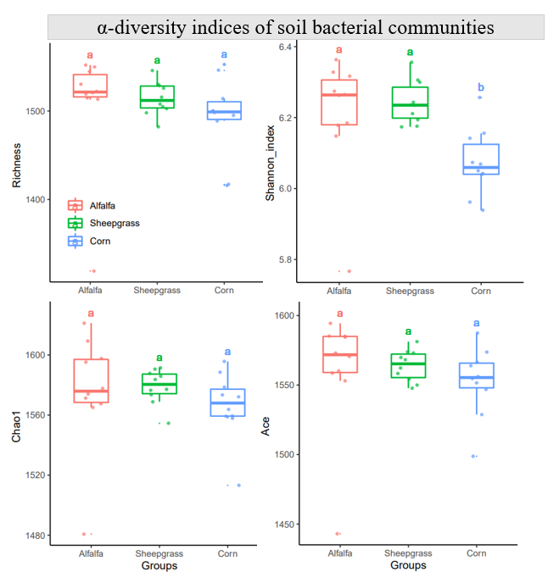
Figure S1. α-diversity of the soil bacterial communities in three systems. a Richness. b Shannon index. c Chao1. d ACE. Different letters on the column showed the significant difference among the three systems.

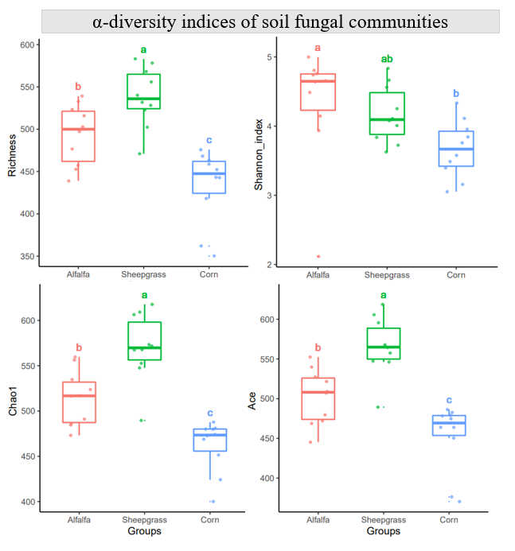
Figure S2. α-diversity of the soil fungal communities in three systems. a Richness. b Shannon index. c Chao1. d ACE. Different letters on the column showed the significant difference among the three systems.

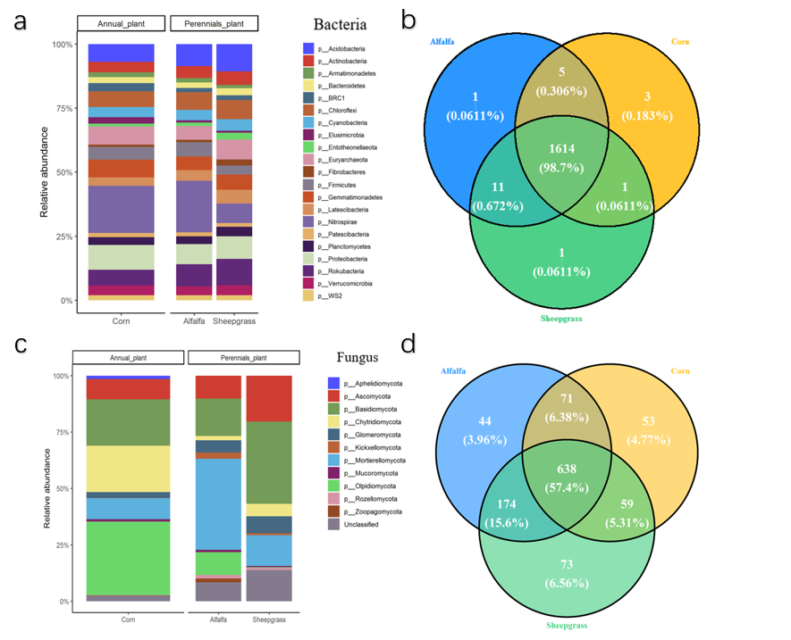
Figure S3. Abundances of total bacteria (16S rRNA gene) and fungal (ITS) among the three systems. Percentage of phylum in the total bacterial (a) fungal (c) community.
The VennDiagram represents the number of common and unique OTUs in bacterial (b) fungal (d) community, and can compare the similarity and overlap of OTUs composition of environmental samples. Different colors represent different samples.

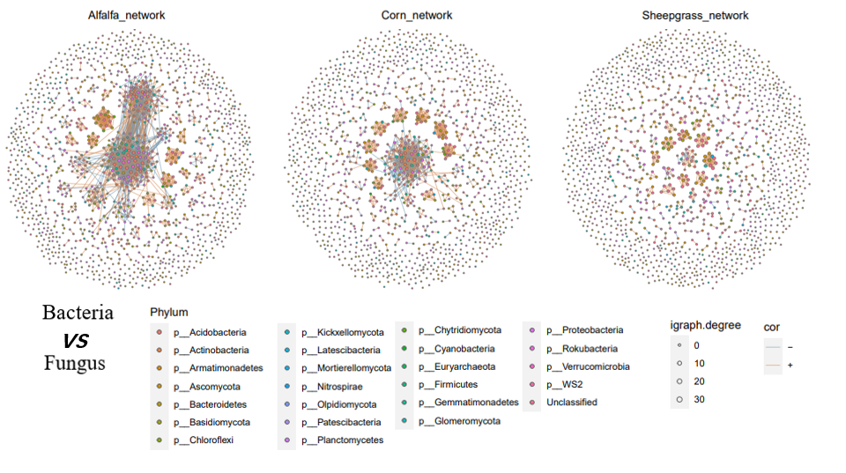
Figure S4. Associations across microbial groups differ among the continuous cropping systems. Nodes are colored according to their taxonomic affiliation at phylum levels. The size of the nodes is proportional to the number of links per node (i.e. degree). Link thickness is proportional to partial correlations between nodes and represents associative (blue, ρ>0.1) or exclusionary relationships (yellow, ρ<−0.1)

