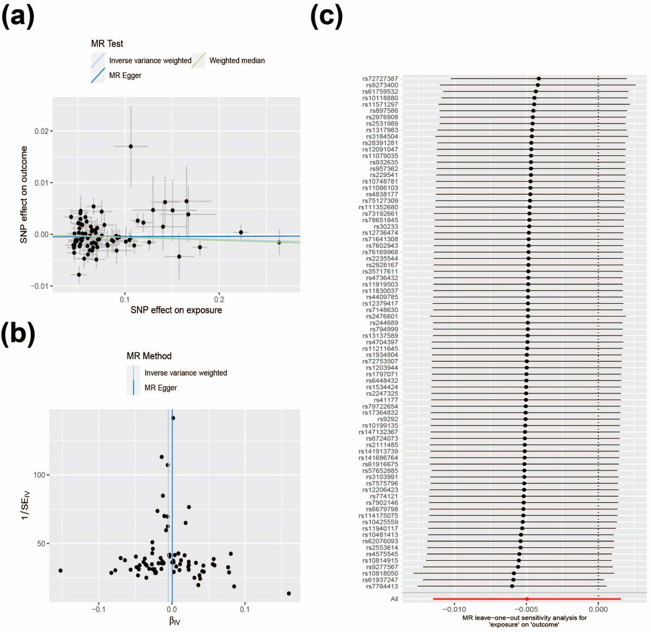
Figure S1: The causal effect of hypothyroidism on insomnia risk. (a) Scatter plots of insomnia with the risk of insomnia. (b) Funnel plot of the causal effect of hypothyroidism on insomnia risk (c) Leave-one-out plots of hypothyroidism with the risk of insomnia.
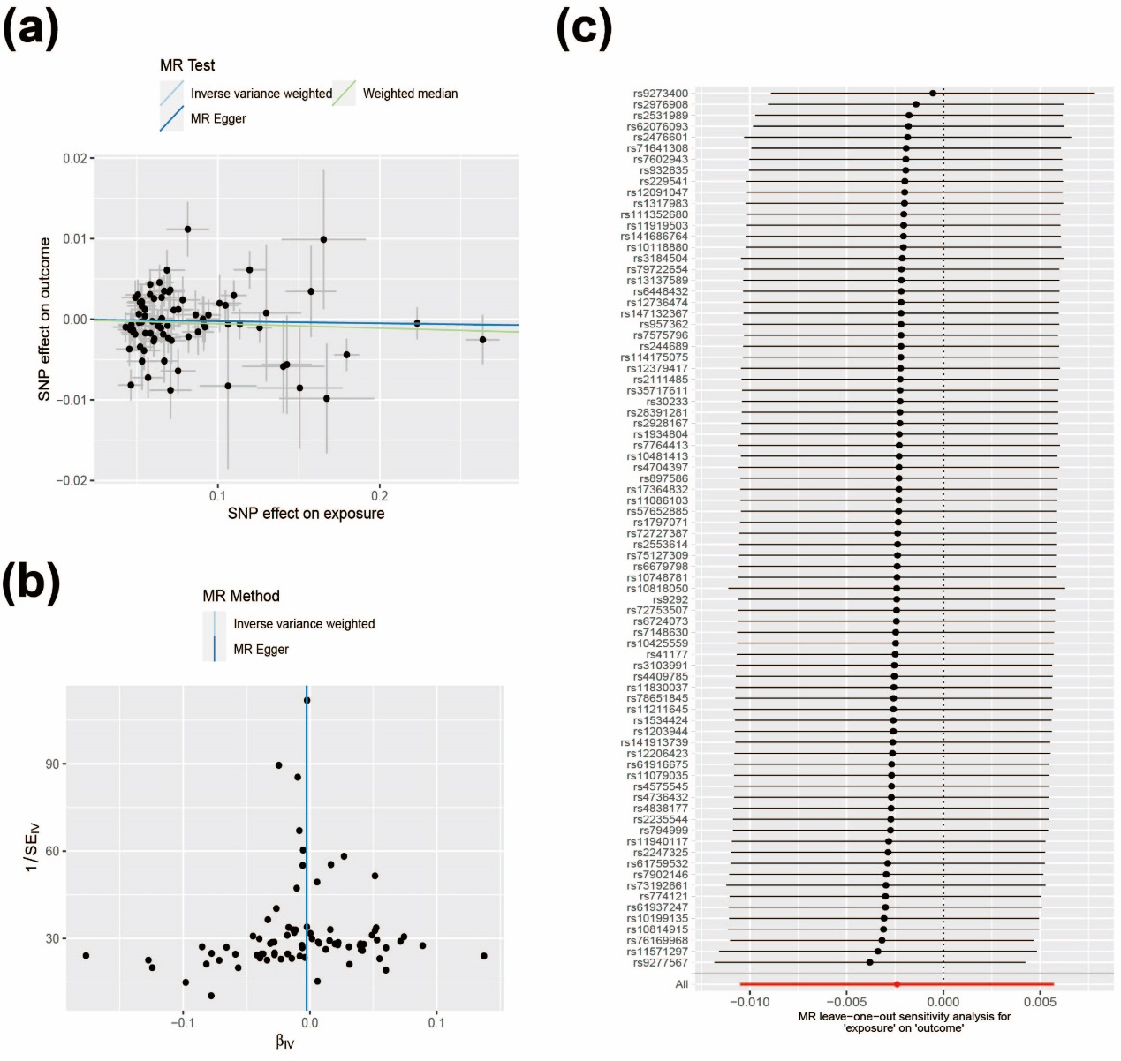
Figure S2: The causal effect of hypothyroidism on sleep duration risk. (a) Scatter plots of insomnia with the risk of sleep duration. (b) Funnel plot of the causal effect of hypothyroidism on sleep duration risk (c) Leave-one-out plots of hypothyroidism with the risk of sleep duration.
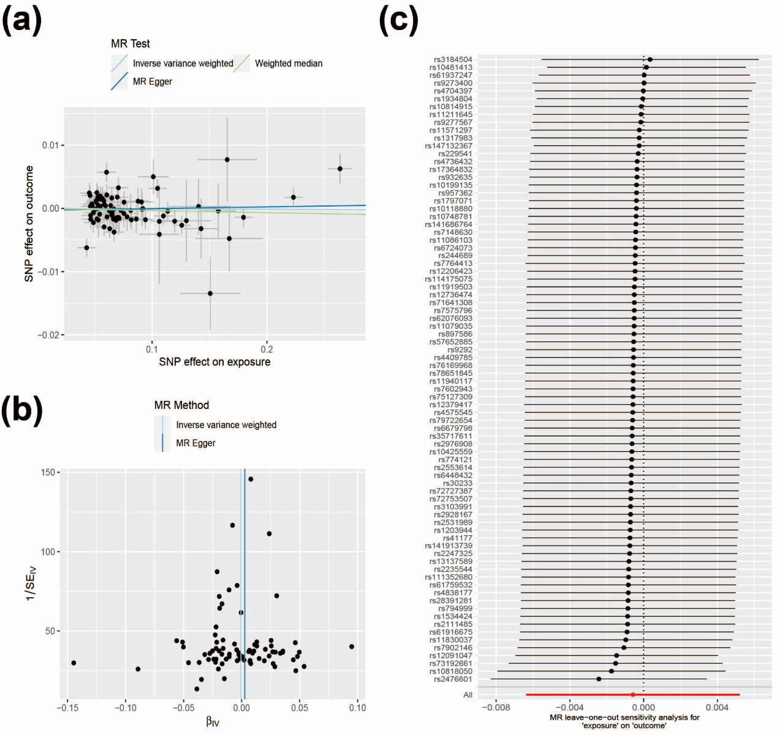
Figure S3: The causal effect of hypothyroidism on nap during day risk. (a) Scatter plots of insomnia with the risk of nap during day. (b) Funnel plot of the causal effect of hypothyroidism on nap during day risk (c) Leave-one-out plots of hypothyroidism with the risk of nap during day.
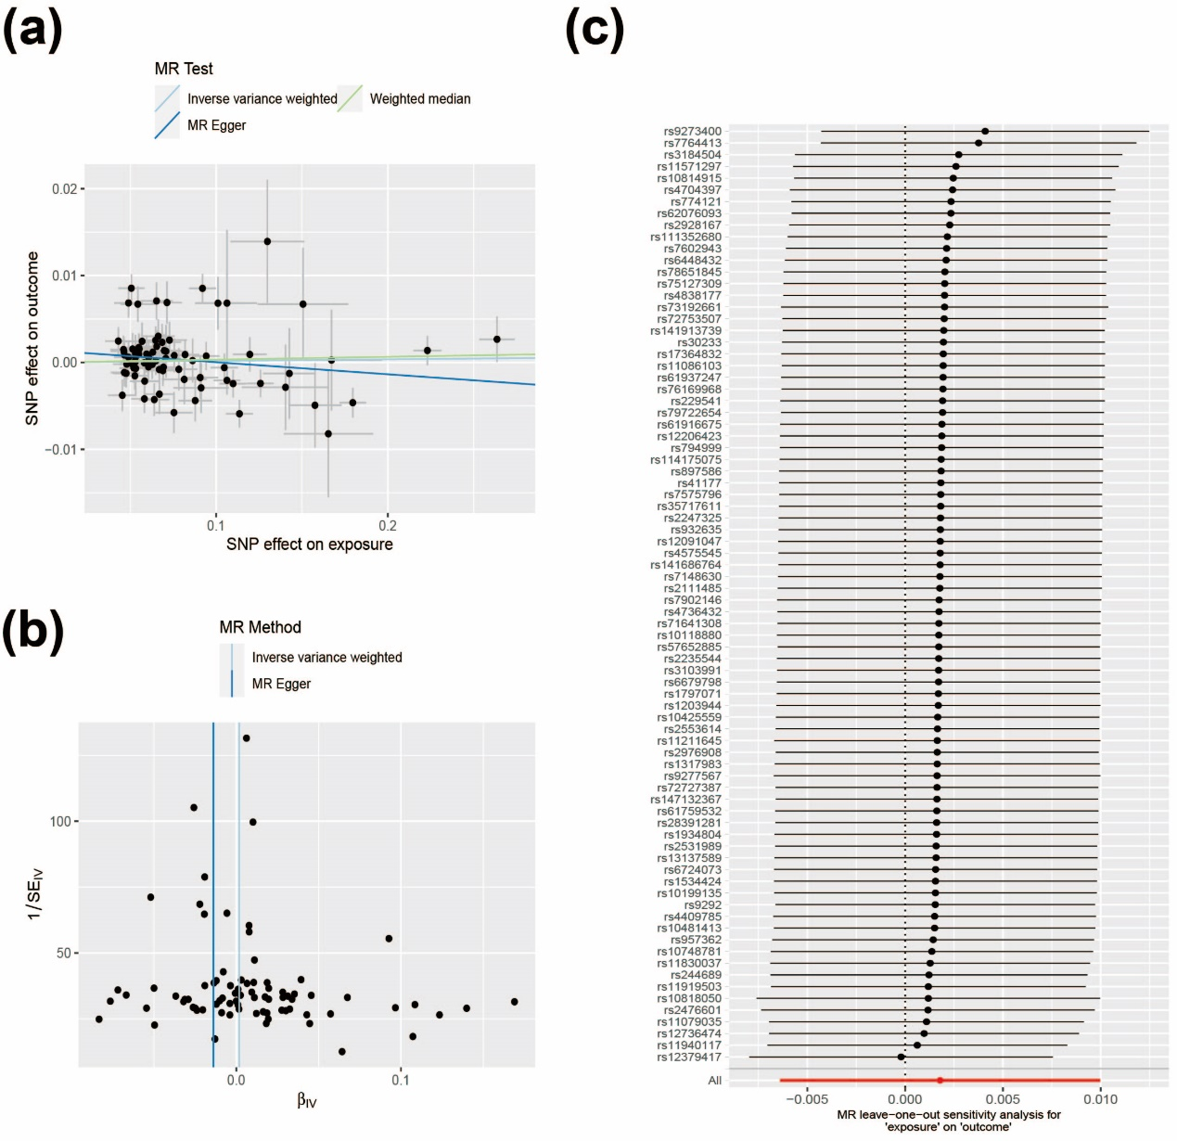
Figure S4: The causal effect of hypothyroidism on getting up in the morning risk. (a) Scatter plots of insomnia with the risk of getting up in the morning. (b) Funnel plot of the causal effect of hypothyroidism on getting up in the morning risk (c) Leave-one-out plots of hypothyroidism with the risk of getting up in the morning.
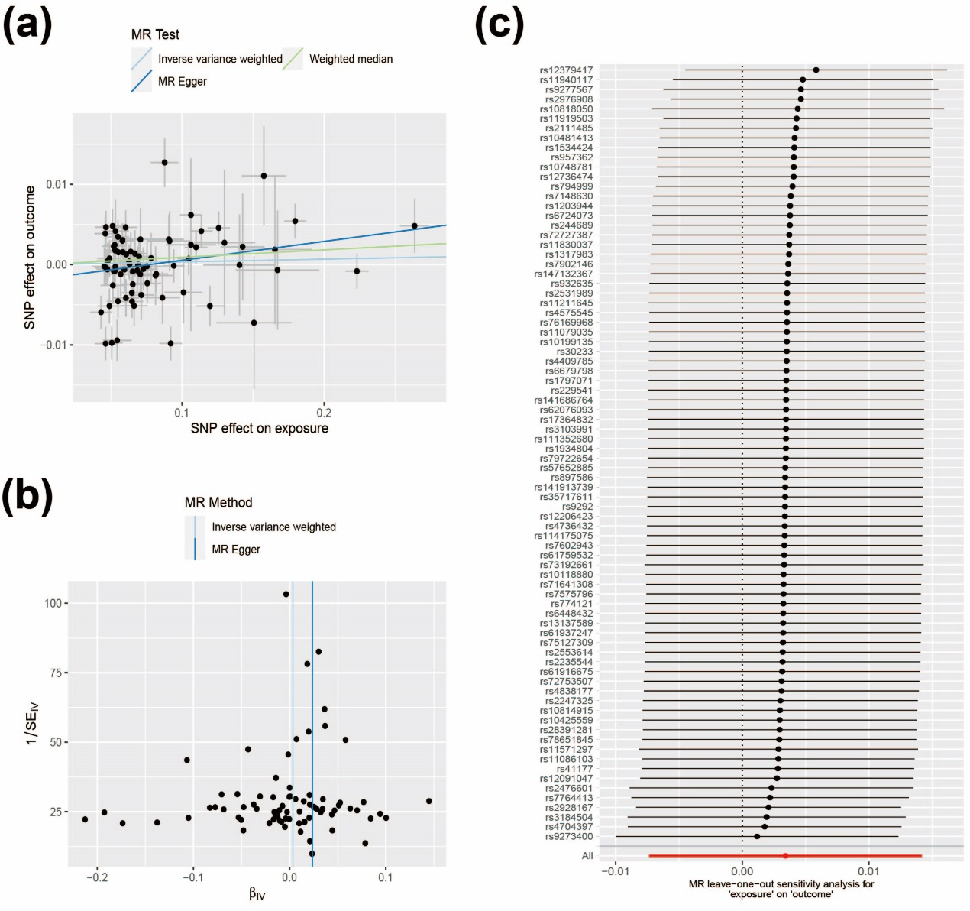
Figure S5: The causal effect of hypothyroidism on chronotype risk. (a) Scatter plots of insomnia with the risk of chronotype. (b) Funnel plot of the causal effect of hypothyroidism on chronotype risk (c) Leave-one-out plots of hypothyroidism with the risk of chronotype.
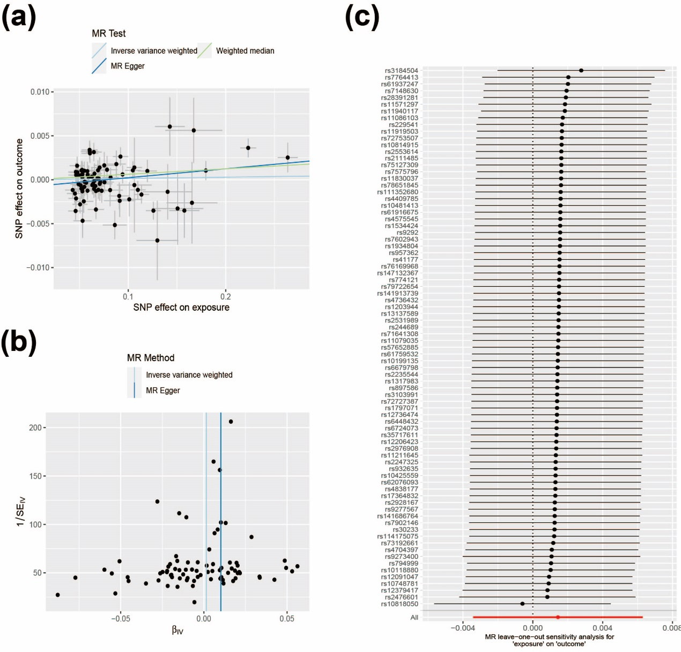
Figure S6: The causal effect of hypothyroidism on snoring risk. (a) Scatter plots of insomnia with the risk of snoring. (b) Funnel plot of the causal effect of hypothyroidism on snoring risk (c) Leave-one-out plots of hypothyroidism with the risk of snoring.

