Figure S1. (A) (Sample clustering was conducted to detect outliers; (B) Selection of the soft-thresholding powers. The left panel showed the scale-free fit index versus soft-thresholding power. The right panel displayed the mean connectivity versus soft-thresholding power.
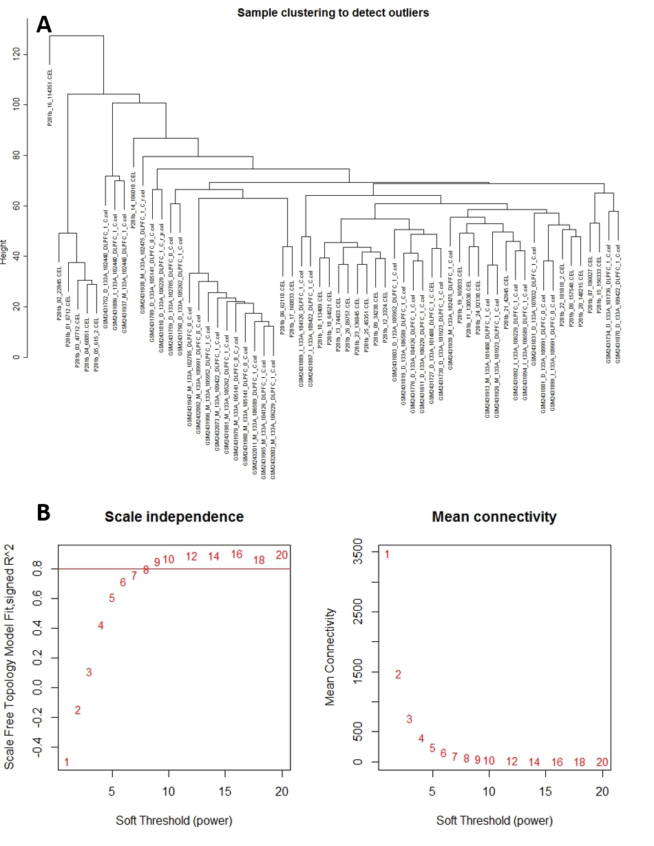

Figure S2. Clustering dendrogram of genes based on a dissimilarity measure (1-TOM), which was then used to group genes into modules. The branches correspond to modules of highly interconnected groups of genes. The height (y-axis) indicates the co-expression distance and the x-axis corresponds to genes. Colors represent the different modules along with gray indicating genes that could not be assigned to any module.
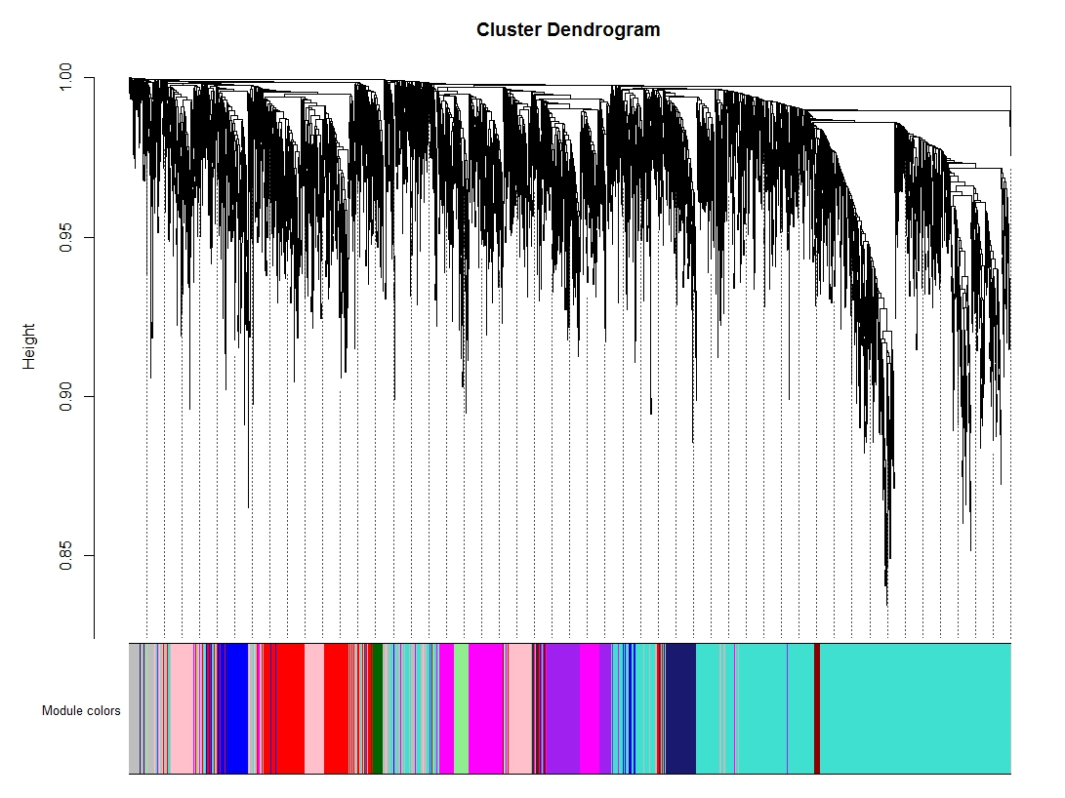

Figure S3. Module stability study using resampling of microarray samples. The upper panel shows the hierarchical clustering dendrogram of all probe sets. Branches of the dendrogram correspond to modules, identified by solid blocks of colors in the color row. Color rows beneath the first row indicate module assignments obtained from networks based on resampled sets of microarray samples.
