Supplementary

Novel Synthesized Ionizable Lipid for LNP-mediated P2X7siRNA
Inhibit Migration and Induce Apoptosis of Breast Cancer Cells

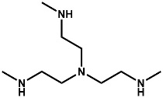 | + | 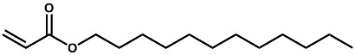 |  | 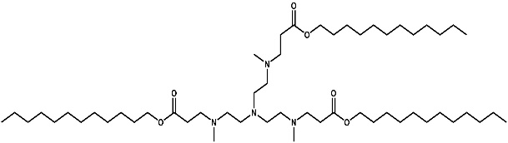

Figure S1. Reaction mechanism of amine structure with Lauryl Acrylate.

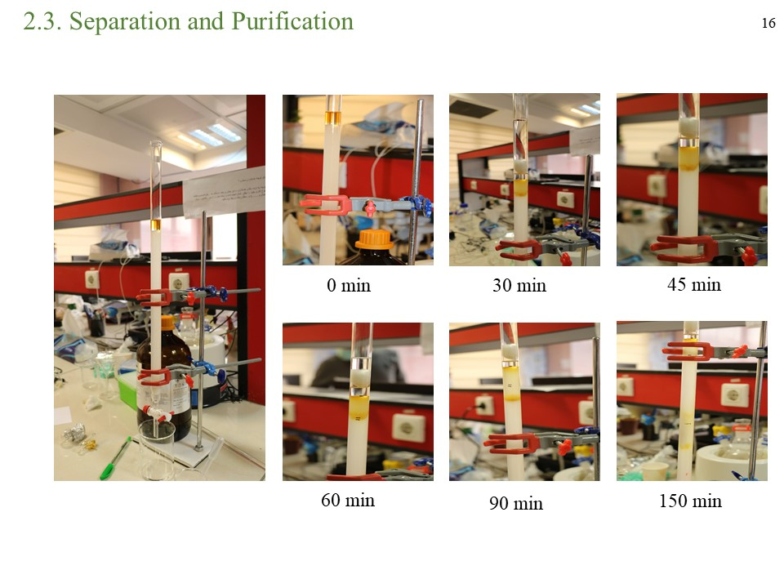
Figure S2. Real pictures of column chromatography for separation
of LA residual and purification following SIL synthesis from 0 to 150 min.

a
b
Figure S3. FT-IR spectra interpreting of initial reactants
, a) Tris-amine and b) LA.

a b
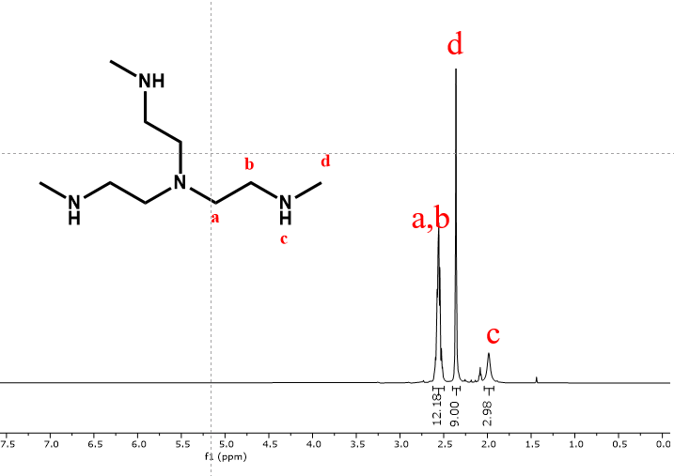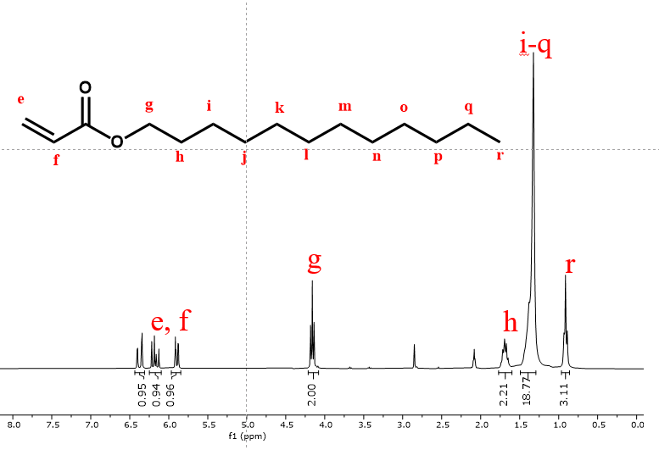
Figure S4. ¹H-NMR spectra assigning of initial reactants a) Tris-amine and b) LA.

a
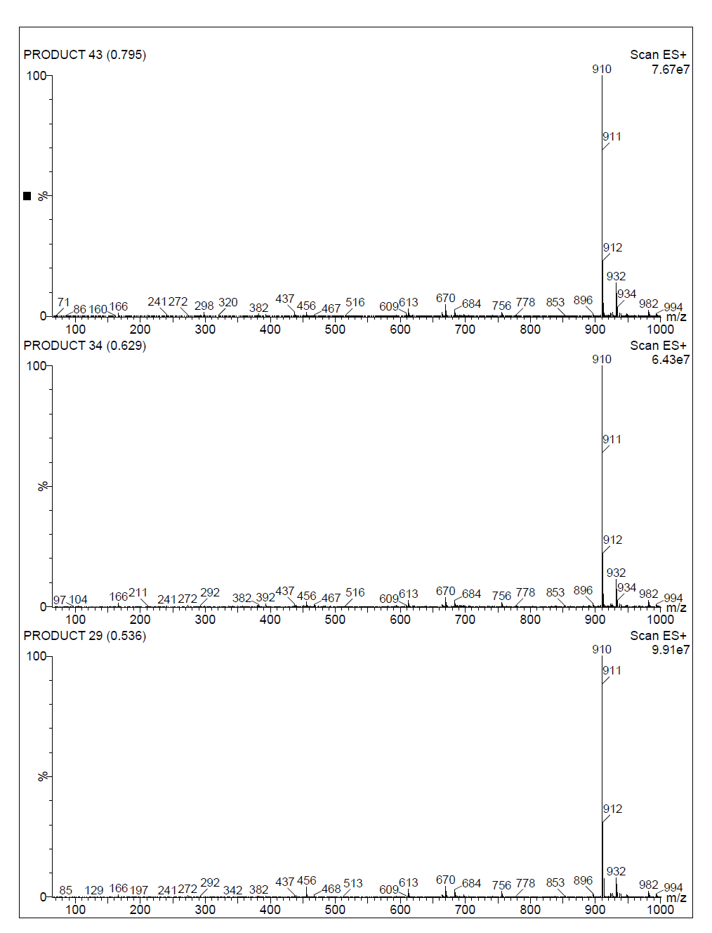
b
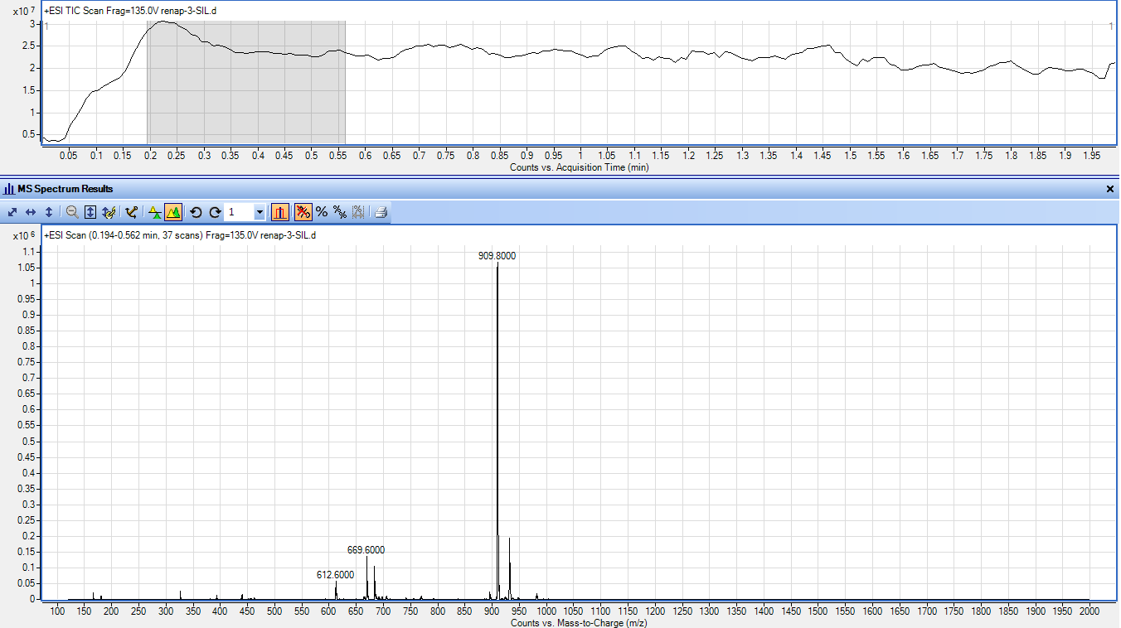

Figure S5. a) LC-MS analysis of SIL product and b) Direct MS analysis of SIL after
purification using column chromatography.

Figure S6. DLS analysis for characterization of prepared SIL-LNP loaded siRNA.
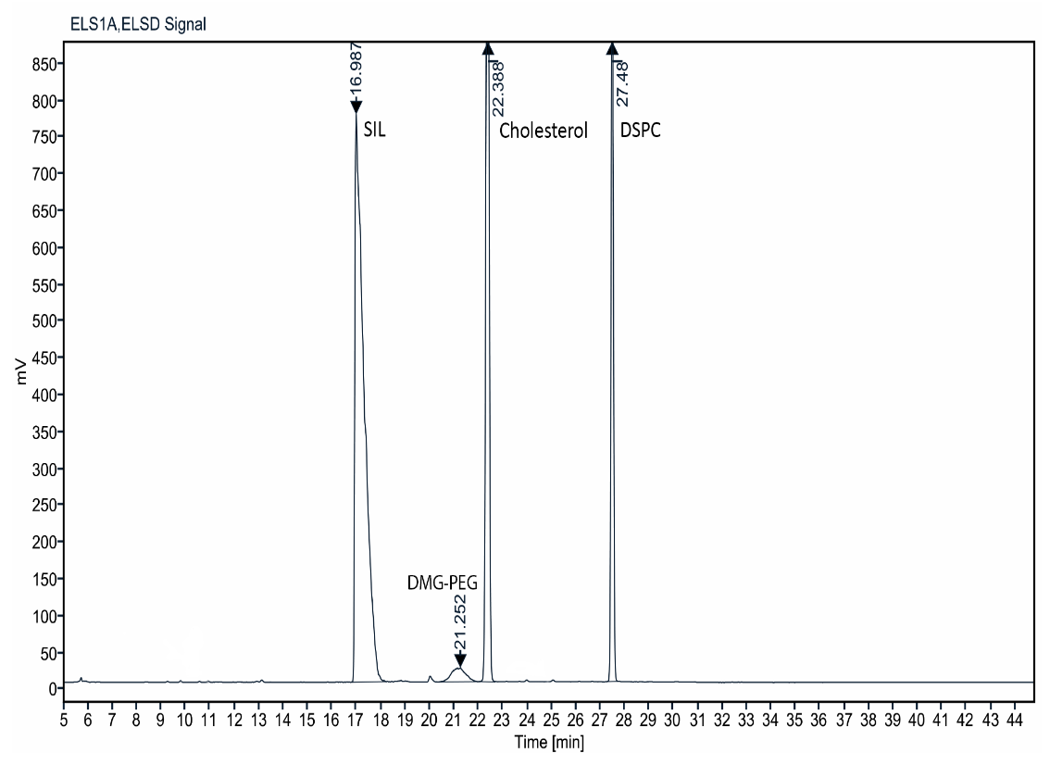

Figure S 8. ELSD-HPLC chromatogram analysis for prepared LNP including SIL.

