Table 1. Core content in the seven modules within SPARX
Module number and name | Content
1. Cave Province  “Finding Hope”  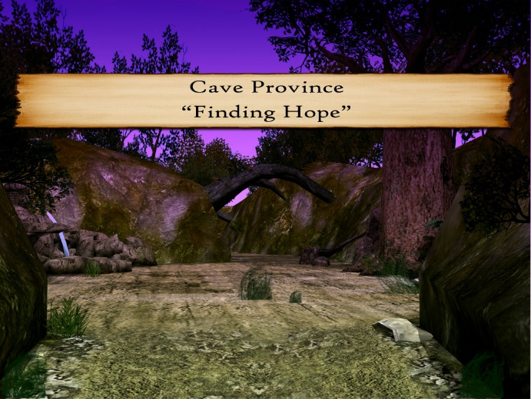 | - Psychoeducation about depression and introduction to the CBT model  - Introducing GNATs (gloomy negative automatic thoughts or unhelpful thoughts)  - Introducing ‘hope’ (e.g., people recover from depression)  - Relaxation: Controlled breathing
2. Ice Province  “Being Active”  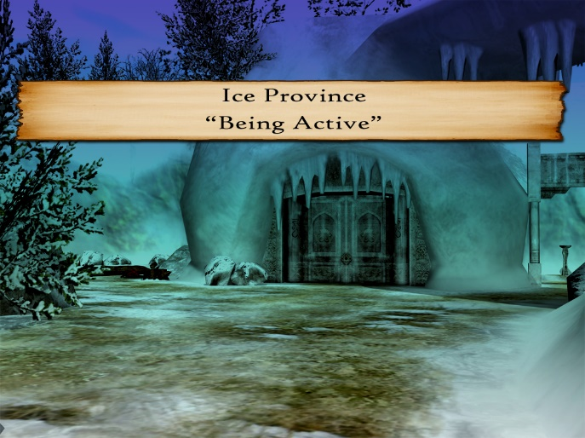 | - Activity scheduling and behavioural activation  - Relaxation: Progressive muscle relaxation  - Basic communication and interpersonal skills
3. Volcano Province  “Dealing with Emotions”  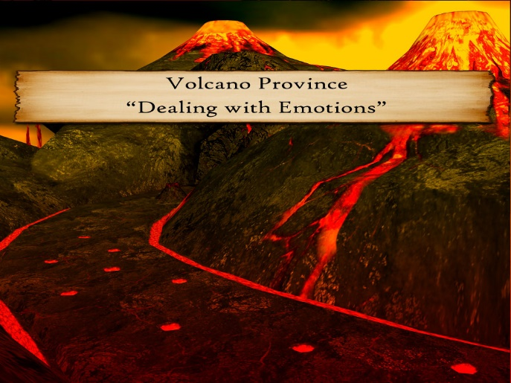 | - Dealing with strong emotions: hurt feelings and anger  - Learning about triggers and ways to deal with those  - Interpersonal skills: assertiveness, listening and negotiation skills
4. Mountain Province  “Overcoming Problems”  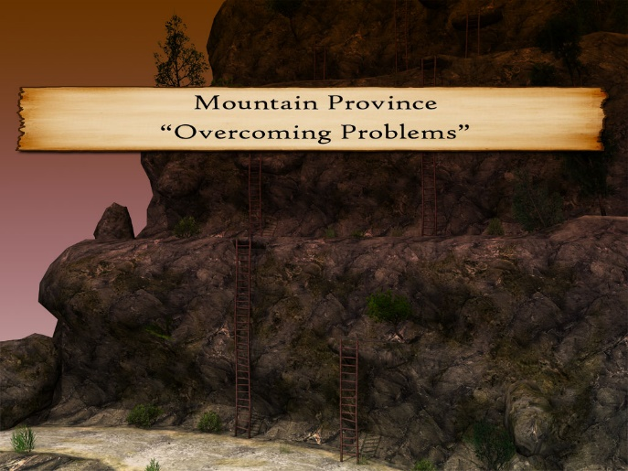 | - Problem solving using ‘STEPS’  - Cognitive restructuring: identifying SPARX – positive / helpful thoughts
5. Swamp Province  “Recognising Unhelpful Thoughts”  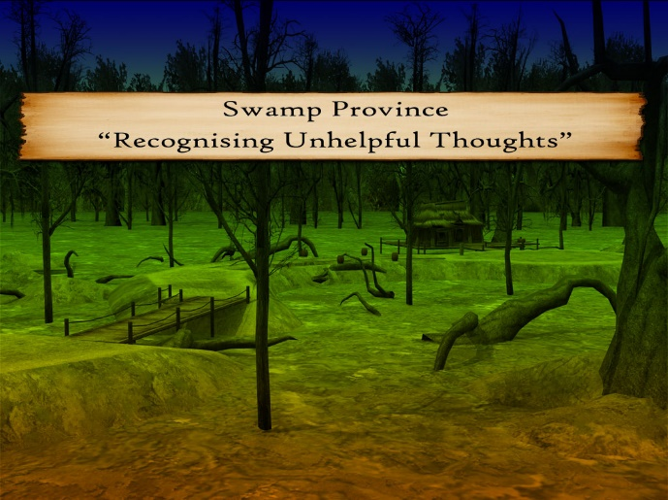 | - Cognitive restructuring: recognising different types of GNATs (negative / unhelpful thoughts)
6. Bridgeland Province  “Challenging Unhelpful Thoughts”  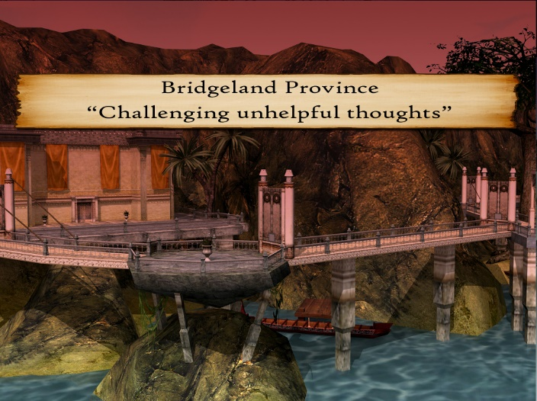 | - Cognitive restructuring: learning to challenge or ‘swap’ negative thoughts/Gnats for helpful ones  - Interpersonal skills continued: negotiation skills
7. Canyon Province  “Bringing it all together”  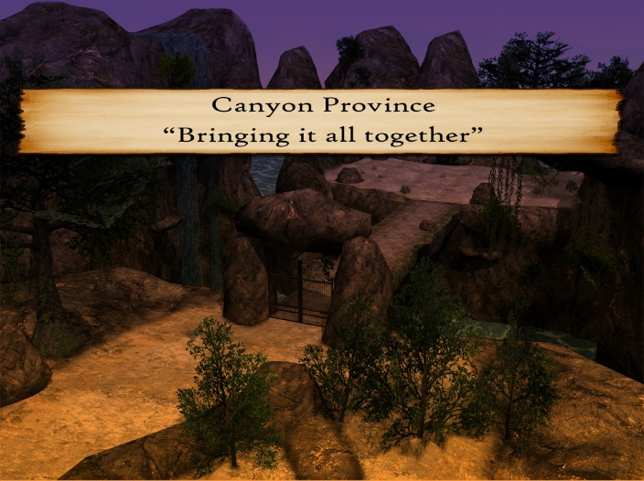 | - Recap of all skills  - Mindfulness: tolerating distress  - Relapse prevention: knowing when to ask for help

