Supporting Information

A novel Approach to the Transformation of Pyrazole-4-Carbonitriles to Novel 3-Aryl-1-Phenyl-1H-Pyrazole-4-Carbothioamide Using Thioacetamide as a Sulfur Source
Tukaram S. Choudhare¹, Devendra S. Wagare,² Dinesh L. Lingampalle,² Prashant. D. Netankar^{1*}
¹Department of Chemistry, Maulana Azad College, Dr. Babasaheb Ambedkar Marathwada University, Aurangabad-431 004, India
²Department of chemistry, Vivekanand Arts,sardar Dalipsingh Commerce and Science College,Auranagbad-43002,India

Corresponding Author * E-mail: pdnchemi@gmail.com

Table of content
- Table S1- physical data of Novel pyrazole-4-thioamide (3a-j)
- Characterization data of pyrazole-4-thioamide (3a-j)
- ¹H and ¹³C NMR spectra of Compounds (3a-j)
- Mass spectra of compounds (3a-j)

.

Table S₁ — Transformation of novel pyrazole thioamide ( 3a-3_{j})
Table : - Synthesis of 3-Aryl-1-phenyl-1H-pyrazole-4-carbothioamides derivatives 3a-j using 1a-j and 2.
Entry | R | Product | Time in hr | (%) Yieldª | MP ºC^{b}
3a | 4-F | 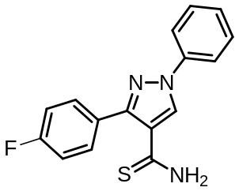 | 1 | 88 | 227-229
3b | -H | 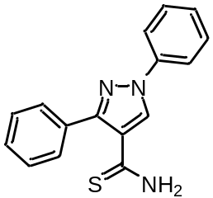 | 1 | 85 | 211-215
3c | 4-Cl | 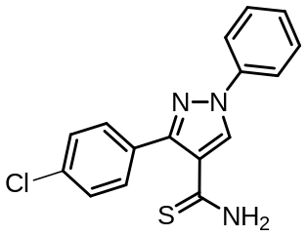 | 1 | 83 | 245-247
3d | 3-Br | 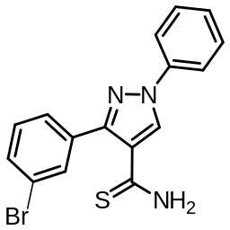 | 1 | 82 | 255-257
3e | 4-NO₂ | 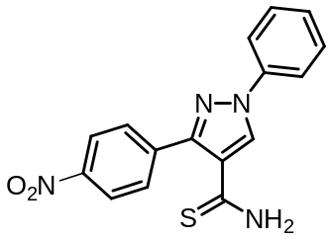 | 1 | 80 | 271-274
3f | 3-NO₂ | 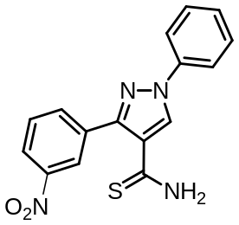 | 1 | 85 | 239-241
3g | 4-Br | 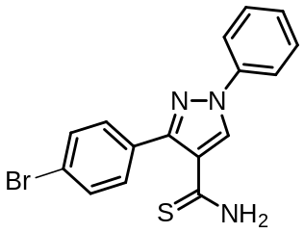 | 1 | 80 | 288-290
3h | 4-OCH₃ | 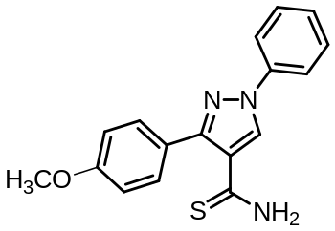 | 1 | 75 | 243-247
3i | 4-OH | 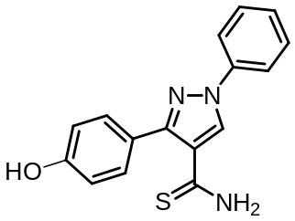 | 1 | 72 | 255-257
3j | 4-CH₃ |  | 1 | 70 | 266-268
Isolated yield, Melting points

2. Characterization of 3-Aryl-1-phenyl-1H-pyrazole-4-carbothioamides. (3a-3_{j})
Supplementary:
3-(4-fluorophenyl)-1-phenyl-1H-pyrazole-4-carbothioamide (3a)
Mass: [ES] ⁺ 298. 1H NMR (DMSO, d6) δppm: 7.26 (d, 2H, Ar-H), 7.35 (d, 2H, Ar-H), 7.41-7.75 (m, 5H, Ar-H), 8.78 (s, 1H, Ar-H), 9.25 (s, 1H, -NH2), 9.78 (s, 1H, -NH2).
1,3-diphenyl-1H-pyrazole-4-carbothioamide (3b).
Mass: [ES] ⁺ 280 ¹H NMR (DMSO) δppm: 7.35-7.41 (m, 5H, Ar-H), 7.43-7.99 (m, 5H, Ar-H), 8.00 (s, 1H, Ar-H), 9.19 (s, 1H, -NH₂), 9.76 (s, 1H, -NH₂). ¹³C NMR (DMSO, d₆) δppm: 90.49, 116.41, 119.26, 125.20, 126.78, 128.08, 129.67, 132.02, 136.22, 138.85, 148.49, 152.57. IR (cm⁻¹): 1626 (C=C), 1596 (C-H), 3412 (N-H), 2223 (C=N).

3-(4-chlorophenyl)-1-phenyl-1H-pyrazole-4
carbothioamide (3c)
Mass: [ES] ⁺ 314 ¹H NMR (DMSO, d₆) δppm ppm: 7.37 (d, 2H, Ar-H), 7.78 (d, 2H, Ar-H), 7.52-7.61 (m, 5H, Ar-H), 8.79 (s, 1H, Ar-H), 9.28 (s, 1H, -NH₂), 9.79 (s, 1H, -NH₂). ¹³C NMR (DMSO, d₆) δppm ppm: 90.93, 114.02, 119.28, 126.96, 129.15, 130.91, 134.38, 136.37, 138.74, 147.68, 151.28, 193.50. IR (cm⁻¹): 1631 (C=C), 1596 (C-H), 3350 (N-H), 2221 (C=N), 752 (C-Cl).
3-(3-bromophenyl)-1-phenyl-1H-pyrazole-4-carbothioamide (3d)
Mass: [ES] ⁺ 358 ¹H NMR (DMSO, d₆) δppm ppm: 7.20 (s, 1H, Ar-H), 7.43 (d, 1H, Ar-H), 7.69 (d, 1H, Ar-H), 7.54 (dd, 1H, Ar-H), 7.71-7.98 (m, 5H, Ar-H), 8.94 (s, 1H, Ar-H), 9.33 (s, 1H, -NH₂), 9.87 (s, 1H, -NH₂).
3-(4-nitrophenyl)-1-phenyl-1H-pyrazole-4-carbothioamide (3e)
Mass: [ES] ⁺325 ¹H NMR (DMSO, d₆) δppm: 7.38 (d, 2H, Ar-H), 7.55 (d, 2H, Ar-H), 7.96-8.23 (m, 5H, Ar-H), 8.42 (s, 1H, Ar-H), 8.85 (s, 1H, -NH₂), 8.87 (s, 1H, -NH₂). IR (cm⁻¹): 1637 (C=C), 1597 (C-H), 3405 (N-H), 2225 (C=N), 1521 (C-NO₂).
3-(3-nitrophenyl)-1-phenyl-1H-pyrazole-4-carbothioamide (3f)
Mass: [ES] ⁺ 325 ¹H NMR (DMSO, d₆) δppm: 9.52 (s, 1H, Ar-H), 7.78 (d, 1H, Ar-H), 8.50 (d, 1H, Ar-H), 7.62 (dd, 1H, Ar-H), 7.89-7.98 (m, 5H, Ar-H), 8.16 (s, 1H, Ar-H), 9.43 (s, 1H, -NH₂), 9.89 (s, 1H, -NH₂). ¹³C NMR (DMSO, d₆) δppm: 90.91, 113.76, 118.67, 119.39, 120.60, 122.59, 124.18, 132.32, 136.67, 138.85, 147.48, 148.14, 150.27, 192.98.
3-(4-bromophenyl)-1-phenyl-1H-pyrazole-4-carbothioamide (3g)
Mass: [ES] ⁺ 358 ¹H NMR (DMSO, d₆) δppm: 7.59 (d, 2H, Ar-H), 7.66 (d, 2H, Ar-H), 7.90-7.94 (m, 5H, Ar-H), 8.80 (s, 1H, Ar-H), 9.29 (s, 1H, -NH₂), 9.79 (s, 1H, -NH₂). ¹³C NMR (DMSO, d₆) δppm: 90.53, 114.02, 118.50, 119.29, 123.08, 125.10, 129.99, 132.09, 136.40, 138.77, 147.73, 151.45.
3-(4-methoxy)-1-phenyl-1H-pyrazole-4-carbothioamide (3h)
Mass: [ES] ⁺310 ¹H NMR (DMSO, d₆) δppm: 3.62 (s, 3H, -OCH₃), 7.00 (d, 2H, Ar-H), 7.12 (d, 2H, Ar-H), 7.51-7.67 (m, 5H, Ar-H), 8.74 (s, 1H, Ar-H), 9.19 (s, 1H, -NH₂), 9.75 (s, 1H, -NH₂). ¹³C NMR (DMSO, d₆) δppm: 55.21, 89.94, 112.55, 114.43, 116.32, 119.14, 122.47, 138.30, 148.29, 152.46, 154.26, 160.26, 194.01.
3-(4-hydroxy)-1-phenyl-1H-pyrazole-4-carbothioamide (3i)
Mass: [ES] ⁺296 ¹H NMR (DMSO, d₆) δppm: 3.56 (s, 1H, -OH), 7.49 (d, 2H, Ar-H), 7.76 (d, 2H, Ar-H), 7.16-7.82 (m, 5H, Ar-H), 7.92 (s, 1H, Ar-H), 9.05 (s, 1H, -NH₂), 9.94 (s, 1H, -NH₂).
3-(4-methyl)-1-phenyl-1H-pyrazole-4-carbothioamide (3j)
Mass: [ES] ⁺294 ¹H NMR (DMSO, d₆) δppm: 2.38 (s, 1H, -CH₃), 7.26 (d, 2H, Ar-H), 7.43 (d, 2H, Ar-H), 7.53-7.86 (m, 5H, Ar-H), 8.75 (s, 1H, Ar-H), 9.15 (s, 1H, -NH₂), 9.75 (s, 1H, -NH₂).

3. NMR Spectra of Thioamide (3_{a}-3_{j})
¹H NMR spectrum of 3-(4-fluorophenyl)-1-phenyl-1H-pyrazole-4-carbothioamide (3_{a})
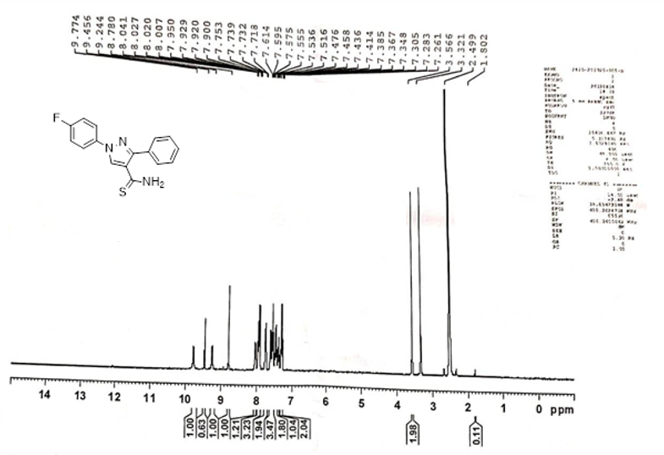

¹H NMR spectrum of1,3-di-phenyl-1H-pyrazole-4-carbothioamide (3b)

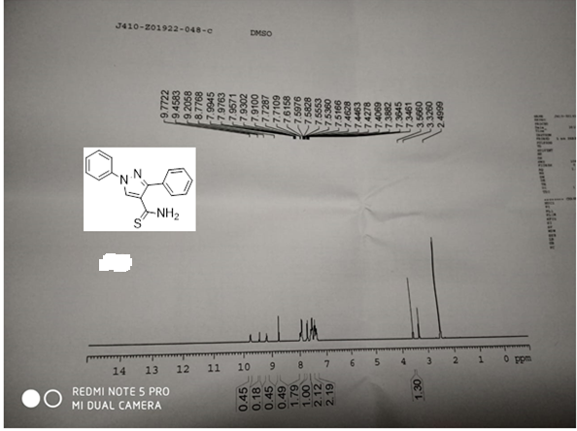

¹³C NMR spectrum of1,3-di-phenyl-1H-pyrazole-4-carbothioamide (3b)

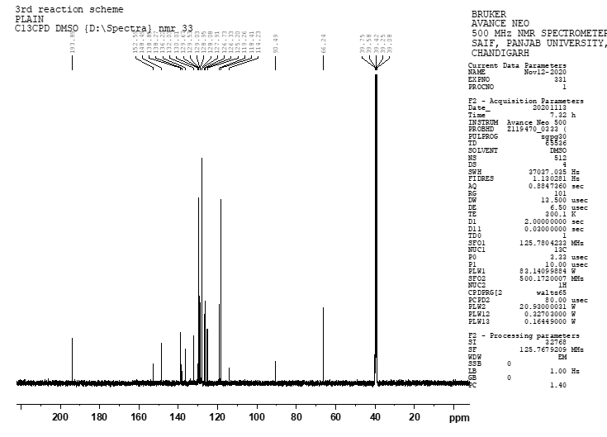

¹H NMR spectrum of 3-(4-chlorophenyl)-1-phenyl-1H-pyrazole-4-carbothioamide (3c)
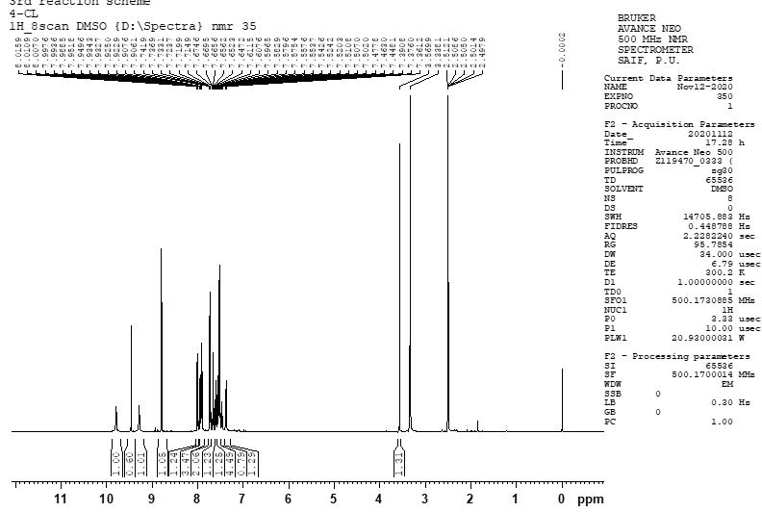

¹³C NMR spectrum of 3-(4-chlorophenyl)-1-phenyl-1H-pyrazole-4-carbothioamide (3c)
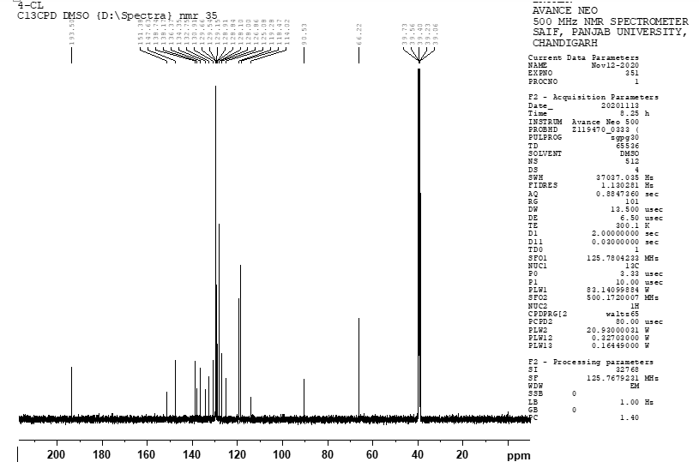

¹H NMR spectrum of 3-(3-bromophenyl)-1-phenyl-1H-pyrazole-4-carbothioamide (3d)
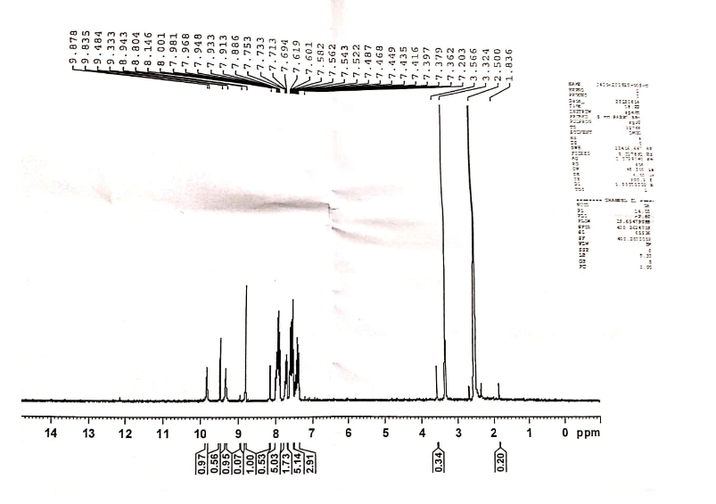

¹H NMR spectrum of 3-(4-nitrophenyl)-1-phenyl-1H-pyrazole-4-carbothioamide (3e)
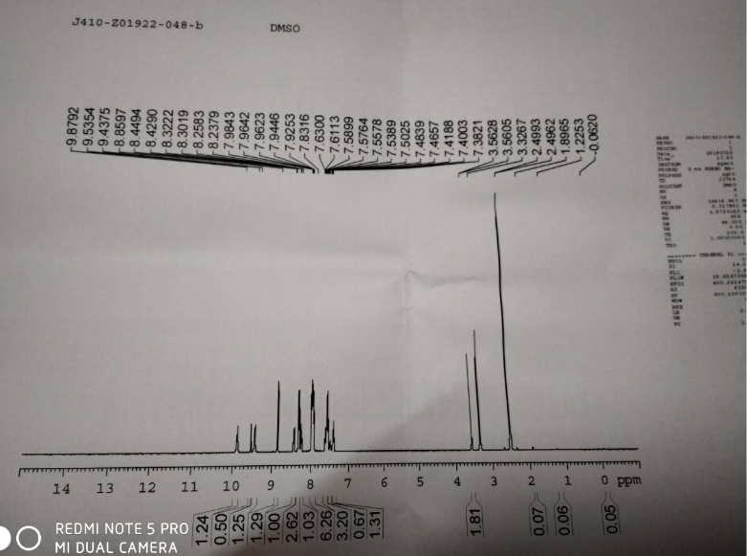

¹H NMR spectrum of 3-(3-nitrophenyl)-1-phenyl-1H-pyrazole-4-carbothioamide (3f)
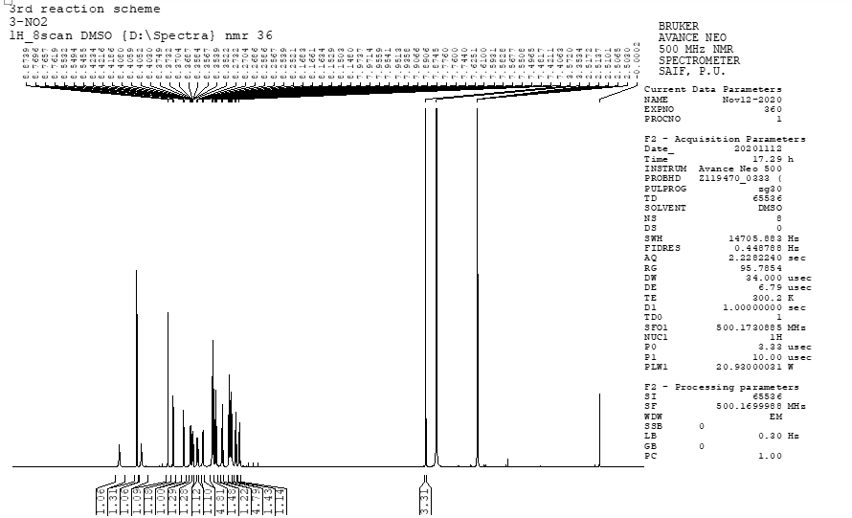

¹³C NMR spectrum of 3-(3-nitrophenyl)-1-phenyl-1H-pyrazole-4-carbothioamide (3f)
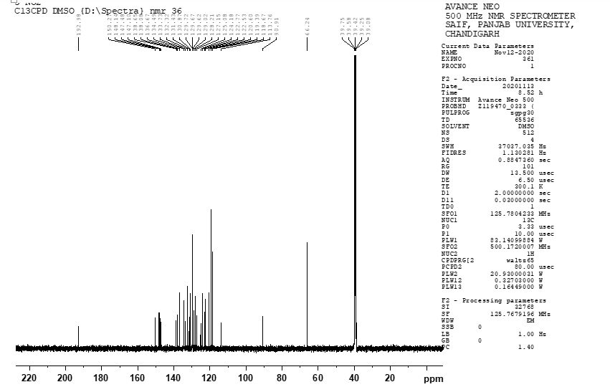

¹H NMR spectrum of 3-(4-bromophenyl)-1-phenyl-1H-pyrazole-4-carbothioamide (3g)
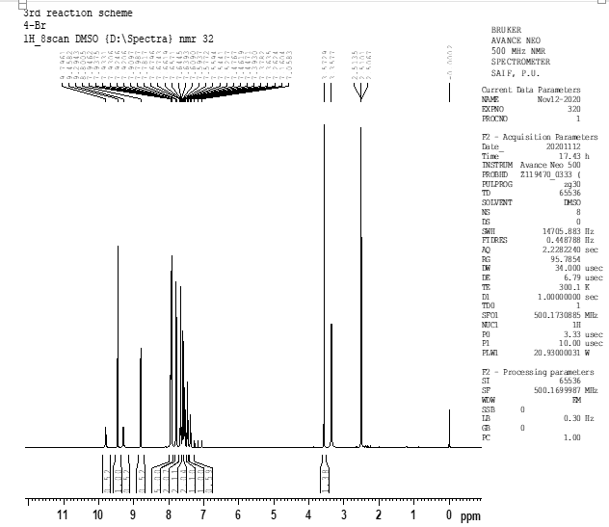

¹³C NMR spectrum of 3-(4-bromophenyl)-1-phenyl-1H-pyrazole-4-carbothioamide (3g)
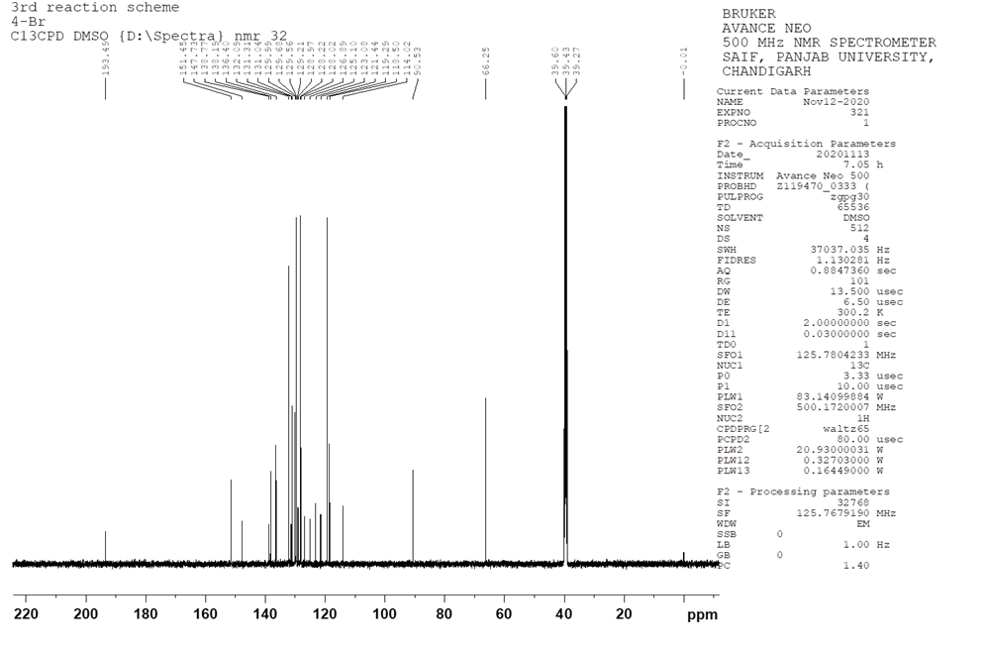

¹H NMR spectrum of 3-(4-methoxyphenyl)-1-phenyl-1H-pyrazole-4-carbothioamide (3h)
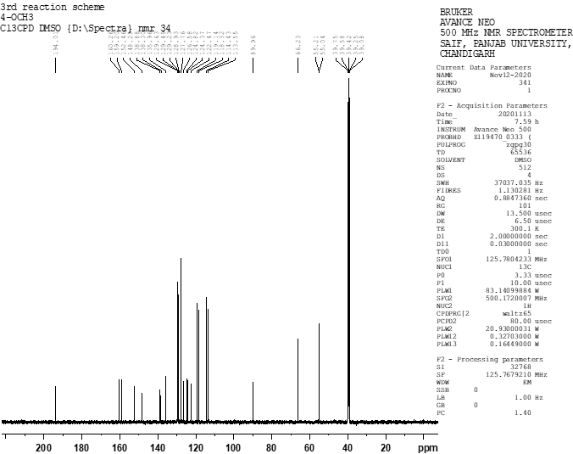

¹H NMR spectrum of 3-(4-hydroxyphenyl)-1-phenyl-1H-pyrazole-4-carbothioamide (3i)
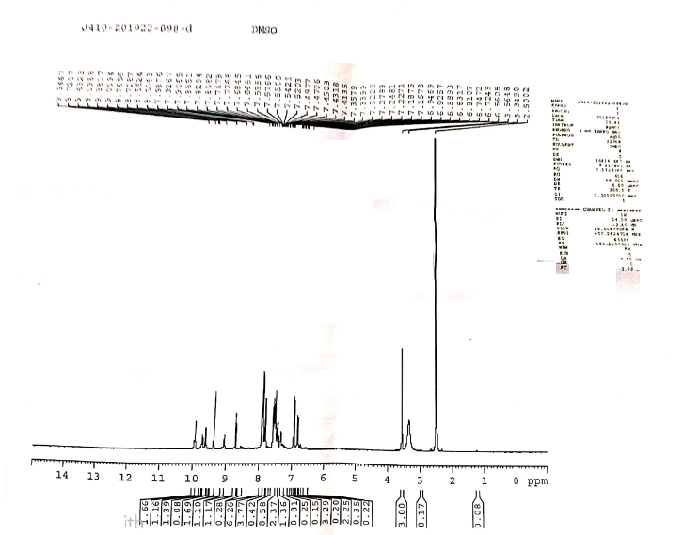

¹H NMR spectrum of 1-phenyl-3-(p-tolyl)-1H-pyrazole-4-carbothioamide (3j)
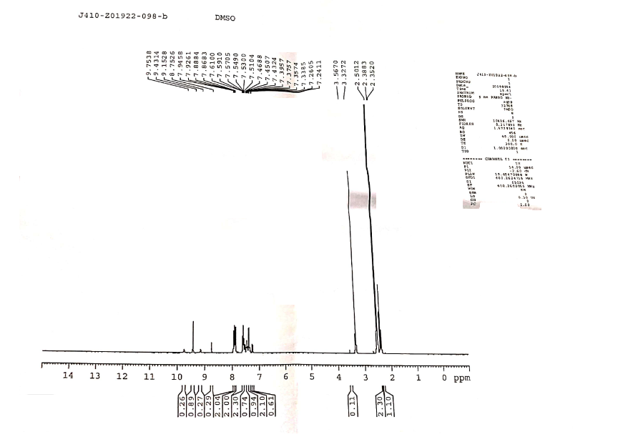

3. Mass Spectra of compounds 3a-j
a) Mass spectrum of 3-(4-fluorophenyl)-1-phenyl-1H-pyrazole-4-carbothioamide (3a)
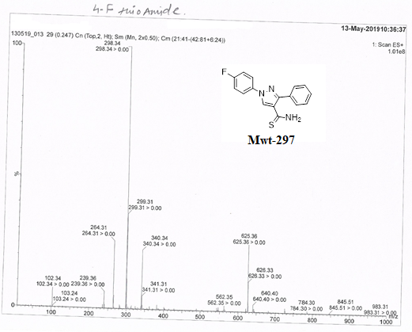

Mass spectrum of 1,3-di-phenyl-1H-pyrazole-4-carbothioamide (3b)
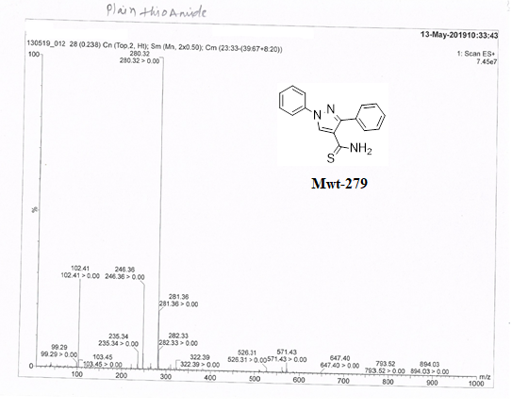

Mass spectrum of 3-(4-chlorophenyl)-1-phenyl-1H-pyrazole-4-carbothioamide (3c)
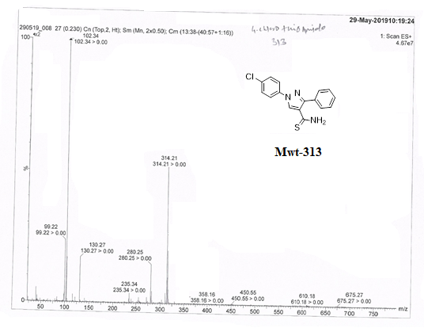

Mass spectrum of 3-(3-bromophenyl)-1-phenyl-1H-pyrazole-4-carbothioamide (3d)
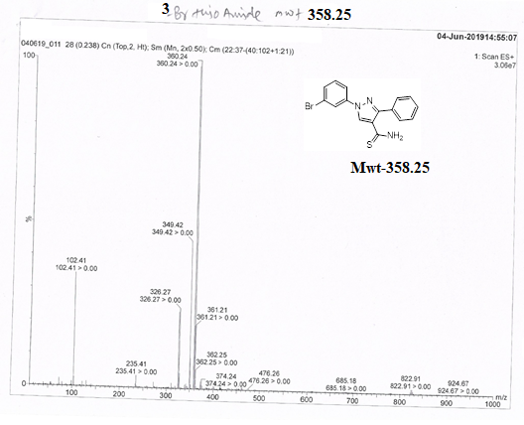

Mass spectrum of 3-(4-nitrophenyl)-1-phenyl-1H-pyrazole-4-carbothioamide (3e)
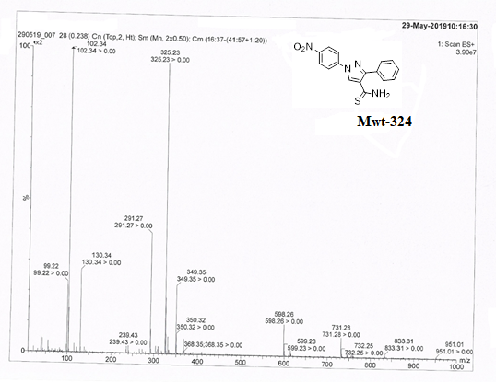

Mass spectrum of 3-(3-nitrophenyl)-1-phenyl-1H-pyrazole-4-carbothioamide (3f)
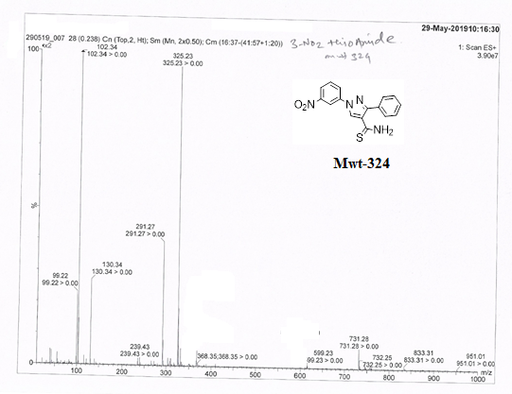

Mass spectrum of 3-(4-bromophenyl)-1-phenyl-1H-pyrazole-4-carbothioamide (3g)
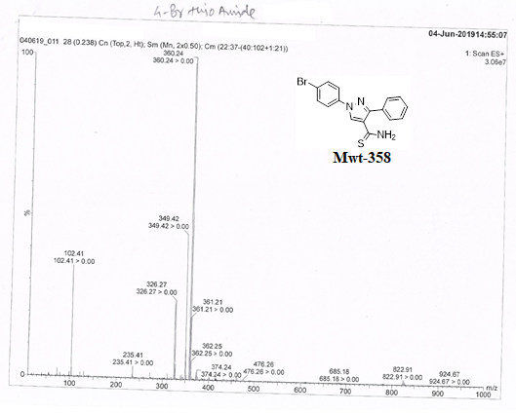

Mass spectrum of 3-(4-methoxyphenyl)-1-phenyl-1H-pyrazole-4-carbothioamide (3h)
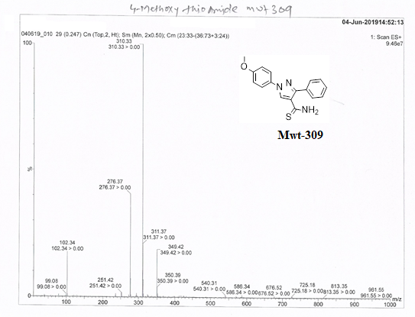

Mass spectrum of 3-(4-hydroxyphenyl)-1-phenyl-1H-pyrazole-4-carbothioamide (3i)
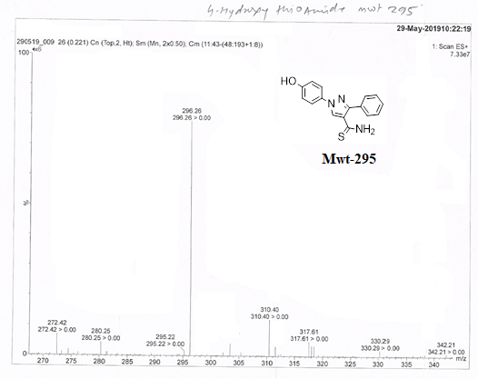

Mass spectrum of 1-phenyl-3-(p-tolyl)-1H-pyrazole-4-carbothioamide (3j)
