Supporting Information

Photo- and pH-dually responsive hydrogel containing spirooxazine groups
Yulong Zouª, He Gaoª, Chengdong Suª, Min Wangª, and Jun Gao^{a*}
ªSchool of Chemical engineering, Sichuan University, Chengdu 610065, PR China
*E-mail：gjun@scu.edu.cn; Fax: +86 28 85401152; Tel: +86 13348884920
Methods and Materials
- Synthesis of 5-Carboxy-2,3,3-trimethyl-3H-indole (compound 1) [1]
6.2 g (40 mmol) of 4-carboxyphenylhydrazine and 6.0 g (68 mmol) of 3-methyl-2-butanone, dissolved in 50 mL of glacial acetic acid, were introduced into a 100 mL flask under a nitrogen atmosphere. The mixture was stirred and heated under reflux for 16 hours, after which the acetic acid was removed via distillation under reduced pressure. The remaining solution was adjusted to a pH of approximately 4 using a saturated solution of Na₂CO₃, then extracted with CH₂Cl₂ and dried using anhydrous MgSO₄ for 24 hours. The filtrate was collected by filtration, and CH₂Cl₂ was subsequently distilled off.
2. Synthesis of 5-Carboxymethyl-2,3,3- trimethyl-3H-indole (compound 2)[2]
2.1 g (10 mmol) of 5-carboxy-2,3,3-trimethyl-3H-indole were carefully introduced into a three-necked flask (250 mL) containing 1.2 mL of 98% H₂SO₄ and 50 milliliters of distilled water. The resulting mixture was then subjected to reflux at 65℃ for a duration of 18 hours. The mixture was then subjected to distillation under reduced pressure in order to remove the methanol. The remaining residue was then subjected to pH adjustment using a saturated solution of Na₂CO₃ until the pH was approximately 7. The resulting solution was then extracted using ethyl acetate, and the extract was dried for 24 hours using anhydrous MgSO₄. The resultant filtrate was collected by filtration, and the ethyl acetate was carefully distilled off.
3. Synthesis of 1-N-butyl-3,3-dimethyl-5-carboxylate-2-methyleneindoline (compound 3)[3]
A three-necked flask (100 mL) was charged with 1.5 grams (10 mL) of compound 2 and 1.8 g (13 mmol) of CH₃CH₂CH₂CH₂Br, both dissolved in 20 mL of CH₃CN. The resulting mixture was then stirred under a protective nitrogen atmosphere, and subjected to heating and refluxing for a period of 48 hours. The CH₃CN was then allowed to cool down, and was subsequently subjected to distillation under reduced pressure in order to obtain a purple-red viscous substance. This substance was then dissolved in distilled water (50 mL) and washed thoroughly. The resulting aqueous phase was then adjusted to a pH of 9-10 using a solution of NaOH, and was mixed with 15 mL of n-hexane. The mixture was then stirred at 25°C for a period of 30 minutes. Thereafter, the mixture was extracted using n-hexane, and the resulting organic phase was collected. The extract was then dried using anhydrous MgSO₄, filtered, and the filtrate was then subjected to concentration.
4. Synthesis of Methyl 6-hydroxy-2-naphthoate (compound 4)
In a three-necked flask (250 mL), 10.0 g (53 mmol) of 6-hydroxy-2-naphthoic acid was dissolved in 40 mL of methanol. After the dissolution was complete, 4 mL of concentrated sulfuric acid was added dropwise as a catalyst, and the resulting reaction mixture was stirred for a period of 18 hours under reflux conditions. As the reaction proceeded, the solid product gradually precipitated out. The resulting product was then transferred to a beaker, and NaHCO₃ saturated solution was added dropwise until no further bubbles were generated. The product was then filtered, and dried to obtain the final product.
5. Synthesis of Methyl 6-carboxylate-1-nitroso-2-naphthol (compound 5)[4]
4.0 g (20 mmol) of methyl 6-hydroxy-2-naphthoate was introduced into a three-necked flask (250 mL) containing 0.8 g (20 mmol) of NaOH and 50 mL of hot water. At 0 °C, an aqueous solution consisting of 1.6 g (20 mmol) of NaNO₂ was gradually added dropwise. Under a nitrogen atmosphere, a solution containing 2.2 g (22 mmol) of H₂SO₄ (V%=9%) was slowly dripped. As the sulfuric acid was added, yellow solid particles gradually formed in the flask and the system became turbid yellow. The temperature was then raised to room temperature and the reaction was allowed to proceed for 2 hours. A small amount of (NH₄)₂SO₄ saturated solution was added to eliminate any unreacted NaNO₂. Finally, the product was transferred to a beaker, neutralized with NaHCO₃ solution until no bubbles were formed, filtered using suction, and dried.
6. Synthesis of SO–OH (compound 7)[5]
In a 250 mL three-necked flask, 2.9 g (12.5 mmol) of compound 5 and 2.8 g (10 mmol) of compound 3 were combined with 120 mL of absolute ethanol, and heated to reflux under a nitrogen atmosphere, then allowed to react for a duration of 16 hours. After cooling, the solution was concentrated and produced a black, viscous substance which was subjected to column chromatography (petroleum ether: ethyl acetate = 5: 1), leading to the formation of compound 6 in the form of yellow solid. At 0 °C, a solution of 4.44 g (10 mmol) of compound 6 in THF (20 mL) was added slowly to anhydrous tetrahydrofuran (30 mL) containing 1.14 g (30 mmol) of LiAlH₄. The reaction was allowed to continue for 6 hours at room temperature. Once the reaction was complete, a small amount of distilled water was added to quench the reaction, the pH of the system was adjusted to 6, and the solution was dried with anhydrous MgSO₄ and rotary evaporation, resulting in a dark green viscous substance. This substance was separated by column chromatography (petroleum ether: ethyl acetate = 1: 1) to yield light green crystals.
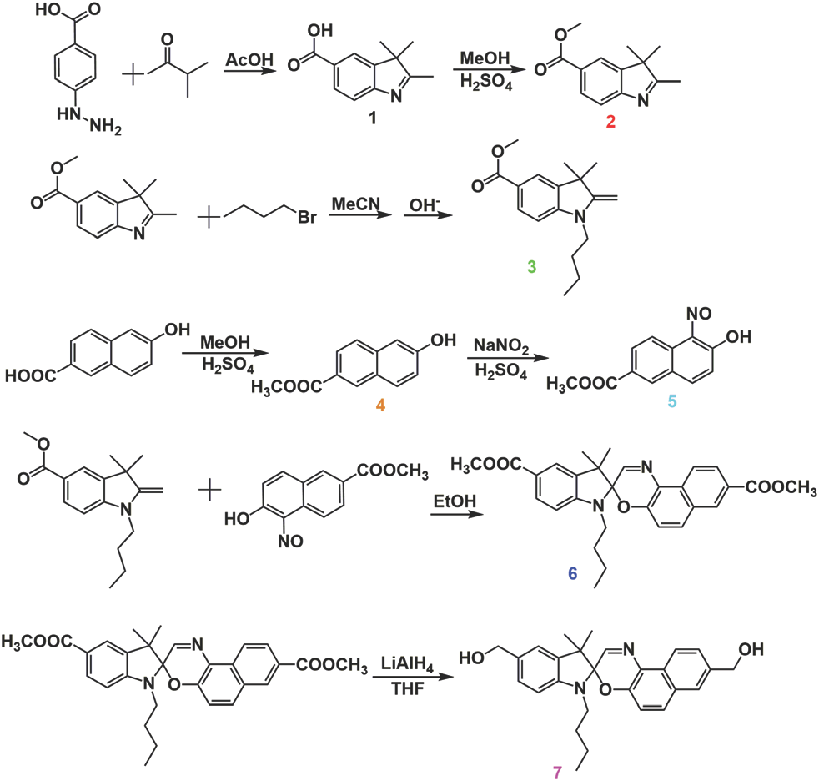
Scheme S1. Synthesis of SO–OH
Structure and performance characterization of SO-DB
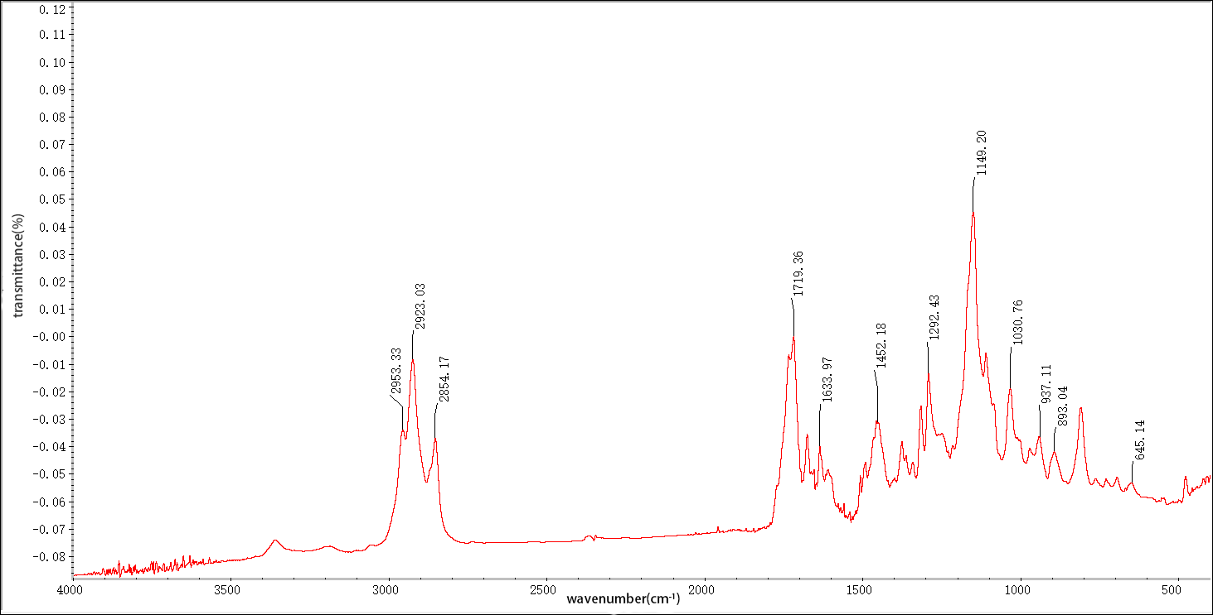
Fig. S1. FTIR spectrum of SO-DB.
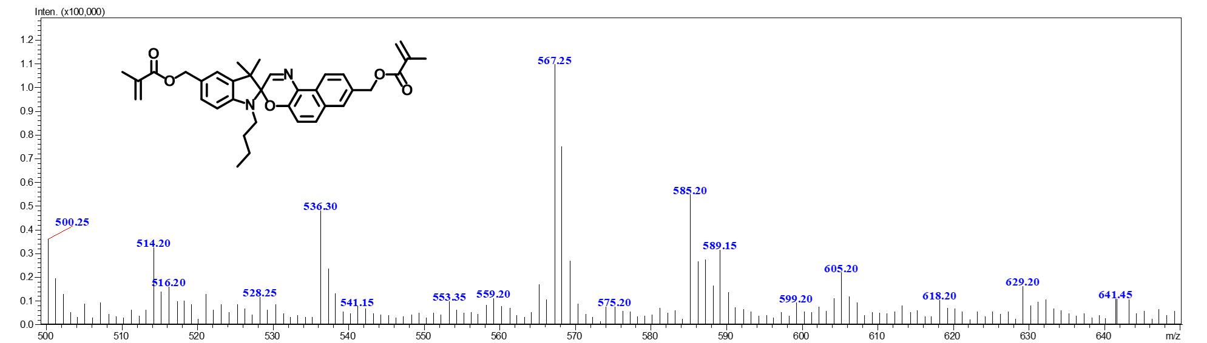
Fig. S2. ESI-MS spectrum of SO-DB.
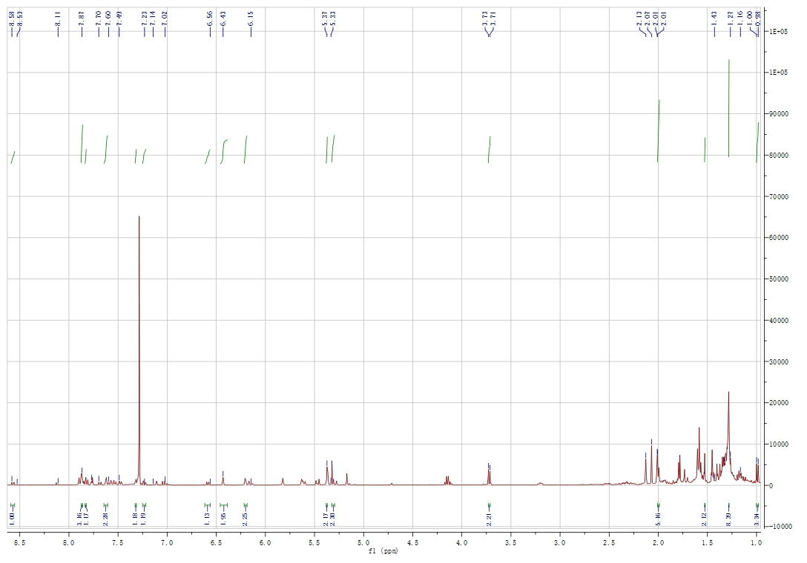
Fig. S3. ¹H NMR spectrum of SO-DB.
Structure and performance characterization of hydrogels
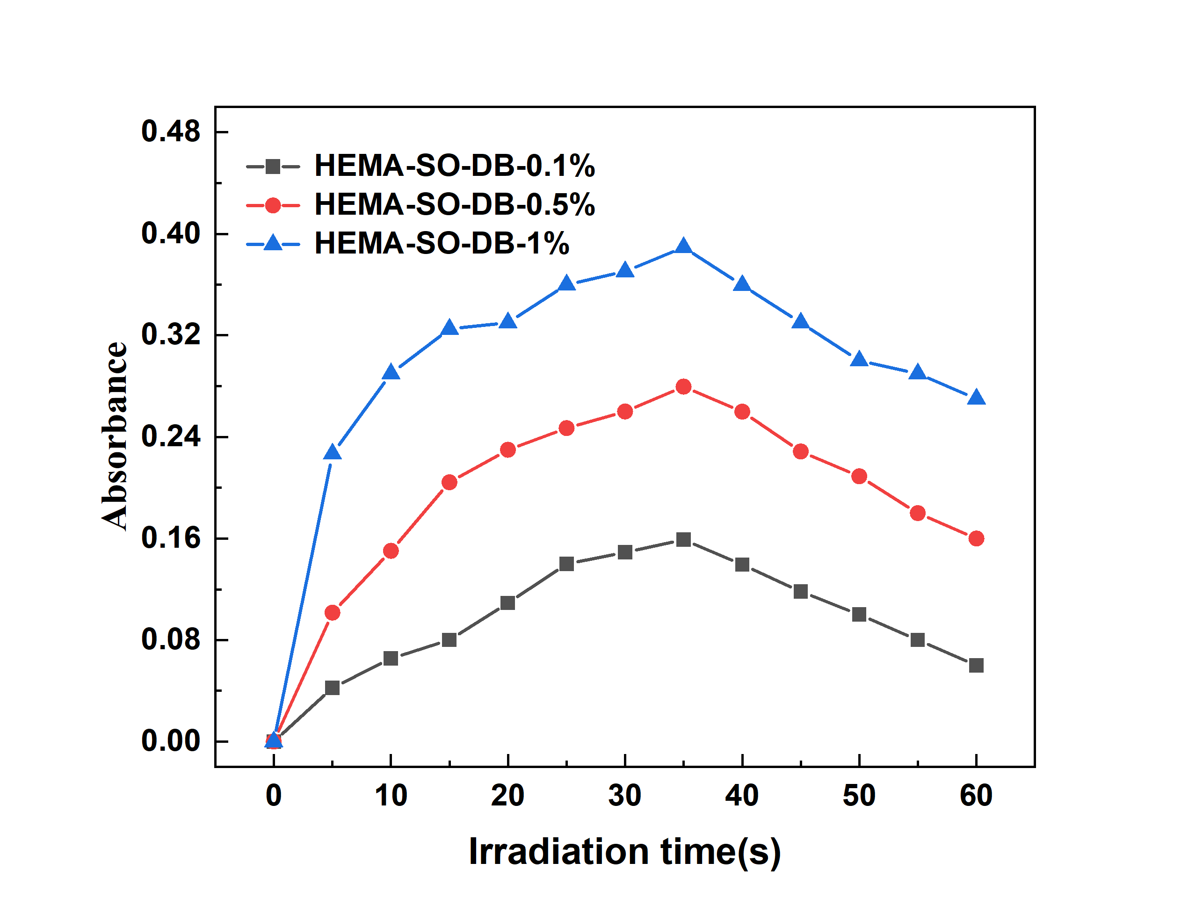
Fig. S4. Absorbance of hydrogels after various times of UV irradiation at λ_{max}.
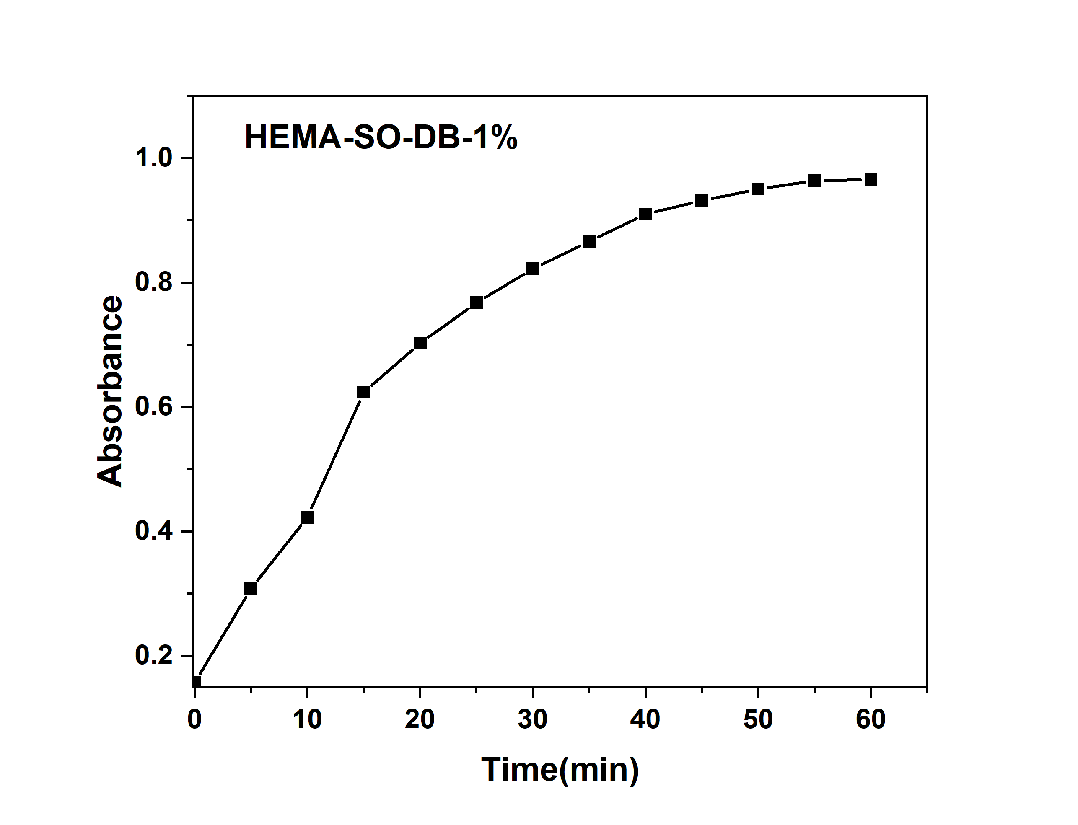
Fig. S5. Absorbance of HEMA-SO-DB-1 % at λmax after immersion in the solution of pH=1 for different times.
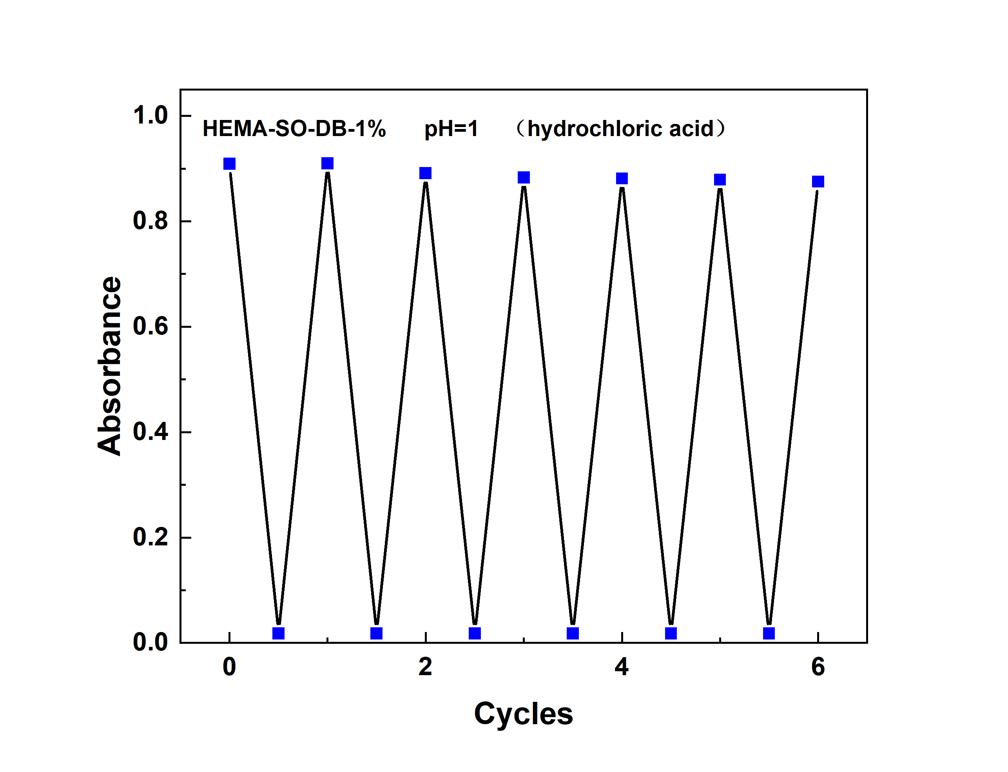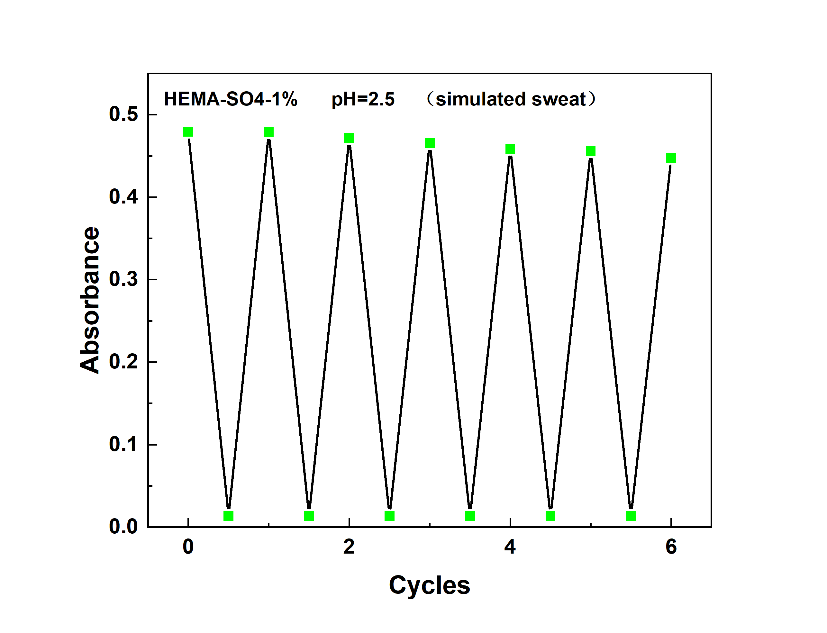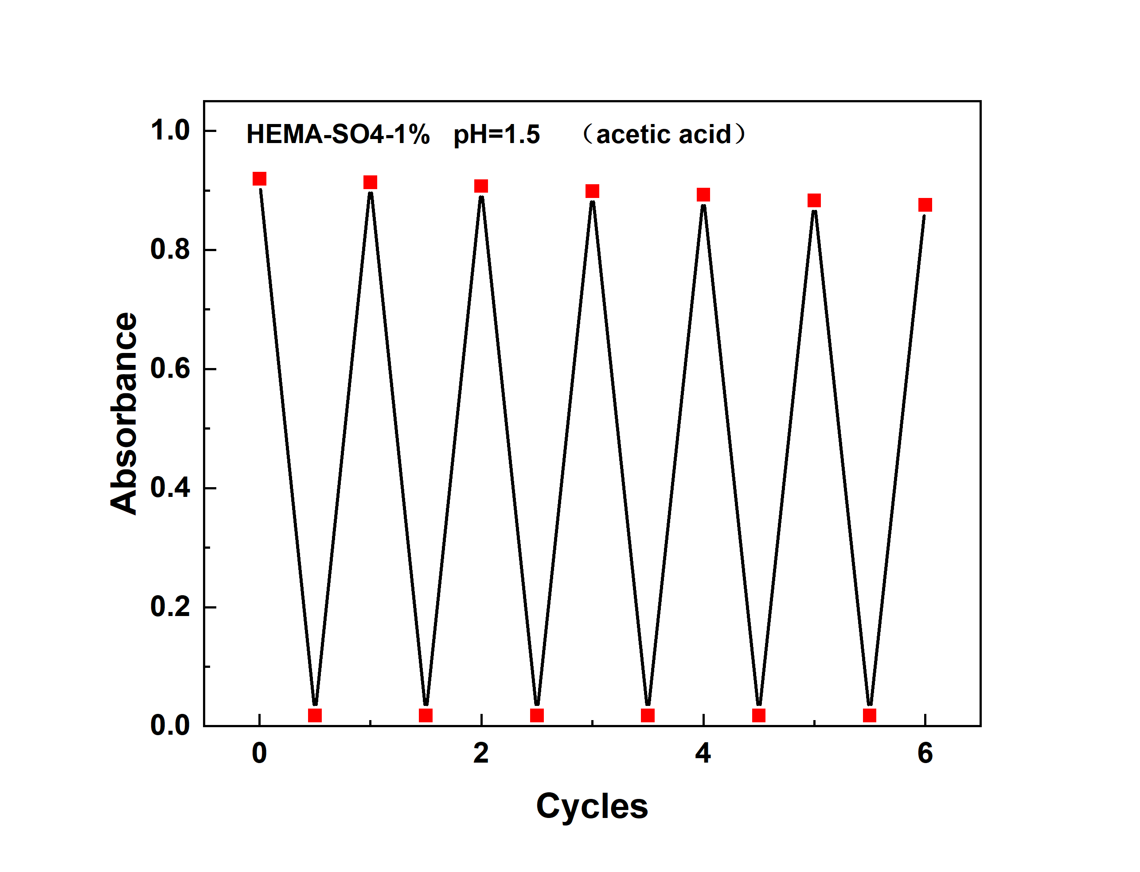
Fig. S6. The pH-chemical cycles of hydrogels.

References:
[1] B.D. Hosangadi, R.H. Dave, An efficient general method for esterification of aromatic carboxylic acids, Tetrahedron Letters 37(35) (1996) 6375-6378.
[2] D. Oushiki, H. Kojima, T. Terai, M. Arita, K. Hanaoka, Y. Urano, T. Nagano, Development and Application of a Near-Infrared Fluorescence Probe for Oxidative Stress Based on Differential Reactivity of Linked Cyanine Dyes, Journal of the American Chemical Society 132(8) (2010) 2795-2801.
[3] H.R. Lim, S.Y. Kim, E.H. Jeon, Y.L. Kim, Y.M. Shin, T.-S. Koo, S.J. Park, K.B. Hong, S. Choi, A highly sensitive fluorescent probe that quantifies transthyretin in human plasma as an early diagnostic tool of Alzheimer's disease, Chemical Communications 55(70) (2019) 10424-10427.
[4] J. Andersson, S. Li, P. Lincoln, J. Andréasson, Photoswitched DNA-Binding of a Photochromic Spiropyran, Journal of the American Chemical Society 130(36) (2008) 11836-11837.
[5] H. Gao, G. Liu, C. Cui, M. Wang, J. Gao, Preparation and properties of a polyurethane film based on novel photochromic spirooxazine chain extension, New Journal of Chemistry 46(19) (2022) 9128-9137.

