Supplementary material
Synthesis, anticancer, antioxidant activities and in silico studies of novel benzhydrylpiperazine bearing Δ²-1,2,3-triazoline hydrides

Najim A. Al-Masoudi,^{1*}, Raad S. Jihad,² Nabeel A. Abdul-Rida,³ Amer M. J. Al-Shamari,⁴ Bahjat A. Saeed⁵ Wasfi A. Al-Masoudi⁶
¹ Department of Chemistry, College of Science, University of Basrah, Basrah, Iraq
Present address: 78464 Konstanz, Germany,
² General Directorate of Muthana Education, Muthana, Iraq
³ Department of Chemistry, University of Al-Qadisiya, Al-Qadisiya, Iraq
⁴ Department of Chemistry, College of Science, University of Kufa, Kufa, Iraq
⁵ Department of Chemistry, College Education for Applied Sciences, University of Basrah, Basrah,
Iraq
⁶ Department of Physiology, Pharmacology and Chemistry, College of Veterinary, University
of Basrah, Basrah 61001, Iraq

¹H and ¹³C NMR spectra
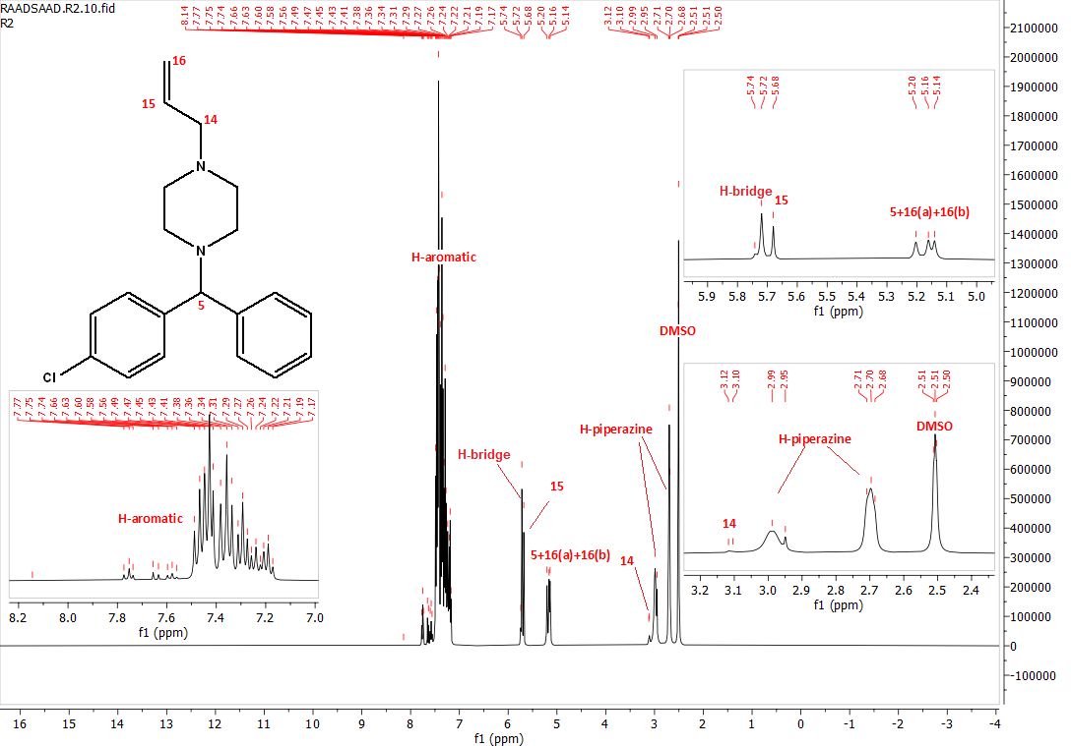
Fig. S1. ¹H NMR spectrum of 7
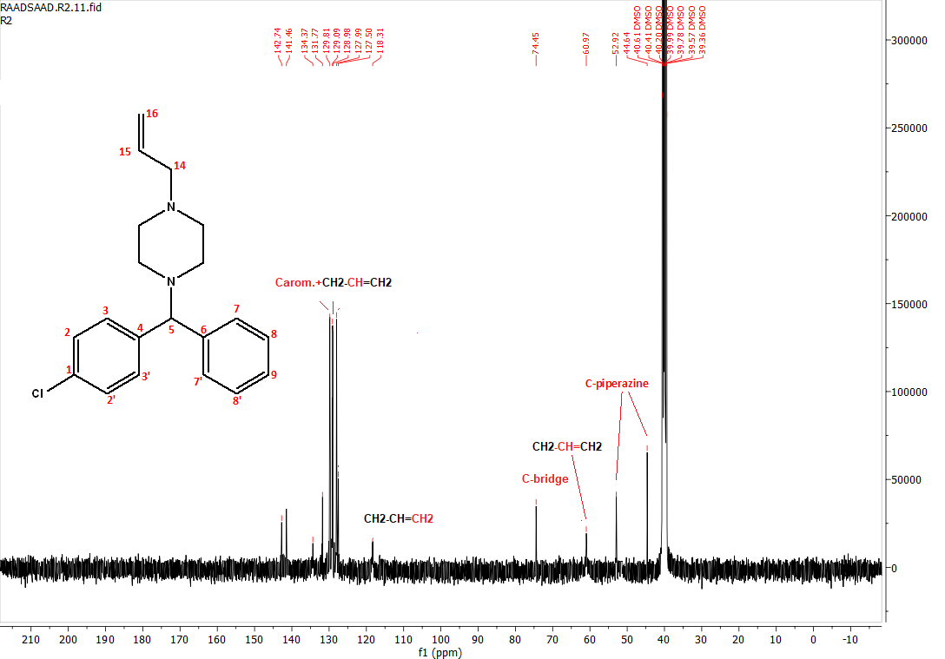
Fig. S2. ¹³C NMR spectrum of 7

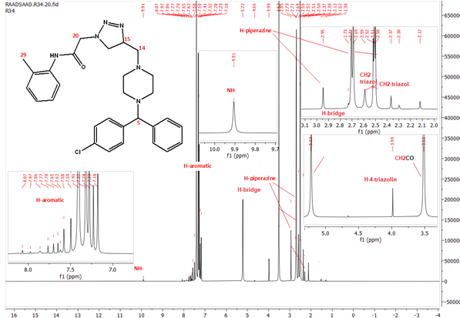
Fig. S3. ¹H NMR spectrum of 8

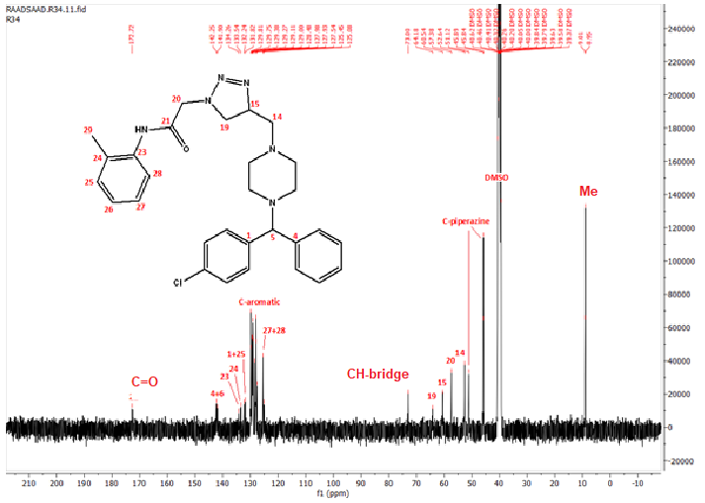
Fig. S4. ¹³C NMR spectrum of 8

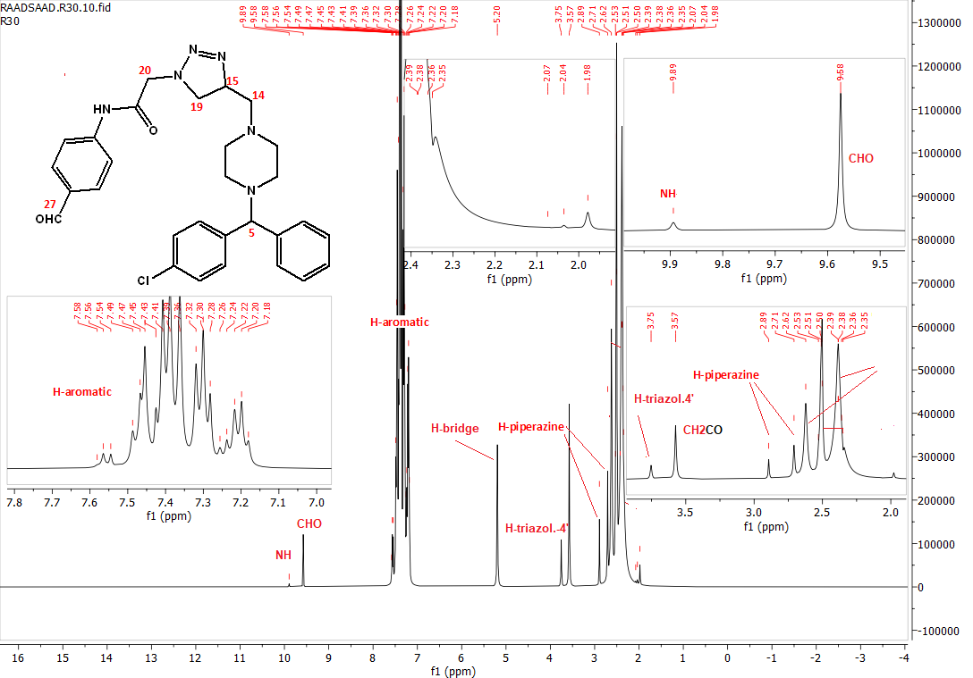
Fig. S5. ¹H NMR spectrum of 9
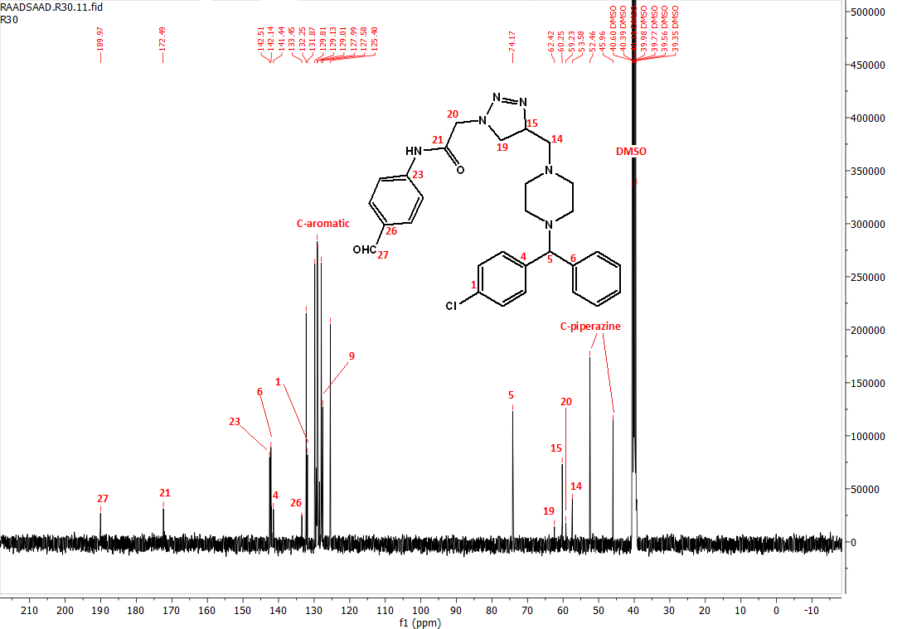
Fig. S6. ¹³C NMR spectrum of 9

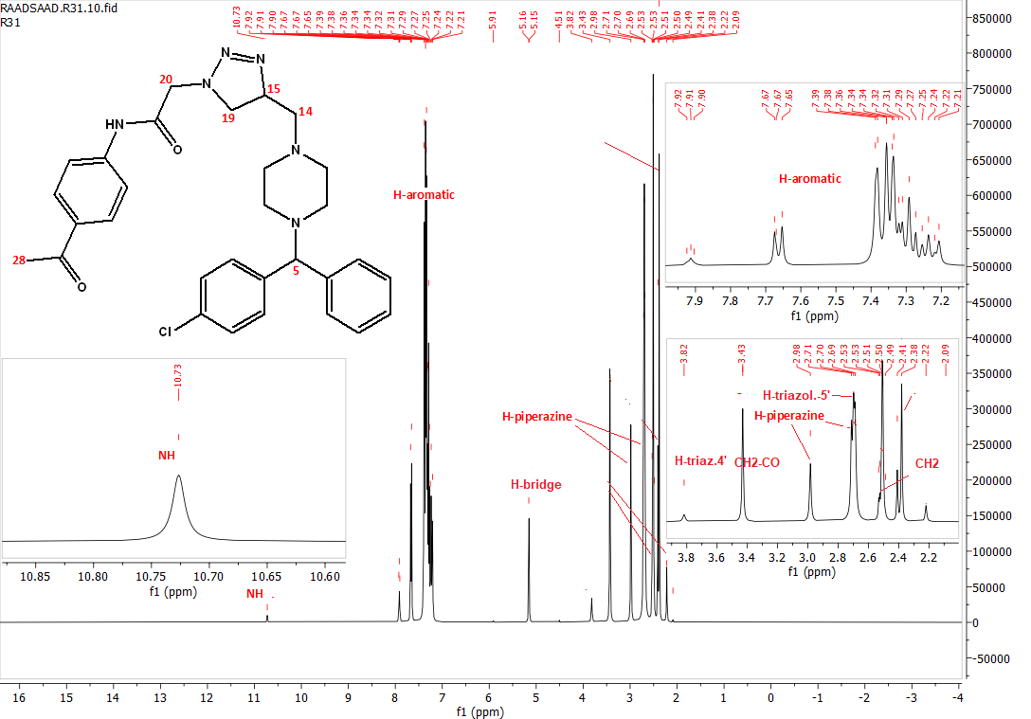
Fig. S7. ¹H NMR spectrum of 10
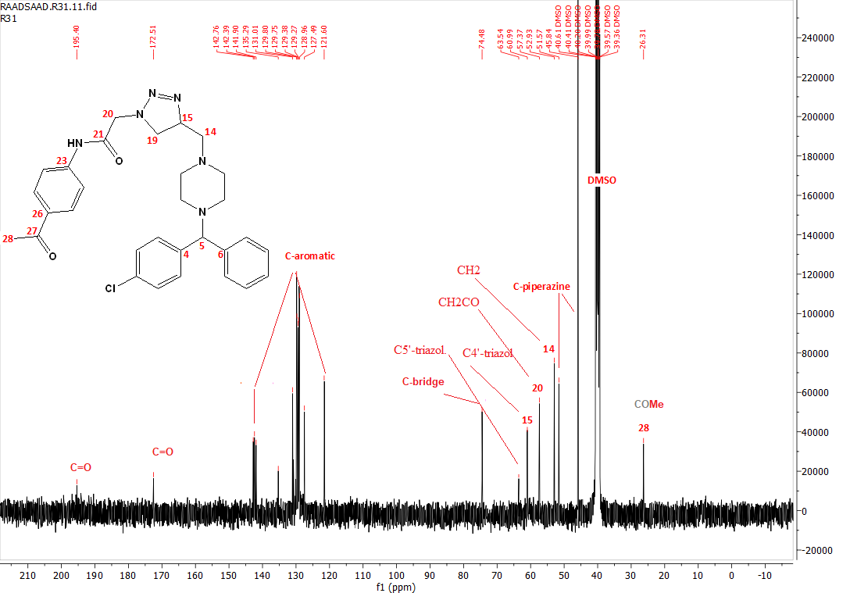
Fig. S8. ¹³C NMR spectrum of 10

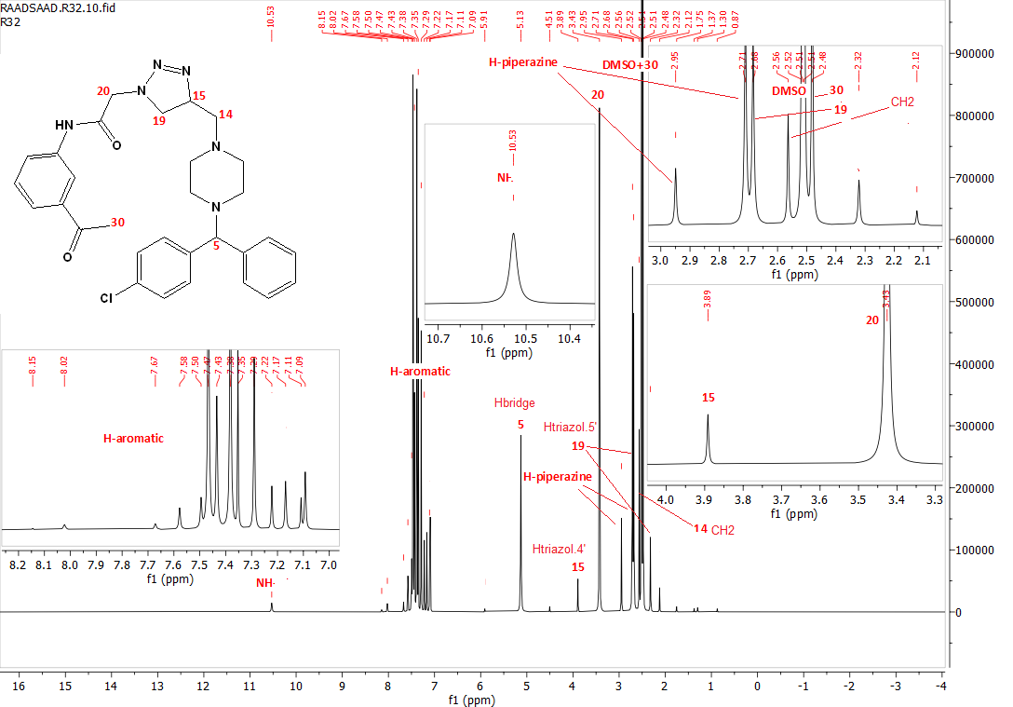
Fig. S9. ¹H NMR spectrum of 11

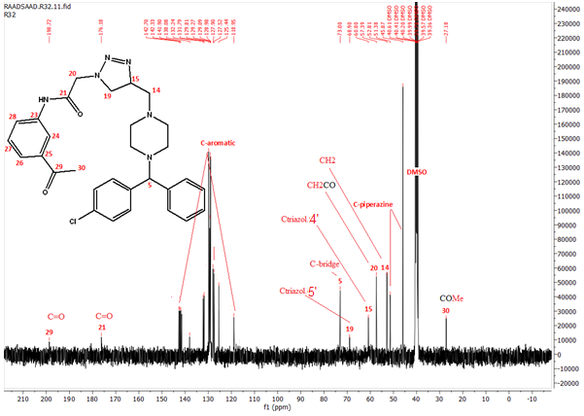
Fig. S10. ¹³C NMR spectrum of 11

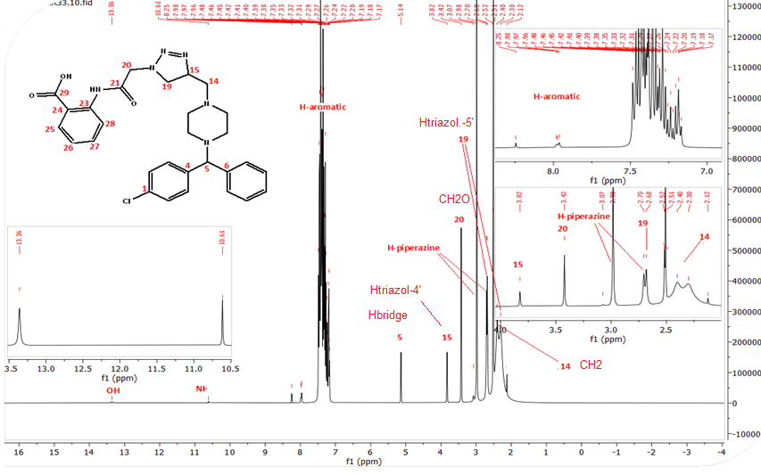
Fig. S11. ¹H NMR spectrum of 12
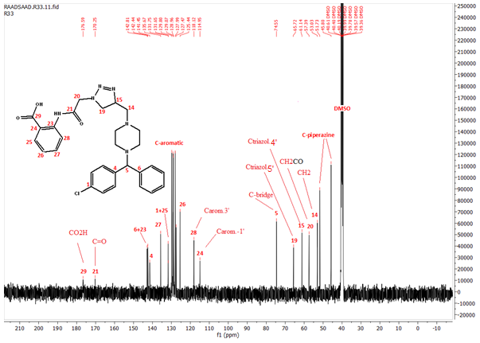
Fig. S12. ¹³C NMR spectrum of 12

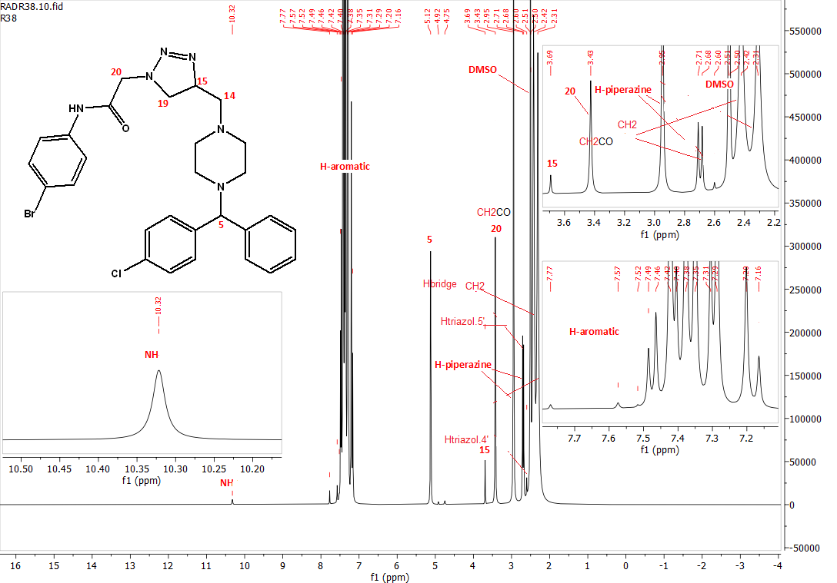
Fig. S13. ¹H NMR spectrum of 13

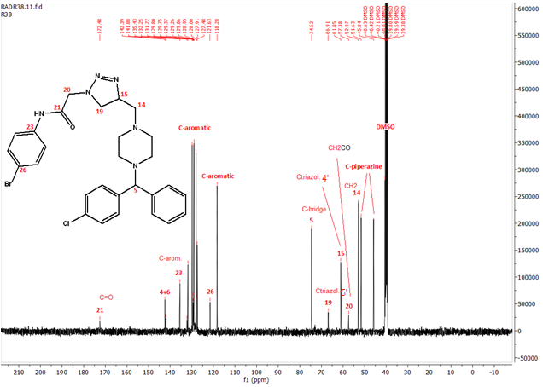
Fig. S14. ¹³C NMR spectrum of 13

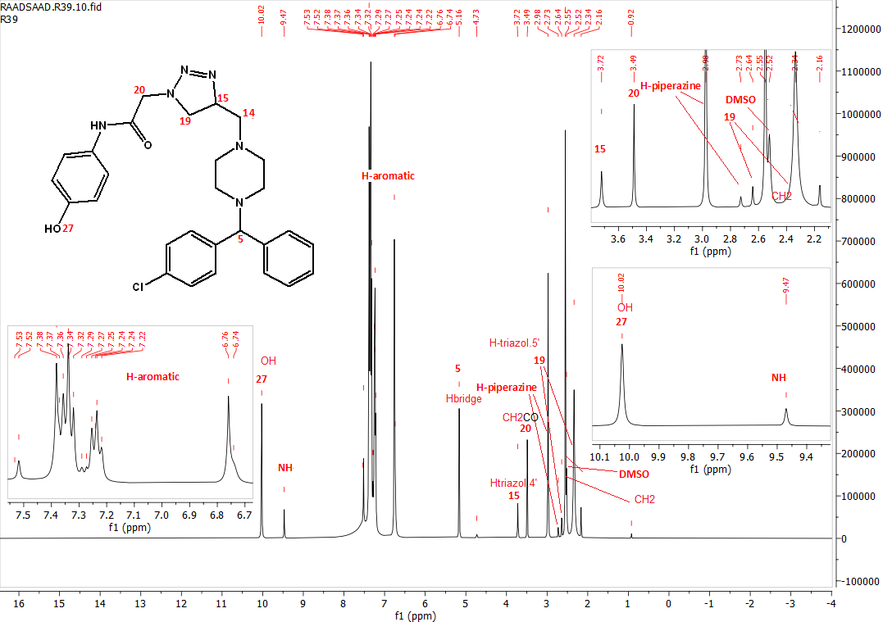
Fig. S15. ¹H NMR spectrum of 14
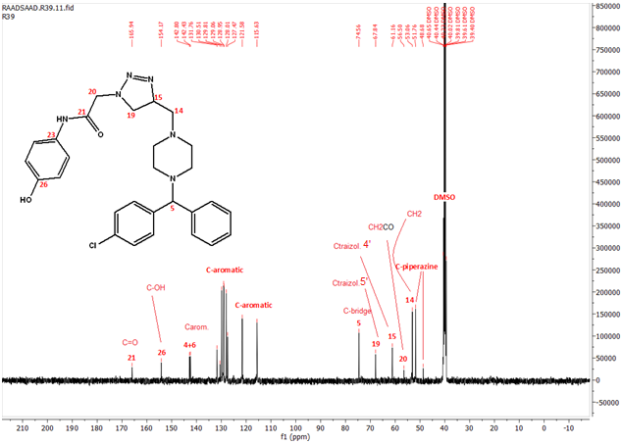
Fig. S16. ¹³C NMR spectrum of 14

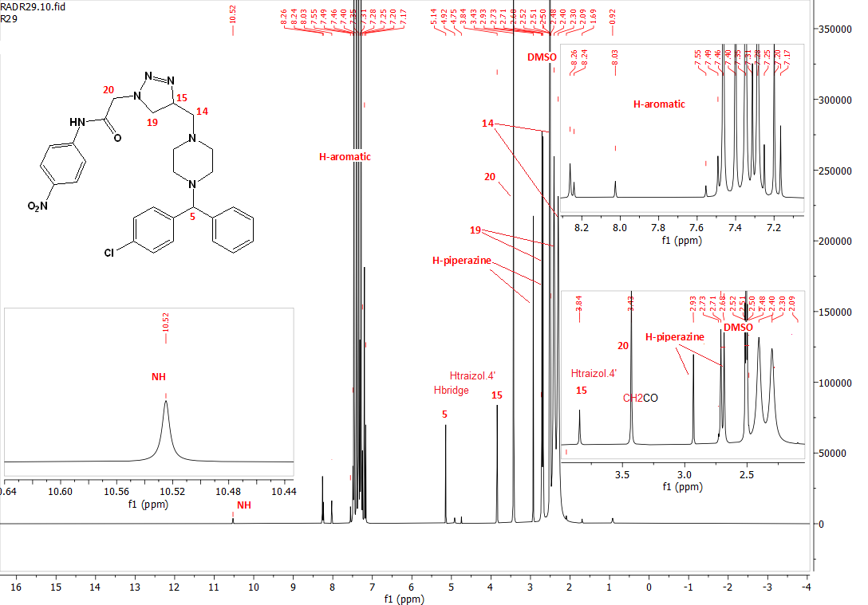
Fig. S17. ¹H NMR spectrum of 15

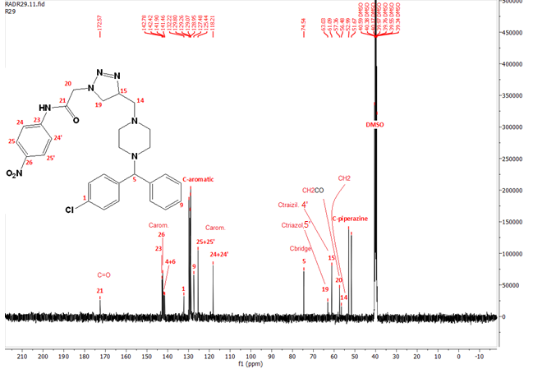
Fig. S18. ¹³C NMR spectrum of 15

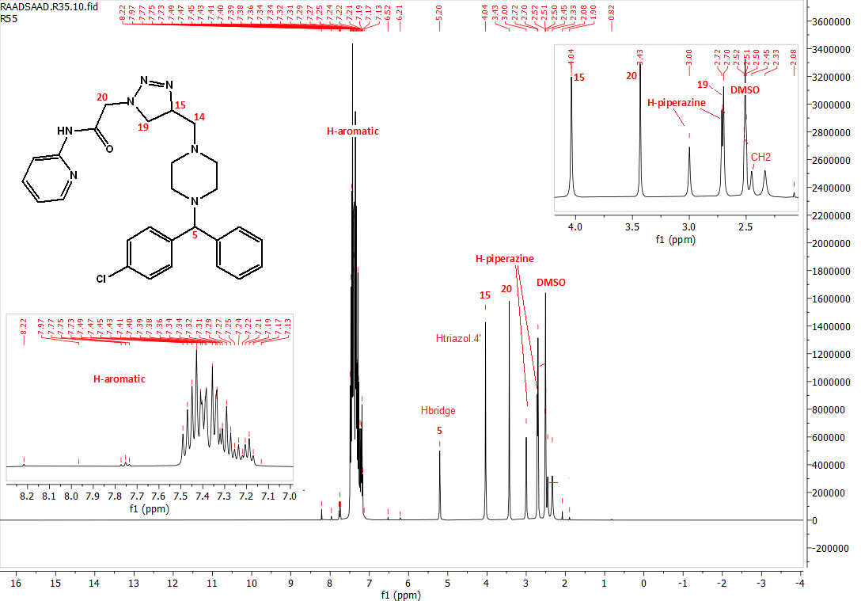
Fig. S19. ¹H NMR spectrum of 16
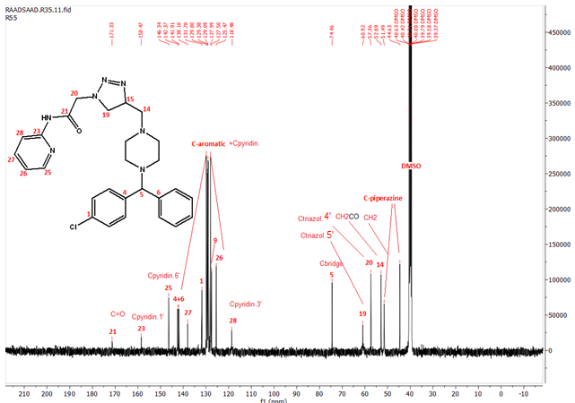
Fig. S20. ¹³C NMR spectrum of 16

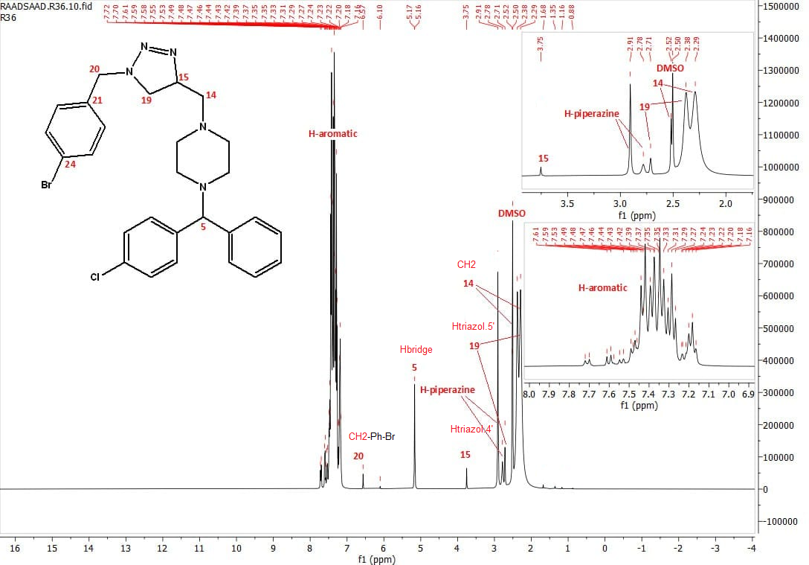
Fig. S21. ¹H NMR spectrum of 17
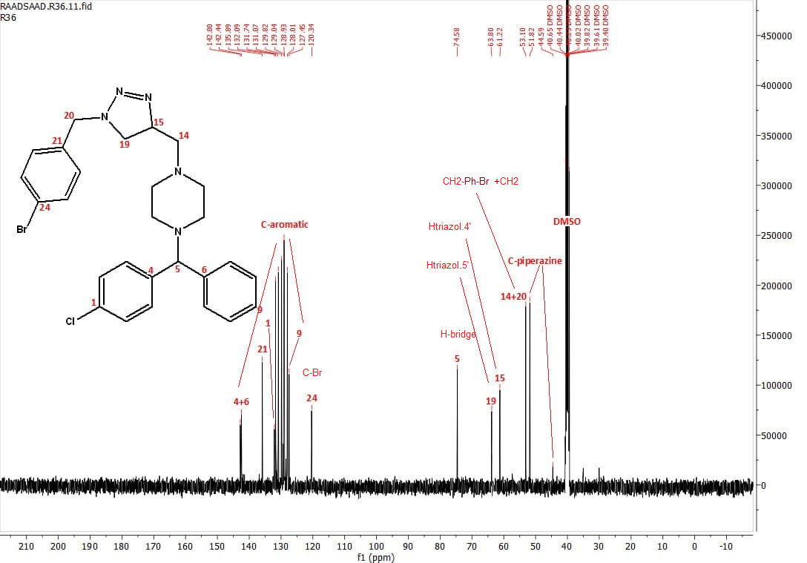
Fig. S22. ¹³C NMR spectrum of 17

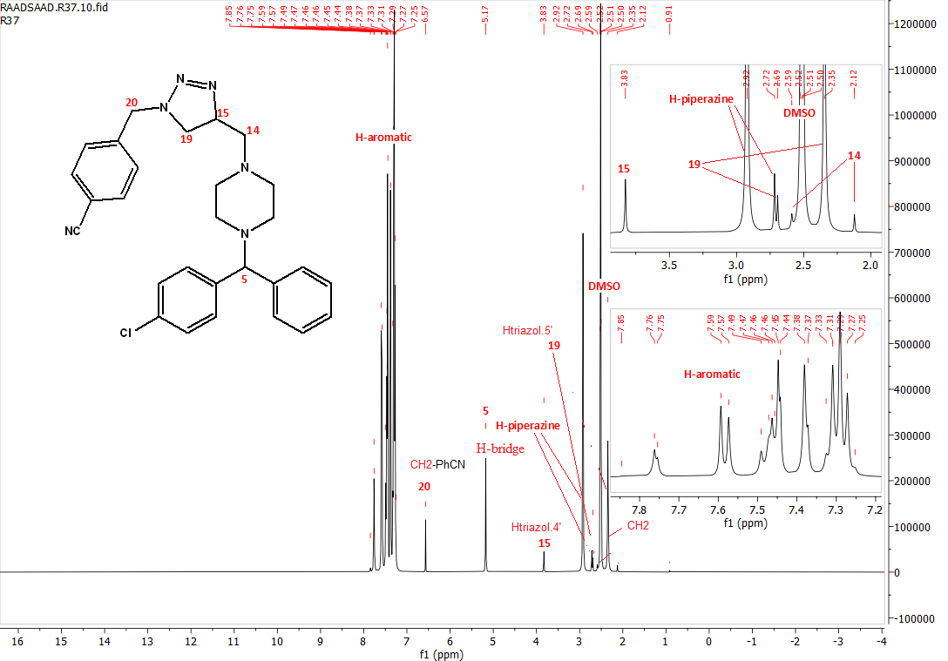
Fig. S23. ¹H NMR spectrum of 18
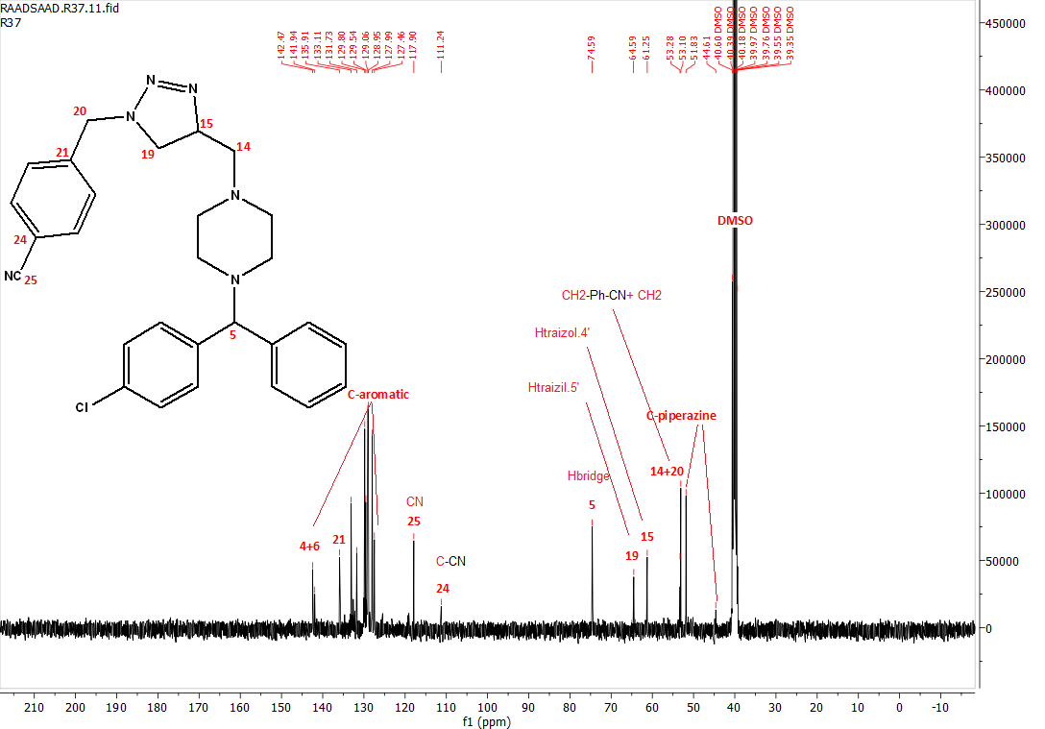
Fig. S24. ¹³C NMR spectrum of 18

