Supplementary Tables and Figures

Supplementary Table S1. Interval likelihood ratios for the prediction of weaning failure using lung ultrasound score measured during the RR and RSBI
 | Weaning failure  (n=13) | Weaning success  (n=22) | Likelihood  Ratio | 95%CI
RR
≤ 18 | 1 | 4 | 0.4 | 0.23-0.59
18-25 | 4 | 16 | 0.4 | 0.17-0.67
≥ 25 | 8 | 2 | 6.8 | 1.69-27.16
RSBI
< 50 | 1 | 8 | 0.2 | 0.03-1.51
50-67 | 5 | 12 | 0.7 | 0.32-1.55
≥ 67 | 7 | 2 | 5.9 | 1.44-24.35
RR, respiratory rate; RSBI, rapid shallow breathing index

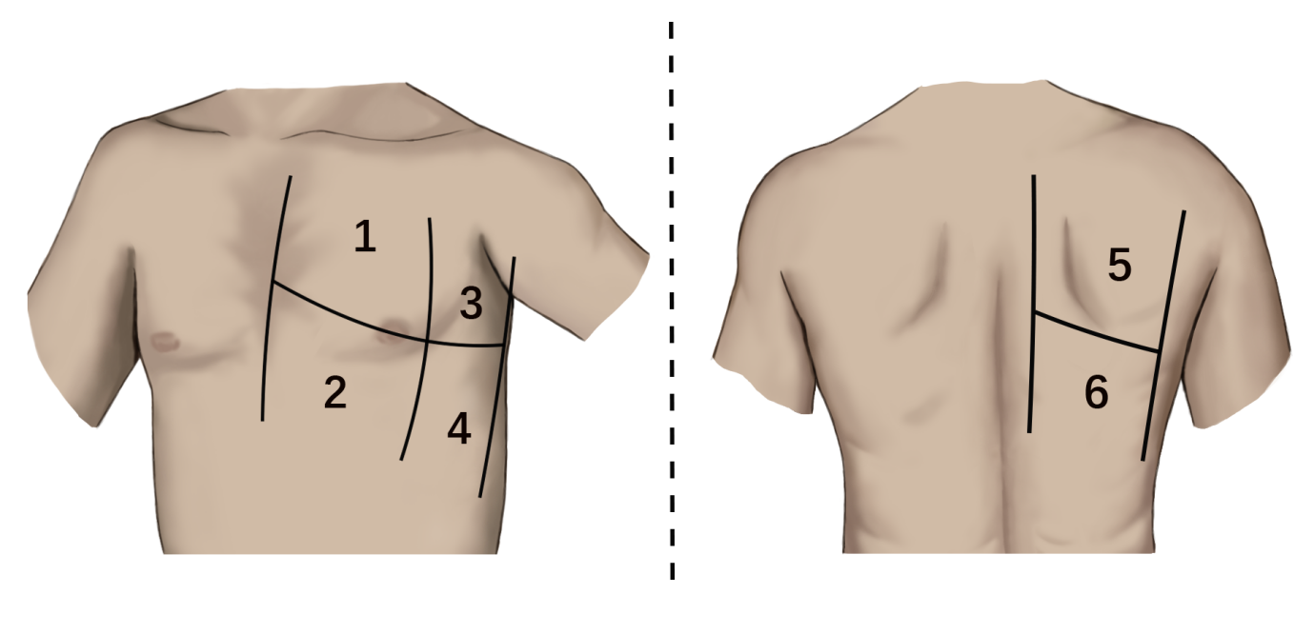
Supplementary Figure S1. The six regions into which the lungs were divided in order to calculate the 12-region lung ultrasound score.

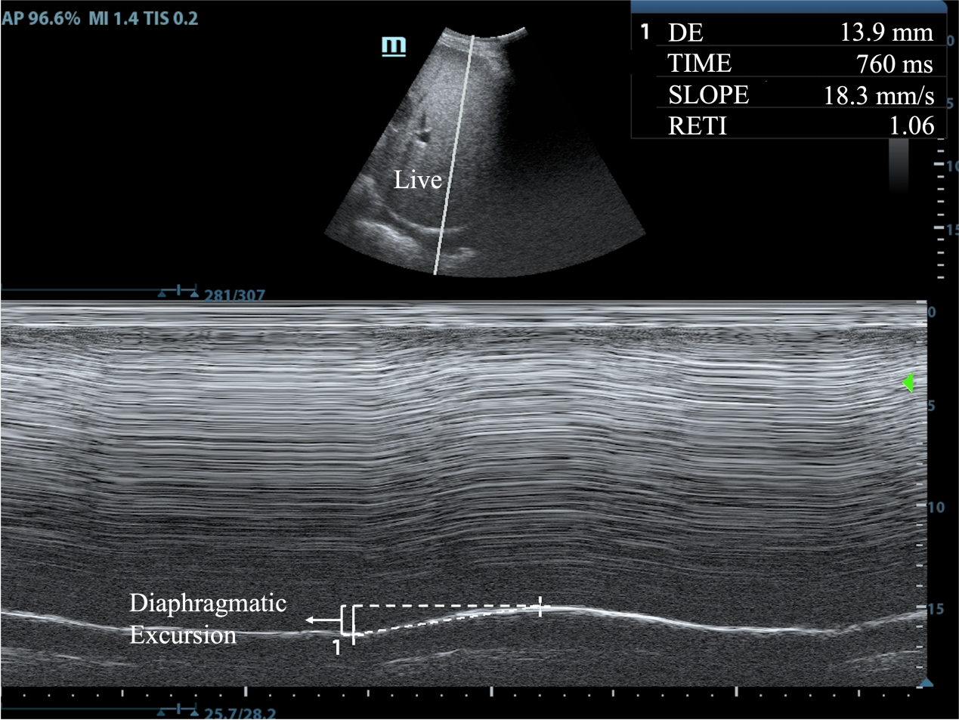
Supplementary Figure S2. An M-mode ultrasound image illustrating how right diaphragmatic excursion was measured in this study. In this patient, the excursion was found to be 13.9mm.

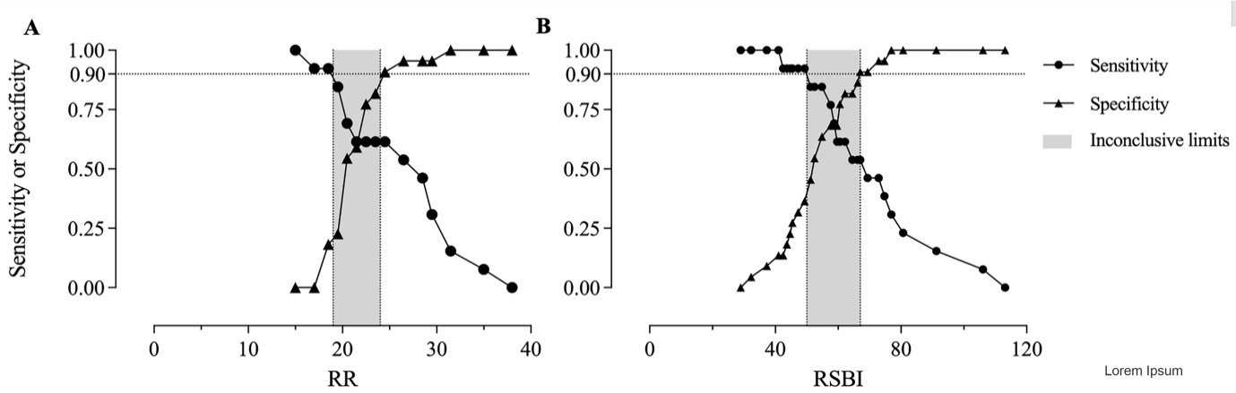
Supplementary Figure S3. Inconclusive limits on the ability of (A) respiratory rate (RR) or (B) rapid shallow breathing index (RSBI) to predict weaning failure. Limits were calculated as described¹⁸.

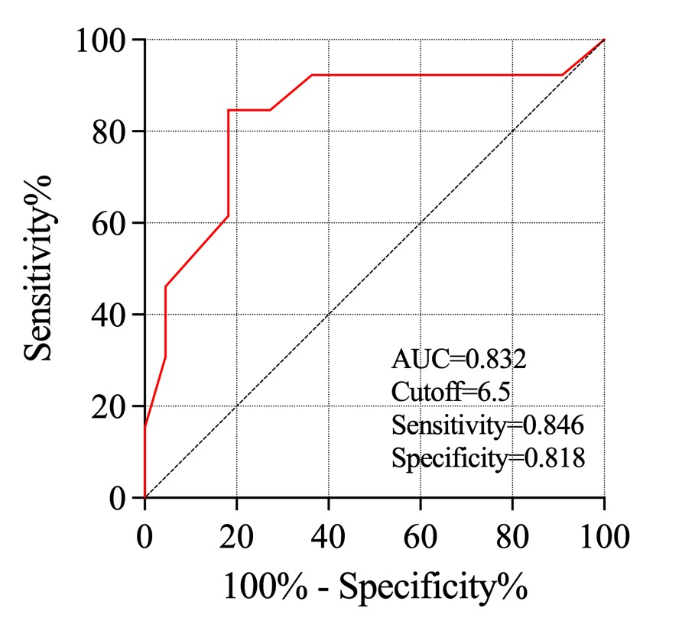
Supplementary Figure S4. Receiver operating characteristic curve to assess the ability of an 8-region lung ultrasound score to predict weaning failure.

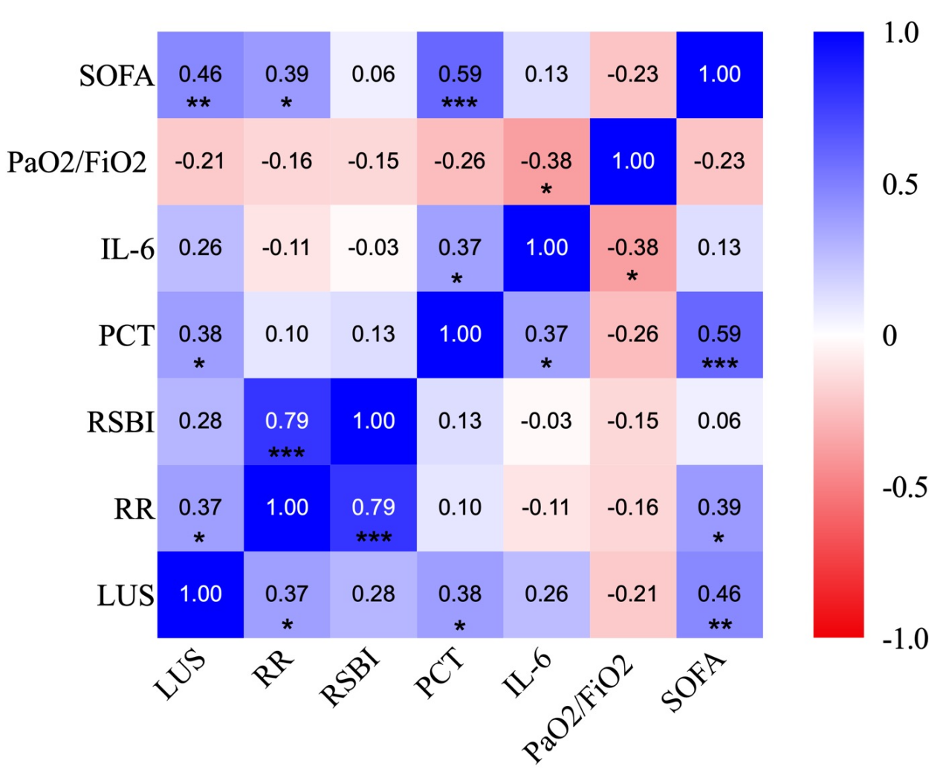
Supplementary Figure S5. Heat map of pairwise Spearman rank correlations between the indicated variables. *p < 0.05, **p < 0.01, ***p < 0.001. IL, interleukin; FiO₂, fraction of inspired oxygen; LUS, lung ultrasound score; PaO₂, partial pressure of oxygen; PCT, Procalcitonin; RR, respiratory rate; SOFA, sequential organ failure assessment score.

