SUPPLEMENTARY INFORMATION
Flexible THV-based nanocomposites filled with GNPs/MWCNTs for advanced applications in EMI shielding and thermal management.
Anna Łapińska¹, Natalia Grochowska¹, Karolina Filak¹, Anna Dużyńska¹ Marek Polański⁴, Iwona Wyrębska⁴, Paweł Jóźwik⁴, Tomasz Gołofit, Kamil Dydek², Przemysław Michalski¹, Andrzej Plichta³.
1 Warsaw University of Technology, Faculty of Physics, Koszykowa 75, 00-662 Warsaw, Poland
2 Warsaw University of Technology, Faculty of Material Science and Engineering, Wołoska 141, 02-507 Warsaw, Poland
3 Warsaw University of Technology, Faculty of Chemistry, S. Noakowskiego 3, 00-664 Warsaw, Poland
4 Military University of Technology, Faculty of Advanced Technologies and Chemistry, gen. S. Kaliskiego 2, 00 -908 Warsaw, Poland

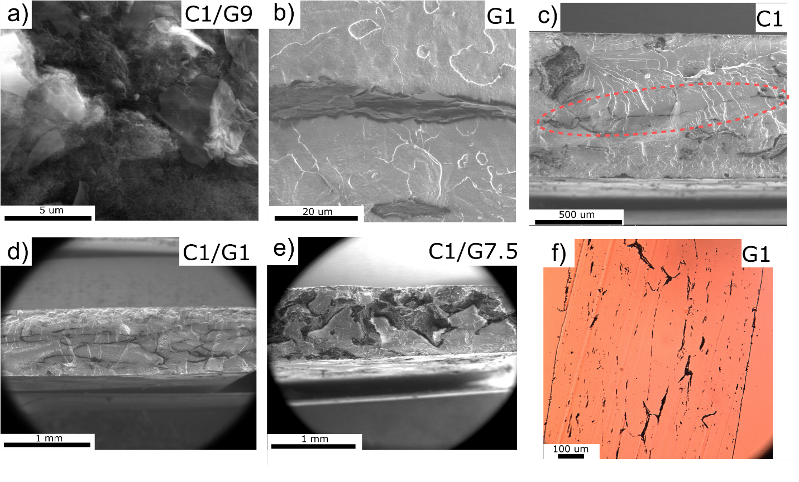
Fig. S1: SEM/SE images of: a) GNP/MWCNT fillers, b) percolation path in sample G1, c) percolation path in sample C1, d) macroscopic percolation path in sample C1/G1, e) macroscopic percolation path in sample C1/G7.5, f) polarizing-interference microscopy example photo of C1 composite (x10 magnification).

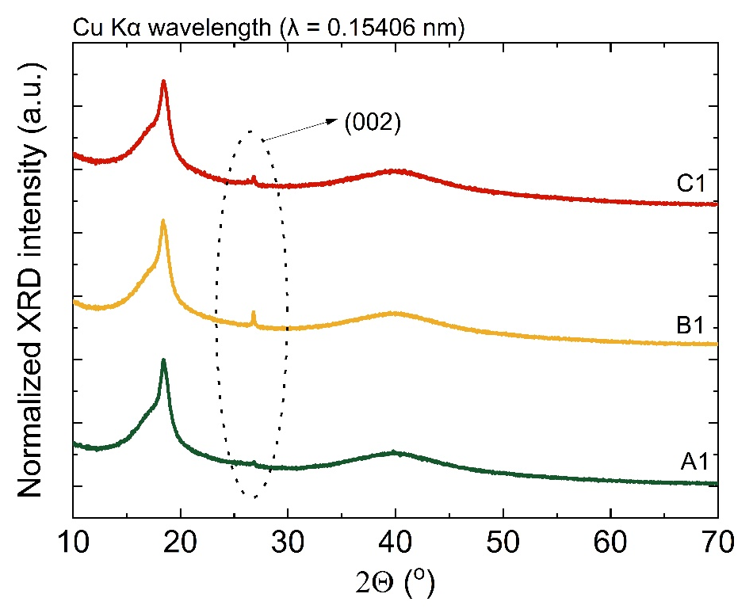
Fig. S2: XRD spectrum of A1, B1, and C1 samples revealing weak (002) plane reflection.
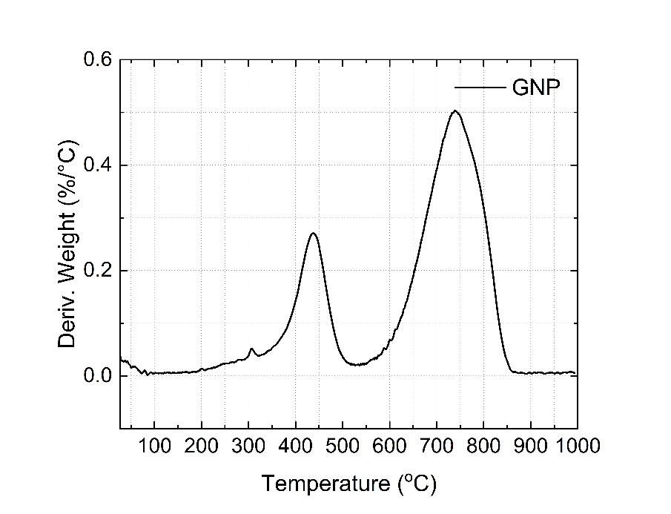
Fig. S3: DTG curve of GNP.
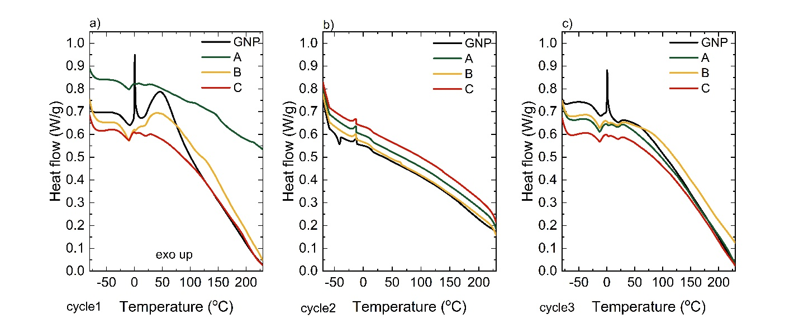
Fig. S4: Fillers’ reference DSC curves for: a) cycle 1, b) cycle 2, c) cycle 3. Where: cycle 1: 1st heating, cycle 2: cooling, cycle 3: 2nd heating.
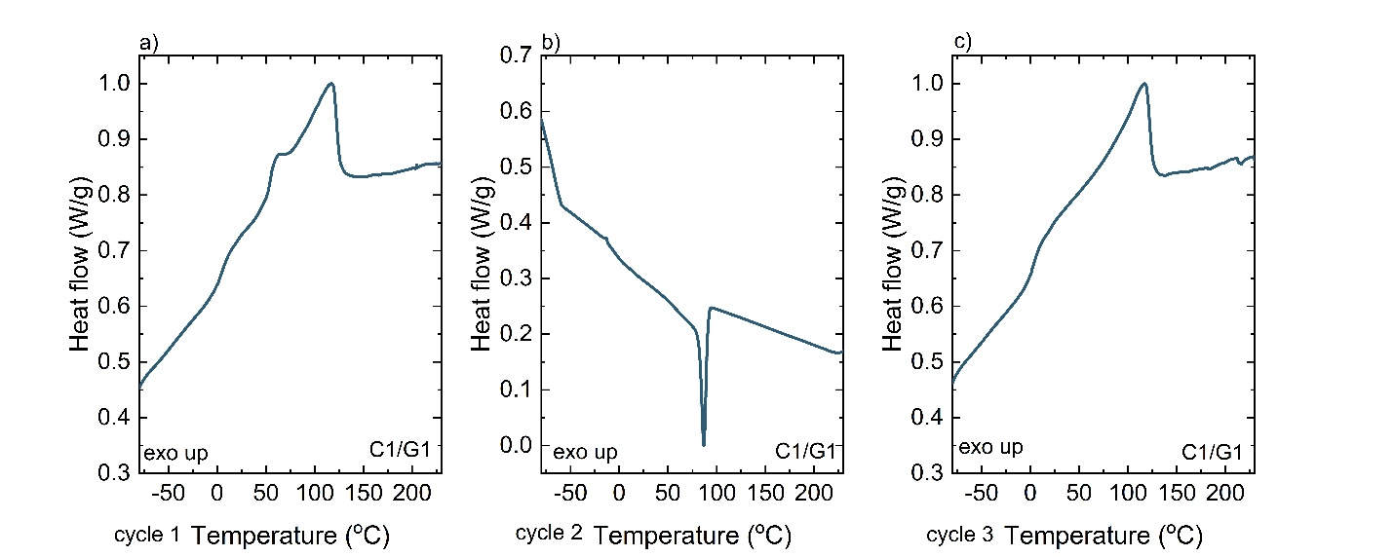
S5: Dried C1/G1 DSC curves for: a) cycle 1, b) cycle 2, c) cycle 3. Where: cycle 1: 1st heating, cycle 2: cooling, cycle 3: 2nd heating.

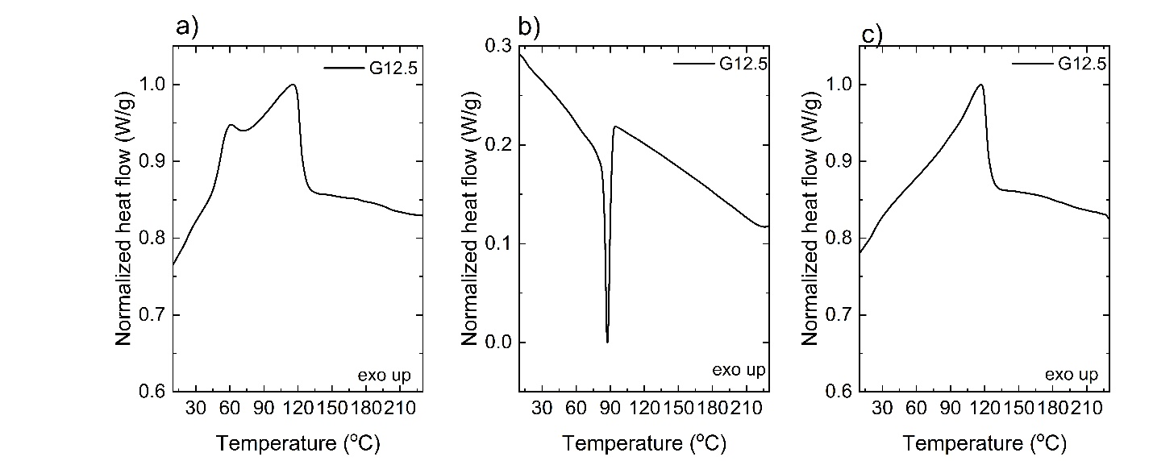
Fig. S6: G12.5 sample another DSC curve: a) cycle 1, b) cycle 2, c) cycle 3. Where: cycle 1: 1st heating, cycle 2: cooling, cycle 3: 2nd heating.

