Supplementary Materials

Linking rhizospheric microbiota and metabolite interactions with harvested aboveground carbon and soil carbon of lakeshore reed wetlands in a subtropical region

Junli Wang • Zishi Fu • Hongxia Qiao • Fuxing Liu* • Yucui Bi
Eco-environmental Protection Research Institute, Shanghai Academy of Agricultural Sciences, Shanghai, 201403, PR China
Shanghai Engineering Research Centre of Low-carbon Agriculture (SERCLA), Shanghai, 201415, PR China
* Corresponding author: liufuxing@126.com (F. Liu).

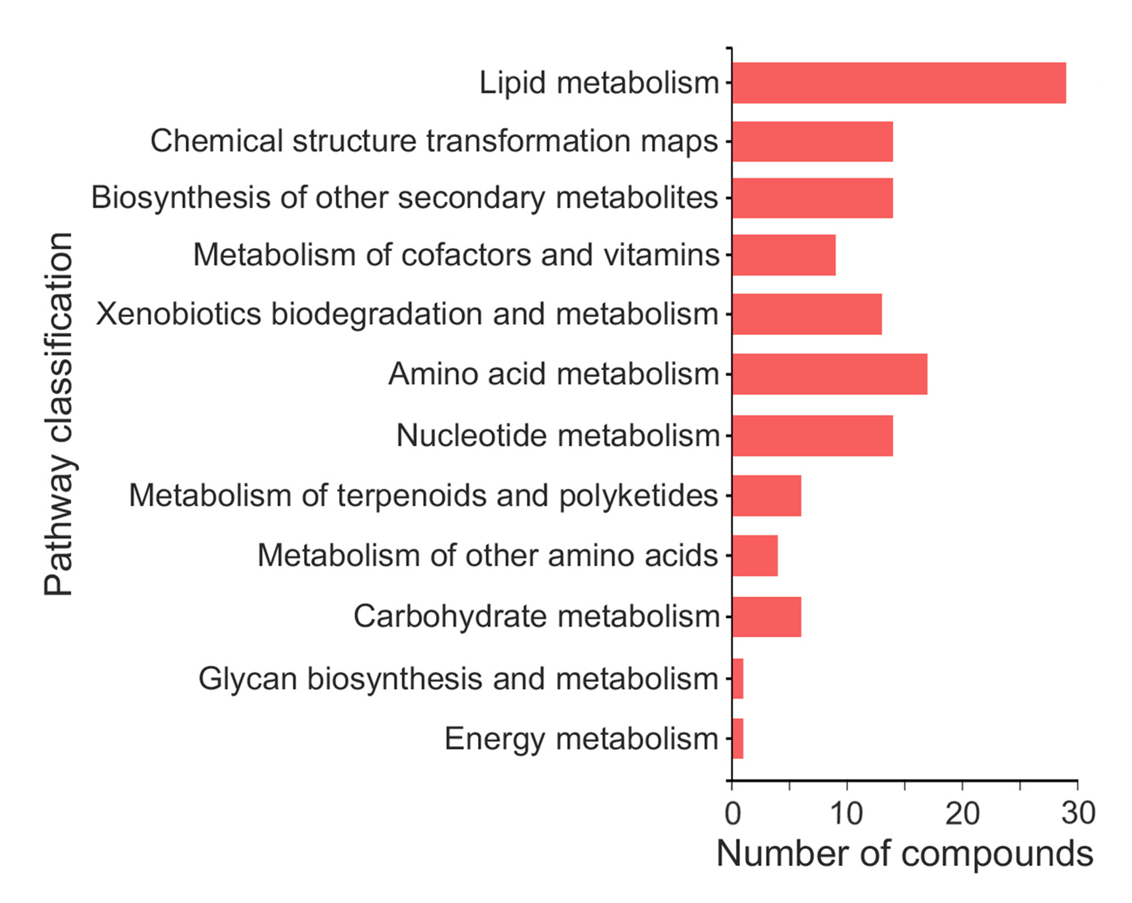
Fig. S1 Number of metabolite compounds involved in the different metabolic pathways from the lakeshore reed wetlands.
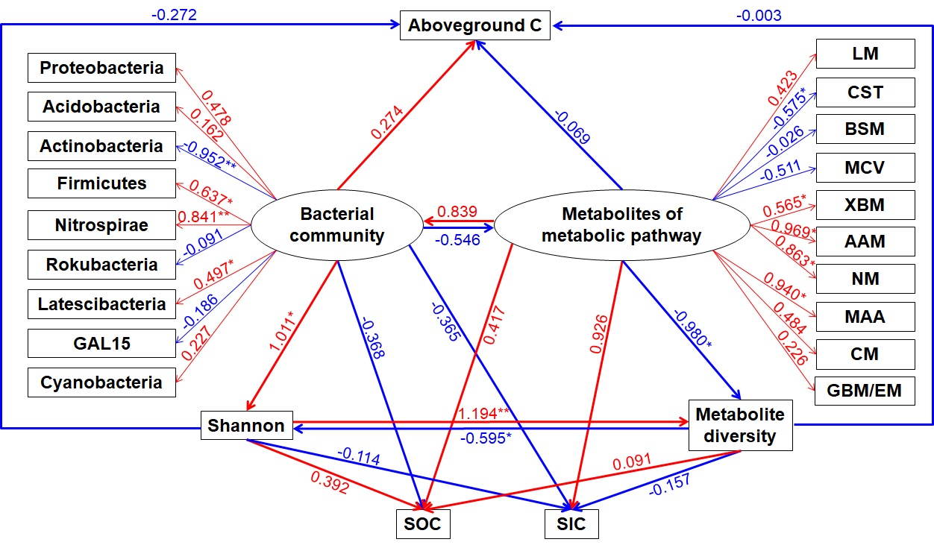
Fig. S2 Structural equation model (SEM) of causal relationships among aboveground C fixation, soil C contents (SOC and SIC), bacterial community (phyla) and diversity (Shannon), and metabolites (metabolic pathway-related) and metabolite diversity. Red arrows represent positive paths. Blue arrows represent negative paths. Numbers adjacent to arrows represent standardized path coefficients, with P-values aside. * indicate P < 0.05, and ** indicate P < 0.01.

Table S1 Pearson correlations between plant characteristics and soil physicochemical properties with aboveground C fixation, SOC and SIC.
 | PD | PH | SD | LB | SB | LC | SC | SWC | pH | EC | STC | STN | STP | C fixation | SOC | SIC
PD | 1
PH | ns | 1
SD | -0.59** | 0.86** | 1
LB | ns | 0.52** | 0.43* | 1
SB | 0.45* | 0.50** | ns | 0.43* | 1
LC | ns | ns | ns | ns | ns | 1
SC | ns | ns | ns | ns | ns | ns | 1
SWC | ns | 0.40* | ns | ns | ns | ns | ns | 1
pH | ns | -0.76** | -0.74** | -0.46* | -0.44* | ns | ns | -0.42* | 1
EC | ns | ns | ns | ns | ns | ns | ns | 0.40* | ns | 1
STC | ns | ns | ns | ns | ns | ns | ns | 0.78** | ns | 0.48** | 1
STN | ns | 0.41* | 0.51** | 0.39* | ns | ns | ns | 0.63** | -0.62** | ns | 0.65** | 1
STP | ns | ns | ns | ns | ns | ns | ns | 0.38* | ns | ns | 0.39* | 0.39* | 1
C fixation | 0.42* | 0.57** | ns | 0.56** | 0.99** | ns | ns | ns | -0.49** | ns | ns | ns | ns | 1
SOC | ns | ns | ns | ns | ns | ns | ns | 0.77** | -0.36* | ns | 0.95** | 0.77** | ns | ns | 1
SIC | 0.38* | -0.49** | -0.70** | ns | ns | ns | ns | ns | 0.59** | 0.48** | ns | ns | 0.41* | ns | ns | 1
PD, plant density; PH, plant height; SD, stem diameter; LB, leaf biomass; SB, stem biomass; LC, leaf C content; SC, stem C content; ns indicate not significant, * indicate P < 0.05, and ** indicate P < 0.01.

Table S2 Details of identified metabolism-related metabolites based on the KEGG database (KEGG Pathway First Category: Metabolism)
No. | ID | Metabolite | M/Z | Retention time | KEGG Compound First Category | KEGG Compound Second Category | KEGG Pathway Second Category
1 | pos_39 | KAPA | 397.1848 | 3.7042 | - | - | Metabolism of cofactors and vitamins
2 | pos_118 | Deoxycytidine | 228.0968 | 0.7246 | Nucleic acids | Nucleosides | Nucleotide metabolism
3 | pos_121 | N-Acetyl-D-glucosamine | 244.0857 | 0.6844 | Carbohydrates | Monosaccharides | Carbohydrate metabolism
4 | pos_188 | 9-OxoODE | 295.2261 | 7.7168 | - | - | Lipid metabolism
5 | pos_517 | (R)-(+)-2-Pyrrolidone-5-carboxylic acid | 130.0491 | 1.0399 | - | - | Metabolism of other amino acids
6 | pos_534 | Thymidine | 243.0968 | 2.1209 | Nucleic acids | Nucleosides | Nucleotide metabolism
7 | pos_542 | Allysine | 187.1067 | 0.7964 | - | - | Amino acid metabolism; Biosynthesis of other secondary metabolites; Chemical structure transformation maps
8 | pos_576 | L-Tryptophan | 205.096 | 2.9916 | Peptides | Amino acids | Chemical structure transformation maps; Biosynthesis of other secondary metabolites; Amino acid metabolism
9 | pos_1069 | Tetrahydrodeoxycorticosterone | 335.2571 | 8.2621 | - | - | Lipid metabolism
10 | pos_1121 | Galactosylsphingosine | 444.3325 | 7.6287 | - | - | Lipid metabolism
11 | pos_1144 | 9,10-DHOME | 279.2315 | 7.4508 | - | - | Lipid metabolism
12 | pos_1246 | 15-deoxy-delta-12,14-PGJ2 | 317.2102 | 6.2121 | - | - | Lipid metabolism
13 | pos_1452 | RHOIFOLIN | 579.1708 | 3.8176 | - | - | Biosynthesis of other secondary metabolites
14 | pos_1482 | Neohesperidin | 611.1963 | 3.9532 | - | - | Biosynthesis of other secondary metabolites
15 | pos_1557 | Tryptophanol | 203.1169 | 4.4047 | - | - | Amino acid metabolism
16 | pos_1741 | (S,S)-Butane-2,3-diol | 73.06525 | 0.0676 | - | - | Carbohydrate metabolism
17 | pos_1759 | D-Sedoheptulose 7-phosphate | 329.0043 | 0.5231 | - | - | Energy metabolism; Glycan biosynthesis and metabolism; Carbohydrate metabolism
18 | pos_1816 | Betaine | 118.0856 | 0.6541 | - | - | Amino acid metabolism
19 | pos_1865 | Uridine | 245.0759 | 1.0612 | Nucleic acids | Nucleosides | Nucleotide metabolism
20 | pos_1874 | Inosine | 269.09 | 1.24 | - | - | Nucleotide metabolism
21 | pos_1876 | Aminocaproic acid | 132.1011 | 1.298 | - | - | Xenobiotics biodegradation and metabolism
22 | pos_1902 | Pantothenic Acid | 220.117 | 2.7253 | Vitamins and Cofactors | Vitamins | Metabolism of cofactors and vitamins; Metabolism of other amino acids
23 | pos_1936 | 1,8-Diazacyclotetradecane-2,9-dione | 227.1743 | 2.9916 | - | - | Xenobiotics biodegradation and metabolism
24 | pos_1963 | Geniposidic acid | 397.1119 | 3.0868 | - | - | Metabolism of terpenoids and polyketides
25 | pos_1979 | 4-ethylamino-6-isopropylamino-1,3,5-triazin-2-ol | 198.1338 | 3.2056 | - | - | Xenobiotics biodegradation and metabolism
26 | pos_2011 | Genistein | 271.06 | 3.3872 | - | - | Biosynthesis of other secondary metabolites; Chemical structure transformation maps
27 | pos_2032 | Hydrocinnamic acid | 183.1005 | 3.5116 | - | - | Amino acid metabolism
28 | pos_2283 | Nobiletin | 403.1383 | 5.6746 | - | - | Biosynthesis of other secondary metabolites
29 | pos_2379 | 10-Deoxymethynolide | 297.2057 | 6.4192 | - | - | Metabolism of terpenoids and polyketides
30 | pos_2394 | Cortisone acetate | 846.4416 | 6.5866 | Steroids;Hormones and transmitters | 21-Carbon atoms;Steroid hormones | Lipid metabolism
31 | pos_2424 | Delphinidin 3-rutinoside | 594.1594 | 6.8012 | - | - | Biosynthesis of other secondary metabolites
32 | pos_3408 | Gamma-Tocotrienol | 393.3133 | 10.5097 | - | - | Metabolism of cofactors and vitamins
33 | pos_3529 | Phthalic acid | 149.0223 | 9.6115 | - | - | Xenobiotics biodegradation and metabolism
34 | pos_3692 | 16R-HETE | 303.2328 | 8.5224 | - | - | Lipid metabolism
35 | pos_3699 | Palmitoyl glucuronide | 383.2788 | 8.5016 | - | - | Carbohydrate metabolism
36 | pos_3724 | Linoleic acid | 281.2478 | 8.3375 | Lipids | Fatty acids | Lipid metabolism; Chemical structure transformation maps
37 | pos_3729 | Gamma-Linolenic acid | 243.21 | 8.3158 | Lipids | Fatty acids | Lipid metabolism
38 | pos_3847 | 21-Hydroxy-5b-pregnane-3,11,20-trione | 329.2113 | 7.8953 | - | - | Lipid metabolism
39 | pos_3876 | LysoPC(20:0/0:0) | 552.4019 | 7.761 | Lipids | Phospholipids | Lipid metabolism
40 | pos_3936 | Maltol | 149.0222 | 7.5113 | - | - | Metabolism of terpenoids and polyketides
41 | pos_3966 | 21-Deoxycortisol | 388.249 | 7.4169 | Hormones and transmitters | Steroid hormones | Lipid metabolism
42 | pos_3980 | 12-OPDA | 293.2096 | 7.3617 | - | - | Lipid metabolism
43 | pos_4051 | 17alpha,21-Dihydroxypregnenolone | 381.2625 | 7.0744 | - | - | Lipid metabolism
44 | pos_4133 | Prostaglandin J2 | 299.2008 | 6.7152 | Lipids | Eicosanoids | Lipid metabolism
45 | pos_4236 | 20-hydroxy LTB4 | 375.2143 | 6.2536 | - | - | Lipid metabolism
46 | pos_4280 | 6beta-Hydroxyestradiol-17beta | 289.1788 | 6.0732 | Steroids | 18-Carbon atoms | Lipid metabolism
47 | pos_4309 | Alpha-Linolenic acid | 311.2564 | 5.9531 | Lipids | Fatty acids | Lipid metabolism; Chemical structure transformation maps
48 | pos_4316 | N-Desmethylcitalopram | 352.182 | 5.9112 | - | - | Xenobiotics biodegradation and metabolism
49 | pos_4362 | Uridine 2',3'-cyclic phosphate | 370.0417 | 5.7421 | Nucleic acids | Cyclic nucleotides | Nucleotide metabolism
50 | pos_4393 | 1-Hexanol | 144.1373 | 5.5846 | - | - | Xenobiotics biodegradation and metabolism
51 | pos_4695 | Hesperetin 7-neohesperidoside | 652.2245 | 4.1107 | - | - | Biosynthesis of other secondary metabolites
52 | pos_4761 | (+)-Abscisic Acid | 265.1423 | 3.8859 | - | - | Metabolism of terpenoids and polyketides; Chemical structure transformation maps
53 | pos_4813 | Retinoyl b-glucuronide | 515.2021 | 3.6817 | - | - | Metabolism of cofactors and vitamins
54 | pos_4882 | Coniferyl alcohol | 181.0852 | 3.4656 | - | - | Biosynthesis of other secondary metabolites; Chemical structure transformation maps
55 | pos_4933 | Hippuric acid | 180.065 | 3.3524 | - | - | Amino acid metabolism
56 | pos_5003 | Sinapine | 355.1379 | 3.1393 | - | - | Biosynthesis of other secondary metabolites
57 | pos_5102 | Dexpanthenol | 206.1377 | 2.7661 | - | - | Metabolism of cofactors and vitamins
58 | pos_5114 | Thymine | 127.0491 | 2.1555 | Nucleic acids | Bases | Nucleotide metabolism
59 | pos_5130 | Deoxyinosine | 253.0934 | 1.441 | - | - | Nucleotide metabolism
60 | pos_5131 | Hypoxanthine | 137.0451 | 1.4243 | - | - | Nucleotide metabolism
61 | pos_5138 | Guanosine | 284.0982 | 1.24 | Nucleic acids | Nucleosides | Nucleotide metabolism
62 | pos_5139 | N-Acetylmuramate | 294.1177 | 1.2232 | Carbohydrates | Monosaccharides | Carbohydrate metabolism
63 | pos_5158 | Folic acid | 480.0987 | 0.9082 | Vitamins and Cofactors | Vitamins | Metabolism of cofactors and vitamins; Chemical structure transformation maps
64 | pos_5182 | Deoxyadenosine | 252.1084 | 0.8196 | Nucleic acids | Nucleosides | Nucleotide metabolism
65 | pos_5184 | L-Phenylalanine | 166.0853 | 0.8196 | Peptides | Amino acids | Metabolism of other amino acids; Biosynthesis of other secondary metabolites; Chemical structure transformation maps; Amino acid metabolism
66 | pos_5186 | L-Isoleucine | 132.1012 | 0.8196 | Peptides | Amino acids | Amino acid metabolism; Metabolism of other amino acids; Biosynthesis of other secondary metabolites; Chemical structure transformation maps
67 | pos_5193 | 7,8-Dihydro-7-hydroxy-8-S-glutathionyl-benzo[a]pyrene | 608.2038 | 0.8084 | - | - | Xenobiotics biodegradation and metabolism
68 | pos_5214 | Niacinamide | 123.0542 | 0.7964 | Vitamins and Cofactors | Vitamins | Metabolism of cofactors and vitamins
69 | pos_5231 | 4-Guanidinobutanoic acid | 146.0915 | 0.7346 | - | - | Amino acid metabolism
70 | pos_5238 | Cytosine | 112.05 | 0.7246 | Nucleic acids | Bases | Nucleotide metabolism
71 | pos_5244 | Adenine | 136.0609 | 0.7142 | Nucleic acids | Bases | Nucleotide metabolism; Metabolism of terpenoids and polyketides
72 | pos_5258 | Acetylcholine | 146.1166 | 0.6744 | Hormones and transmitters | Neurotransmitters | Lipid metabolism
73 | pos_5310 | Choline | 104.1065 | 0.6441 | - | - | Lipid metabolism; Amino acid metabolism
74 | neg_217 | 13(S)-HODE | 295.2275 | 7.6513 | - | - | Lipid metabolism
75 | neg_219 | 13(S)-HpODE | 311.2225 | 7.74 | - | - | Lipid metabolism
76 | neg_479 | Phenyllactic acid | 165.0552 | 4.0118 | - | - | Biosynthesis of other secondary metabolites
77 | neg_1359 | Adipic acid | 437.1287 | 2.9055 | Organic acids | Carboxylic acids | Xenobiotics biodegradation and metabolism
78 | neg_1692 | Xanthosine | 283.0684 | 1.5704 | - | - | Chemical structure transformation maps; Nucleotide metabolism; Biosynthesis of other secondary metabolites
79 | neg_1700 | O-Phosphohomoserine | 397.045 | 1.9239 | - | - | Amino acid metabolism
80 | neg_1798 | P-Salicylic acid | 137.024 | 3.2619 | - | - | Xenobiotics biodegradation and metabolism; Metabolism of cofactors and vitamins; Amino acid metabolism; Chemical structure transformation maps
81 | neg_1873 | 4-Hydroxyphenyl acetate | 151.0397 | 3.706 | - | - | Xenobiotics biodegradation and metabolism
82 | neg_1948 | 4-Pyridoxic acid | 164.0348 | 4.1832 | - | - | Metabolism of cofactors and vitamins
83 | neg_2016 | 4-Nitrophenol | 138.019 | 4.6047 | - | - | Xenobiotics biodegradation and metabolism
84 | neg_2259 | 9(S)-HpOTrE | 309.2066 | 6.4837 | - | - | Lipid metabolism
85 | neg_2396 | (S)-10,16-Dihydroxyhexadecanoic acid | 287.2225 | 7.6677 | - | - | Lipid metabolism
86 | neg_3539 | LysoPC(20:4(8Z,11Z,14Z,17Z)) | 588.3314 | 7.8318 | Lipids | Phospholipids | Lipid metabolism
87 | neg_3586 | LysoPC(16:1(9Z)/0:0) | 538.3161 | 7.6677 | Lipids | Phospholipids | Lipid metabolism
88 | neg_3923 | Dodecanedioic acid | 229.1439 | 5.9665 | - | - | Lipid metabolism
89 | neg_3959 | Traumatic Acid | 227.1282 | 5.7741 | - | - | Lipid metabolism
90 | neg_4179 | Indoleacetic acid | 210.032 | 4.6575 | - | - | Chemical structure transformation maps; Amino acid metabolism
91 | neg_4387 | M-Coumaric acid | 163.0396 | 3.8632 | - | - | Amino acid metabolism
92 | neg_4419 | N-Acetyl-L-phenylalanine | 206.0818 | 3.7893 | - | - | Amino acid metabolism
93 | neg_4431 | Jasmonic acid | 255.1235 | 3.736 | - | - | Lipid metabolism; Chemical structure transformation maps
94 | neg_4498 | N-Acetyl-D-phenylalanine | 206.0819 | 3.487 | - | - | Amino acid metabolism
95 | neg_4516 | Tetracycline | 479.1233 | 3.4338 | Antibiotics | Polyketides and nonribosomal peptides | Metabolism of terpenoids and polyketides
96 | neg_4560 | Phenylacetylglutamine | 263.1031 | 3.2834 | - | - | Amino acid metabolism
97 | neg_4565 | 1,2-Cyclohexanedione | 93.03549 | 3.2619 | - | - | Xenobiotics biodegradation and metabolism
98 | neg_4716 | 2,3-Dihydro-2-S-glutathionyl-3-hydroxy bromobenzene | 524.0341 | 2.7526 | - | - | Xenobiotics biodegradation and metabolism
99 | neg_4763 | Deoxyguanosine | 266.0891 | 1.3502 | Nucleic acids | Nucleosides | Nucleotide metabolism
100 | neg_4873 | L-Ribulose | 185.0213 | 0.6794 | Carbohydrates | Monosaccharides | Carbohydrate metabolism

Table S3 Direct, indirect and total effect coefficients of bacterial community and diversity, metabolites and metabolite diversity were related to aboveground C fixation, SOC and SIC.
Factors | Aboveground C |  |  | SOC |  |  | SIC
Factors | Direct path | Indirect path | Total effect | Direct path | Indirect path | Total effect | Direct path | Indirect path | Total effect
Microbiota | 0.274 | -0.138 | 0.136 | -0.368 | 0.132 | -0.236 | -0.365 | -0.374 | -0.739
Shannon | -0.272 | 0.111 | -0.161 | 0.392 | -0.099 | 0.293 | -0.114 | -0.063 | -0.177
Metabolites | -0.069 | 0.023 | -0.046 | 0.417 | -0.117 | 0.3 | 0.926 | -0.568 | 0.358
Metabolite diversity | -0.003 | 0.096 | 0.093 | 0.091 | -0.174 | -0.083 | -0.157 | 0.105 | -0.052

