Supplementary Figures
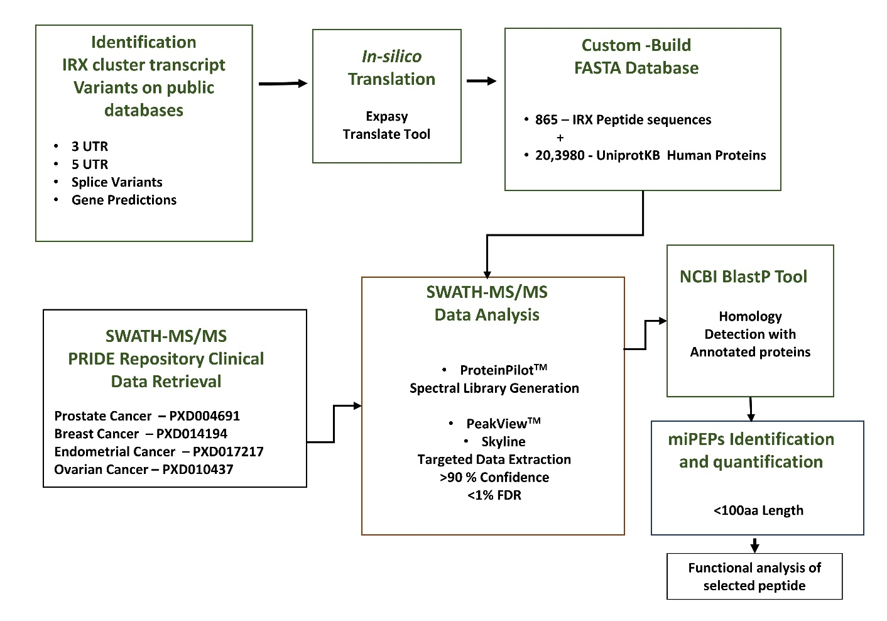
Figure S1. Workflow to identify and quantify micro peptides in hormone-related cancers. The first step was to retrieve the nucleotide sequences of IRX novel ORFs from the UCSC genome browser followed by an in-silico translation to obtain the hypothetical peptide sequences and assembled a FASTA database with peptide sequences. The SWATH-MS/MS raw files originating from prostate, breast, endometrial and ovarian cancer patient tissue samples retrieved from the PRIDE database were subjected to ProteinPilot software for re-processing. Custom built FASTA database was used for peptide spectrum match (PSM) and identified unique peptides of IRXs (<100 amino acids) and quantified using PeakView and Skyline software. NCBI blast using UniProtKB databse was performed for homology detection with annotated Uniprot proteins and one identified miPEP was selected for further functional analysis in PCa. This figure is related to main Figure 1.
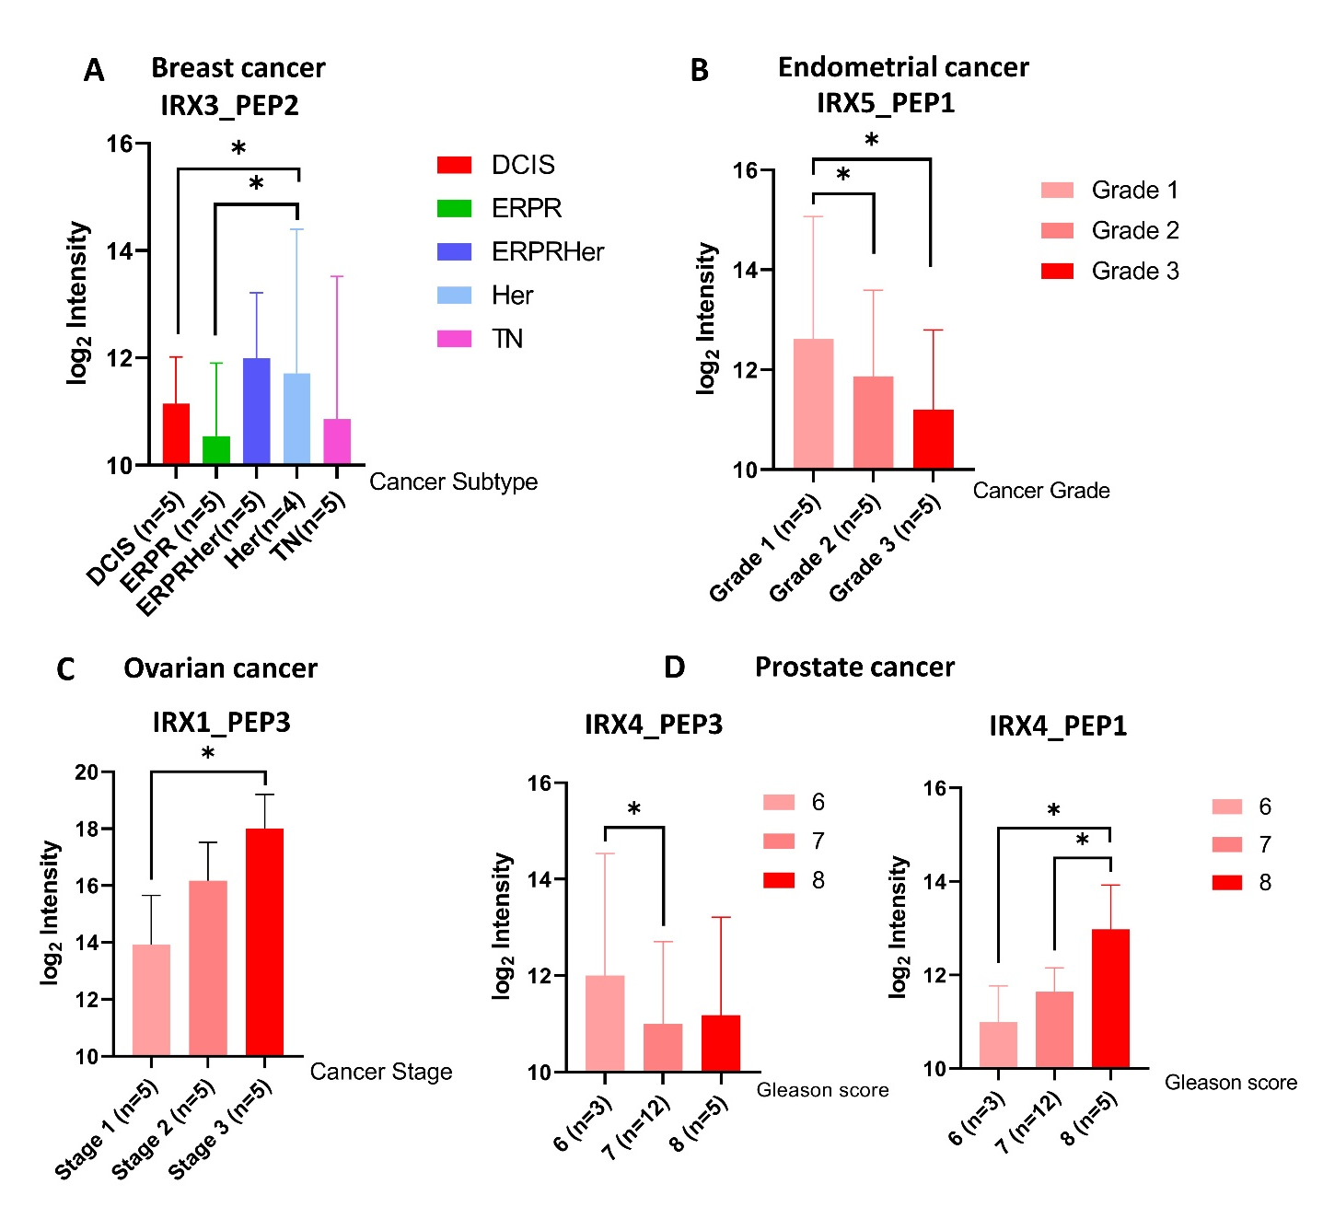
Figure S2. Expression of significantly differentially expressed IRX-miPEPs in hormone-sensitive cancers based on the subtypes, grades, and Gleason Score. (A) The expression of IRX3_PEP2 by breast cancer subtypes. (B) The expression of IRX5_PEP1 by endometrial cancer grades. (C) The expression of IRX1_PEP3 by ovarian cancer stages. (D) The expression of IRX4_PEP3 and IRX4_PEP1 by prostate cancer Gleason scores. The normalized log2 intensities of the miPEPs were used to plot and the number of patients is shown in brackets. Mean±SD, *P<0.05. This figure is related to main Figure 2.

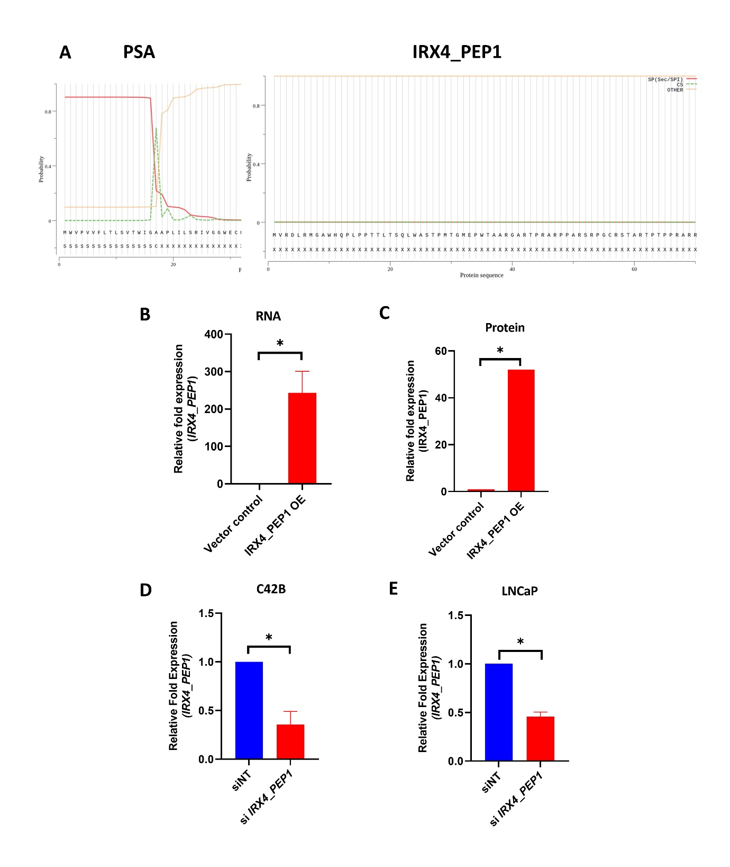
Figure S3. Stable overexpression and Transient knockdown efficiency of IRX4_PEP1 at RNA and protein level. (A) According to SignalP - 5.0 signal peptide prediction software no signal peptide was predicted for IRX4_PEP1 miPEP (right), in comparison to PSA (left) which has a signal peptide peak. (B) The OE efficiency of IRX4_PEP1 at the RNA level in doxycycline treated PC3 cells compared to vector control. RPL32 has been used as a housekeeping gene. (C) The OE efficiency of IRX4_PEP1 at the protein level by densitometry analysis in doxycycline treated PC3 cells compared to vector control. (D) IRX4_PEP1 transient knockdown efficiency in C42B compared to nontargeting control (siNT). RPL32 expression was used as the housekeeping control. (E) IRX4_PEP1 transient knockdown efficiency in LNCaP cells compared to nontargeting control (siNT). RPL32 expression was used as the housekeeping control. (n=3 biological replicates, Mean±SD, *p<0.05). This figure is related to main Figure 3.
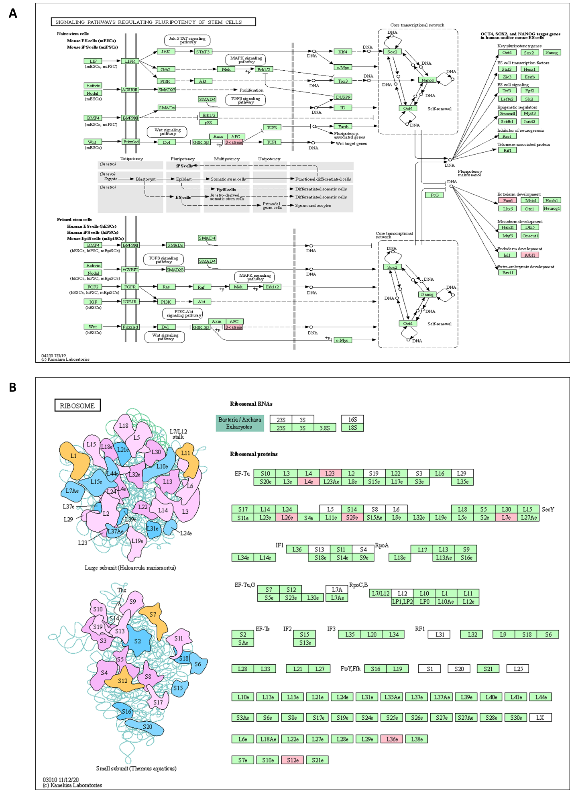

Figure S4. KEGG pathway analysis with potential co-partner proteins of IRX4_PEP1 identified by CO-IP assay. (A) The signaling pathway regulating pluripotency of stem cells that was mapped with KEGG analysis of co-partner proteins of IRX4_PEP1. The matched proteins are highlighted in a pink color. (B) The ribosomal pathway that was mapped with KEGG analysis of co-partner proteins of IRX4_PEP1. The matched proteins are highlighted in pink color. This figure is related to main Figure 4.

Supplementary Tables
Table S1. Identification and characterization of novel miPEPs generated from IRX cluster.
Table S2. Differentially regulated proteins with IRX4_PEP1 overexpression vs vector control.
Table S3. IPA pathway analysis with differentially regulated proteins with IRX4_PEP1 overexpression vs vector control.
Table S4. The potentially interacting proteins with IRX4_PEP1 miPEP.
Table S5. Primer and siRNA sequences were used in the study.

