Supplementary information
Mild heat treatment in vitro potentiates human adipose stem cells: delayed aging and improved quality

Chiseon Ryu¹ and Jae Young Lee^{1,}*
¹School of Materials Science and Engineering, Gwangju Institute of Science and Technology, Gwangju, 61005, Republic of Korea

*jaeyounglee@gist.ac.kr

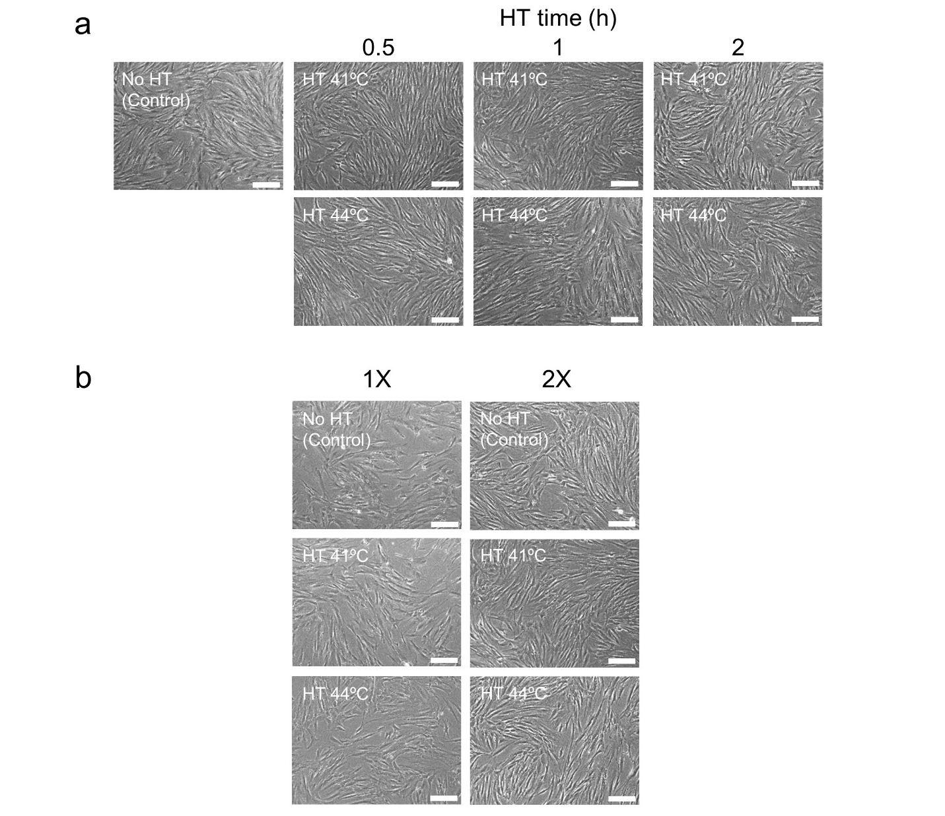
Supplementary Fig. 1: The optical images for the heat treatment (HT) of MSCs. a The optical images of MSCs for HT at temperature 41 and 44ºC for 0.5, 1, and 2 h. b The optical images of MSCs for HT at temperature 41 and 44ºC for 1 h once (1X) and twice (2X). Scale bars are 200 μm.
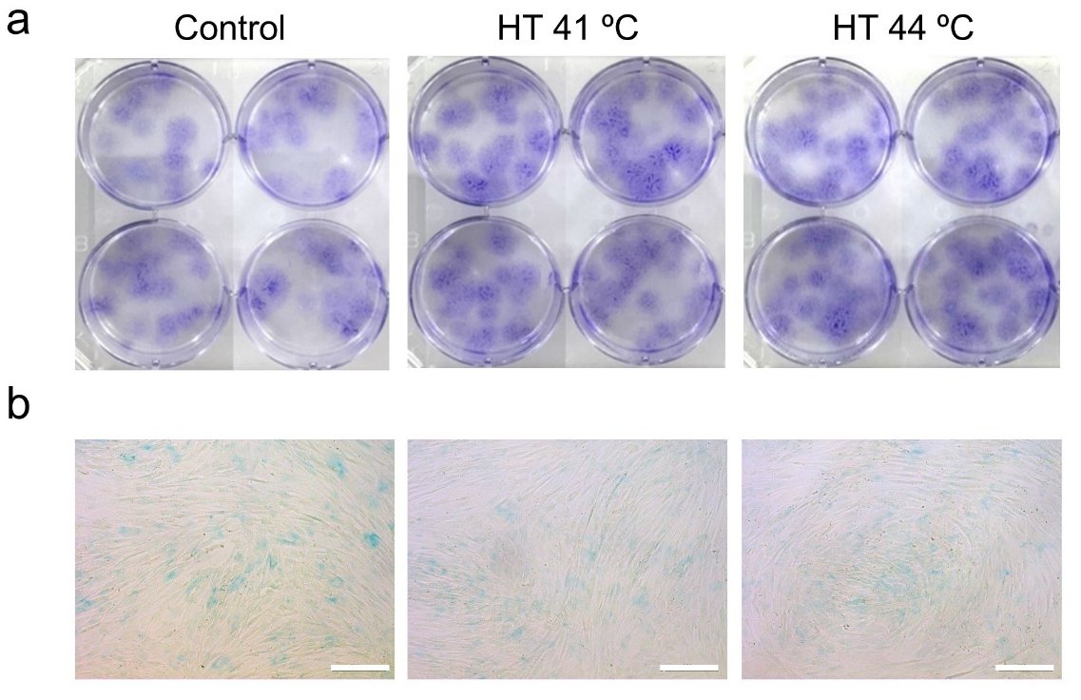
Supplementary Fig. 2: Optical images for colony formation assay and ß-gal staining. a The images of stained colonies formed by MSCs in six-well plates. b The images of ß-gal-stained MSCs in 12-well plates. Scale bars are 200 μm.

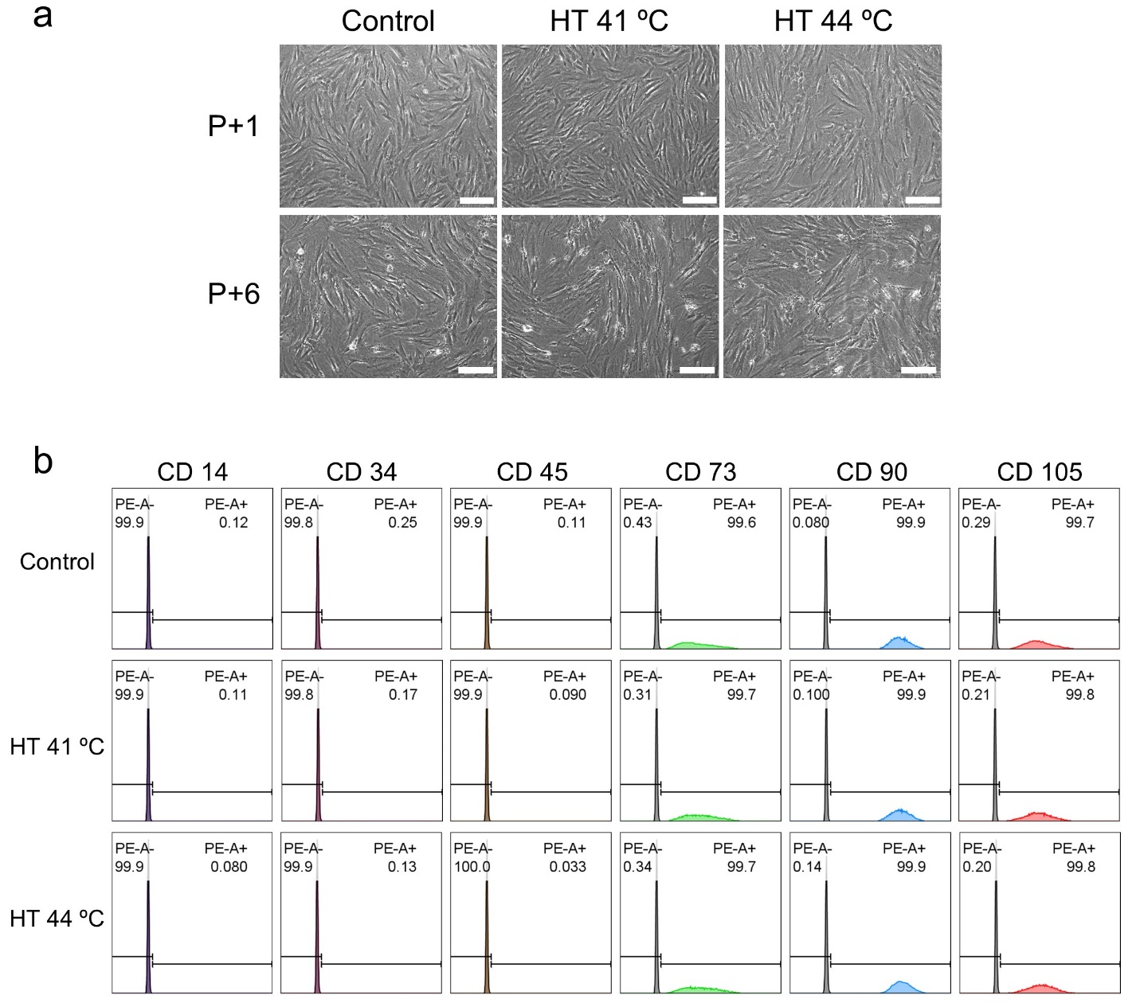
Supplementary Fig. 3: The lasting effect. a The optical images of MSCs at each passage. b The population of each surface marker-stained MSCs at P+6 using flow cytometry. Scale bars are 200 μm.

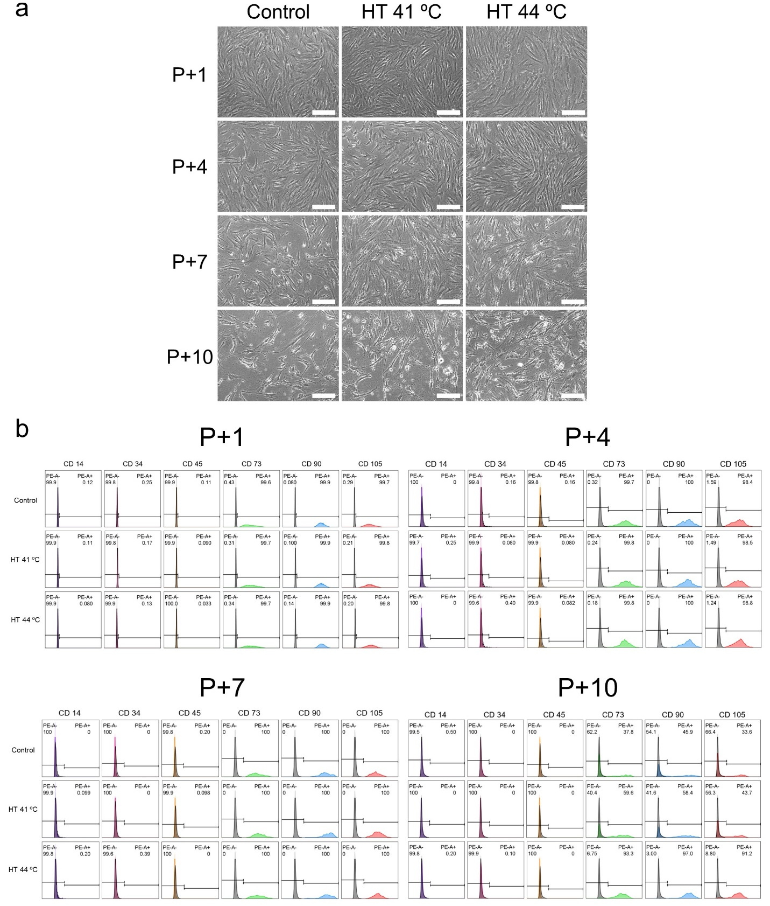
Supplementary Fig. 4: Periodic HT. a The optical images of heat treated-MSCs at each passage. b The population of surface marker-stained MSCs at each passage using flow cytometry. Scale bars are 200 μm.
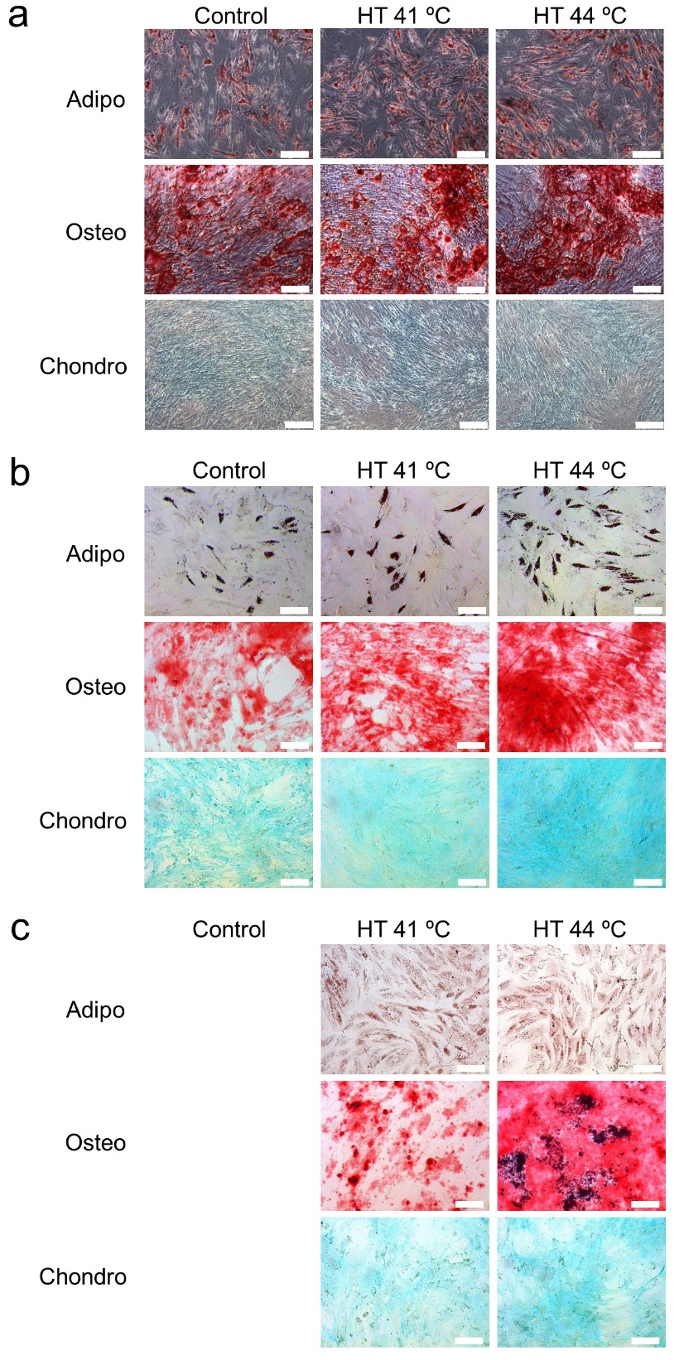
Supplementary Fig. 5: Periodic HT. The stained images of trilineage differentiation at a P+4, b P+7, and c P+10. Scale bars are 200 μm.
Gene | Forward primer (5′-3′) | Reverse primer (5′-3′)
GAPDH | ATTTGGTCGTATTGGGCG | TGGAAGATGGTGATGGGATT
HSP27 | GTCCAACGAGATCACCATCC | CGGCAGTCTCATCGGATTT
HSP70 | TTGCAGTGTGCCATCTTATC | GAGAAAGGAGCAGCATGATT
HSP90 | CACCACTCTACTCTGTCTCT | GTTTCCTCAGGCATCAGTAG
SOX2 | TGCGAGCGCTGCACAT | GCAGCGTGTACTTATCCTTCTTCA
OCT4 | ACATCAAAGCTCTGCAGAAA | CTGAATACCTTCCCAAATAGAAC
NANOG | AATACCTCAGCCTCCAGCAGAT | TGCGTCACACCATTGCTATTCTT
C/EBPΑ | CGGTGGACAAGAACAGCAAC | CGGAATCTCCTAGTCCTGGC
PPARΓ | TGTCTCATAATGCCATCAGGTTTG | GATAACGAATGGTGATTTGTCTGTT
FABP | ATGCTTTTGTAGGTACCTGG | CTCTCTCATAAACTCTCGTG
RUNX2 | GGCCCACAAATCTCAGATCGTT | CACTGGCGCTGCAACAAGAC
OPN | TTGCAGCCTTCTCAGCCAA | GGAGGCAAAAGCAAATCACTG
ALP | AACACCACCCAGGGGAAC | GGTCACAATGCCCACAGATT
COL2A1 | CCGGGCAGAGGGCAATAGCAGGTT | CAATGATGGGGAGGCGTGAG
SOX9 | AGCGAACGCACATCAAGAC | CTGTAGGCGATCTGTTGGGG
ACAN | CTACCGCTGCGAGGTGATG | TCGAGGGTGTAGCGTGTAGAGA
TEL1 | GGTTTTTGAGGGTGAGGGTGAGGGTGAGGGTGAGGGT
TEL2 | TCCCGACTATCCCTATCCCTATCCCTATCCCTATCCCTA
36B4U | CAGCAAGTGGGAAGGTGTAATCC
36B4D | CCCATTCTATCATCAACGGGTACAA
Table S1: Primer sequences for qRT-PCR.

