Supplementary Figure 1 Clinical and molecular characteristics of CP in gliomas
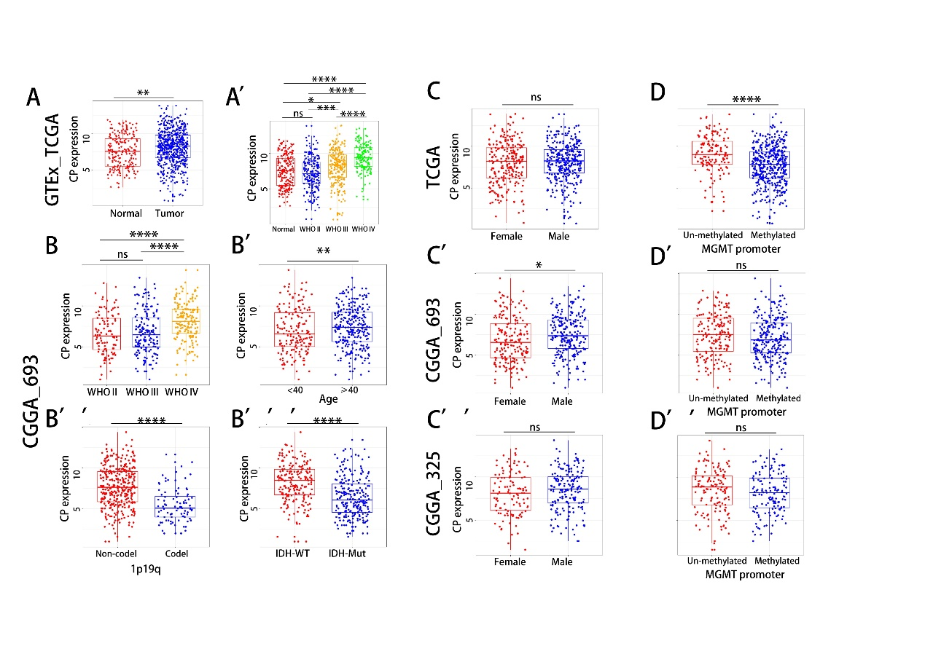
Supplementary Figure 1 Clinical and molecular characteristics of CP in gliomas
- The expression of CP between normal cortex and tumor in GTEx and TCGA LGG-GBM dataset
(A’) The expression of CP between normal cortex and different WHO pathological grades glioma in GTEx and TCGA LGG-GBM dataset
(B) The expression of CP stratified by WHO pathological grades, age, 1p/19q-codeletion status, IDH mutant status in CGGA_693 dataset
(C, C’, C’’) The expression of CP between male and female in TCGA LGG-GBM (C) CGGA_693(C’) and CGGA_325 dataset (C’’)
(D, D’, D’’) The expression of CP between MGMT promoter methylation and un-methylation status in TCGA LGG-GBM (C) CGGA_693(C’) and CGGA_325 dataset (C’’).In (A’,B) p values obtained by the one-way ANOVA test and in (A,B’-D’’) p values obtained by the two tailed student’s t test. *p < 0.05, **p < 0.01, ***p < 0.001, ****p < 0.0001; ns, no statistics significance

Supplementary Figure 2 Differentially expressed genes and functional enrichment analysis of CP high- and low-expression groups in CGGA_693 dataset
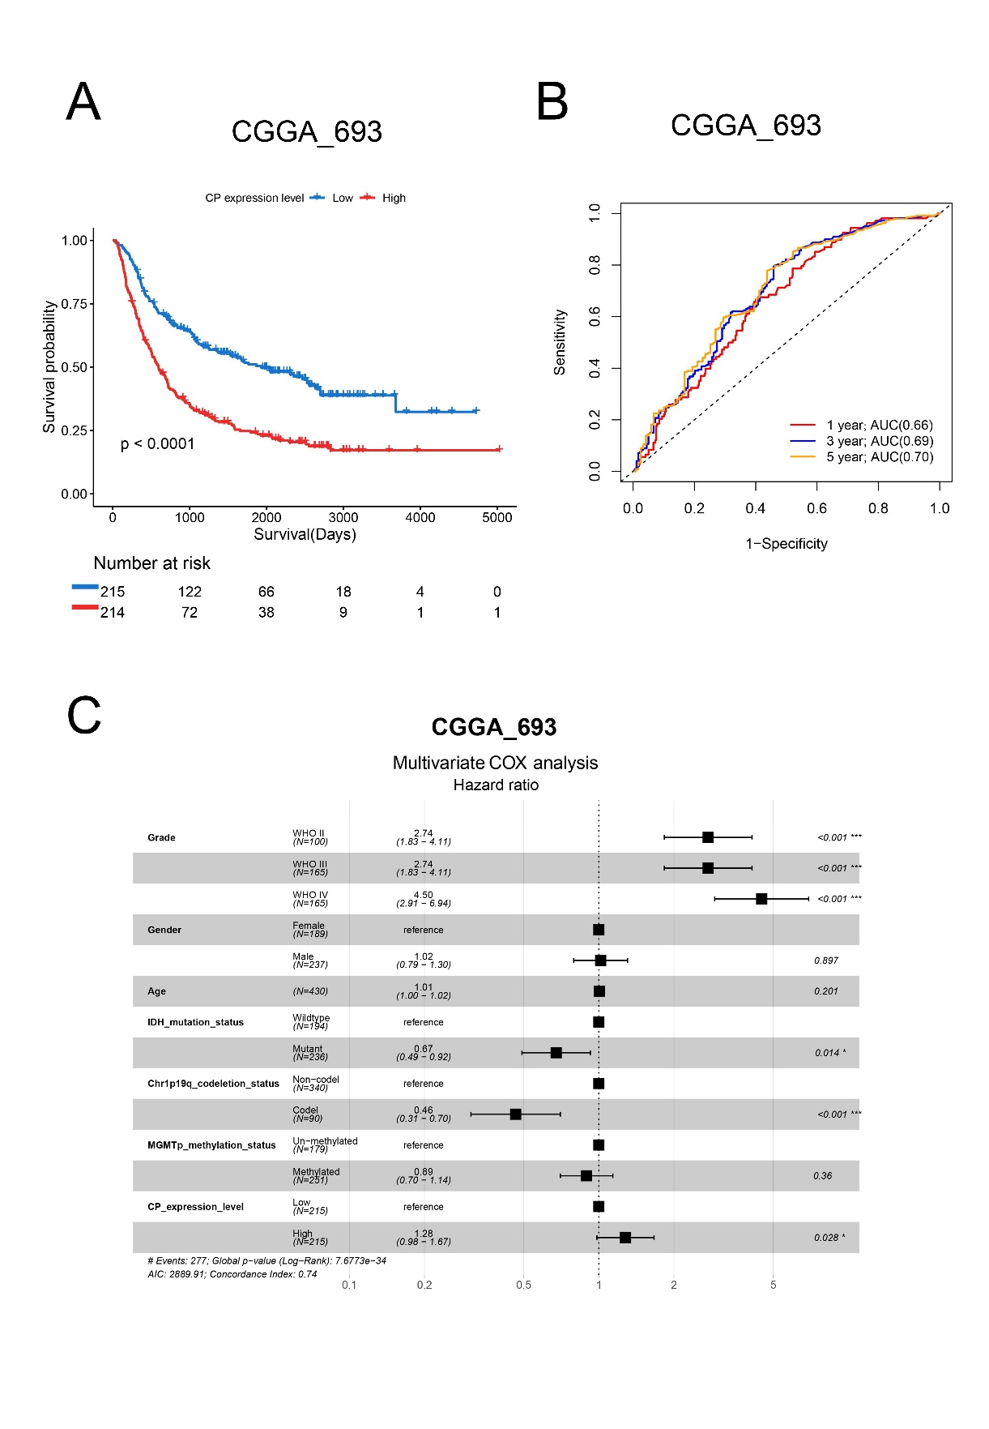
Supplementary Figure 2 Differentially expressed genes and functional enrichment analysis of CP high- and low-expression groups in CGGA_693 dataset
(A) Survival analysis of glioma
(B) Time-dependent receiver operating characteristic (ROC) curves for survival rates over one, three, and five years
(C) Forest plot representing multifactor Cox regression analysis including CP, gender, age, IDH mutation status, 1p19q deletion status, and MGMT promoter methylation status

Supplementary Figure 3 Differentially expressed genes and functional enrichment analysis of CP high- and low-expression groups in CGGA_693 dataset
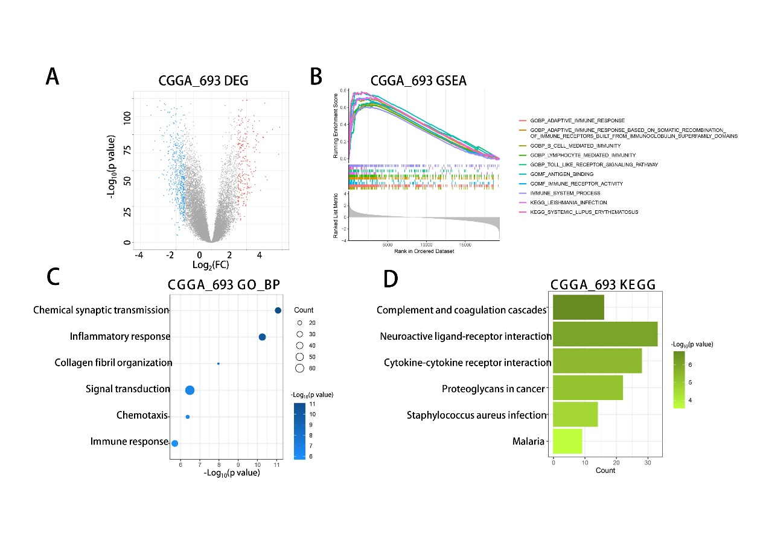
Supplementary Figure 3 Differentially expressed genes and functional enrichment analysis of CP high- and low-expression groups in CGGA_693 dataset
(A) Differential expression genes (DEGs)
(B) Gene Ontology Biological Process (GO_BP) enrichment analysis based on DEGs between low and high CP groups.
(C) Kyoto Encyclopedia of Genes and Genomes (KEGG) enrichment analysis based on DEGs between low and high CP groups
(D) Gene Set Enrichment Analysis (GSEA) enrichment analysis between low and high CP groups

Supplementary Figure 4 Immune landscape based on bulk RNA-seq data of CGGA

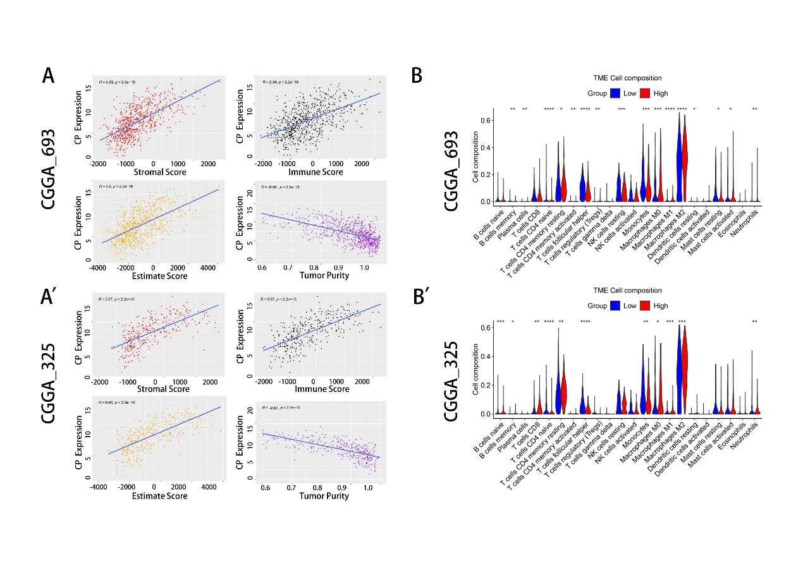
Supplementary Figure 4 Immune landscape based on bulk RNA-seq data of CGGA
(A, A') Correlations between Stromal score, ESTIMATE score, Immune score, tumor purity, and CP expression in CGGA_693 (A) and CGGA_325 dataset (A')
(B, B') Infiltration ratio of all immunocytes in the tumor microenvironment (TME) between low and high CP expression groups analyzed by CIBERSORT in CGGA_693 (B) and CGGA_325 dataset (B')

Supplementary Figure 5 Infiltration ratio of B cells memory, T cells CD4 memory resting, Macrophages M0, Macrophages M1, Dendritic cells activated, and Eosinophils in low and high CP expression groups based on CIBERSORT analysis in TCGA dataset
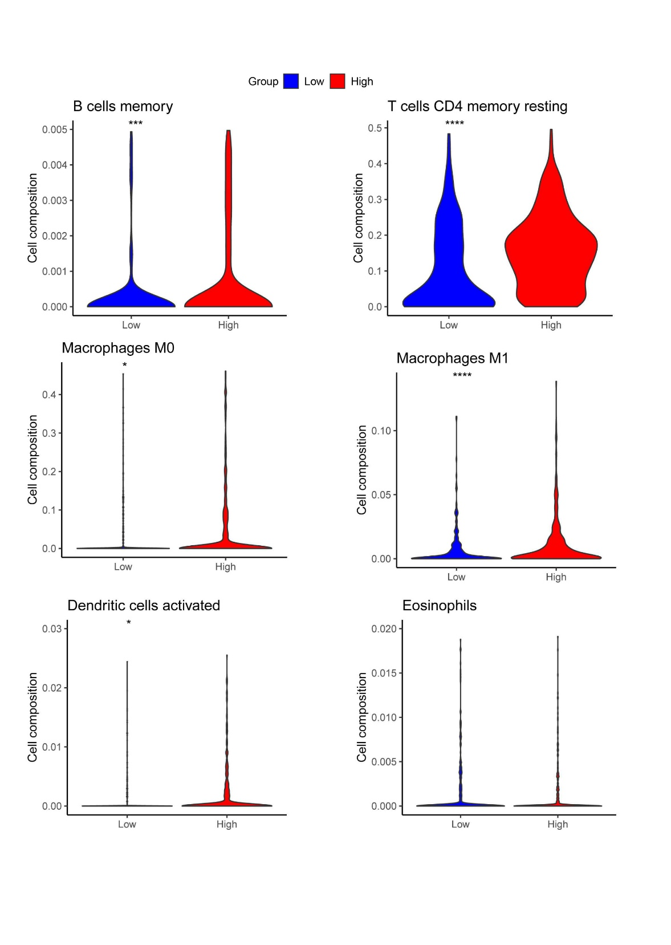

Supplementary Figure 6 Correlation between CP expression and immune checkpoint markers in CGGA_693 dataset
