Appendix
Fig. S1 - Temporal organization of mouthwashes and saliva sampling--------------------------------------- 2
Materials and Methods------------------------------------------------------------------------------------------------- 3
Table S1 - RT-PCR for the detection of SARS-CoV-2: primers and probes used --------------------------- 4
Table S2 - Baseline characteristics of the study groups- --------------------------------------------------------- 5
Table S3 – Salivary SARS-CoV-2 load from the day 1 T1 to day 7 for the CDCM
and placebo groups------------------------------------------------------------------------------------------------------ 6
Fig. S2 – Evolution of SARS-CoV-2 salivary load from the day 1 T1 to day 7 for the CDCM
and placebo groups------------------------------------------------------------------------------------------------------ 7

Fig. S1 - Temporal organization of mouthwashes and saliva sampling
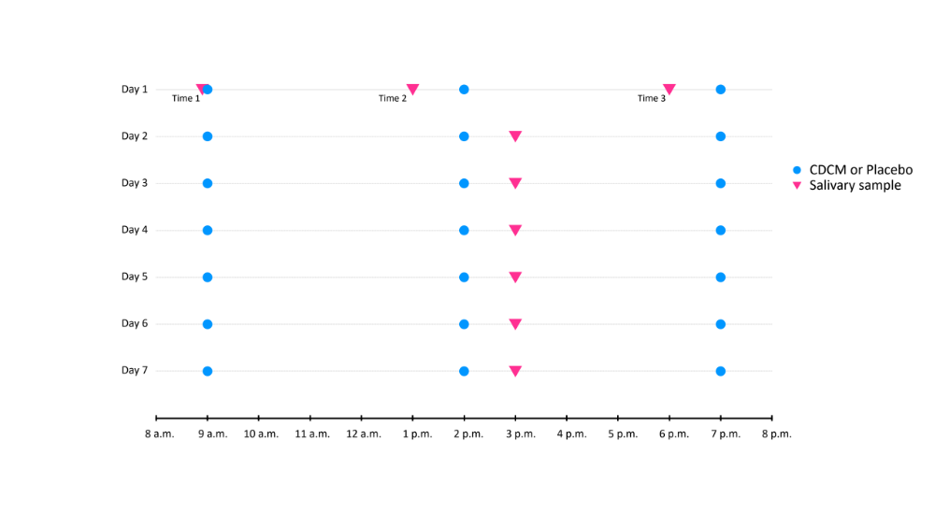

Materials and Methods
Participants and source of data
The patients were COVID-19 confirmed cases that correspond to a positive SARS-CoV-2 RT-PCR on nasopharyngeal samples (performed by an accredited laboratory). Clinical, biological and radiological data were carefully recorded from computerized medical records.

Temporal organization of mouthwashes and saliva sampling
The temporal organization is summarized in the Supplementary Fig. S1. The day 1, at 9 a.m. (Time 1), the patient collected the first saliva sample and then proceeded with his first mouthwash either with the mouthwash containing ß-cyclodextrin and citrox (bioflavonoids) or with the placebo. The second saliva sample was collected at 1 pm. (Time 2) and one hour later, at 2 p.m., the patient performed a mouthwash. Then, at 6 p.m. (Time 3), the patient collected his saliva and at 7 p.m., he proceeded to a mouthwash. For the next 6 days, the patient performed 3 daily mouthwashes at 9 a.m., 2 p.m. and 7 p.m. and collected his saliva once a day at 3 p.m.

RNA extraction and real-time RT-PCR
RNA extraction was performed with the Extraction NucliSens easyMAG instrument (bioMérieux, Marcy-l’Etoile, France) using manufacturer's instructions. RNA was extracted from 200 μL of specimen and eluted in 50 μL of water and used as a template for real-time (rt) RT-PCR. A 25 μL reaction contained 5 μL of RNA, 1 μL of RdRp-IP2 forward primer (0·4 μM), 1 μL of RdRp-IP2 reverse primer (0·4 μM), 1 μL of RdRp-IP4 forward primer (0·4 μM), 1 μL of RdRp-IP4 reverse primer (0·4 μM), 12·5 μL of 2X reaction buffer provided with the Superscript III one step RT-PCR system with Platinum Taq Polymerase (Invitrogen, Darmstadt, Germany; containing 0·4 mM of each dNTPs and 3 mM magnesium sulfate), 1 μL of Superscript III RT/Platinum Taq Mix, 0·4 μL of a 50 mM magnesium sulfate solution (Invitrogen). The rt RT-PCR was performed on a Quant Studio 5 (Thermofisher, Dardilly, France) with the following conditions: 55°C for 10 min (reverse transcription), followed by 95°C for 2 min and then 45 cycles of 95°C for 3 s, 58°C for 30 s. Each RT-PCR run included in addition of unknown samples: three negatives samples bracketing unknown samples during RNA extraction, two positive controls and one negative amplification control. When a sample was positive with RdRp-IP4, quantification of the number of RNA copies was done according to a scale ranging from 10² to 10⁶ copies/μL. All positive saliva samples were quantified and expressed as number of RNA copies/mL.

Primers and probes
Primer and probe sequences (Eurofins, Genomics, Germany) are shown in Supplementary Table S1. Based on the first sequences of SARS-CoV-2 available on the GISAID database on January 11, 2020, primers and probes (nCoV_IP2 and nCoV_IP4) were designed to target the RdRp gene spanning nt 12621-12727 and 14010-14116 positions according SARS-CoV, NC_004718).

References
- Corman VM, Landt O, Kaiser M, Molenkamp R, Meijer A, Chu DK, et al. Detection of 2019 novel coronavirus (2019-nCoV) by real-time RT-PCR. Euro Surveill. 2020;25(3).

Table S1 - RT-PCR for the detection of SARS-CoV-2: primers and probes used

Name | Sequences (5’-3’) | PCR  product | Ref
RdRp gene / nCoV_IP2
nCoV_IP2-12669Fw | ATGAGCTTAGTCCTGTTG | 108 pb | CNR
nCoV_IP2-12759Rv | CTCCCTTTGTTGTGTTGT | 108 pb | CNR
nCoV_IP2-12669bProbe(+) | [5']HEX - AGATGTCTTGTGCTGCCGGTA - [3']BHQ-1 | 108 pb | CNR
RdRp gene / nCoV_IP4
nCoV_IP4-14059Fw | GGTAACTGGTATGATTTCG | 107 pb | CNR
nCoV_IP4-14146Rv | CTGGTCAAGGTTAATATAGG | 107 pb | CNR
nCoV_IP4-14084Probe(+) | [5']Fam - TCATACAAACCACGCCAGG - [3']BHQ-1 | 107 pb | CNR
CNR: National Reference Center for Respiratory Viruses, Institut Pasteur, Paris, France

Table S2 - Baseline characteristics of the study groups

 | CDCM | Placebo | Overall | p-value
Gender, n/N (%) |  |  |  | 0·700ª
Male | 36/75 (48·00%) | 34/78 (43·59%) | 70/153 (45·75%)
Female | 39/75 (52·00%) | 44/78 (56·96%) | 83/153 (54·25%)
Age (years) | N=75 | N=77 | N=152
mean ± SD | 43·81 ±15·1 | 43·97 ±16·17 | 43·89 ±15·55 | 0·949^{b}
median [IQR] | 44 [32·5 - 53·5] | 42 [30 - 56] | 43 [30·75 - 55] | 0·994^{c}
No comorbidity, n/N (%) | 55/68 (80·88%) | 57/75 (76·00%) | 112/143 (78·32%) | 0·614 ª
Diagnosis-inclusion time (days), | N=74 | N=73 | N=147
mean ± SD | 3·82 ±4·37* | 2·9 ±1·57 | 3·37 ±3·31*
median [IQR] | 4 [2 - 4·75] | 3 [2 - 4] | 3 [2 - 4] | 0·032^{c}
Initial place of care, n/N (%) |  |  |  | 1·000ª
Home | 69/72 (95·83%) | 70/74 (94·59%) | 139/146 (95·21%)
Hospital | 3/72 (4·17%) | 3/74 (4·05%) | 6/146 (4·11%)
Nursing care | 0/72 (0·00%) | 1/74 (1·35%) | 1/146 (0·68%)
Diagnostic delay-day 1 (days) | N=74 | N=74 | N=148
mean ± SD | 4·38 ±3·53* | 3·65 ±1·46 | 4·01 ±2·71*
median [IQR] | 4 [3 - 5] | 4 [3 - 5] | 4 [3 - 5] | 0·059^{c}
Delay clinical signs-day 1 (days) | N=64 | N=71 | N=135
mean ± SD | 5·59 ±1·59* | 5·62 ±1·59 | 5·61 ±1·58*
median [IQR] | 6 [4·75 - 7] | 6 [5 - 7] | 6 [5 - 7] | 0·884^{c}
Delay PCR-day 1 (days) | N=73 | N=74 | N=147
mean ± SD | 4·1 ±1·48* | 3·8 ±1·38 | 3·95 ±1·44*
median [IQR] | 4 [3 - 5] | 4 [3 - 5] | 4 [3 - 5] | 0·146^{c}
ªPearson's Chi-square, ^{b}Student’s t-test, ^{c}Mann-Whitney test. *Shapiro test: Normality hypotheses rejected. CDCM: ß-cyclodextrin and citrox mouthwash

Table S3 – Salivary SARS-CoV-2 load from the day 1 T1 to day 7 for the CDCM and placebo groups

 | CDCM | Placebo | p-valueª
Day 1 T1 | N=76 | N=78
mean ± SD | 3·74 ±2·03 | 3·86 ±2·26
median (min; max) [IQR] | 4·14 (0 ; 6·71) [2·95 - 5·15] | 4·04 (0 ; 10·19) [2·95 - 5·14] | 0·808
Day 1 T2 | N=76 | N=78
mean ± SD | 2·99 ±1·91 | 3·41 ±2·17
median (min; max) [IQR] | 3·61 (0 ; 5·81) [1·6 - 4·37] | 3·92 (0 ; 8·07) [1·92 - 4·94] | 0·173
Day 1 T3 | N=75 | N=77
mean ± SD | 2·88 ±2·06 | 3·19 ±2·29
median (min; max) [IQR] | 3·17 (0 ; 7) [0 - 4·31] | 3·34 (0 ; 8·16) [0 - 4·91] | 0·368
Day 2 | N=75 | N=78
mean ± SD | 2·58 ±2·11 | 2·83 ±2·18
median (min; max) [IQR] | 3·07 (0 ; 7·43) [0 - 4·16], | 3·42 (0 ; 7·96) [0 - 4·48] | 0·451
Day 3 | N=75 | N=77
mean ± SD | 2·24 ±1·83 | 2·43 ±2·11
median (min; max) [IQR] | 2·58 (0 ; 5·65) [0 - 3·58] | 2·79 (0 ; 7·31) [0 - 3·87] | 0·578
Day 4 | N=73 | N=78
mean ± SD | 2·02 ±1·96 | 2·1 ±2·24
median (min; max) [IQR] | 2·2 (0 ; 6·66) [0 - 3·52] | 1·6 (0 ; 7·94) [0 - 3·87] | 0·896
Day 5 | N=75 | N=74
mean ± SD | 1·59 ±1·87 | 1·94 ±2·19
median (min; max) [IQR] | 0 (0 ; 6·11) [0 - 2·99] | 0·68 (0 ; 7·36) [0 - 3·7] | 0·363
Day 6 | N=73 | N=72
mean ± SD | 1·53 ±1·77 | 1·76 ±1·95
median (min; max) [IQR] | 0 (0 ; 7·32) [0 - 2·72] | 1·48 (0; 7·29) [0 - 3·4] | 0·429
Day 7 | N=73 | N=68
mean ± SD | 1·23 ±1·76* | 1·52 ±1·96
median (min; max) [IQR] | 0 (0; 6·12) [0 - 2.65] | 0 (0; 7·44) [0 - 3·05] | 0·406
ªMann-Whitney test of the differences with a unilateral alternative hypothesis (H1 CDCM < Placebo). CDCM: ß-cyclodextrin-citrox mouthwash

Fig. S2 – Evolution of SARS-CoV-2 salivary load from the day 1 T1 to day 7 for the CDCM and placebo groups
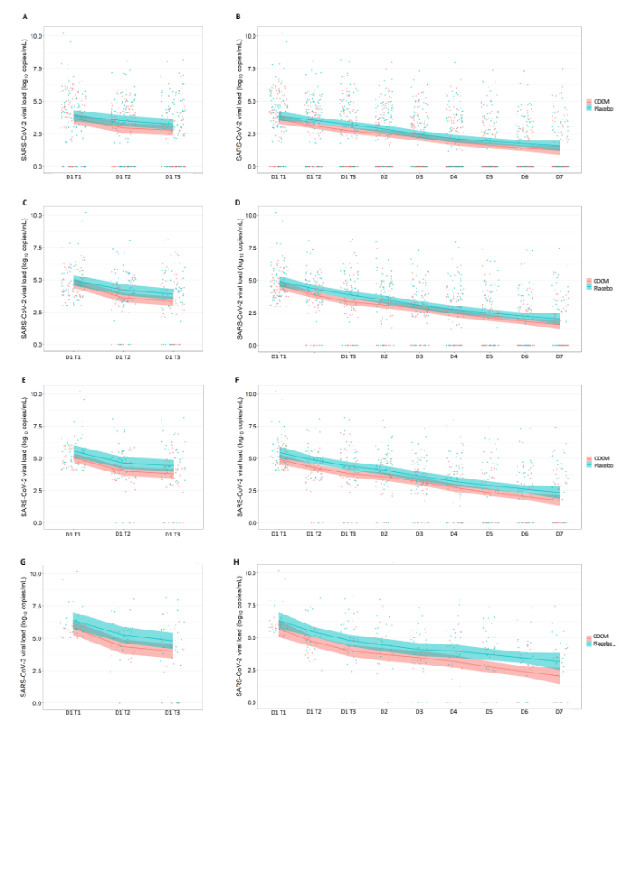
(A-B) Evolution for all the patients. (C-D) Evolution for patients for patients with a viral load greater than 2·95 log₁₀ copies/mL at day 1 time 1. (E-F) Evolution for patients for patients with a viral load greater than 4·12 log₁₀ copies/mL at day 1 time 1. (G-H) Evolution for patients for patients with a viral load greater than 5·16 log₁₀ copies/mL at day 1 time 1. Shaded areas are 90% CIs.

