Supporting Information

Diffusion-Kinetically Dormant Ni-Rich Cathode at High Potentials
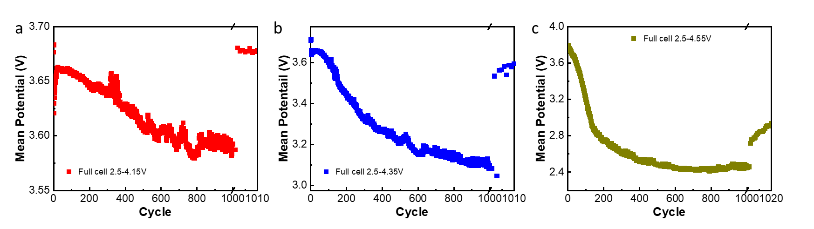
Figure S1. Mean potentials evolves during the long-term cycling of Ni83/Gr full cells in the (a) 2.5-4.15 V, (b) 2.5-4.35 V, and (c) 2.5-4.55 V.

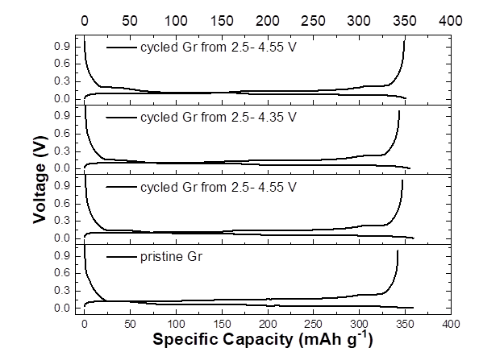
Figure S2. Charge-discharge profile comparison of pristine and the harvested graphite anodes from full cells in different voltage windows.

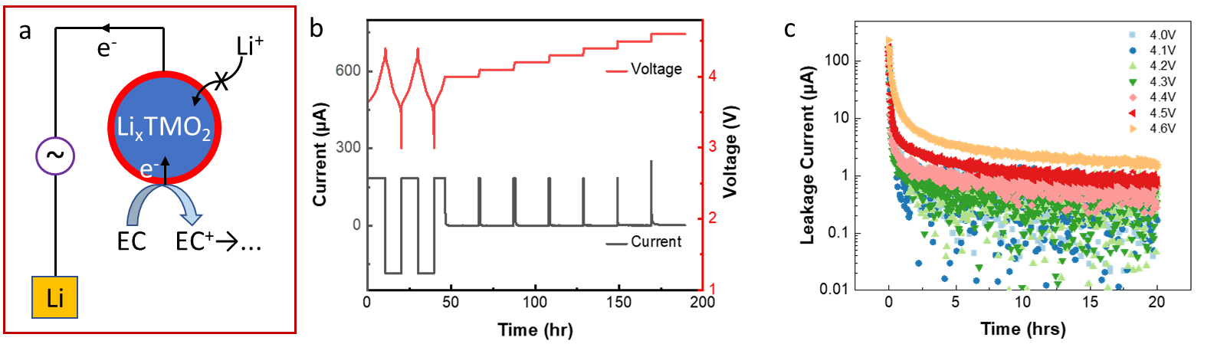
Figure S3. a) Schematic illustration of parasitic reaction measurement via our in-house high-precision leakage current (HpLC) system. b) Standard protocol of HpLC test on Ni83/Li half cells to measure leakage current while holding potentials from 4.0-4.6 V. c) Leakage current profiles measured on Ni83 cathode at different potentials.

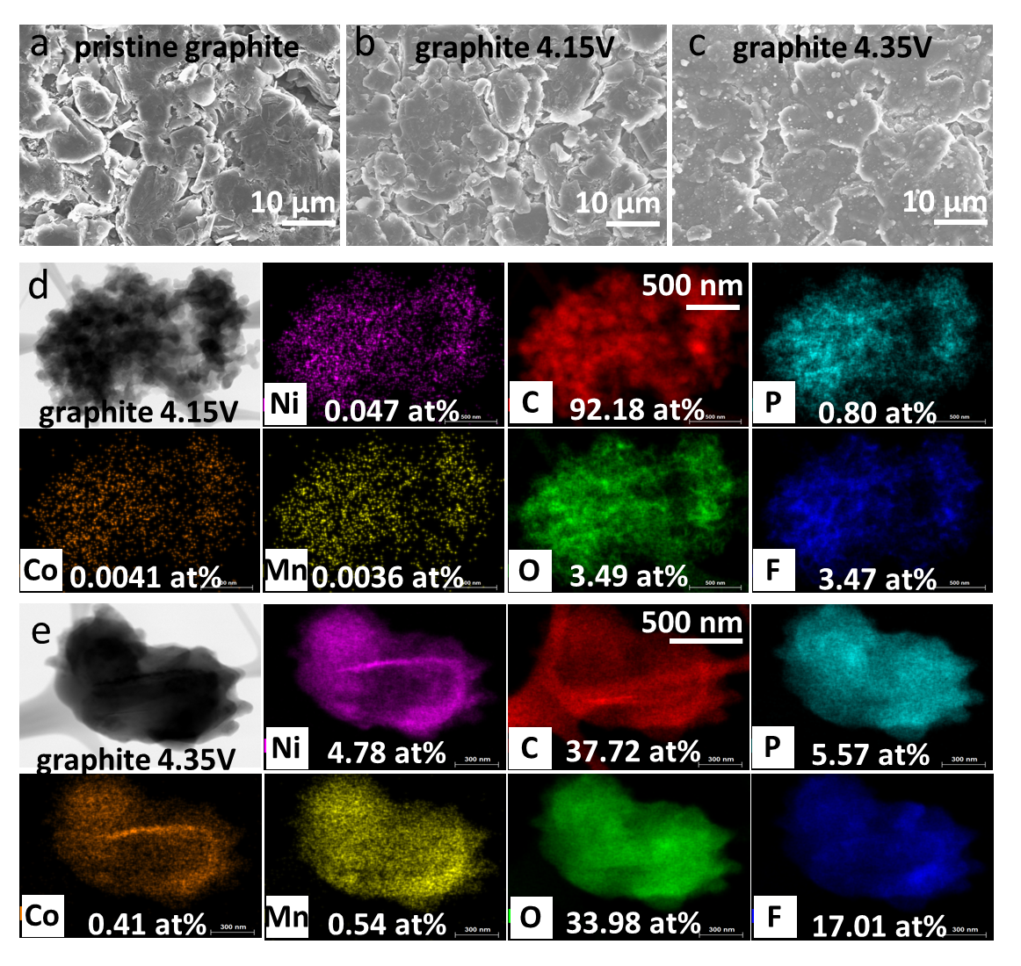
Figure S4. SEM images present the morphology of the graphite surface when (a) pristine and cycled at (b) 4.15 V and (c) 4.35V. EDX mappings reveal different SEI contents on the graphite anodes at (d) 4.15V and (e) 4.35 V.

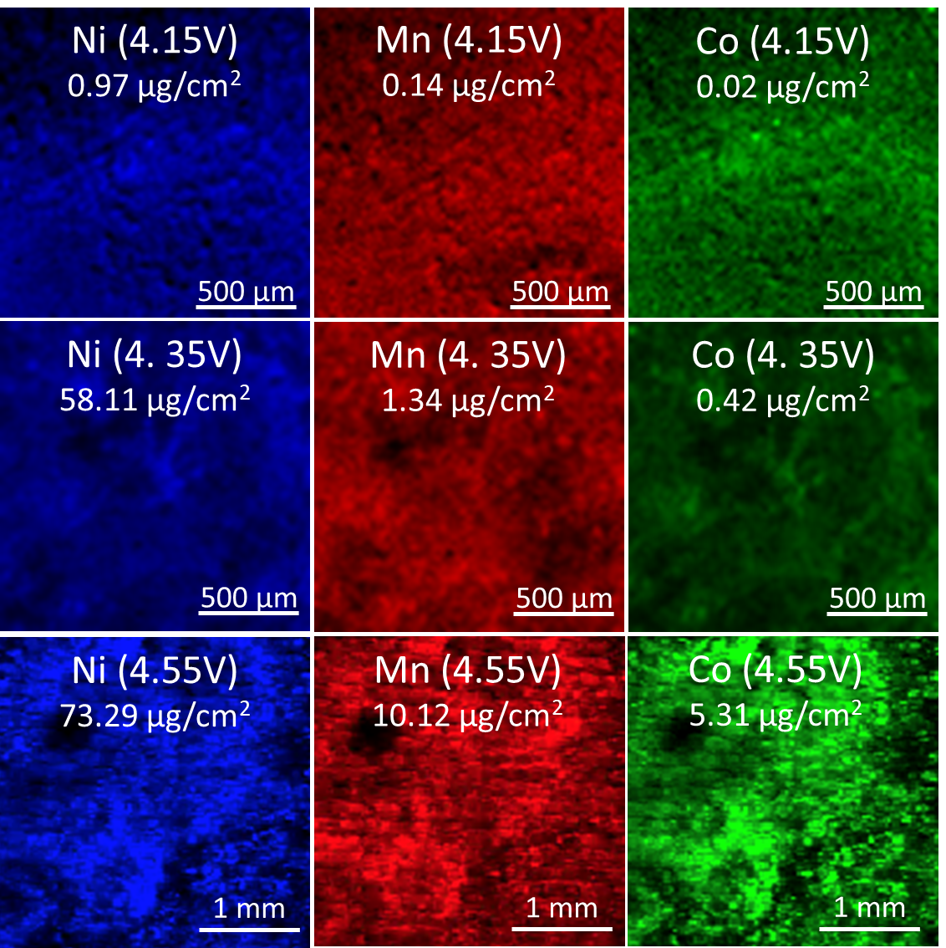
Figure S5. XRF images of graphite electrode surfaces with quantitative analysis of migrated transition metals at 4.15 V, 4.35 V, and 4.55 V.

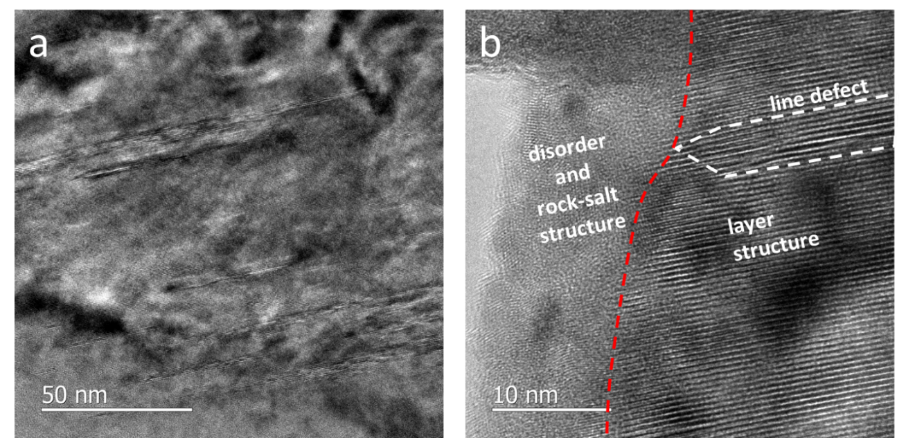
Figure S6. (a) TEM image of Ni83 cathode at 4.35 V at a low magnification shows several 100-nm intragranular cracks, probably throughout entire primary particle (around 200 nm). (b) HRTEM images of another local surface of Ni83 cathode primary particles after being cycled at 4.35 V confirm the interface-originated intragranular cracking between rock-salt and layered structure.

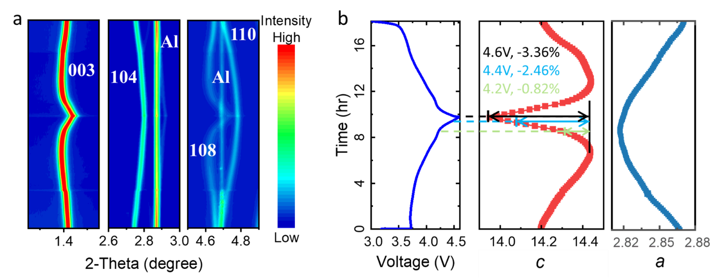
Figure S7. (a) In situ synchrotron HEXRD characterization of Ni83 phase evolutions during first charge/discharge cycle. (b) Electrochemical charge/discharge profile and the evolution of lattice constant c and a of Ni83/Li half cells at C/9 current rate in 3.0–4.6V vs. Li/Li⁺.

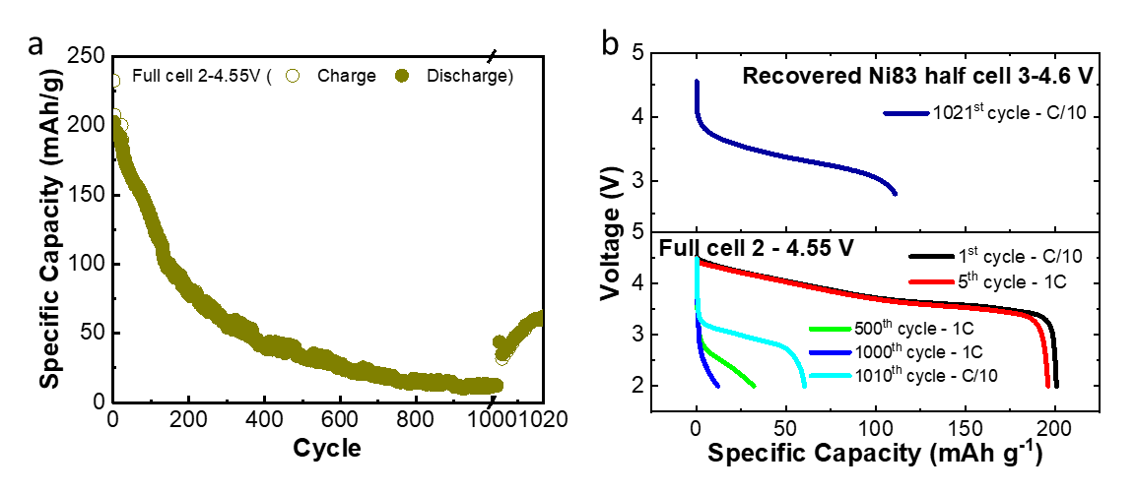
Figure S8. (a) Long-term cycling performance evaluation of Ni83/Gr full cells in the voltage window of 2.5-4.55 V, showing the rapid capacity fading. (b) The discharge profiles of full cells during long-term cycling tests in 2.5-4.55 V and the recovered Ni83 half cell.

