SUPPORTING INFORMATION

Current Collectors Corrosion Behaviours and Rechargeability of TiO₂ in Aqueous Electrolyte Aluminium-ion Batteries

Burcu Unal^{a,b}, Ozlem Sel^{c,d} and Rezan Demir-Cakan^{a,b*}
ª Department of Chemical Engineering, Gebze Technical University, Gebze, Kocaeli, 41400, Turkey
^{b} Institute of Nanotechnology, Gebze Technical University, Gebze, Kocaeli, 41400, Turkey
^{c} Chimie du Solide et de l’Energie, UMR 8260, Collège de France, 11 Place Marcelin Berthelot, 75231 Paris Cedex 05, France
^{d} Réseau sur le Stockage Electrochimique de l’Energie (RS2E), CNRS FR 3459, 33 Rue Saint Leu, 80039 Amiens Cedex, France

*Corresponding author: demir-cakan@gtu.edu.tr

Figure S1. pH and ionic conductivities of a) AlCl₃, b) Al₂(SO₄)₃ and c) Al(NO₃)₃ aqueous electrolytes at different concentrations.

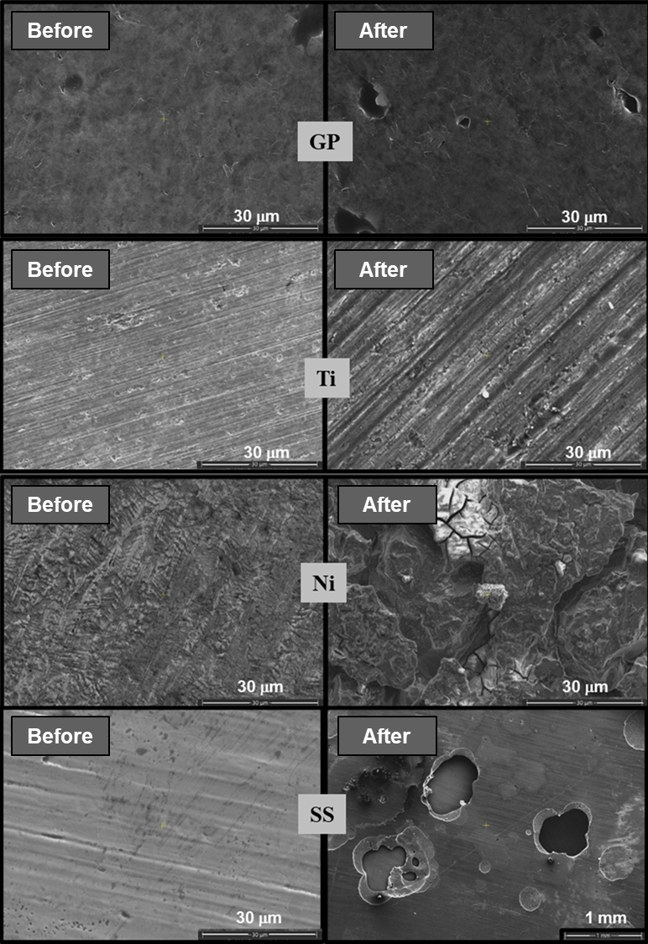

Figure S2. SEM images of current collectors, before and after CV measurements in 1.0 M AlCl₃: GP, Ti, Ni, SS (from up to down, respectively).

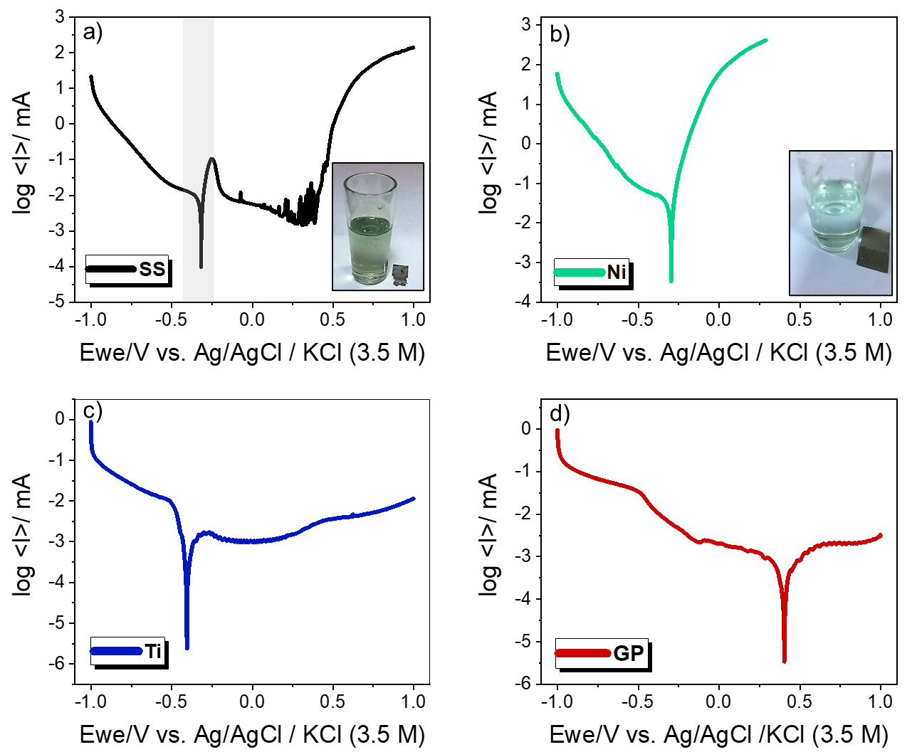
Figure S3. Potentiodynamic polarization curves between (-1.0 – 1.0) V at 1mV/s scan rate in 1.0 M AlCl₃. a) SS, b) Ni, c) Ti, d) GP.

Figure S4. Electrochemical test of TiO₂ on Ti current collector cycled in 1.0 M AlCl₃ containing aqueous electrolyte at 3A/g a) galvanostatic charge-discharge curves and b) capacity retention profile

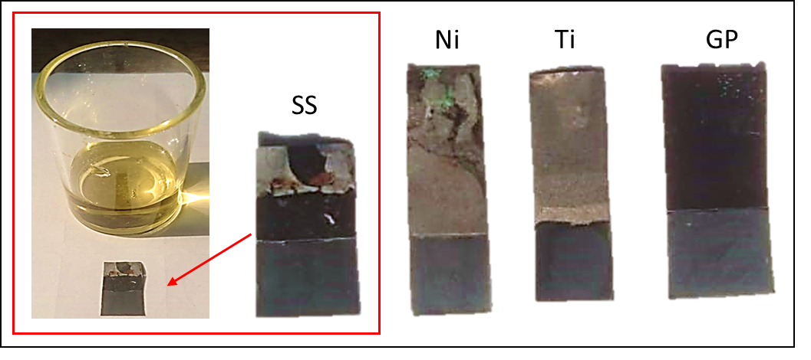

Figure S5. Images of TiO₂ coated SS, Ni, Ti and GP current collectors demonstrating the macroscopic changes in electrolyte after galvanostatic charge-discharge experiment in 1.0 M AlCl₃ containing aqueous electrolyte.

Table S1. Lattice spaces attributed to the Miller Index of anatase TiO₂ from selected area electron diffraction (SAED).
 | 1/2r (nm⁻¹) | 1/r (nm⁻¹) | r (nm) | d-space (Å) | Miller Index (hkl)
1 | 5.973 | 2.987 | 0.335 | 3.348 | 101
2 | 8.441 | 4.221 | 0.237 | 2.369 | 004
3 | 10.621 | 5.311 | 0.188 | 1.883 | 200
4 | 11.928 | 5.964 | 0.168 | 1.677 | 105
5 | 13.605 | 6.803 | 0.147 | 1.470 | 204
6 | 14.982 | 7.491 | 0.133 | 1.335 | 220

Table S2. An electrochemical performance comparison of TiO₂ electrodes for aqueous electrolyte Al-ion batteries.
Electrode | Electrolyte | Current Collector | Current Density | Discharge Capacity | Efficiency (%) | Ref.
Anodic treated TiO₂-NTA | 0.25 M Al₂(SO₄)₃ 1.5 M NaCl mixed soln. | Ti foil | 4mA/cm² | 74.5 mAh/g | N/A | ⁽¹⁵⁾
TiO₂, anatase nanotube | 1.0 M AlCl₃ | Ti foil | 4mA/cm² | 75 mAh/g  (14 cycles) | N/A | ⁽¹⁸⁾
Treated- TiO₂ | 1.0 M AlCl₃/1.0 M KCl | Carbon polymer | 0.2 - 10 A/g  (various current densities) | 23.1 mAh/g  (60 cycles at 1.0 A/g)  15.3 mAh/g at 10 A/g | 96.2  99.95 | ⁽²⁰⁾
TiO₂-NSs | 1.0 M AlCl₃ | Nickel disks | 0.15C and 6.0C | 183 mAh/g at 0.15C  (initial capacity)  108 mAh/g at 6.0 C (initial) | N/A | ⁽¹⁹⁾
TiO₂/CNT | 1.0 M AlCl₃ | Nickel disks | 1C  (335 mA/g) | 170 mAh/g (100 cycles) | 99.9 | ⁽²⁹⁾
TiO₂, anatase | 1.0 M AlCl₃ | Graphite  Ti foil | 4A/g | 140 mAh/g  (20 cycles)  35 mAh/g  (30 cycles) | ~48  ~50 | ₍₄₃₎
Ti-deficient rutile TiO₂ | 1.0 M AlCl₃/1.0 M NaCl | Tantalum  foil | 3A/g | 64 mAh/g  (110 cycles) | ~50 | ⁽⁴⁴⁾
TiO₂, anatase | 1.0 M AlCl₃ | Graphite plate | 3 A/g | 249 mAh/g (initial)  105 mAh/g (50 cycles) | ~73.9 | Present work

