Table 1.
Distribution of Participants; Level of Health-promoting Behaviors and Quality of Life of the Ilocano Older Adults According to Profile (n 383).
 | Profile |  | Health-promoting Behavior |  |  | Quality  of Life
 | F | % | M | DI | SD | M | DI | SD
Age
60 – 69 y/o | 202 | 52.74 | 2.81 | High | 0.50 | 3.40 | Average | 0.49
70 – 79 y/o | 128 | 33.42 | 3.03 | High | 0.47 | 3.35 | Average | 0.45
80 y/o & above | 53 | 13.84 | 3.01 | High | 0.43 | 3.31 | Average | 0.41
Gender
Male | 118 | 30.81 | 2.95 | High | 0.45 | 3.41 | Average | 0.51
Female | 265 | 69.19 | 2.90 | High | 0.51 | 3.36 | Average | 0.44
Marital Status
Single | 45 | 11.75 | 2.84 | High | 0.53 | 3.27 | Average | 0.38
Married | 200 | 52.22 | 2.93 | High | 0.51 | 3.42 | Average | 0.50
Widow/er | 128 | 33.42 | 2.95 | High | 0.44 | 3.34 | Average | 0.44
Separated | 10 | 2.61 | 2.42 | Low | 0.42 | 3.21 | Average | 0.18
Highest Educational Att.
None | 34 | 8.88 | 2.81 | High | 0.46 | 3.33 | Average | 0.43
Elementary | 123 | 32.11 | 2.81 | High | 0.53 | 3.36 | Average | 0.47
High School | 79 | 20.63 | 2.88 | High | 0.45 | 3.42 | Average | 0.47
Vocational | 20 | 5.22 | 2.88 | High | 0.49 | 3.44 | Average | 0.63
College | 110 | 28.72 | 3.08 | High | 0.45 | 3.35 | Average | 0.45
Post Graduate | 17 | 4.44 | 2.98 | High | 0.45 | 3.42 | Average | 0.34
Work Status
Employed | 133 | 34.73 | 2.92 | High | 0.48 | 3.40 | Average | 0.48
Unemployed | 250 | 65.27 | 2.91 | High | 0.50 | 3.36 | Average | 0.45
Monthly family Income
< Php 15,000.00 | 366 | 95.56 | 2.92 | High | 0.49 | 3.37 | Average | 0.47
$≥$Php 15,000.00 | 17 | 4.44 | 2.77 | High | 0.50 | 3.38 | Average | 0.40
Type of family structure
Nuclear | 129 | 33.68 | 2.82 | High | 0.49 | 3.37 | Average | 0.44
Extended | 120 | 31.33 | 2.97 | High | 0.49 | 3.45 | Average | 0.55
Dyad | 97 | 25.33 | 2.95 | High | 0.46 | 3.29 | Average | 0.46
Single | 37 | 9.66 | 2.93 | High | 0.54 | 3.37 | Average | 0.42
Health Status
With diagnosed medical condition | 180 | 47.00 | 2.95 | High | 0.45 | 3.32 | Average | 0.44
Without diagnosed medical condition | 203 | 53.00 | 2.88 | High | 0.52 | 3.42 | Average | 0.48

Table 2
Health-promoting Behavior of the Ilocano Older Adults on Six Subscales of HPLP II
Subscale | Mean | Description | SD | Rank
Health Responsibility | 2.91 | High | 0.57 | 4
Physical Activities | 2.44 | Low | 0.70 | 6
Nutrition | 2.86 | High | 0.58 | 5
Spiritual Growth | 3.14 | High | 0.55 | 1
Interpersonal Relations | 3.06 | High | 0.55 | 2
Stress Management | 3.03 | High | 0.52 | 3
Overall Mean | 2.91 | High | 0.49
Note: 1.00-1.50 Very low,1.51-2.50 Low,2.51-3.50 High, 3.51-4.0 -Very high

Table 3
Differences in the Health-promoting Behaviors of the Ilocano Over Older Adults According to Profile
Category | Sum of Squares | df | Mean Squares | F | Sig.
Age
Between Groups | 4.403 | 2 | 2.202 | 9.505* | .000
Within Groups | 88.019 | 380 | .232
Total | 92.422 | 382
Gender
Between Groups | 0.187 | 1 | 0.187 | 0.773 | .380
Within Groups | 92.235 | 381 | 0.242
Total | 92.422 | 382
Marital Status
Between Groups | 2.879 | 3 | 0.960 | 4.063* | .007
Within Groups | 89.543 | 379 | 0.236
Total | 92.422 | 382
Highest Educational Att.
Between Groups | 4.688 | 5 | 0.938 | 4.029* | .001
Within Groups | 87.735 | 377 | 0.233
Total | 92.422 | 382
Work Status
Between Groups | 0.013 | 1 | .013 | 0.052 | .819
Within Groups | 92.410 | 381 | .243
Total | 92.422 | 382
Monthly family Income
Between Groups | 0.348 | 1 | 0.348 | 1.438 | .231
Within Groups | 92.075 | 381 | 0.242
Total | 92.422 | 382
Type of family structure
Between Groups | 1.592 | 3 | 0.531 | 2.214 | .086
Within Groups | 90.830 | 379 | 0.240
Total | 92.422 | 382
Health Status
Between Groups | 0.430 | 1 | 0.430 | 1.780 | .183
Within Groups | 91.993 | 381 | 0.241
Total | 92.422 | 382
Note. *Bold values denote statistical significance P<0.05
Table 4
Quality of Life of the Ilocano Older Adults on Four Domains
 | Mean | Description | SD | Rank
Physical Health | 3.44 | Average | 0.51 | 1
Psychological | 3.36 | Average | 0.53 | 2
Social Relationship | 3.33 | Average | 0.66 | 4
Environmental | 3.34 | Average | 0.54 | 3
Overall Mean | 3.37 | Average | 0.46
Note: 1.00-1.50-Very poor,1.51-2.50 Poor,2.51-3.50 Average, 3.51-4.50 Good, and 4.51- 5.00-Very good
Table 5
Differences in the Quality of Life of the Ilocano Over Older Adults According to Profile
Category | Sum of Squares | df | Mean Squares | F | Sig.
Age
Between Groups | 0.487 | 2 | 0.243 | 1.134 | .323
Within Groups | 81.606 | 380 | 0.215
Total | 82.093 | 382
Gender
Between Groups | 0.179 | 1 | 0.179 | 0.834 | .362
Within Groups | 81.914 | 381 | 0.215
Total | 82.093 | 382
Marital Status
Between Groups | 1.406 | 3 | 0.469 | 2.201 | .088
Within Groups | 80.687 | 379 | 0.213
Total | 82.093 | 382
Highest Educational Attainment
Between Groups | 0.429 | 5 | 0.086 | 0.396 | .851
Within Groups | 81.664 | 377 | 0.217
Total | 82.093 | 382
Work Status
Between Groups | 0.169 | 1 | 0.169 | 0.784 | .377
Within Groups | 81.925 | 381 | 0.215
Total | 82.093 | 382
Monthly family Income
Between Groups | 0.001 | 1 | 0.001 | 0.003 | .957
Within Groups | 82.093 | 381 | 0.215
Total | 82.093 | 382
Type of family structure
Between Groups | 1.533 | 3 | 0.511 | 2.405 | .067
Within Groups | 80.560 | 379 | 0.213
Total | 82.093 | 382
Health Status
Between Groups | 1.077 | 1 | 1.077 | 5.066* | .025
Within Groups | 81.016 | 381 | 0.213
Total | 82.093 | 382
Note. *Bold values denote statistical significance p-value <0.05

Table 7
Relationship between the Health-Promoting behaviors and quality of life of the Ilocano Older Adults.
Health-Promoting behaviors |  | Quality of Life
 |  | Physical Health | Psychological | Social Relationship | Environmental
Health Responsibility | Pearson Correlation  Sig. (2 tailed)  N | .308**  .000  383 | .409**  .000  383 | .256**  .000  383 | .397**  .000  383
Physical Activities | Pearson Correlation  Sig. (2 tailed)  N | .284**  .000  383 | 373**  .000  383 | .200**  .000  383 | .399**  .000  383
Nutrition | Pearson Correlation  Sig. (2 tailed)  N | .182**  .000  383 | .343**  .000  383 | .119**  .019  383 | .334**  .000  383
Spiritual Growth | Pearson Correlation  Sig. (2 tailed)  N | .300**  .000  383 | .439**  .000  383 | .304**  .000  383 | .435**  .000  383
Interpersonal Relation | Pearson Correlation  Sig. (2 tailed)  N | .280**  .000  383 | .418**  .000  383 | .284**  .000  383 | .399**  .000  383
Stress Management | Pearson Correlation  Sig. (2 tailed)  N | .328**  .000  383 | .388**  .000  383 | .314**  .000  383 | .398**  .000  383
Note. ** Correlation is significant at the 0.01 level (2-tailed); Bold values indicate a moderately strong correlation

Table 8
Regression Results for Predicting the Quality of Life
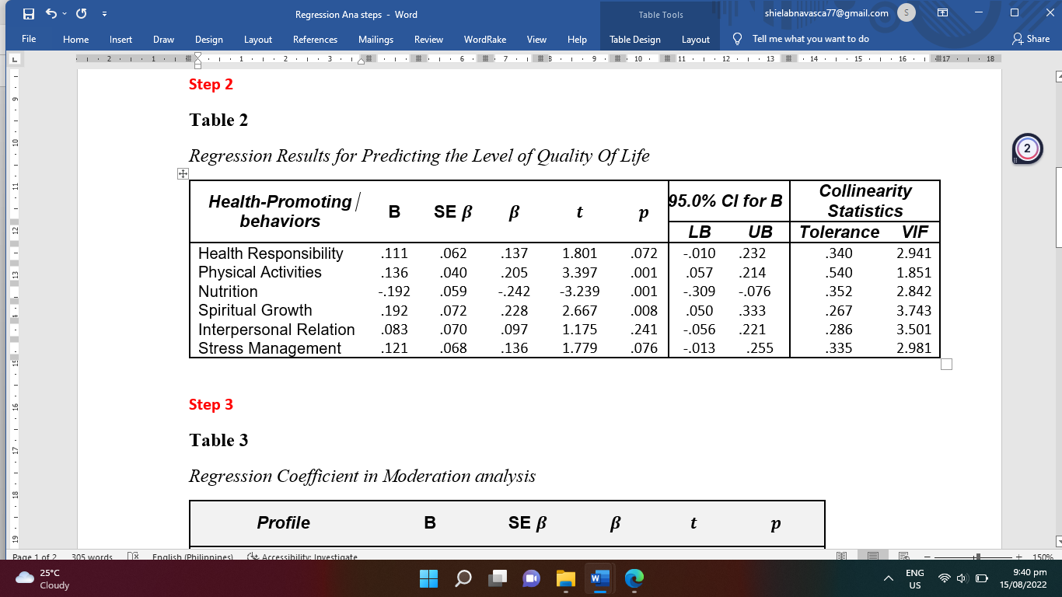
p-value< 0.05
Table 9
Regression Coefficient in Moderation analysis

Profile | B | SE $β$ | $$β$$ | $$t$$ | $$p$$
Age | -.026 | .007 | -.169 | -3.733* | .000
Gender | -.039 | .022 | -.080 | -1.766 | .078
Marital Status | -.008 | .020 | -.018 | -.404 | .686
Highest Educational Att. | .001 | .022 | .002 | .052 | .959
Work Status | -.002 | .021 | -.005 | -.112 | .911
Monthly Family Income | -.071 | .102 | -.032 | -.696 | .487
Type of Family Structure | -.042 | .021 | -.089 | -1.954 | .051
Health Status | .136 | .042 | .147 | 3.282* | .001
* p-value< 0.05

