Supplementary material
- Supplementary Tables
Supplementary Table1. Construct validity: Overall fit coefficient of the four scales
Scale | χ2/df | RMSEA | GFI | CFI | IFI | TLI
AESS | 7.965 | 0.066 | 0.976 | 0.990 | 0.990 | 0.985
LAS | 11.542 | 0.071 | 0.953 | 0.977 | 0.977 | 0.970
ASS | 7.049 | 0.061 | 0.953 | 0.981 | 0.981 | 0.975
LMS | 9.974 | 0.043 | 0.955 | 0.979 | 0.979 | 0.971
Note: AESS=Academic Environment Satisfaction Scale, LAS=Learning Adaptability Scale, ASS=Academic Stress Scale, LMS=Learning Motivation Scale.
Supplementary Table2. Convergent validity: Factor Loading for the four scales
Item | Scale | I | II | III | AVE | CR
AES 1 | AESS | 0.935 |  |  | 0.837 | 0.954
AES 2 | AESS | 0.904 |  |  | 0.837 | 0.954
AES 3 | AESS | 0.928 |  |  | 0.837 | 0.954
AES 4 | AESS | 0.892 |  |  | 0.837 | 0.954
AES 5 | AESS |  | 0.952 |  | 0.704 | 0.899
AES 6 | AESS |  | 0.916 |  | 0.704 | 0.899
AES 7 | AESS |  | 0.834 |  | 0.704 | 0.899
AES 8 | AESS |  | 0.445 |  | 0.704 | 0.899
LA 1 | LAS | 0.895 |  |  | 0.814 | 0.956
LA 2 | LAS | 0.854 |  |  | 0.814 | 0.956
LA 3 | LAS | 0.921 |  |  | 0.814 | 0.956
LA 4 | LAS | 0.929 |  |  | 0.814 | 0.956
LA 5 | LAS | 0.909 |  |  | 0.814 | 0.956
LA 6 | LAS |  | 0.798 |  | 0.738 | 0.933
LA 7 | LAS |  | 0.830 |  | 0.738 | 0.933
LA 8 | LAS |  | 0.852 |  | 0.738 | 0.933
LA 9 | LAS |  | 0.889 |  | 0.738 | 0.933
LA 10 | LAS |  | 0.924 |  | 0.738 | 0.933
AS 4 | ASS | 0.863 |  |  | 0.688 | 0.898
AS 3 | ASS | 0.904 |  |  | 0.688 | 0.898
AS 2 | ASS | 0.835 |  |  | 0.688 | 0.898
AS 1 | ASS | 0.703 |  |  | 0.688 | 0.898
AS 8 | ASS |  | 0.863 |  | 0.758 | 0.926
AS 7 | ASS |  | 0.904 |  | 0.758 | 0.926
AS 6 | ASS |  | 0.835 |  | 0.758 | 0.926
AS 5 | ASS |  | 0.703 |  | 0.758 | 0.926
AS 11 | ASS |  |  | 0.703 | 0.653 | 0.848
AS 10 | ASS |  |  | 0.795 | 0.653 | 0.848
AS 9 | ASS |  |  | 0.913 | 0.653 | 0.848
LM 4 | LMS | 0.909 |  |  | 0.687 | 0.897
LM 3 | LMS | 0.907 |  |  | 0.687 | 0.897
LM 2 | LMS | 0.751 |  |  | 0.687 | 0.897
LM 1 | LMS | 0.730 |  |  | 0.687 | 0.897
LM 8 | LMS |  | 0.940 |  | 0.857 | 0.960
LM 7 | LMS |  | 0.941 |  | 0.857 | 0.960
LM 6 | LMS |  | 0.901 |  | 0.857 | 0.960
LM 5 | LMS |  | 0.921 |  | 0.857 | 0.960
LM 11 | LMS |  |  | 0.861 | 0.789 | 0.912
LM 10 | LMS |  |  | 0.864 | 0.789 | 0.912
LM 9 | LMS |  |  | 0.937 | 0.789 | 0.912
Note：Bold = salient (> 3.0) loading.
Supplementary Table3. Discriminant validity: The square roots of AVE and correlation between the constructs
Scale |  | AESS |  | LAS |  | ASS |  |  | LMS
 |  | I | II | I | II | I | II | III | I | II | III
AESS | I | 0.837
AESS | II | 0.599*** | 0.704
LAS | I |  |  | 0.814
LAS | II |  |  | 0.171*** | 0.738
ASS | I |  |  |  |  | 0.688
ASS | II |  |  |  |  | 0.404*** | 0.758
ASS | III |  |  |  |  | 0.372*** | 0.595*** | 0.653
LMS | I |  |  |  |  |  |  |  | 0.687
LMS | II |  |  |  |  |  |  |  | 0.364*** | 0.857
LMS | III |  |  |  |  |  |  |  | 0.375*** | 0.551*** | 0.789
Square root of AVE |  | 0.915 | 0.839 | 0.902 | 0.859 | 0.830 | 0.871 | 0.808 | 0.829 | 0.926 | 0.888
Note：* P<0. 05，** P<0. 01，*** P<0. 001
Supplementary Table4. Testing the moderated mediating effect of academic stress on learning motivation
Variables | Equation 4  Outcome variable: LM
Variables | B | SE | t-value | 95%CI
Gender | -0.746 | 0.412 | -1.811 | [-1.554,0.062]
Major | 0.045 | 0.110 | 0.409 | [-0.170,0.260]
Economic condition | -0.472 | 0.457 | -1.033 | [-1.367,0.424]
Urban and rural origin | -0.020 | 0.360 | -0.055 | [-0.726,0.686]
Family atmosphere | -0.326 | 0.123 | -2.660** | [-0.567,-0.086]
AS | 0.235 | 0.025 | 9.247*** | [0.185,0.284]
LA | -0.060 | 0.035 | -1.734 | [-0.129,0.008]
AS*LA | -0.025 | 0.003 | -8.441*** | [-0.031,-0.019]
AES | 0.239 | 0.034 | 6.979*** | [0.172,0.307]
R-sq | 0.144
F | 29.750***
Note：* P<0. 05，** P<0. 01，*** P<0. 001. AES=academic environment satisfaction; LA= learning adaptability; AS=academic stress; LM=learning motivation.
- Supplementary Figures

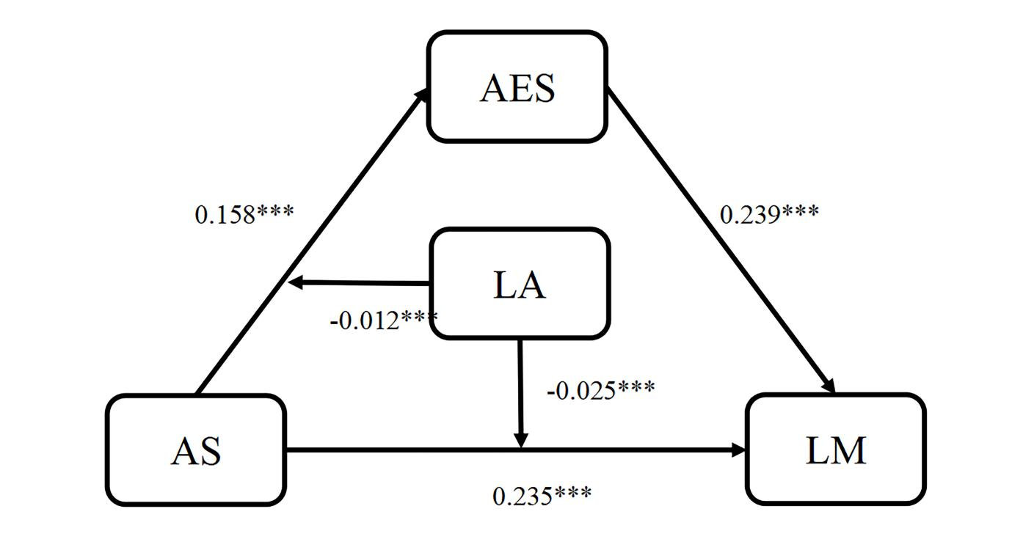
Supplementary Figure.1 Moderated mediation model
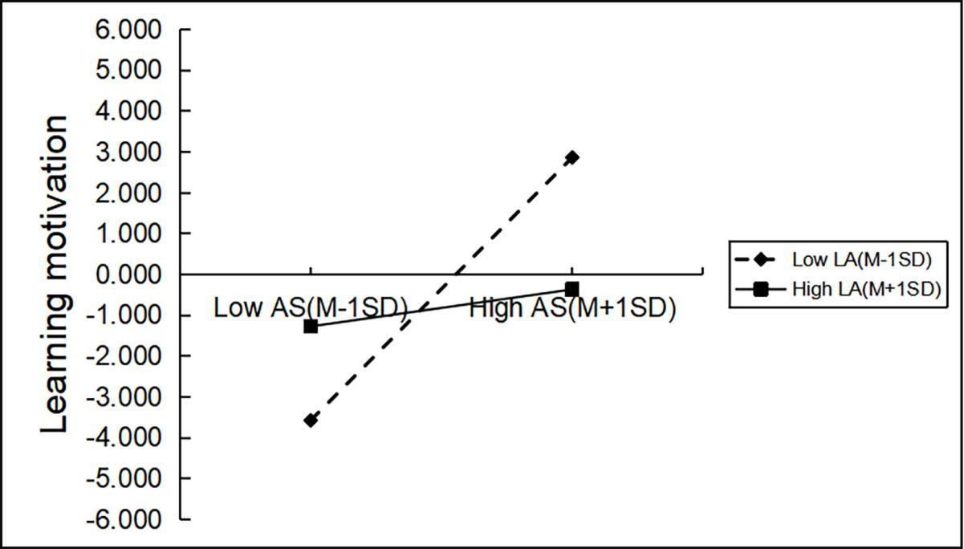
Supplementary Figure.2 The moderating role of learning adaptability in the relationship between academic stress and learning motivation

