B) onto CGC | A) onto CC
D) onto CGC | C) onto CC

Figure (6 S) Intra-particle diffusion plots for the removal of Cu⁺²

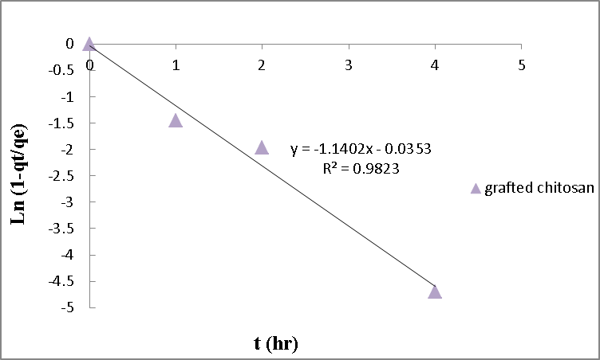  B) onto NGC | 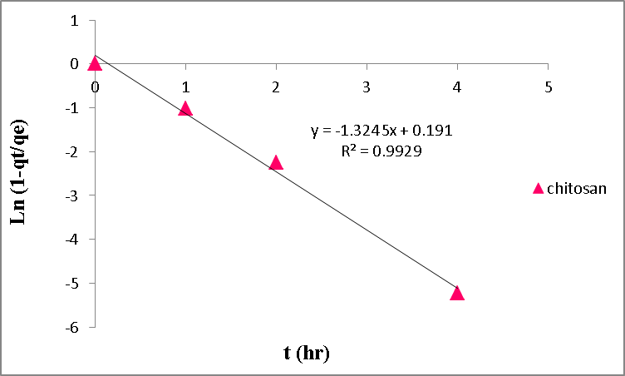  A) onto NC
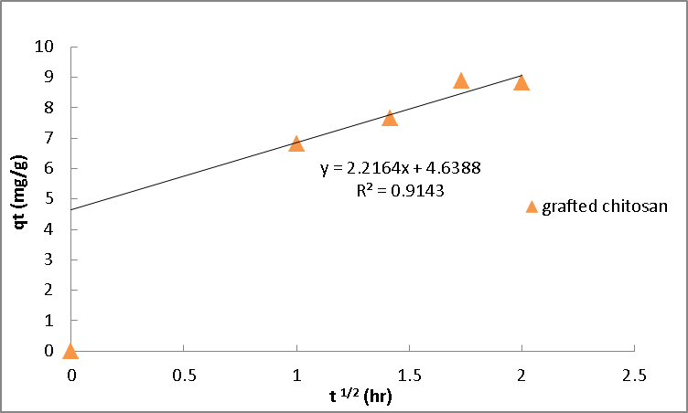  D) onto NGC | 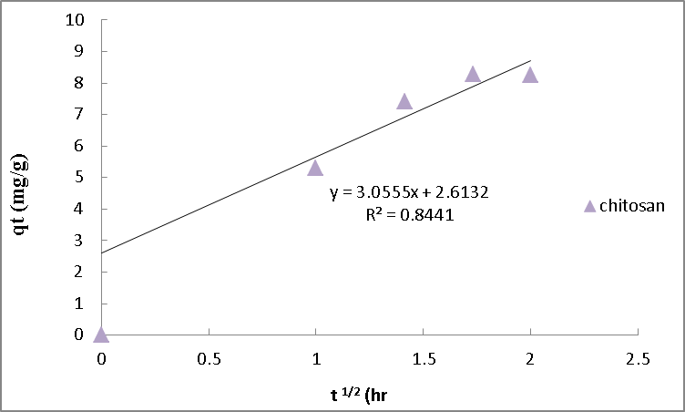  C) onto NC

Figure (7 S) Film diffusion plots for the removal of Cu⁺²

