TiO₂ coated SiO₂ core-shell stationary phase with uniform and tunable TiO₂ thickness for high performance liquid chromatography separation
Jiafei Wang,¹ Xiang Wan,¹ YingYing Li,¹ Debby Mangelings,² Fazhi Xie,^{1,3*} Xianhuai Huang,³ Weihua Li,³ Donglin Zhao,¹ Qishu Qu^{1*}

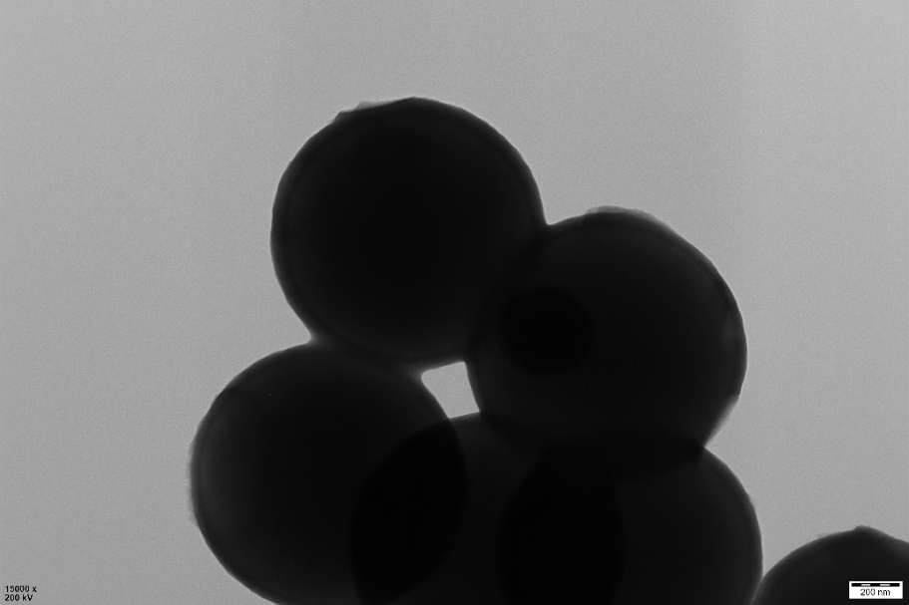
Fig. S1. TEM images of TiO₂ core-shell spheres prepared by the same method as the preparation of SST-0.5-60, but using non-porous SiO₂ spheres.

Fig. S2. Pore size distribution of TiO₂ core-shell spheres with non-porous SiO₂.
Table S1
Chromatographic parameters of the separation of four acidic compounds on C18-SST-0.5-60 and C18-SST-0.7-30 columns.
columns | samples | k | R_{s} | α | A_{s} | N (plates m⁻¹)
C18-SST-0.5-60 | p-nitrophenol | 0.39 | - | - | 1.3 | 7772
C18-SST-0.5-60 | phenol | 0.87 | 3.3 | 2.7 | 1.2 | 4722
C18-SST-0.5-60 | o-chlorophenol | 1.2 | 1.1 | 1.5 | 1.5 | 2644
C18-SST-0.5-60 | m-chlorophenol | 2.2 | 5.0 | 1.9 | 0.9 | 38342
C18-SST-0.7-30 | p-nitrophenol | 0.52 | - | - | 1.4 | 1897
C18-SST-0.7-30 | phenol | 1.2 | 1.9 | 2.6 | 1.3 | 1240
C18-SST-0.7-30 | o-chlorophenol | 1.8 | 0.9 | 1.4 | 1.4 | 927
C18-SST-0.7-30 | m-chlorophenol | 4.5 | 5.4 | 1.7 | 1.1 | 27246

Table S2
Chromatographic parameters of the separation of a standard mixture of adenosine, ATP, ADP and AMP on C18-SST-0.5-60 and C18-SST-0.7-30 columns.
columns | samples | k | R_{s} | α | A_{s} | N (plates m⁻¹)
C18-SST-0.5-60 | adenosine | 0.68 | - | - | 1.1 | 1402
C18-SST-0.5-60 | AMP | 4.1 | 1.9 | 6.0 | 2.0 | 162
C18-SST-0.5-60 | ADP | - | - | - | - | -
C18-SST-0.5-60 | ATP | 40.1 | 3.9 | 9.8 | 1.1 | 1448
C18-SST-0.7-30 | adenosine | 0.48 | - | - | 1.2 | 887
C18-SST-0.7-30 | AMP | 3.0 | 1.8 | 6.3 | 2.0 | 130
C18-SST-0.7-30 | ADP | - | - | - | - | -
C18-SST-0.7-30 | ATP | 38.2 | 3.3 | 12.7 | 1.2 | 952

