Supporting Information

Highly diastereoselective synthesis of pyridinium salts of 2-piperidinones from pyridinium ylides, aldehydes, Michael acceptors and ammonium acetate.

Andrey D. Vinokurov,ª Taygib M. Iliyasov,ª Kirill A. Karpenko,ª Radmir N. Akchurin,^{a,b} Yana V. Derkach^{a,b} and Anatoly N. Vereshchaginª*
  - N. D. Zelinsky Institute of Organic Chemistry, Leninsky Prospect 47, Moscow, Russian Federation 119334; vereshchagin@ioc.ac.ru (A.N.V.)
  - Mendeleev University of Chemical Technology of Russia, Miusskaya Square 9, Moscow, Russian Federation 125047;

Content:
¹H, ¹³C NMR spectra of compounds 4a-i 2
¹H, ¹³C NMR spectra of compounds 5a-e 11

¹H, ¹³C NMR spectra of compounds 4a-i
¹H NMR of 1-((3SR,4RS,6SR)-5,5-dicyano-2-oxo-4,6-diphenylpiperidin-3-yl)pyridin-1-ium bromide (4a)
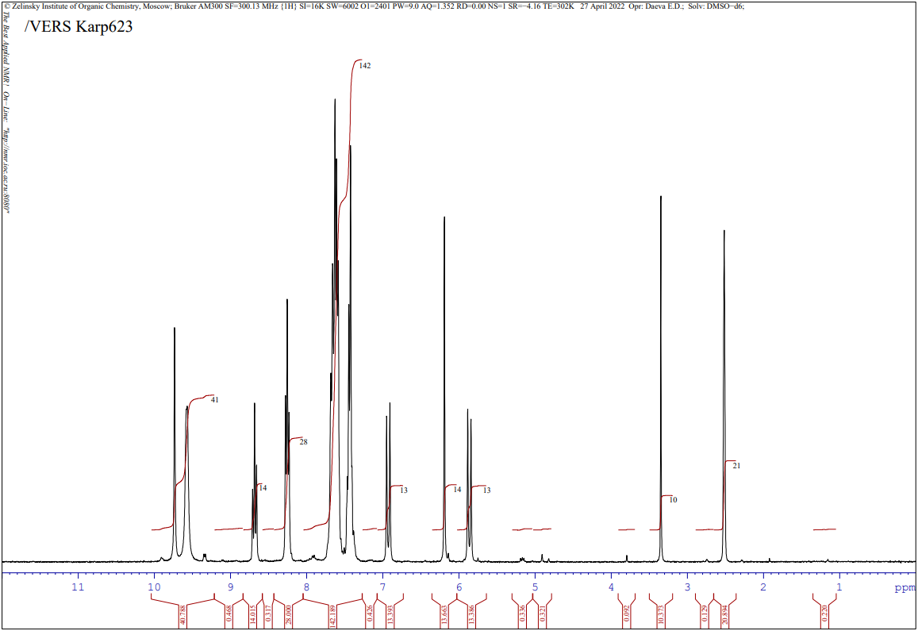
¹³C NMR of (4a)
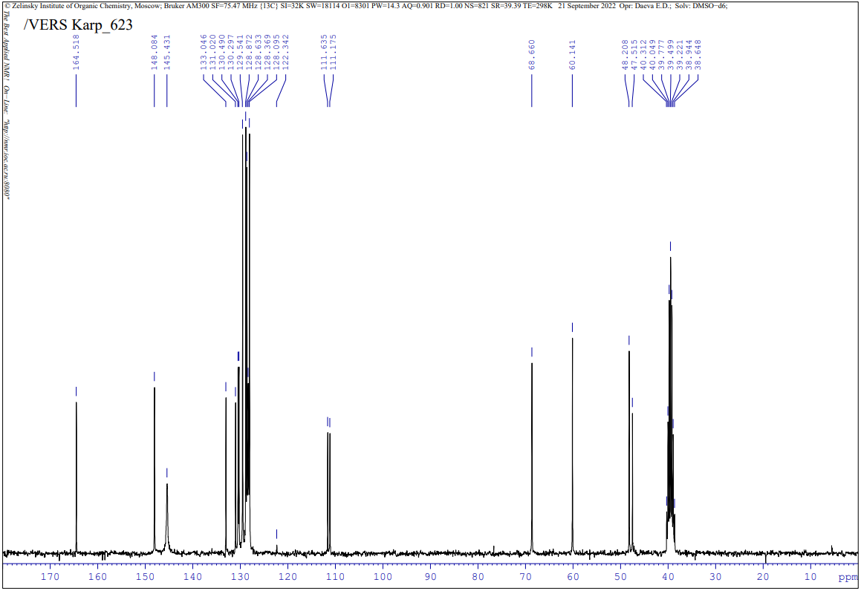
¹H NMR of 1-((3SR,4RS,6SR)-5,5-dicyano-2-oxo-4,6-di-m-tolylpiperidin-3-yl)pyridin-1-ium bromide (4b)
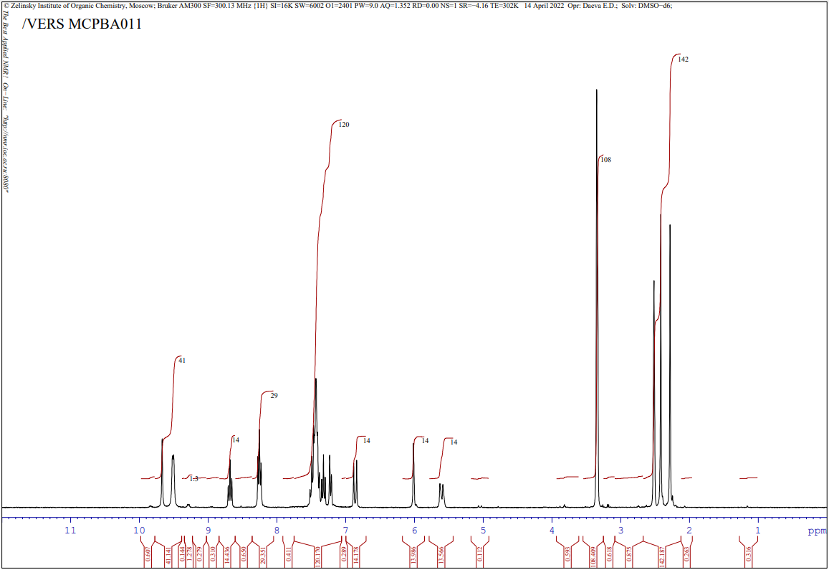
¹³C NMR of (4b)
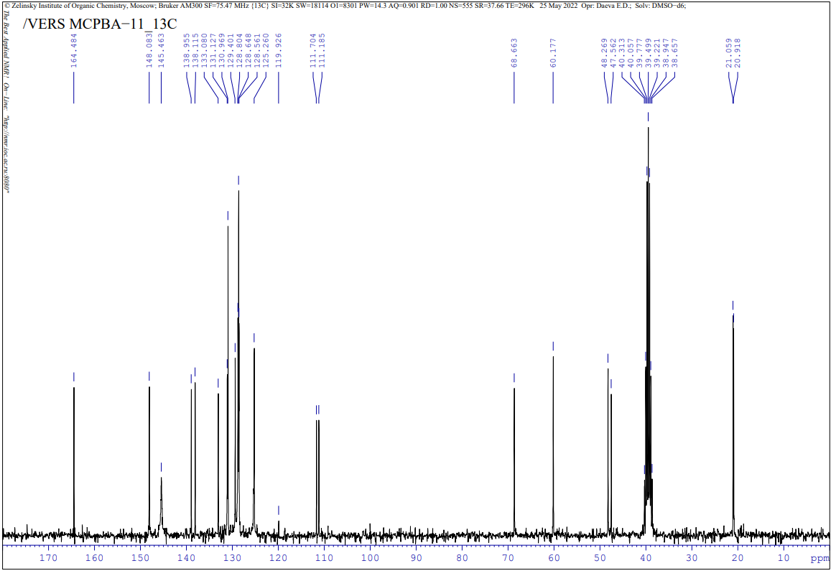

¹H NMR of 1-((3SR,4RS,6SR)-5,5-dicyano-4,6-bis(4-fluorophenyl)-2-oxopiperidin-3-yl)pyridin-1-ium bromide (4c)
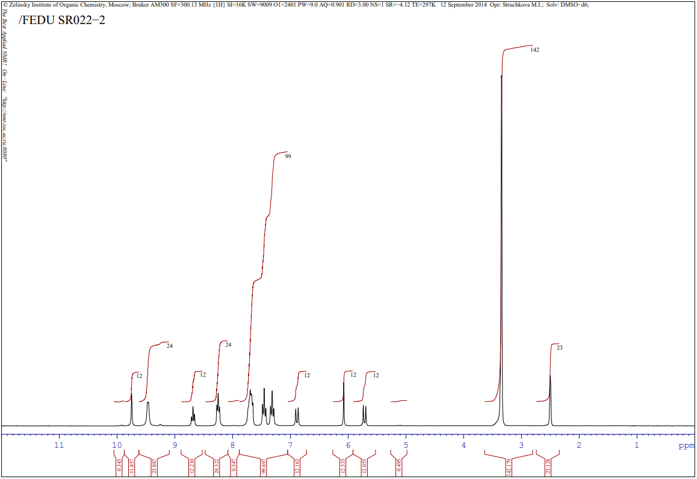
¹³C NMR of (4c)
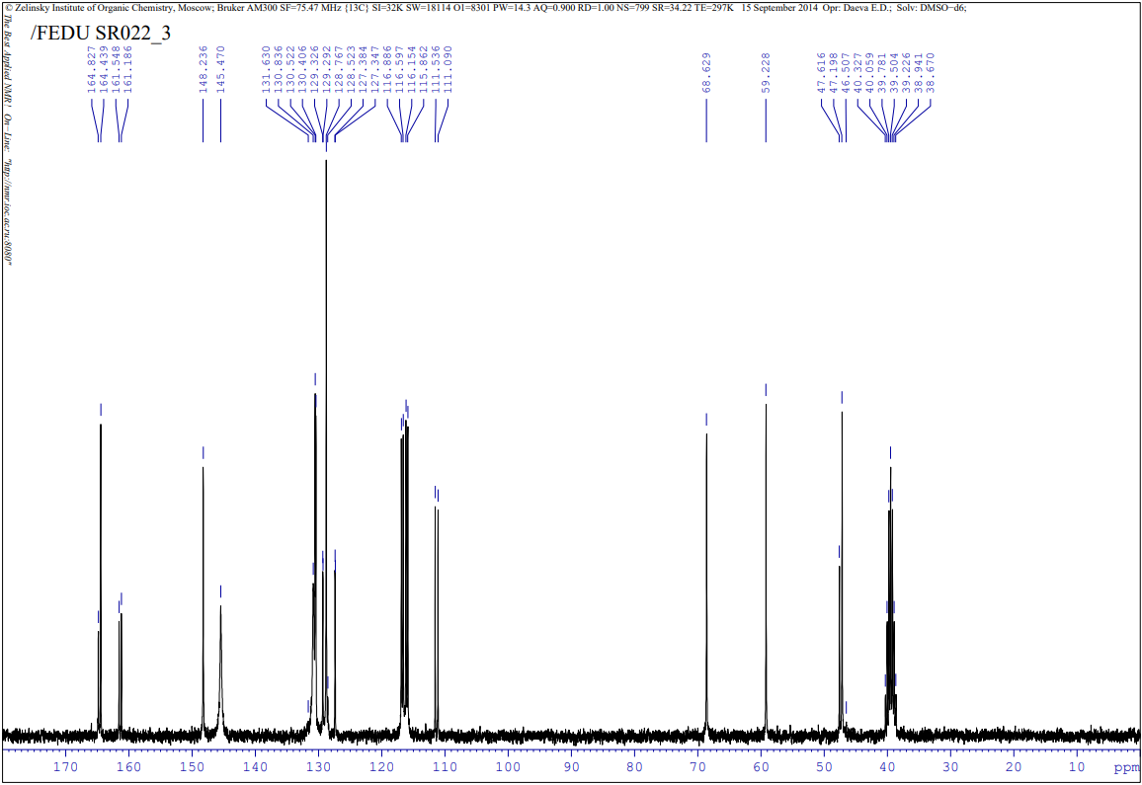

¹H NMR of 1-((3SR,4RS,6SR)-4,6-bis(3-bromophenyl)-5,5-dicyano-2-oxopiperidin-3-yl)pyridin-1-ium bromide (4d)
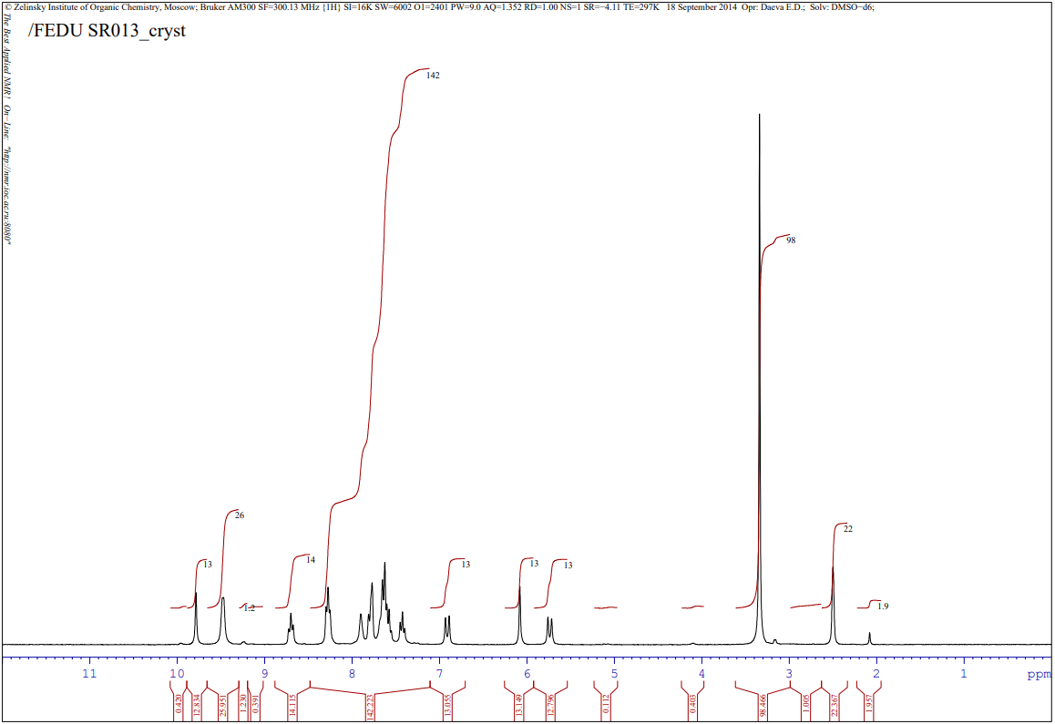
¹³C NMR of (4d)
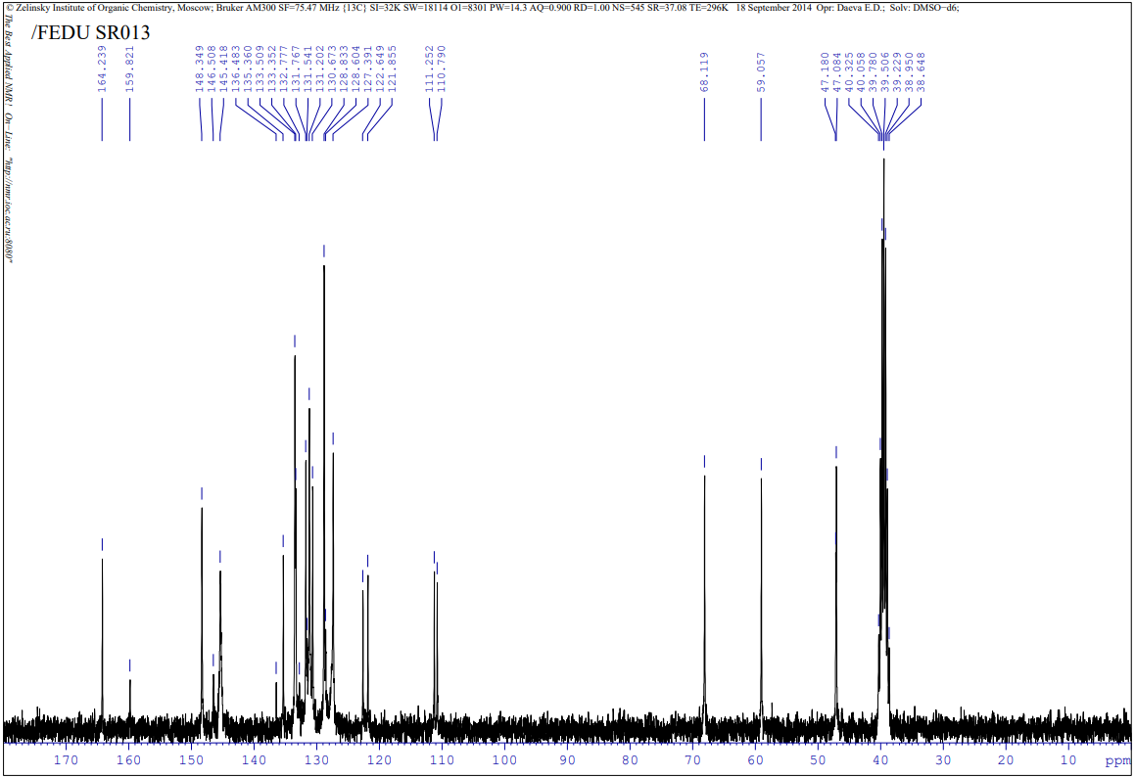

¹H NMR of 1-((3SR,4RS,6SR)-4,6-bis(4-bromophenyl)-5,5-dicyano-2-oxopiperidin-3-yl)pyridin-1-ium bromide (4e)
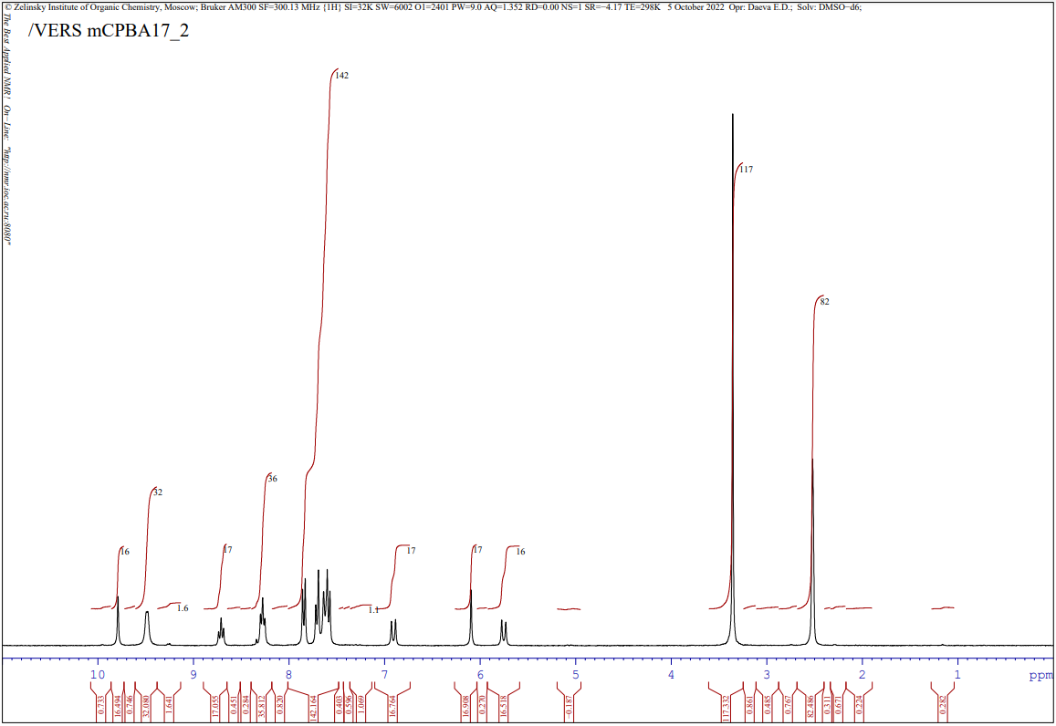
¹³C NMR of (4e)
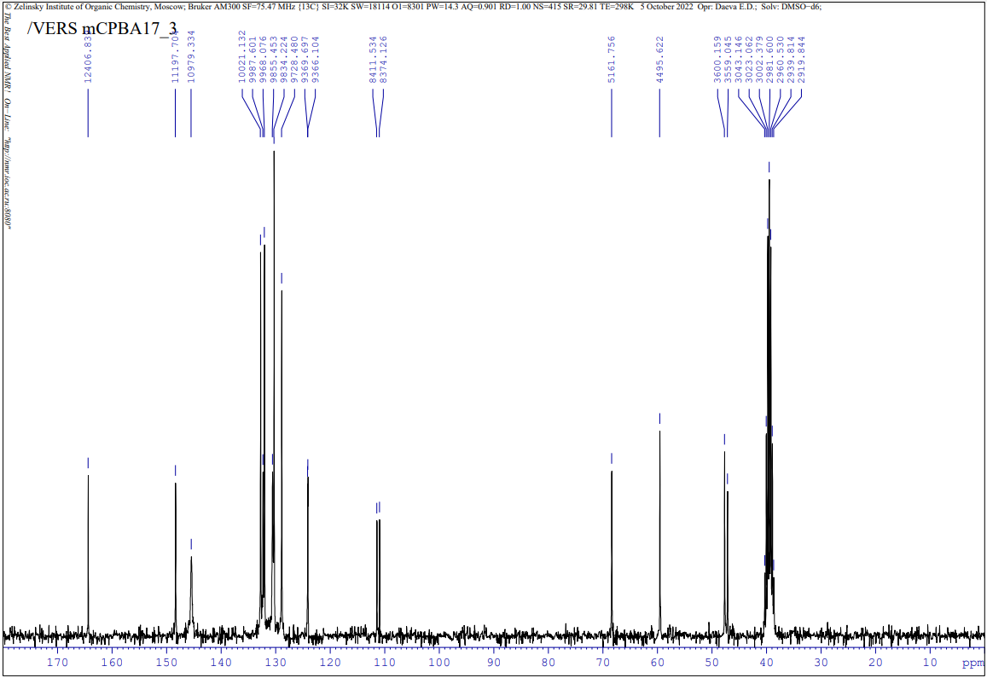

¹H NMR of 1-((3SR,4RS,6SR)-5,5-dicyano-2-oxo-4,6-di(pyridin-3-yl)piperidin-3-yl)pyridin-1-ium bromide (4f)
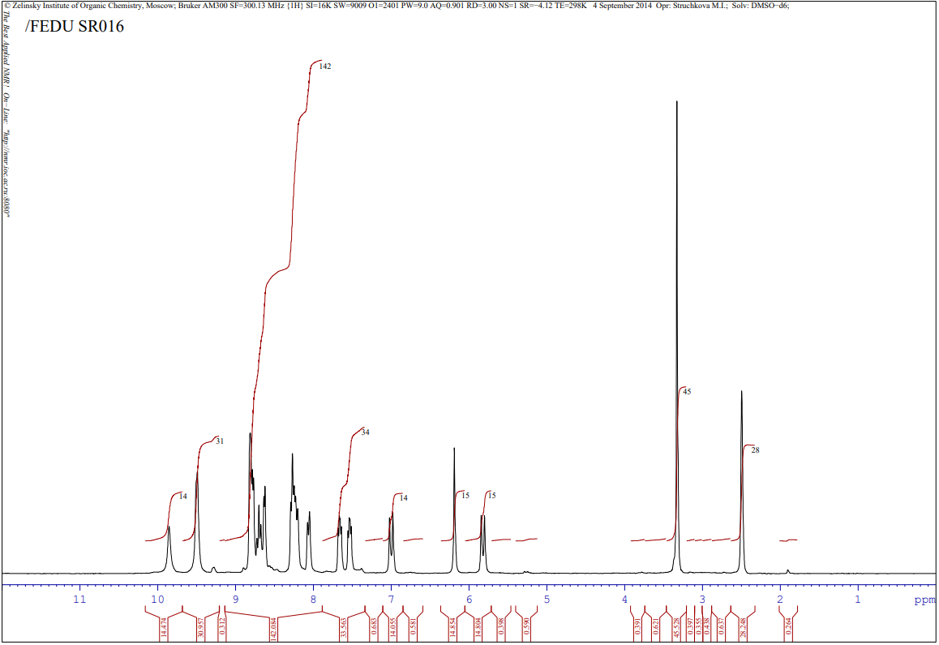
¹³C NMR of (4f)
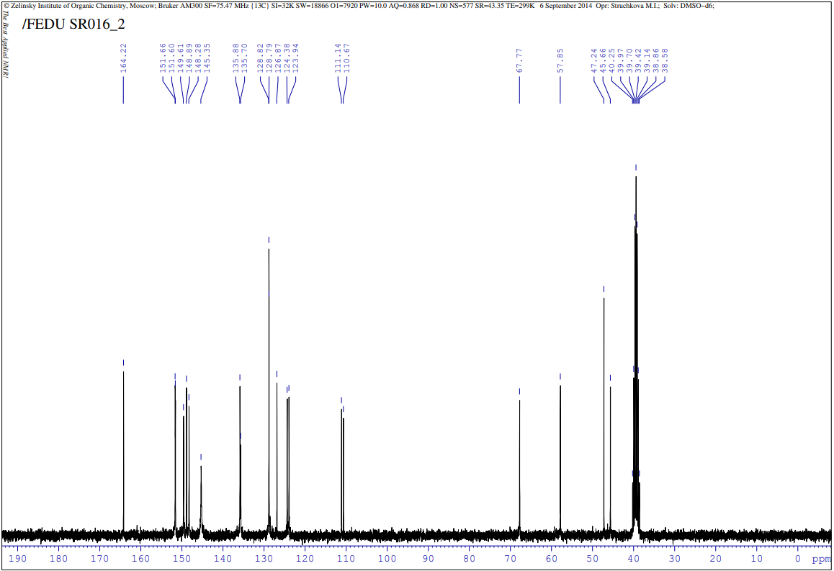

¹H NMR of 1-((3SR,4RS,6SR)-5,5-dicyano-4,6-bis(4-fluorophenyl)-2-oxopiperidin-3-yl)-3-hydroxypyridin-1-ium bromide (4g)
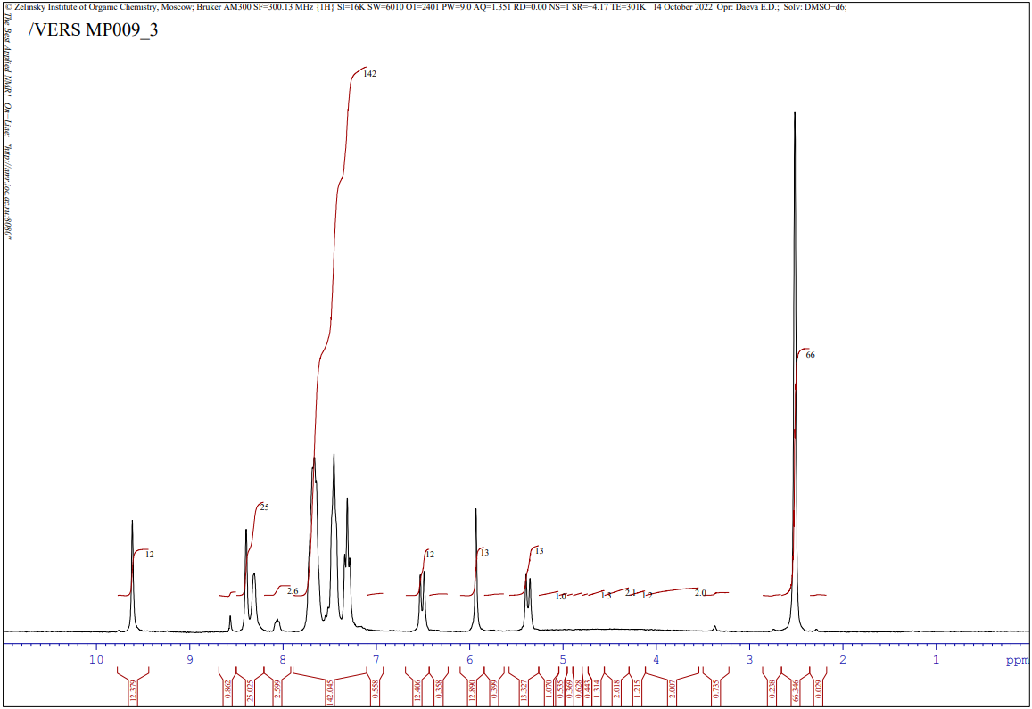
¹³C NMR of (4g) 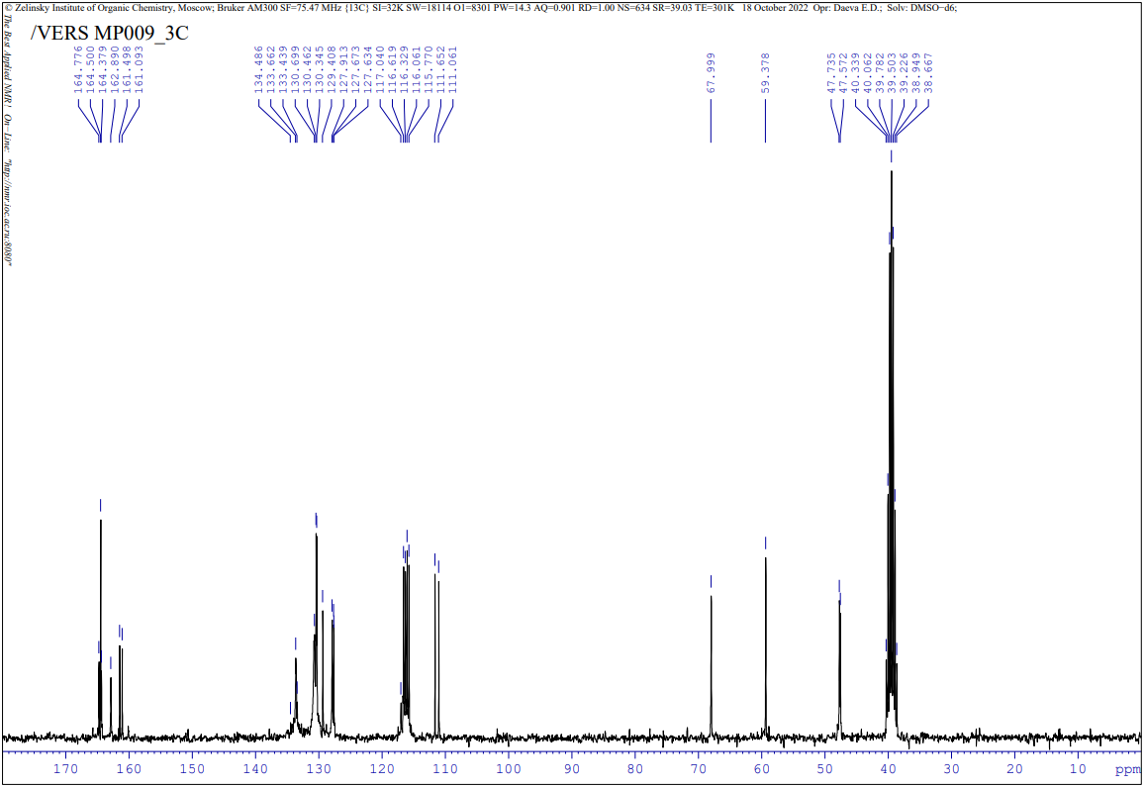
¹H NMR of 1-((3SR,4RS,6SR)-4,6-bis(4-bromophenyl)-5,5-dicyano-2-oxopiperidin-3-yl)-3-hydroxypyridin-1-ium bromide (4h)
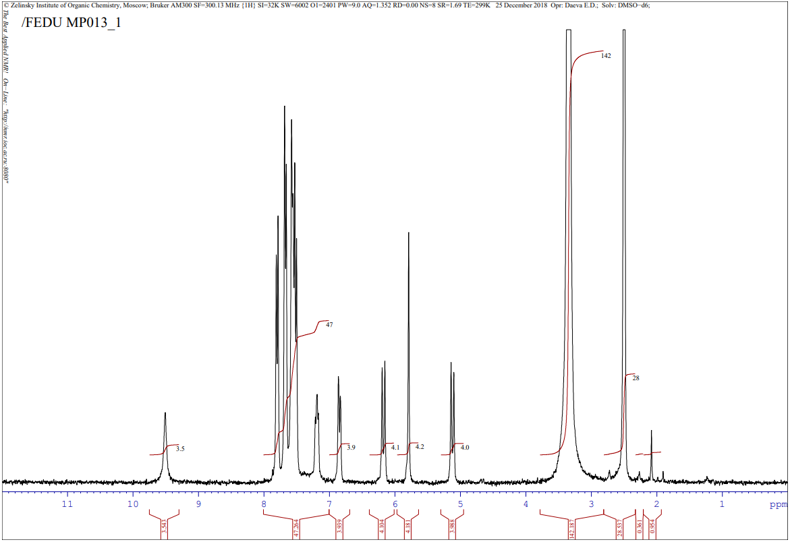
¹³C NMR of (4h)
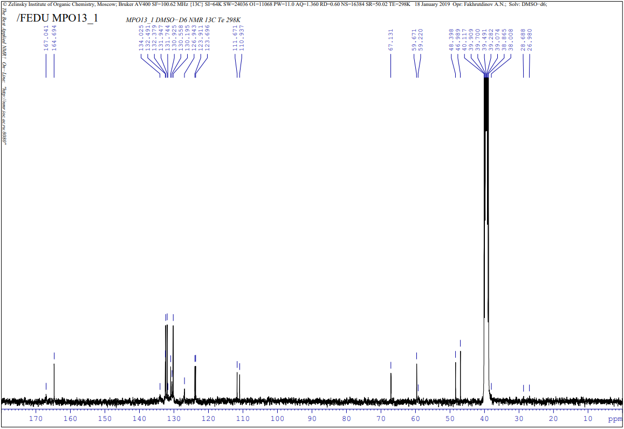

¹H NMR of 1-((3SR,4RS,6SR)-4,6-bis(4-bromophenyl)-5,5-dicyano-2-oxopiperidin-3-yl)-3-bromopyridin-1-ium chloride (4i)
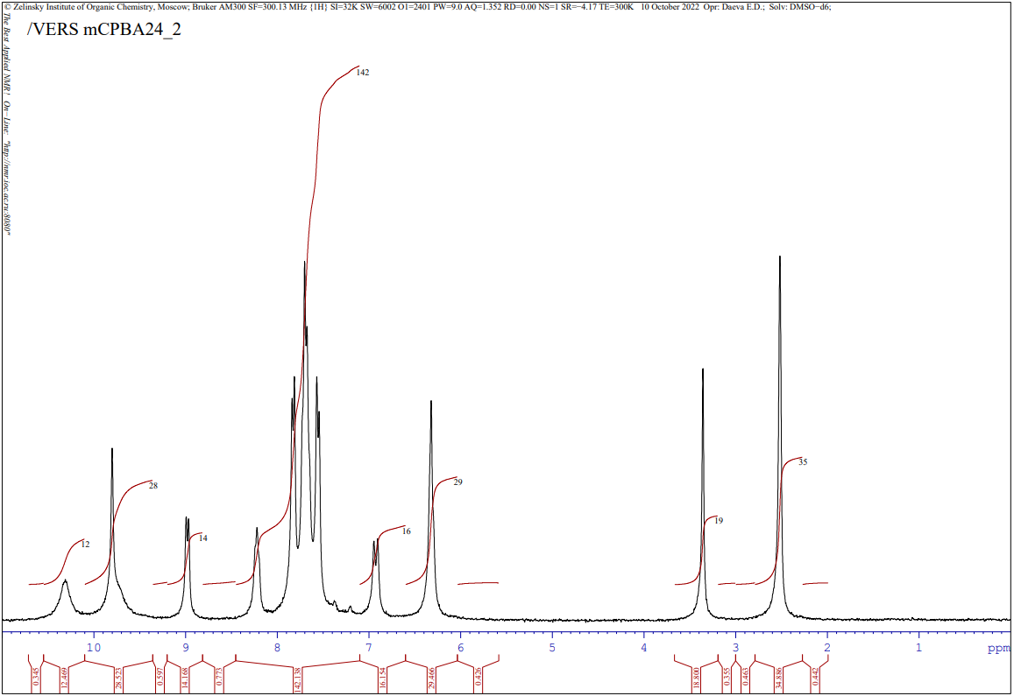
¹³C NMR of (4i)
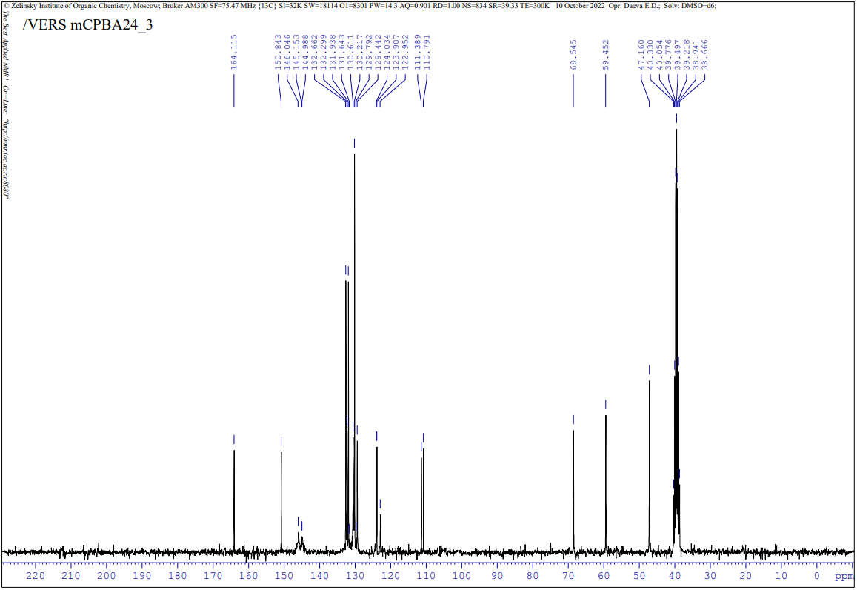

¹H, ¹³C NMR spectra of compounds 5a-e
¹H NMR of 1-((3SR,4RS,5RS,6SR)-5-cyano-5-(methoxycarbonyl)-2-oxo-4,6-diphenylpiperidin-3-yl)pyridin-1-ium bromide (5a)
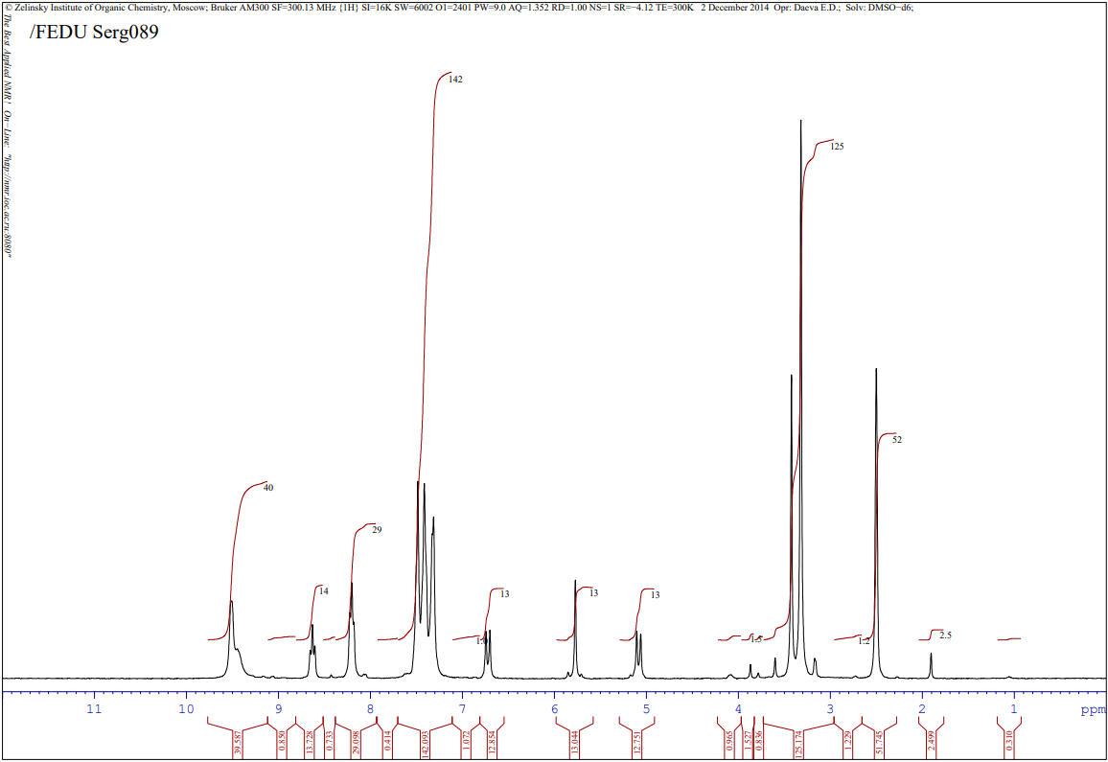
¹³C NMR of (5a)
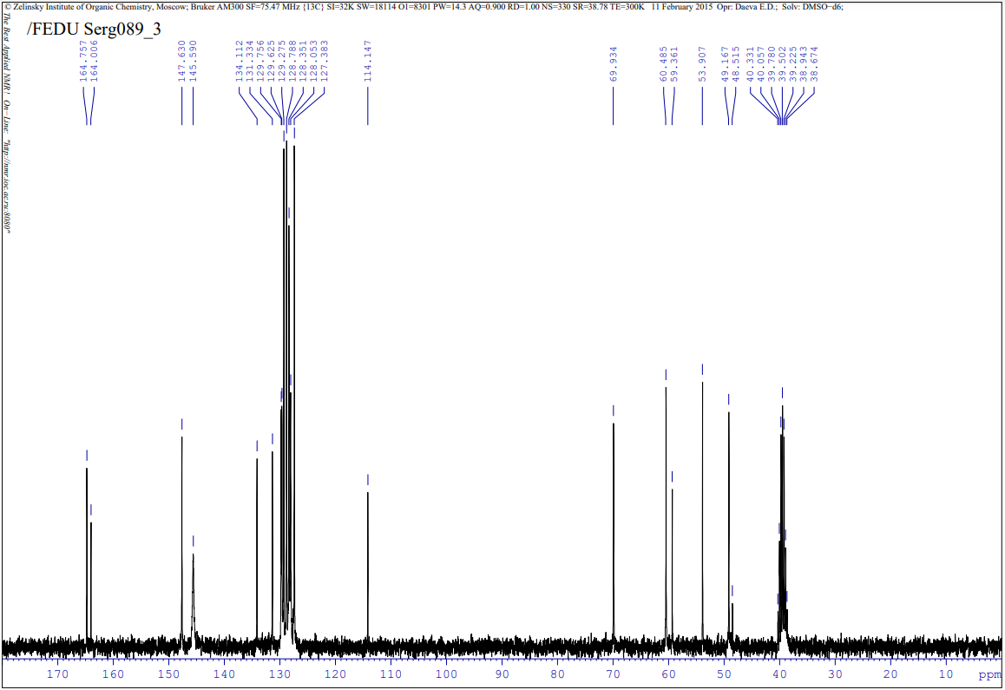
¹H NMR of 1-((3SR,4RS,5RS,6SR)-5-cyano-5-(methoxycarbonyl)-2-oxo-4,6-di-m-tolylpiperidin-3-yl)pyridin-1-ium bromide (5b)
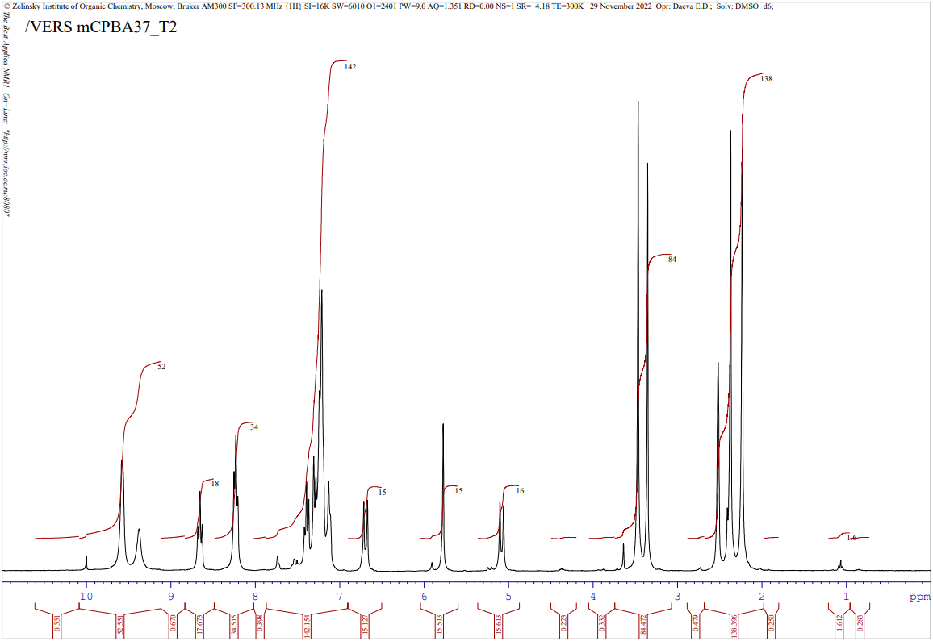
¹³C NMR of (5b)
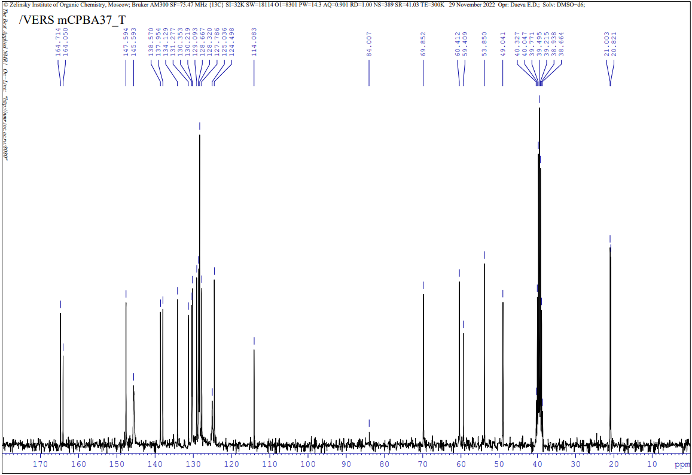

¹H NMR of 1-((3SR,4RS,5RS,6SR)-5-cyano-5-(methoxycarbonyl)-2-oxo-4,6-di-p-tolylpiperidin-3-yl)pyridin-1-ium bromide (5c)
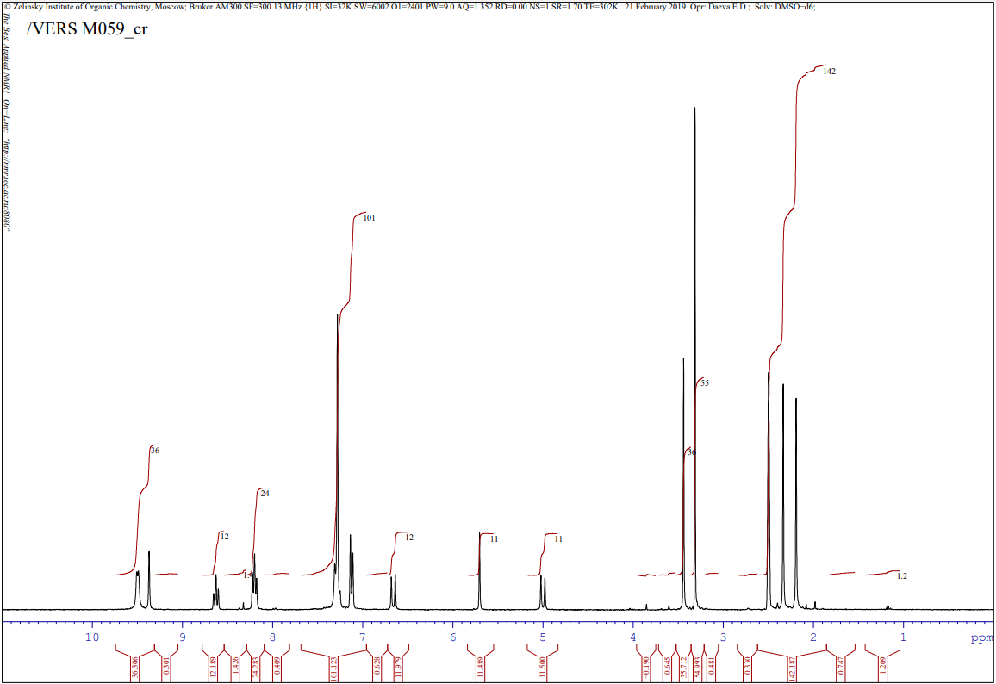
¹³C NMR of (5c)
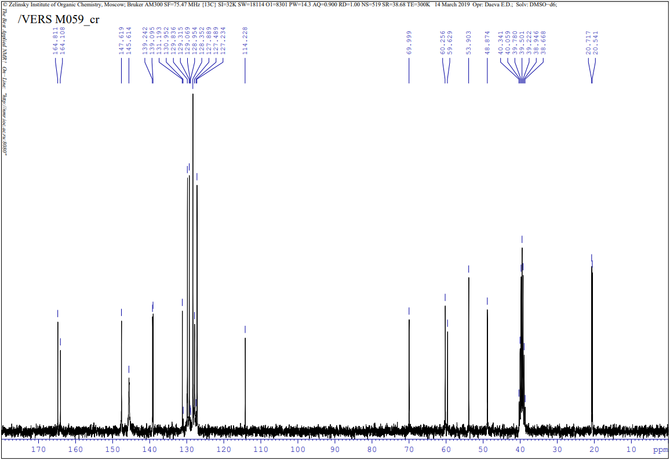
¹H NMR of 1-((3SR,4RS,5RS,6SR)-5-cyano-4,6-bis(4-fluorophenyl)-5-(methoxycarbonyl)-2-oxopiperidin-3-yl)pyridin-1-ium bromide (5d)
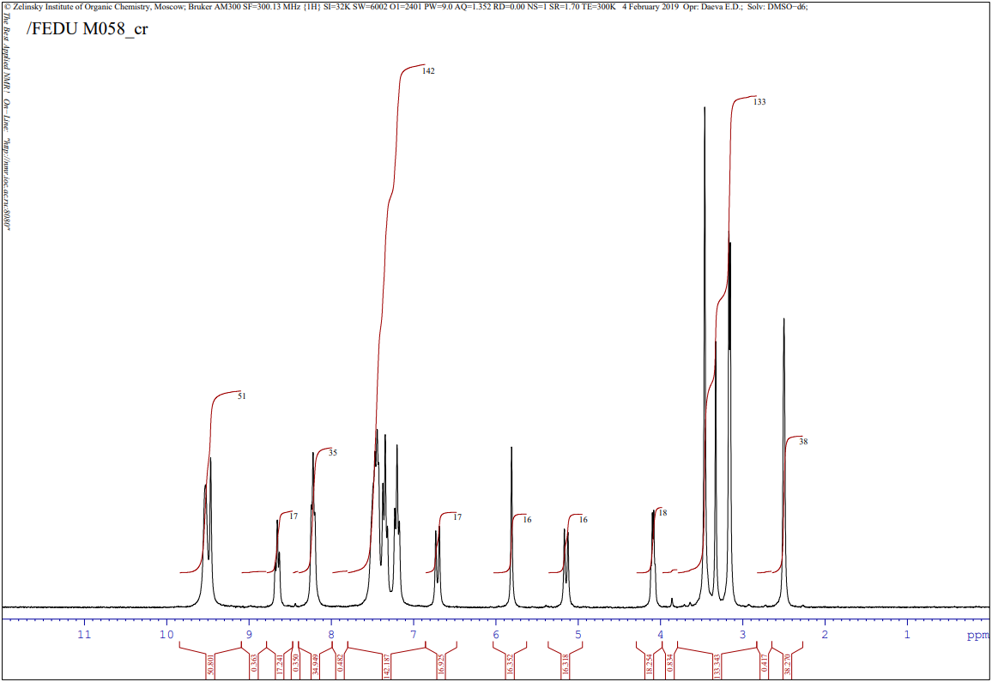

¹³C NMR of (5d)
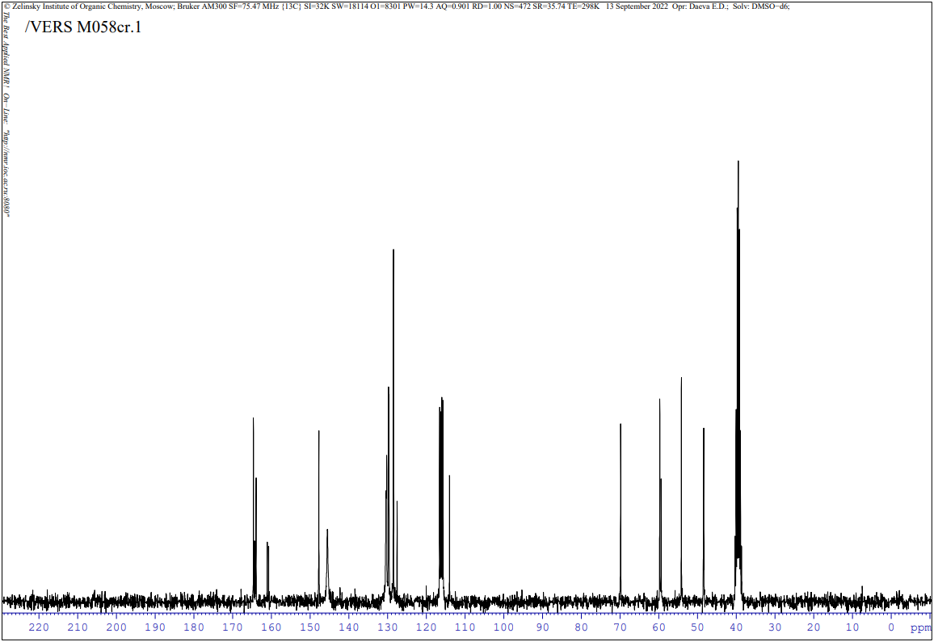
¹H NMR of 1-((3SR,4RS,5RS,6SR)-5-cyano-4,6-bis(4-fluorophenyl)-5-(methoxycarbonyl)-2-oxopiperidin-3-yl)pyridin-1-ium bromide (5e)
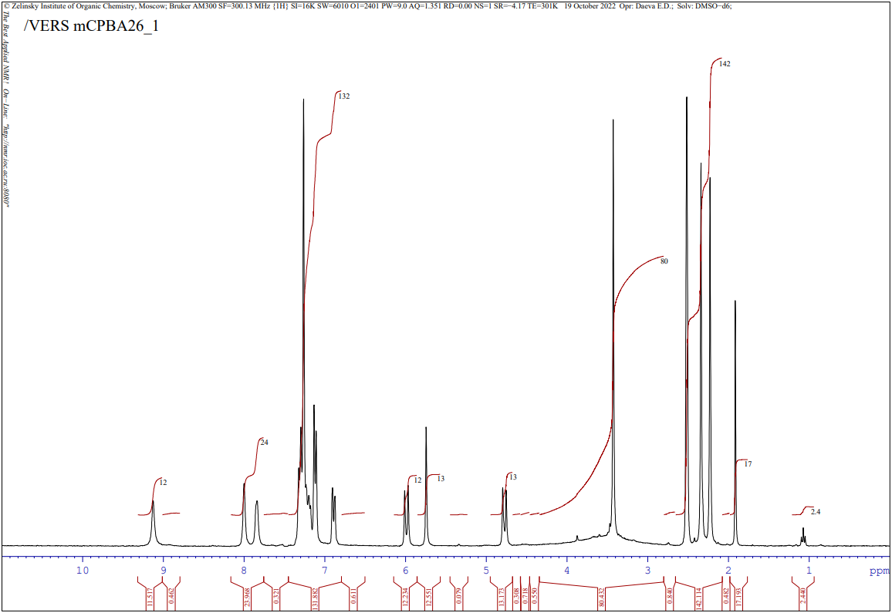
¹³C NMR of (5e)
