Additional Figure 1. Proportion of patients with coagulopathy according to the severity of TBI and items for coagulopathy.

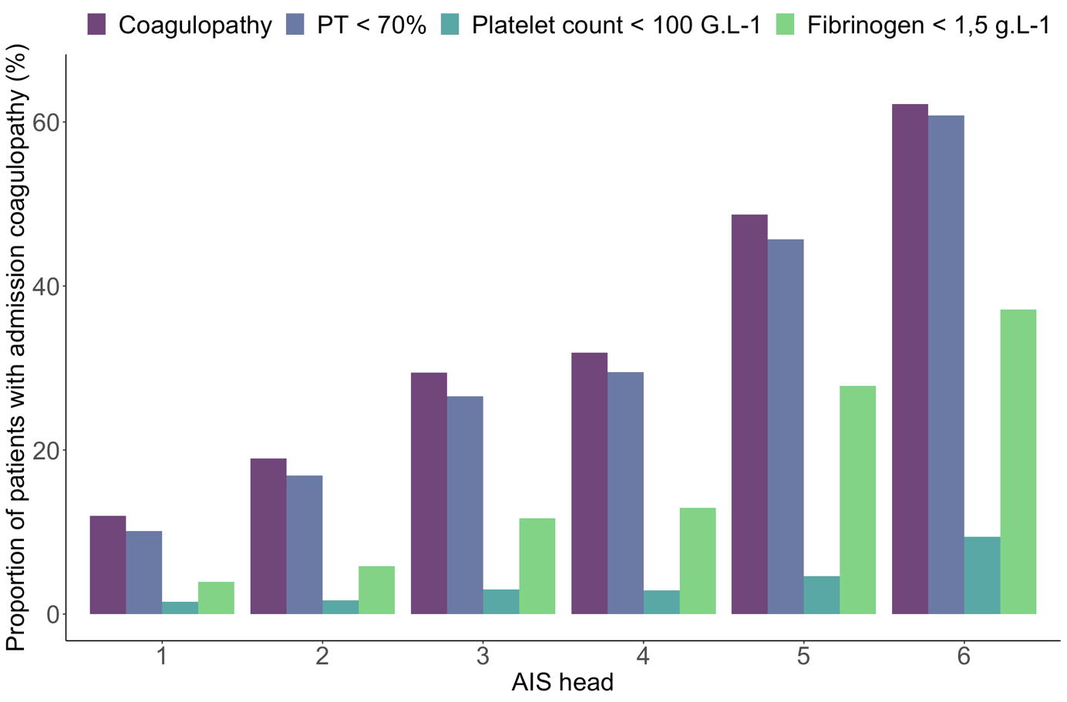

AIS : Abbreviated injury score; PT: prothrombin time ratio (in Quick percent).

