Table 1 The equations of the mathematical models
Model | Model equation | Reference
MGM | 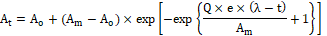 | [27]
MLM | 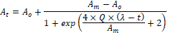 | [27]
MRM | 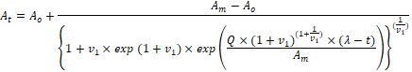 | [27]
Stannard | 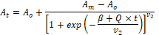 | [22]
Weibull |  | [25]
MMF | 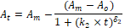 | [21]
Asymmetric | 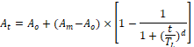 | [6]
Baranyi | 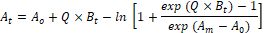 | [4]
Huang | 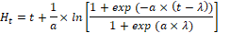 | [15]
Fitzhugh |  | [9]

