SUPPLEMENTARY INFORAMTION

Quantitative size-resolved characterization of mRNA nanoparticles by in-line coupling of asymmetrical-flow field-flow fractionation with small angle X-ray scattering
Melissa A Graewert^{1*✉}, Christoph Wilhelmy^{2*}, Tijana Bacic^{3*}, Jens Schumacher³, Clement Blanchet¹, Florian Meier⁴, Roland Drexel⁴, Roland Welz⁴, Bastian Kolb², Kim Bartels², Thomas Nawroth², Thorsten Klein⁴, Dmitri Svergun^{1,5}, Peter Langguth² & Heinrich Haas^{2,3,✉}
¹ European Molecular Biology Laboratory, Hamburg Unit, Hamburg, Germany
² Department of Biopharmaceutics and Pharmaceutical Technology, Johannes Gutenberg-University, Mainz, Germany
³ BioNTech SE, Mainz, Germany,
⁴ Postnova Analytics GmbH, Landsberg am Lech, Germany
⁵ BIOSAXS GmbH, Hamburg, Germany
*These authors contributed equally
✉melissa.graewert@embl-hamburg.de
✉haashein@uni-mainz.de

Acknowledgments
This research was funded by the „Bundesministerium für Bildung und Forschung BMBF“ grant 05K22UM3 and by the “Deutsche Forschungsgemeinschaft DFG” as part of the collaborative research center (CRC) 1066.
Declaration of interest
MAG is consultant to BioSAXS GmbH
PL is consultant to BioNTech SE

Supplement Table 1. SAXS sample details, data collection, analysis, and 3D modelling details for BSA in solution.
 | Batch |  | AF4 monomer peak
Sample temperature (°C) | 20
In beam sample cell | 1‐mm quartz capillary
Sample concentration, mg/mL | 5.0 |  | 5.0 (40 ul injection volume).
In-line separation | n.a. |  | semi-preparative frit-inlet AF4 channel  PES membrane (10 kDa MW cut-off)  and a Mylar spacer of 350µm height
Detector flowrate, mL/min | n.a. |  | 0.5 mL/min
Data acquisition/reduction software | SASFLOW
Instrument | P12, Petra3@DESY, 6M-Pilatus detector
Measured q-range (nm⁻¹) | 0.02 – 5.83
Exposure time(s), number of exposures. | 0.050, 20 frames |  | 1, 2500 frames (23 averaged)
Methods/Software | PRIMUS |  | CHROMIXS, PRIMUS
Guinier Analysis
I(0) ± σ (cm^{-1;} a.u) | 2639.21 ± 3.84 |  | na
R_{g} CHROMIXS, PRIMUS σ (nm) | 3.43 ± 0.01 |  | 2.87 ± 0.01
min < qR_{g} < max limit (or data point range) | 0.16 - 1.21 |  | 0.25 – 1.28
PDDF/P(r) analysis
I(0) ± σ (cm^{-1;} a.u.) | 2650 ± 4.22 |  | 0.39 ± 0.00
R_{g} ± σ (nm) | 3.53±0.01 |  | 2.89 ± 0.01
d_{max} (nm) | 13.5 |  | 9.1
q-range (nm⁻¹) | 0.05 – 2.33 |  | 0.09 – 2.79
P(r) fit assessment | 0.7648 |  | 0.9497
Molecular weight (M) estimates (kDa)
From chemical composition | 66.4 |  | 66.4
From SAS, concentration-independent method (Bayesian) | 94.2  (84.0 – 110.1) |  | 70.6  (68.9 – 105.7)
From SAS-independent measure (MALS) | na |  | 62 kD
Shape modelling method(s)
Software | DAMMIF |  | DAMMIF
q-range for fit (q_{min} – q_{max}; nm⁻¹) | 0.05 – 2.33 |  | 0.09 – 2.79
Symmetry/anisotropy assumptions | P1 |  | P1
Number of individual model reconstructions | 10 |  | 10
χ², CorMap P-values for fit | 1.087, 0.031 |  | 1.015, 0.258
Atomistic modelling methods
Software | CRYSOL |  | CRYSOL
q-range for fit (q_{min} – q_{max}; nm⁻¹) | 0.03 – 5.00 |  | 0.05 – 5.00
χ ² | 7.521 |  | 1.091
Data and model deposition
SASBDB IDs | na. |  | SASDRQ8*
*preliminary accession link: https://www.sasbdb.org/data/SASDRQ8/hvr44vui42/
Supplement Fig. 1: SAXS data processing
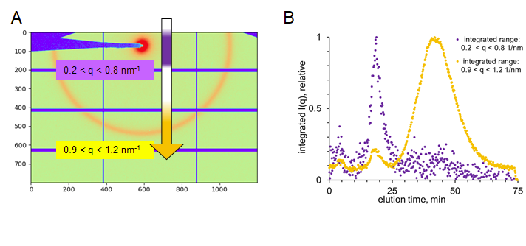
Supplement Fig. 1 Processing of AF4-SAXS data from lipoplex formulation
A. 2D scattering image from LPX formulation indicating the ranges of intensity used for the integration to generate the SAXS fractionation (elution) profiles. For clarity and pronounced visualization of the characteristic Bragg Peak at 1 nm⁻¹, the detector image collected in batch mode at higher concentration is shown.
B. SAXS elution profiles from AF4 separation of LPX formulation. The integration at low q highlights the elution of RNA throughout the run (purple). The integration around the Bragg Peak highlights the elution of the lipoplex particles (orange).

Supplement Fig. 2: LS derived structural information
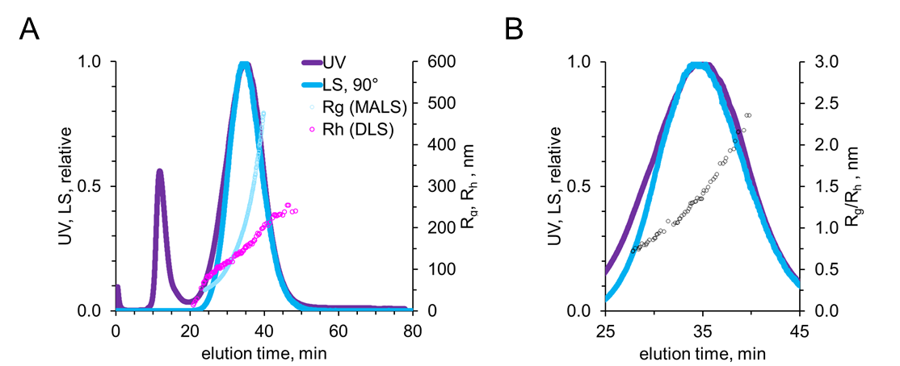
Supplement Fig. 2: Off-line-AF4 measurement
To confirm that the separation of the particles was not compromised with the increased amount of sample that was loaded (to obtain a stronger scattering signal) an off-line measurement was performed. A. The elution profiles are in good agreement with the ones presented in Fig. 3B. In addition to the derived R_{g} values, R_{h} values could also be determined as the dynamic light scattering was measured in addition. B. The ratio R_{g}/R_{h} is plotted as open spheres. While for a hard sphere a value of ~0.78 is expected, we observed a continuous increase of R_{g}/R_{h} up to >2 with larger particle size indicating an increasing deviation of their morphology towards more elongated particles⁴⁶.
Supplement Fig. 3: SAXS analysis of RNA peak
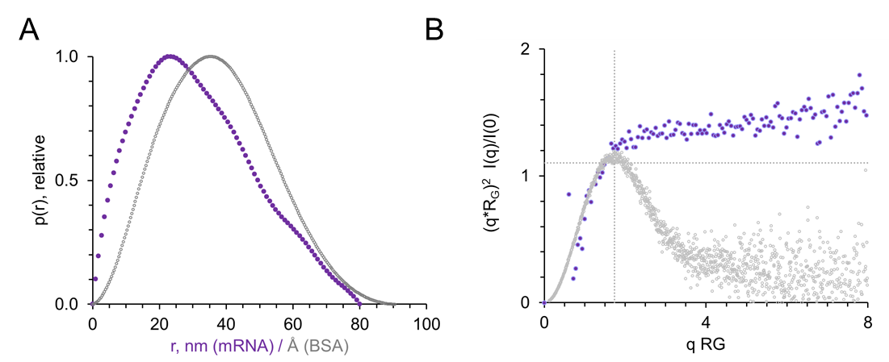
Supplement Fig. 3: SAXS analysis of free RNA indicates an unstructured/elongated structure
The scattering RNA curve from the fractionation of pure RNA formulation was further characterized and shown here in comparison with BSA as an example of a globular structure.
A. p(r) function, normalized. The skewed peak is typical for unstructured or elongated structures (in contrast to the almost Gaussian distribution displayed by BSA (grey). Note, the BSA data is displayed in Å for better comparison)
B. Dimensionless Kratky plot ((q*R_{g})² I(q)/I(0) vs q*R_{g}). The dotted lines are drawn at qR_{g} = √3 and (qR_{g})²I(q)/I(0) = 1.104. Globular structures (such as BSA (grey)) have a local maximum where the two lines intersect. The lack of a maximum for the RNA scattering is in agreement with an elongated structure. Concentration-independent MW estimates were in the range of the expected monomer (Bayesian, 440-450 kDa) and in accordance with the MW estimated from MALS.
.Supplement Figure 4: Limitation of SAXS Guinier analysis for larger LPX
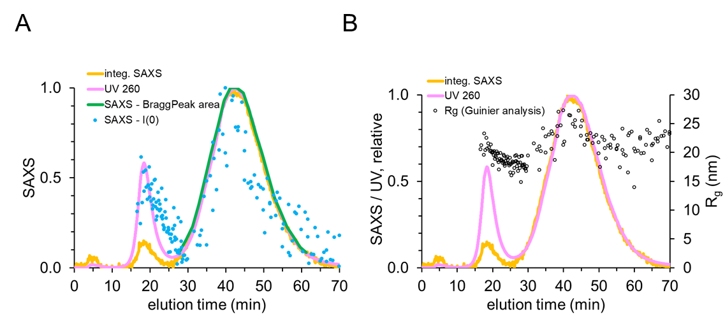
Supplement Figure S4: Limitation of SAXS Guinier analysis for larger LPX
A) I(0) and B) R_{G} derived from Guinier analysis (determined with AutoRG) of subtracted frames across the complete fractionation process (both peaks) in comparison with UV (pink) and SAXS trace (orange). Note, due to the overall large size of the nanoparticles with and the limited covered q range for these experiments, the Guinier analysis of the second peak does not reflect the scattering of the LPX, solely that of the RNA molecules. This explains the constant RG across the peak instead of the continuous size distribution detected with MALS (Figure 1C, black trace). However, the overall good fit of the SAXS elution profile derived from fitting of the Bragg Peaks at the various eultion time points (green curve) to the various other profiles, justifying its use for the subsequent quantitative data analysis.

Supplement Table 2: Peak fitting parameters of lipoplex Bragg peak with Lorentzian function and results of R_{g} analysis of fractions with different elution times
Elution time  (min) | peak position  (nm⁻¹) | σ  (nm⁻¹) | peak width  (nm⁻¹) | σ  (nm⁻¹) | peak area | σ | d-spacing  (nm) | σ  (nm) | Correlation length  (nm) | σ  (nm) | R_{g}
29.9 | 1.037 | 5.26E-03 | 0.173 | 2.97E-02 | 1.01E-03 | 2.17E-04 | 6.058 | 3.07E-02 | 11,542 | 1,981 | 81.6
31.6 | 1.038 | 2.30E-03 | 0.142 | 1.15E-02 | 1.70E-03 | 1.58E-04 | 6.056 | 1.34E-02 | 14,074 | 1,140 | 91.6
33.2 | 1.038 | 1.13E-03 | 0.115 | 5.07E-03 | 2.47E-03 | 1.16E-04 | 6.050 | 6.57E-03 | 17,436 | 0,771 | 102.8
34.9 | 1.039 | 6.64E-04 | 0.103 | 2.85E-03 | 3.77E-03 | 1.07E-04 | 6.049 | 3.87E-03 | 19,447 | 0,538 | 117.8
36.6 | 1.039 | 3.91E-04 | 0.093 | 1.59E-03 | 5.41E-03 | 9.02E-05 | 6.048 | 2.27E-03 | 21,461 | 0,367 | 135.8
38.2 | 1.039 | 2.80E-04 | 0.085 | 1.10E-03 | 6.90E-03 | 8.47E-05 | 6.048 | 1.63E-03 | 23,599 | 0,306 | 154.7
39.9 | 1.039 | 2.17E-04 | 0.079 | 8.32E-04 | 8.44E-03 | 8.27E-05 | 6.048 | 1.26E-03 | 25,388 | 0,268 | 179.2
41.6 | 1.039 | 1.60E-04 | 0.073 | 5.98E-04 | 9.95E-03 | 7.39E-05 | 6.048 | 9.30E-04 | 27,325 | 0,223 | 208.8
43.2 | 1.039 | 1.49E-04 | 0.070 | 5.50E-04 | 1.07E-02 | 7.59E-05 | 6.049 | 8.71E-04 | 28,738 | 0,227 | 242.4
44.9 | 1.039 | 1.43E-04 | 0.066 | 5.19E-04 | 1.07E-02 | 7.43E-05 | 6.049 | 8.33E-04 | 30,243 | 0,237 | 276.3
46.6 | 1.039 | 1.32E-04 | 0.064 | 4.76E-04 | 1.04E-02 | 6.76E-05 | 6.049 | 7.70E-04 | 31,089 | 0,230 | 303.2
48.2 | 1.039 | 1.41E-04 | 0.062 | 5.03E-04 | 9.35E-03 | 6.64E-05 | 6.049 | 8.21E-04 | 32,260 | 0,262 | 319.3
49.9 | 1.039 | 1.48E-04 | 0.060 | 5.25E-04 | 7.98E-03 | 6.08E-05 | 6.048 | 8.63E-04 | 33,395 | 0,293 | 355.67
51.6 | 1.039 | 1.67E-04 | 0.060 | 5.89E-04 | 6.78E-03 | 5.82E-05 | 6.047 | 9.69E-04 | 33,552 | 0,332 | 385.97
53.2 | 1.039 | 2.03E-04 | 0.059 | 7.15E-04 | 5.45E-03 | 5.75E-05 | 6.046 | 1.18E-03 | 34,102 | 0,415 | 406.17
54.9 | 1.039 | 2.52E-04 | 0.056 | 8.81E-04 | 4.14E-03 | 5.56E-05 | 6.046 | 1.47E-03 | 35,450 | 0,553 | 426.35
56.6 | 1.039 | 3.13E-04 | 0.057 | 1.09E-03 | 3.25E-03 | 5.40E-05 | 6.045 | 1.82E-03 | 35,281 | 0,681 | 446.51
58.2 | 1.039 | 4.42E-04 | 0.058 | 1.55E-03 | 2.42E-03 | 5.62E-05 | 6.045 | 2.57E-03 | 34,467 | 0,924 | 466.59
59.9 | 1.040 | 5.21E-04 | 0.058 | 1.84E-03 | 1.83E-03 | 5.00E-05 | 6.042 | 3.03E-03 | 34,209 | 1,076 | na
61.6 | 1.040 | 7.73E-04 | 0.055 | 2.69E-03 | 1.24E-03 | 5.18E-05 | 6.041 | 4.49E-03 | 36,143 | 1,758 | na
63.2 | 1.040 | 1.11E-03 | 0.059 | 3.94E-03 | 9.02E-04 | 5.25E-05 | 6.042 | 6.47E-03 | 34,038 | 2,281 | na

