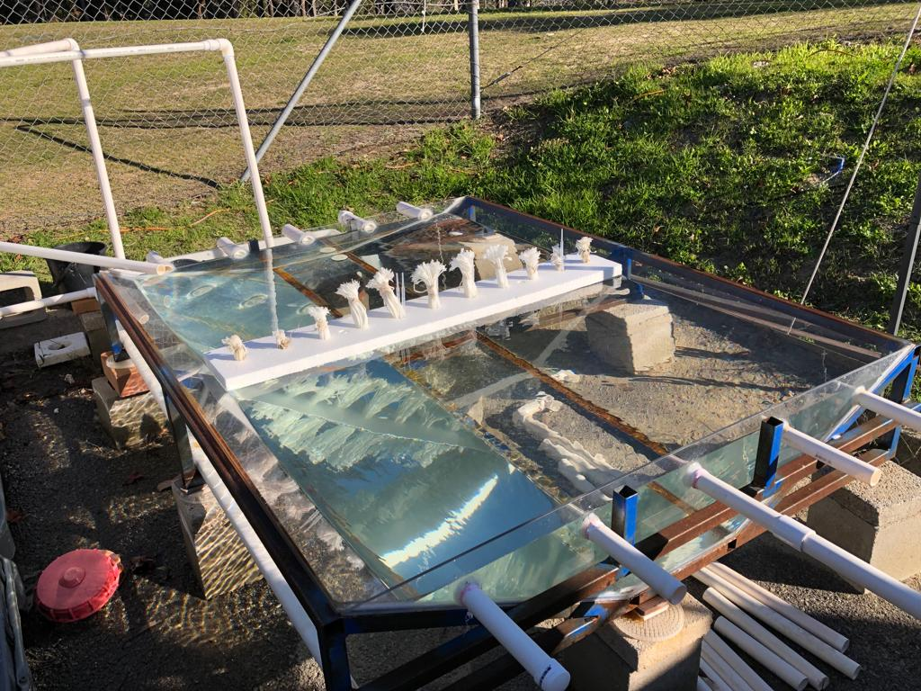
Outlet
FTW
Inlet
(a)
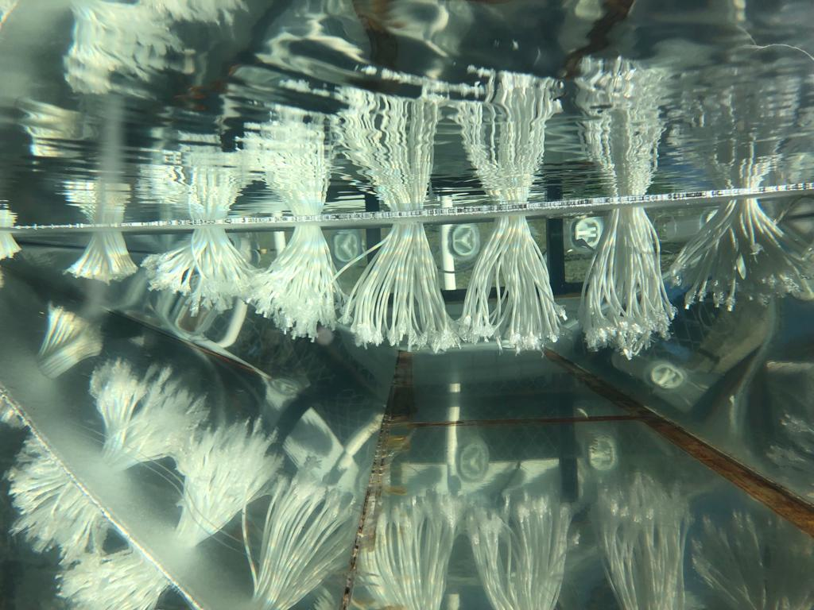
(b)
Figure S1: Hydraulic tracer experiment. (a) experimental setup (b) synthetic roots of the FTW.

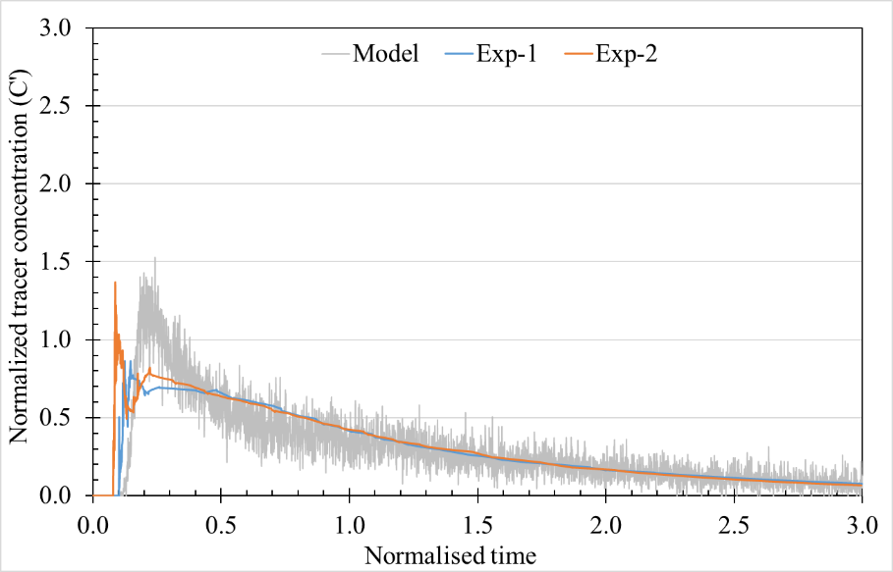
R² =0.71, 0.62
(a)
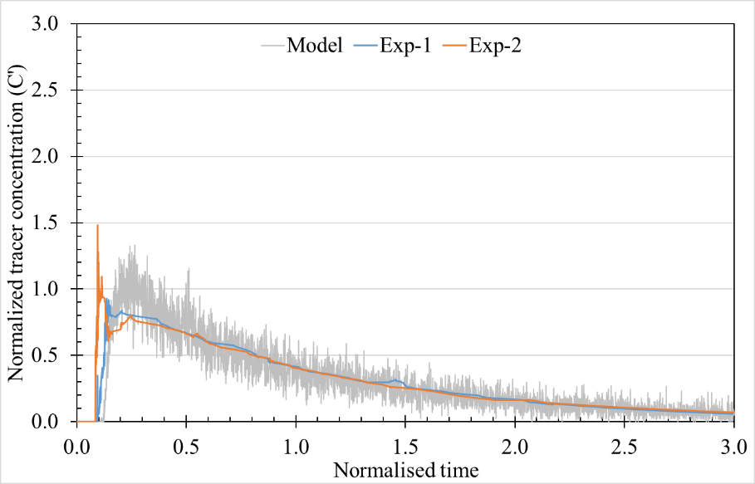
R² =0.85, 0.69
(b)
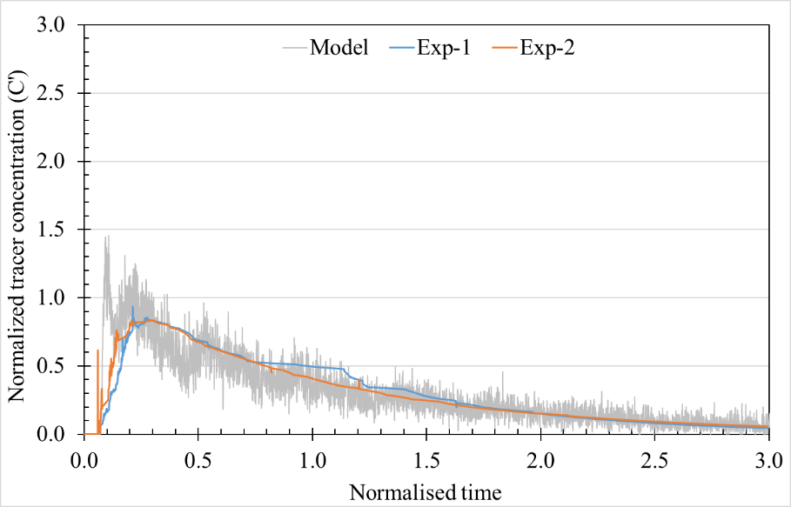
R² =0.63, 0.71
(c)
Figure S2: Comparison between experimental and modeled RTD curves
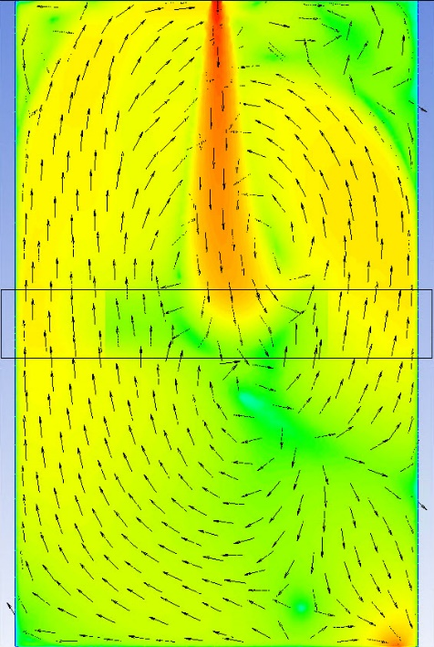 | 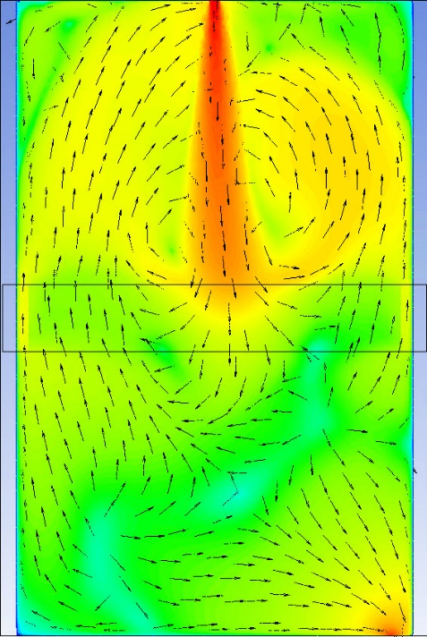 | 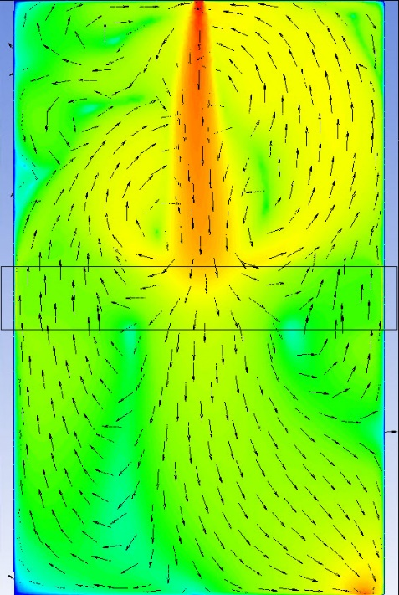
SDR = 0.15 | SDR = 0.60 | SDR = 0.90

Figure S3: Velocity contours for FWF of varying SDR (plane b-b)

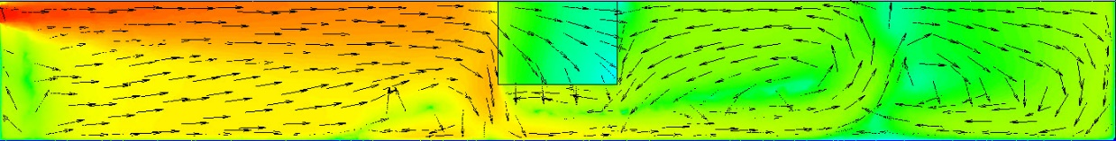 | Porosity = 0.87
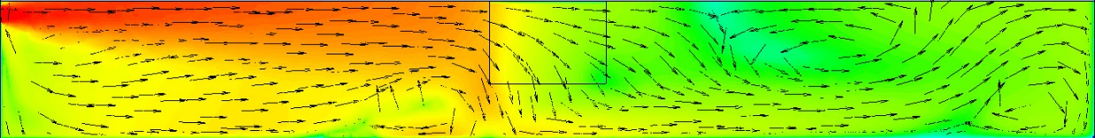 | Porosity = 0.96
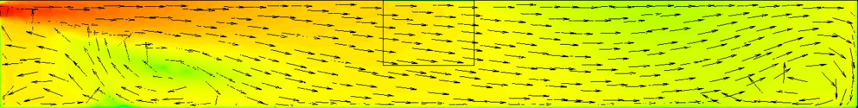 | Porosity = 0.995
Figure S4: Velocity contours for FWF of varying porosity (plane a-a)

(a)
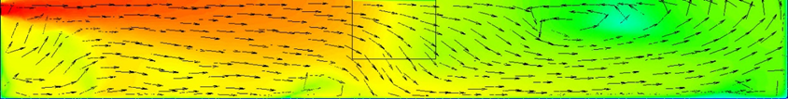 | Coverage = 10%
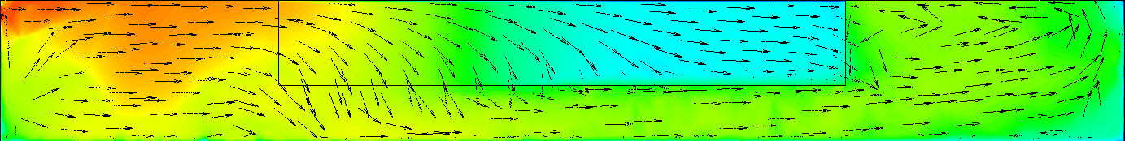 | Coverage = 50%
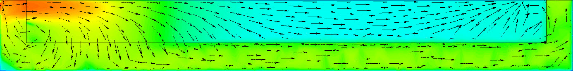 | Coverage = 90%
(a)
 | 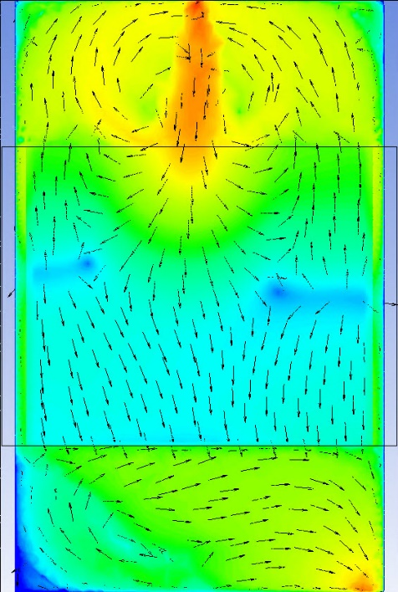 | 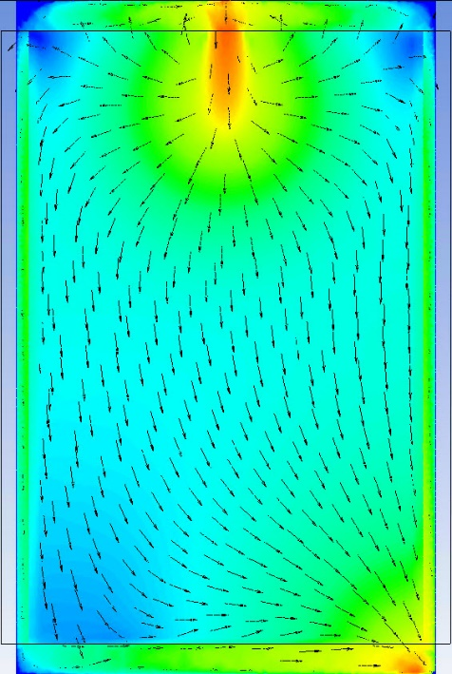
FTW Coverage = 10% | FTW Coverage = 50% | FTW Coverage = 90%

(b)
Figure S5: Velocity contours for FWF of varying coverage area. (a) plane a-a (b) plane b-b

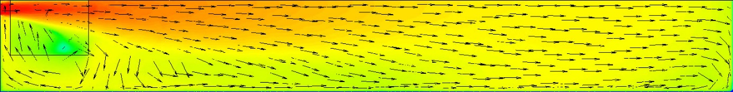 | 0.01L
 | 0.44L
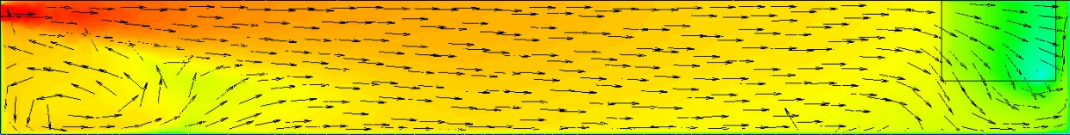 | 0.88L
(a)
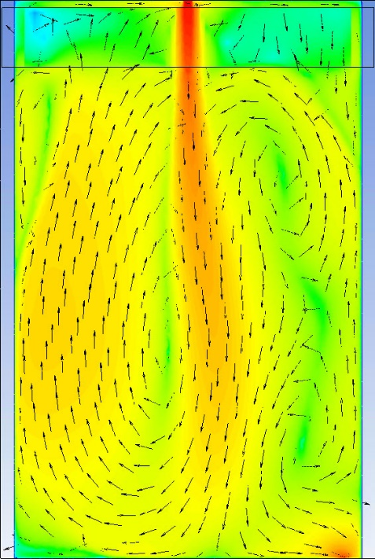 |  | 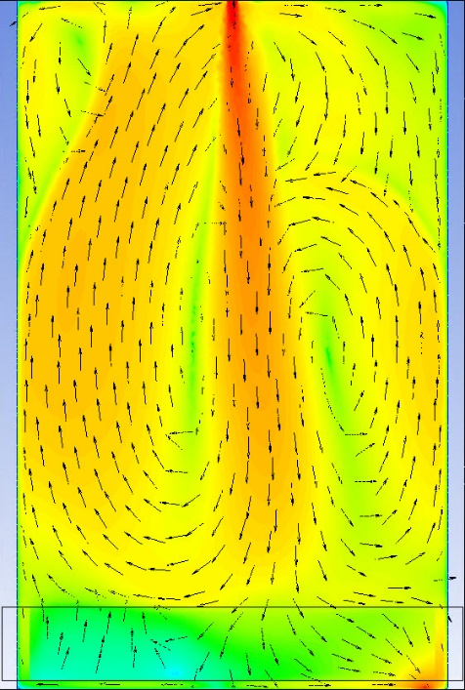
0.01L | 0.44L | 0.88L

(b)
Figure S6: Velocity contours for FWF positioned at different locations. (a) plane a-a (b) plane b-b

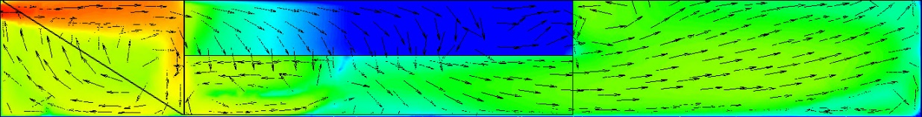 | Porosity = 0.87
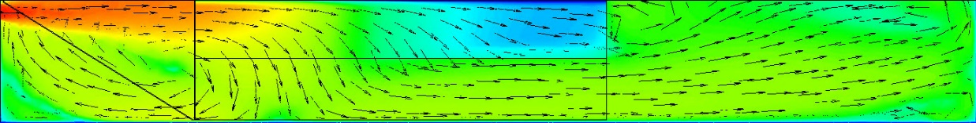 | Porosity = 0.96
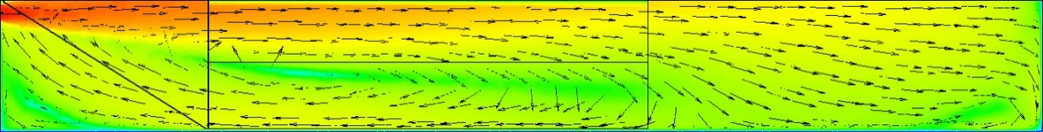 | Porosity = 0.995

Figure S7: Velocity contours for FIC of varying porosity

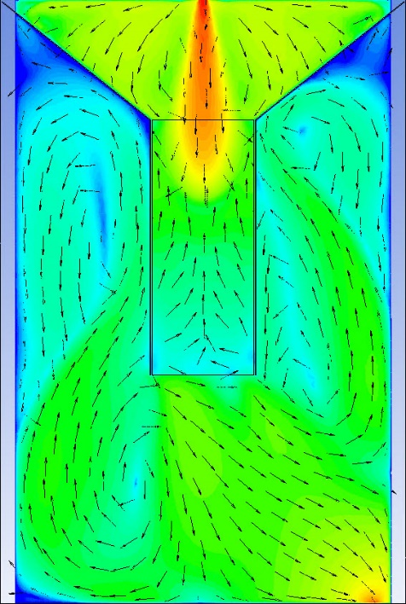 | 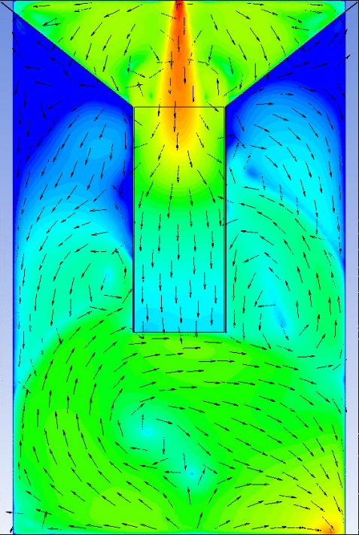 | 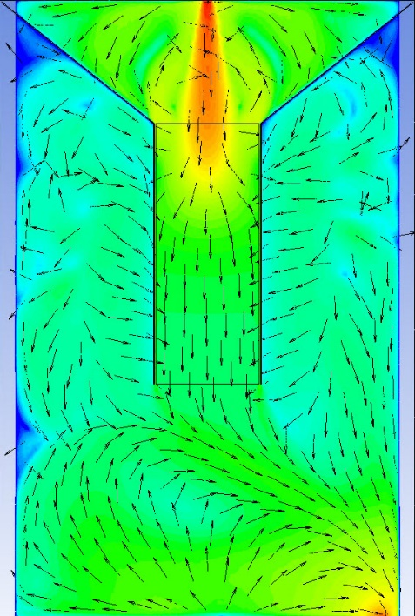
SDR = 0.15 | SDR = 0.60 | SDR = 0.90

(a)
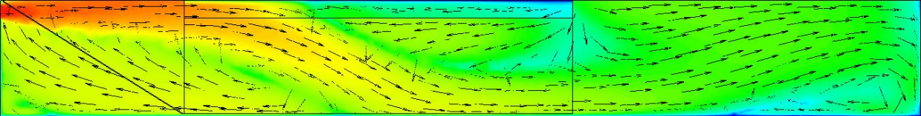 | SDR = 0.15
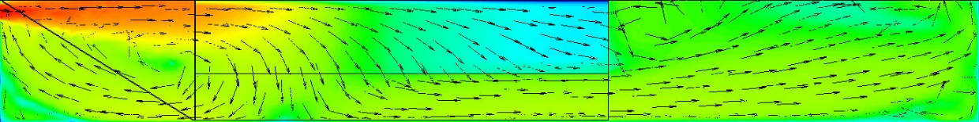 | SDR = 0.6
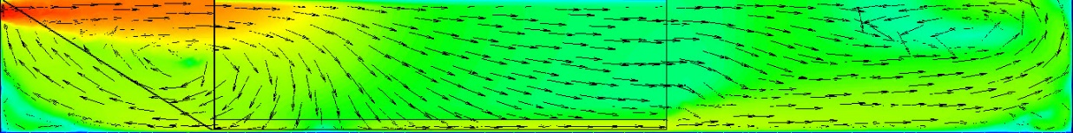 | SDR = 0.90
(b)
Figure S8: Velocity contours for FIC of varying SDR. (a) ZX plane at 0.203 m (b) longitudinal plane at 0.6m.

