Electronic Supplementary Material

Table S1: Forest soil locations
Location
1 | (N 35°33'49"E 59°33'13")
2 | (N 35°33'34"E 24°33'14")
3 | (N 35°34'24"E 46°33'14")
4 | "(N 35°33'07"E 29°33'13")

Table S2: Manual irrigation details
Average of the weight of the pots | Amount of water (ml) | Date
4.72±0.24 | 400 | 7.5.2020
4.75±0.44 | 400 | 12.5.2020
4.637±0.21 | 400 | 14.5.2020
4.61±0.22 | 400 | 18.5.2020
4.92±1.02 | 400 | 21.5.2020
4.66±0.2 | 400 | 26.5.2020
4.7±0.21 | 400 | 31.5.2020
4.69±0.22 | 400 | 4.6.2020
4.66±0.2 | 400 | 8.6.2020
4.73±0.22 | 400 | 14.6.2020
4.69±0.21 | 200 | 18.6.2020
4.65±0.2 | 400 | 23.6.2020
4.7±0.23 | 200 | 28.6.2020
4.69±0.23 | 200 | 1.7.2020
4.67±0.23 | 200 | 5.7.2020
4.7±0.24 | 200 | 9.7.2020
4.71±0.23 | 200 | 13.7.2020
4.72±0.24 | 200 | 17.7.2020
4.68±0.23 | 200 | 22.7.2020
4.67±0.23 | 200 | 26.7.2020
4.69±0.22 | 100 | 2.8.2020
4.65±0.22 | 100 | 6.8.2020
4.62±0.21 | 200 | 11.8.2020
Average= 4.69±0.06 | Average= 286.96±111.53 | Average time gap= 4.36±1.02

Table S3: Statistical analysis of plant growth and genetic analysis according to water, competition and ectomycorrhiza treatments and the interactions between them with outliers. The orange color represents a negative connection between the treatments and the growth index/ EMF present, while the blue color represents a positive connection.
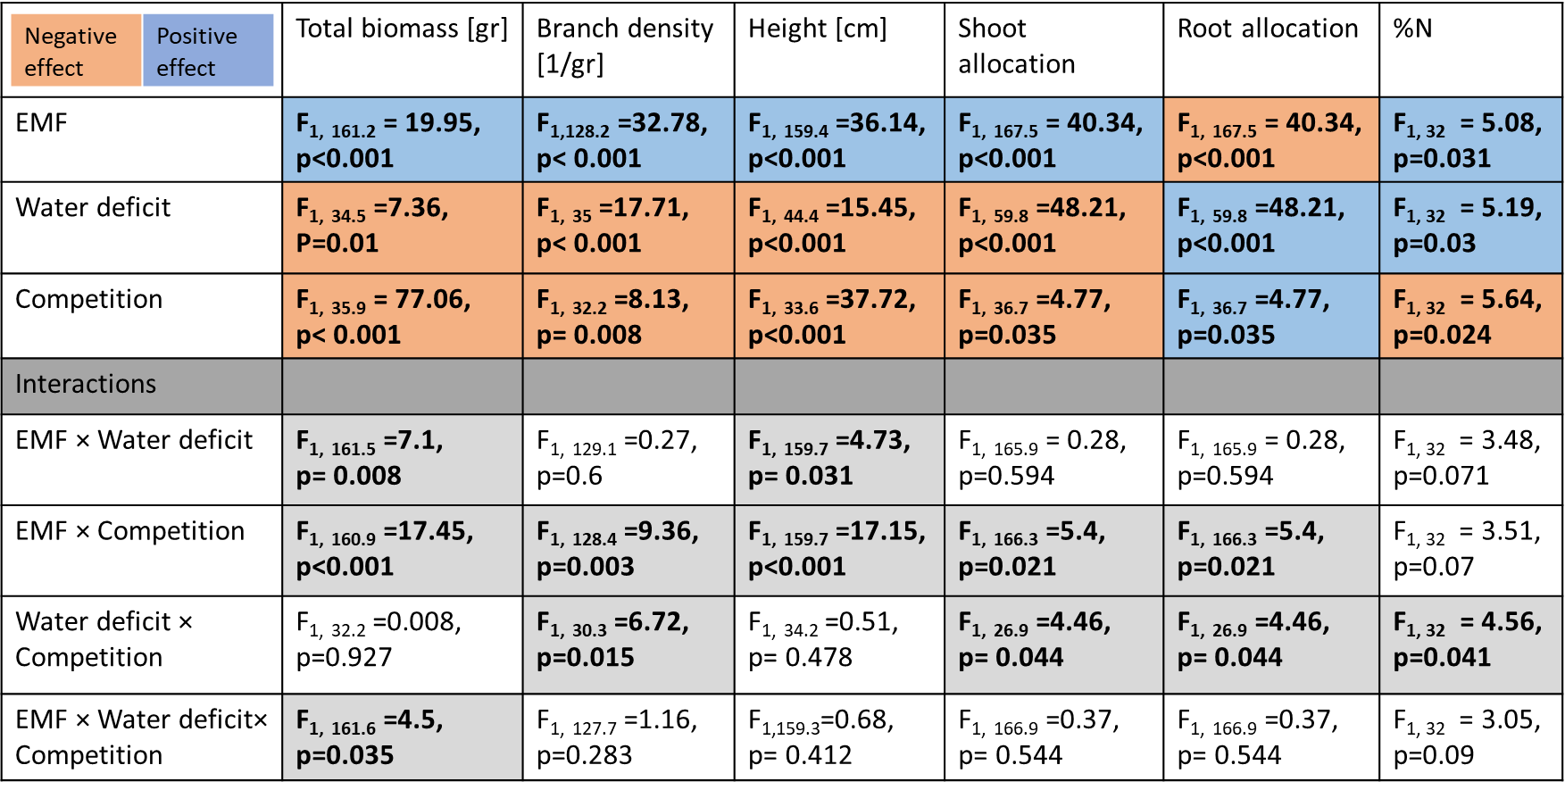
- | + | - | + | Competition  \  Drought
17  Drought stress | 13  Double stress | 4  Drought stress | 4  Double stress | +
16  Optimal condition | 14  Competition stress | 4  Optimal condition | 4  Competition stress | -
With EMF presence | With EMF presence | No EMF presence | No EMF presence | EMF
Table S4: Number of samples for molecular identification of fungal species‏

Ectomycorrhizal fungal colonization: As expected, during root tip collection we did not observe colonized root-tips on plants which were not amended with EMF inoculum. However, some levels of colonization were revealed during the molecular sequencing. These low levels of read abundance could mean that small amounts of inoculum were present in the potting material. Nevertheless, the reduced growth of these plants suggests that these levels of colonization are not ecologically significant. The inoculated plants were strongly dominated by a single taxon belonging to the genus Geopora (99.44%), which had a higher sequence abundance on the roots of plants inoculated with EMF in comparison to non-inoculated plants (F_{1, 55} =14.05, p<0.001, Fig.1d). On average, the sequence abundance of Geopora decreased in the presence of a competitor (F_{1, 53.2} =5.99, p=0.018, Fig.1d). However, this was evident only under drought (non-significant; Ectomycorrhiza ×Water × Competition: F_{1,} _{60.8} =3.64, p= 0.061, Fig.1d), it appears that when plants were suffering a single stress, Geopora was still present on their roots. However, when encountering the combined stress of both drought and competition, Geopora sequence abundance was reduced to the same level as in plants that were not inoculated at all. In addition, there was a significant positive correlation between branch density and sequence abundance of Geopora (Pearson's r‏= 0.438, p<0.001).

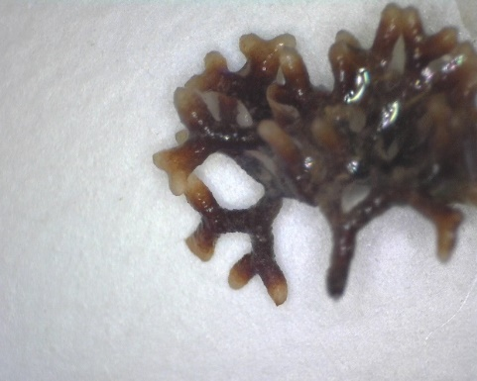
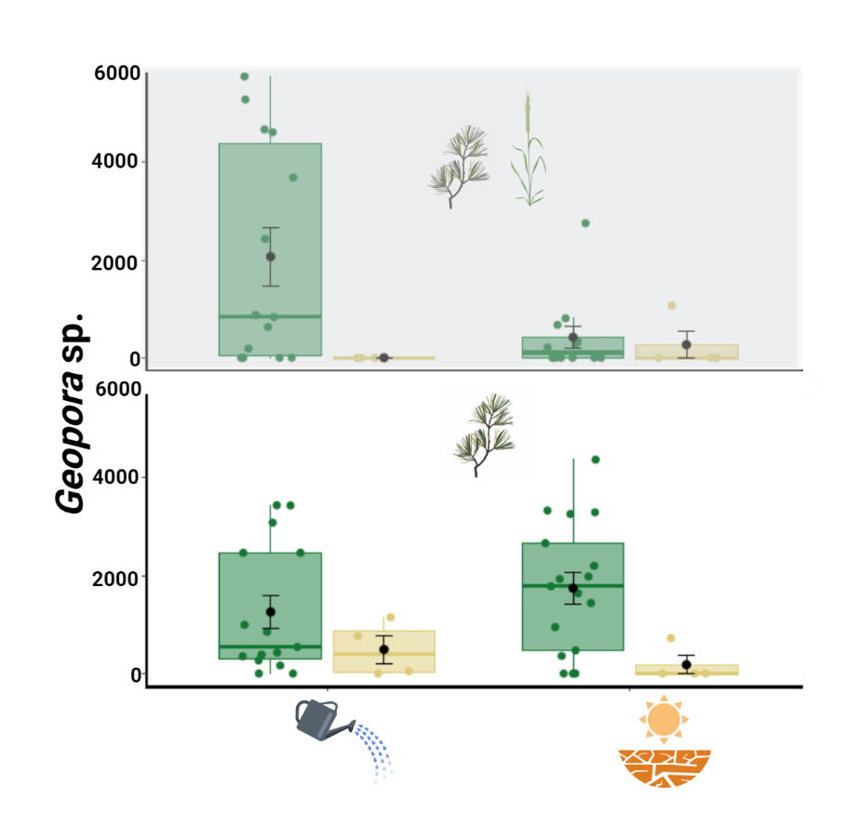
Fig S1: a) Geopora sp. sequence abundance, divided by water/drought (along the horizontal axis), competition (top and bottom figures in each panel) and ectomycorrhiza treatments (bar color). The first and third hinge of each box plot represent the 25th and 75th percentile, the middle hinge is the median and the black point is the mean ±SE b) typical mycorrhizal root tip morphology later identified as colonized by Geopora sp.
a
b

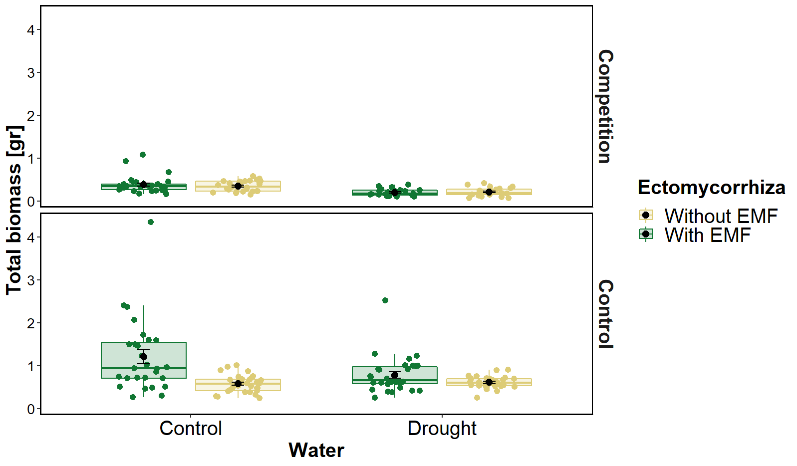
Fig.S2 Pine seedling total biomass [g] according to water, competition and ectomycorrhiza treatments with the two outliers (circled). The first and third hinge of each box plot represent the 25th and 75th percentile, the middle hinge is the median and the black point is the mean ±SE
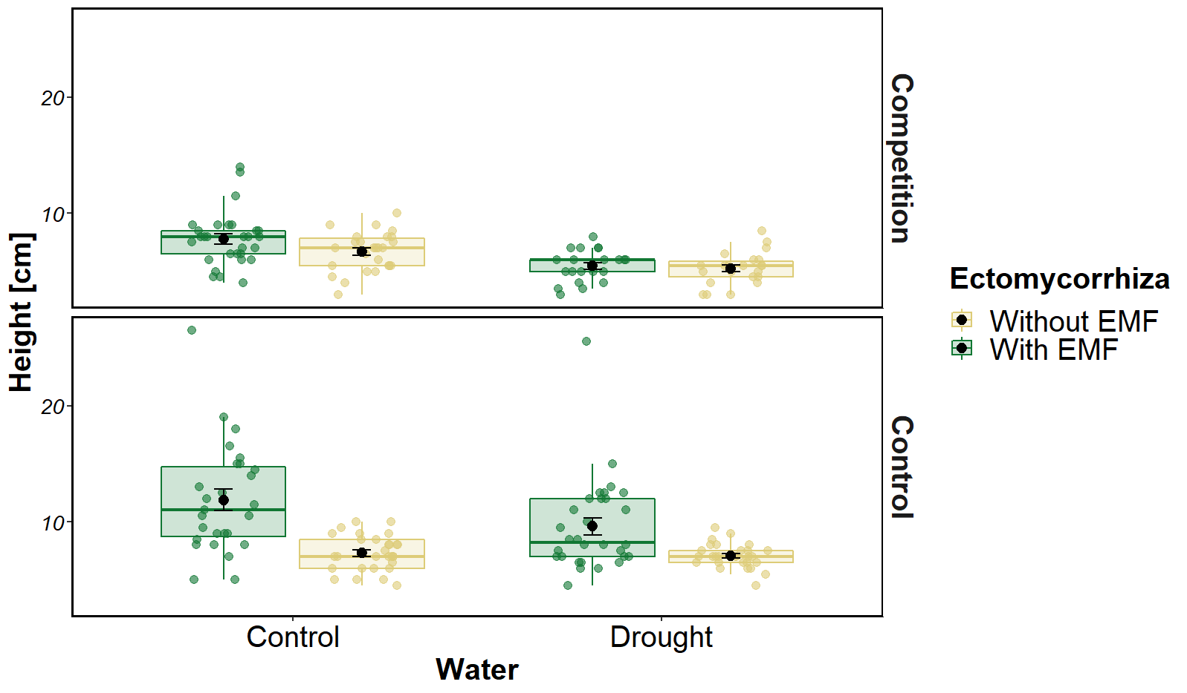
Fig.S3 Pine seedling height according to water, competition and ectomycorrhiza treatments with the two outliers (circled). The first and third hinge of each box plot represent the 25th and 75th percentile, the middle hinge is the median and the black point is the mean ±SE
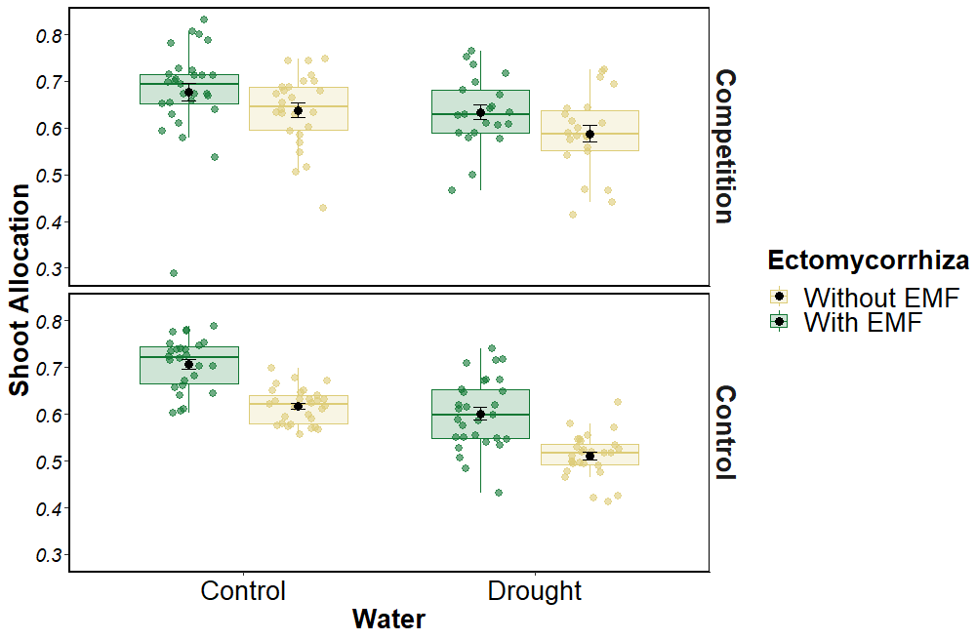
Fig.S4 Pine seedling shoot allocation according to water, competition and ectomycorrhiza treatments. The first and third hinge of each box plot represent the 25th and 75th percentile, the middle hinge is the median and the black point is the mean ±SE
The relation between pine and Hordeum Spontaneous biomasses:
We used general linear mixed model, using a fully factorial design, to account for differences in the plant's total biomasses. The following explanatory variables were included as fixed factors: water treatment and Hordeum Spontaneous biomass, as well as their interaction. The experimental blocks were included in the model while allowing for random slopes and intercepts for each fixed factor.
As expected, drought caused a decrease of 43% to the plant's total biomass (Ample watering: 0.366±0.169; Drought: 0.208±0.089; F_{1,93.2} =12.5, p<0.001, Fig.S5). Notice the 4 conspicuous outliers.
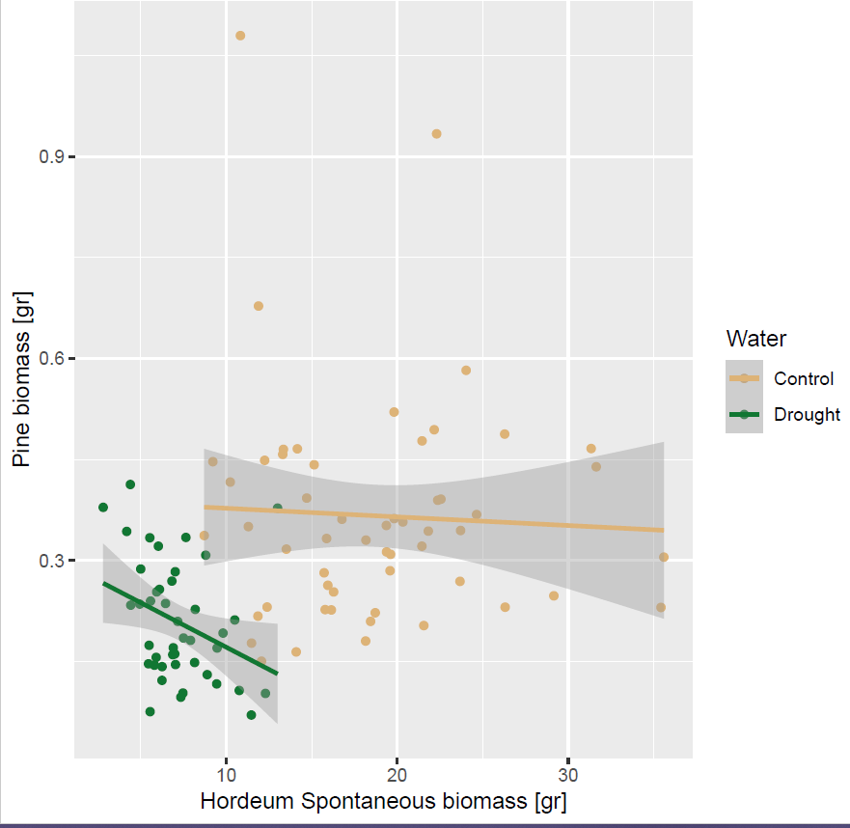

Fig. S5: Pine seedling total biomass [g] according to water treatment and Hordeum Spontaneous biomass with outliers.

We here report the analysis after the removal of the 4 outliers. As expected, drought caused a decrease of 39% to the plant's total biomass (Ample watering: 0.335±0.105; Drought: 0.204±0.086; F _{1,89.7} =26.81, p<0.001, Fig.S6). Similarly, the size of the grass competitor caused a decrease in the plant's total biomass (F _{1, 87.2} = 7.63, p=0.007, Fig.S6). Nevertheless, the negative effect of high competitor biomass was only evident when the plants were grown under water stress (Water × Hordeum Spontaneous biomass: F _{1, 90} =10.19, p=0.002, Fig.S6).
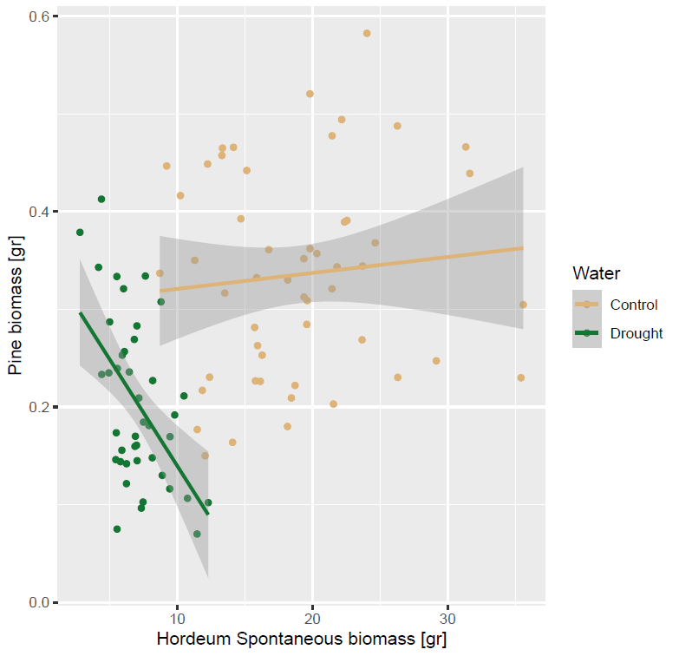
Fig. S6: Pine seedling total biomass according to water treatment and Hordeum Spontaneous biomass without outliers.

Interpretation
The effect of the size of the grass competitor (estimated by grass biomass) on the biomass of the pine seedling was dependent on water availability (interaction grass X drought only after removal of outliers). While the presence of a competitor always had a negative effect on pine biomass (Fig. 1a) the size of the competitor seems to have a negative effect only under drought conditions (pines experiencing both stresses simultaneously, Fig. S6). Grass plants under high water availability might have been large enough to monopolize the soil resources (besides water) regardless of their size. The grass plants under drought were significantly smaller and might have not been able to take up all the soil resources. The ability of grass plants under drought to uptake resources could have been proportional to their size.

