Supporting Information
Multiple Applications of a Novel Fluorescence Probe with Large Stokes Shift and Sensitivity for Rapid H₂S Detection
Lai-Xin Hong, Le Sun, Cong Li, Rong-Lan Zhang*, Jian-She Zhao
Key Laboratory of Synthetic and Natural Functional Molecule of the Ministry of Education, Xi'an Key Laboratory of Functional Supramolecular Structure and Materials, College of Chemistry and Materials Science, Northwest University, Xi’an, Shaanxi 710069, PR China
* Corresponding Author.
- mail: zhangrl@nwu.edu.cn
Experimental section
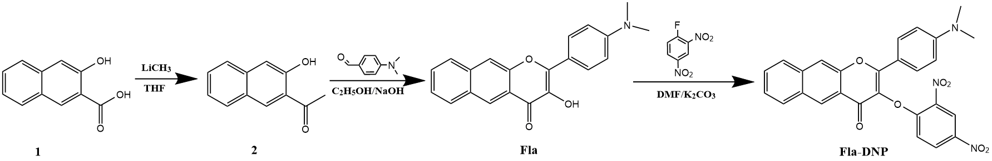
Scheme S1. The synthetic route of probe Fla-DNP
Synthesis of Compound 2
Under the protection of the N₂ atmosphere, an anhydrous THF (40 ml) of 3-Hydroxy-2-naphthoic acid (1.88 g, 10 mmol) was cooled to 0 ºC. After that, the LiCH₃ solution (1.6 M, 30 mmol) dissolved in n-hexane was added to the reaction solution dropwise with a syringe. The resulting mixture was allowed to stir for 3 hours at 0 ºC and then quenched by dropwise addition of 0.5 M HCl solution until no more bubbles. The solvent was then removed under reduced pressure and the residual solid was dissolved in 0.5 M HCl solution (60 mL). The resulting acidic aqueous solution was extracted with CH₂Cl₂, the organic phase was collected and dried over anhydrous sodium sulfate. The solution was then filtered and evaporated to obtain bright yellow solid compound 2. Yield: 68%, ¹H NMR (400 MHz, Chloroform-d) δ 8.37 (s, 1H), 7.83 (d, J = 8.3 Hz, 1H), 7.76 – 7.64 (m, 2H), 7.57 – 7.48 (m, 1H), 7.35 (d, J = 8.1 Hz, 1H), 7.29 (s, 1H), 2.81 (s, 3H).
Synthesis of Fla
To a mixture of compound 2 (3.9 g, 21 mmol) in 60 ml of ethanol was added sodium hydroxide solution (5 M, 21 mL) and the resulting mixture was stirred for 30 min at room temperature. After adding P-dimethylaminobenzaldehyde to the reaction solution and stirring for 5 hours, a dark purple solution was obtained. When the mixture was cooled to 0 ºC, drop H₂O₂ (7.6 mL, 30%) and stirred at room temperature overnight. The solution was acidified to pH=6.5 with 0.5 M HCl to obtain a purple precipitate, followed by the suspension was filtered and the product was washed with ethanol to afford purple solid Fla. Yield: 36%. ¹H NMR (600 MHz, Chloroform-d) δ 9.75 (s, 1H), 8.83 (s, 1H), 8.32 – 8.26 (m, 2H), 8.06 (d, J = 8.4 Hz, 1H), 8.02 (s, 1H), 7.92 (d, J = 8.4 Hz, 1H), 7.59 (ddd, J = 8.2, 6.6, 1.2 Hz, 1H), 7.50 (ddd, J = 8.0, 6.6, 1.2 Hz, 1H), 6.85 – 6.83 (m, 2H), 3.10 (s, 6H).
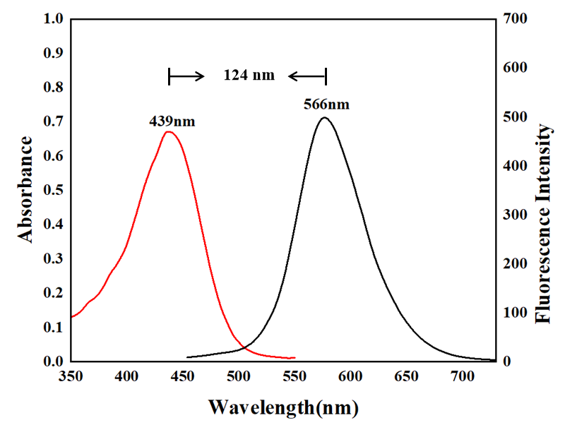
Figure S1. Fluorescence and absorption spectra of Fla at pH 7.4 under the excitation wavelength of 566 nm.

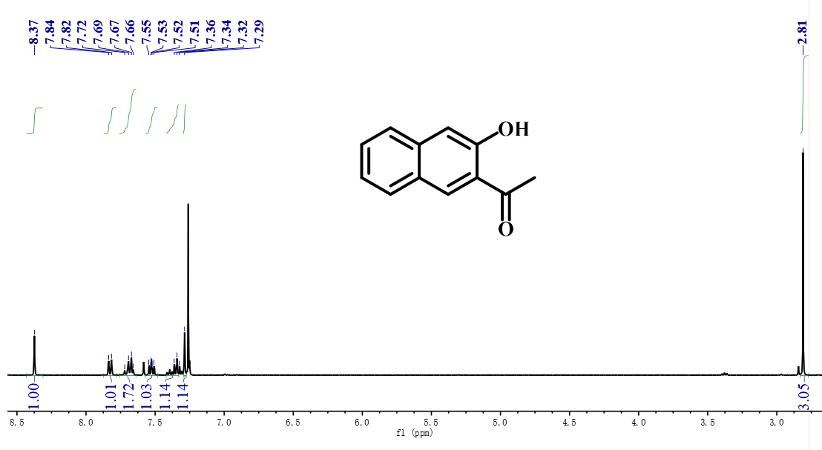
Figure S2. ¹H NMR spectrum of compound 2 in CDCl₃.

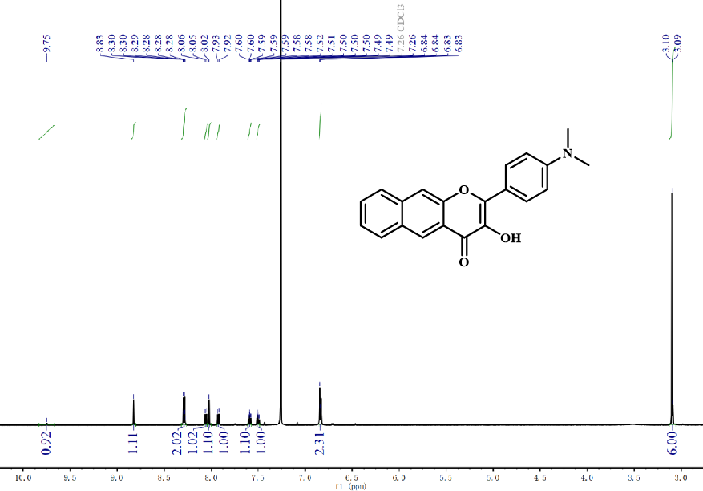
Figure S3. ¹H NMR spectrum of compound Fla in CDCl₃.

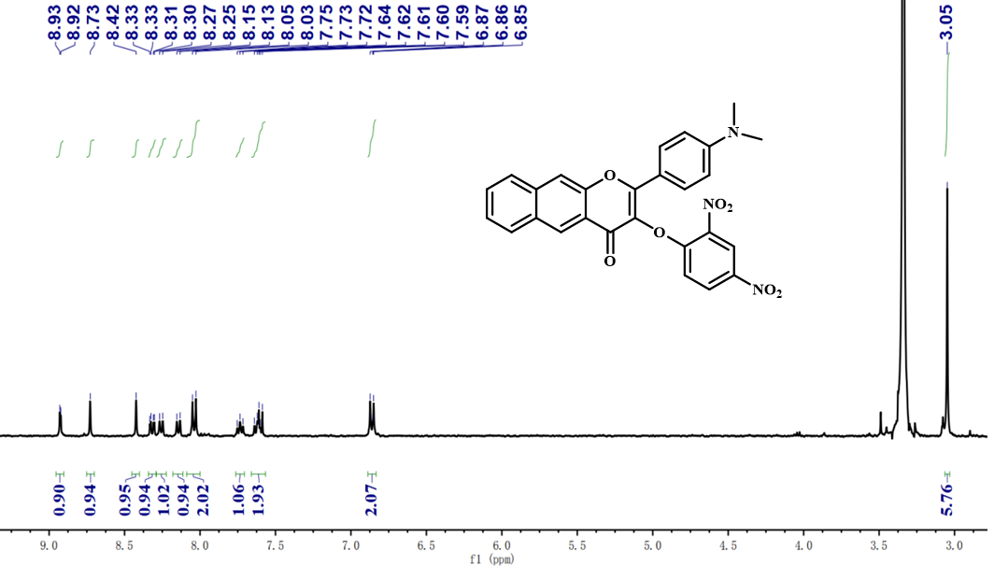
Figure S4. ¹H NMR spectrum of probe Fla-DNP in DMSO-d₆.
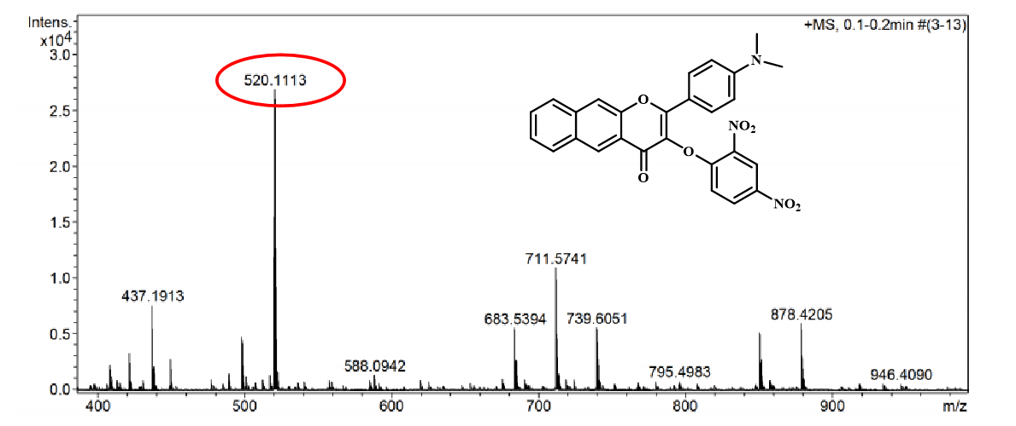
Figure S5. The HRMS spectrum of probe Fla-DNP [M+Na]⁺ in acetonitrile.

Table S1. The ADCH charge of each atom in the Fla-DNP molecule. The numbers marked in red are the maximum and minimum atomic charge values, respectively.

Atom | ADCH  (a.u.) | Atom | ADCH  (a.u.) | Atom | ADCH  (a.u.)
C1 | 0.02960531 | O20 | -0.08110547 | H39 | 0.03983428
C2 | 0.11120328 | O21 | -0.27421714 | H40 | 0.03820067
C3 | -0.03083375 | O22 | -0.08785151 | H41 | 0.02749465
C4 | 0.07569199 | C23 | -0.03677395 | C42 | 0.11409233
C5 | 0.09293807 | C24 | -0.03954326 | C43 | 0.02284771
C6 | -0.01693654 | C25 | -0.03504053 | C44 | -0.03933365
C7 | -0.05206325 | C26 | -0.05691938 | C45 | -0.01858656
C8 | 0.00812229 | H27 | 0.04523688 | C46 | -0.01084380
C9 | 0.00069818 | C28 | -0.06352408 | H47 | 0.05598991
C10 | -0.03235932 | H29 | 0.04502701 | C48 | 0.02008925
H11 | 0.04964192 | C30 | 0.05679990 | H49 | 0.05900267
C12 | -0.03876969 | H31 | 0.04482499 | H50 | 0.06213940
C13 | -0.03292788 | H32 | 0.04114860 | N51 | 0.24946844
C14 | -0.03984177 | N33 | -0.06207670 | N52 | 0.24714982
H15 | 0.05433494 | C34 | -0.03058141 | O53 | -0.20265299
H16 | 0.05226654 | H35 | 0.02936097 | O54 | -0.20256652
H17 | 0.04841183 | H36 | 0.04276564 | O55 | -0.20028663
H18 | 0.04884795 | H37 | 0.04048256 | O56 | -0.18361209
H19 | 0.04632302 | C38 | -0.03074207

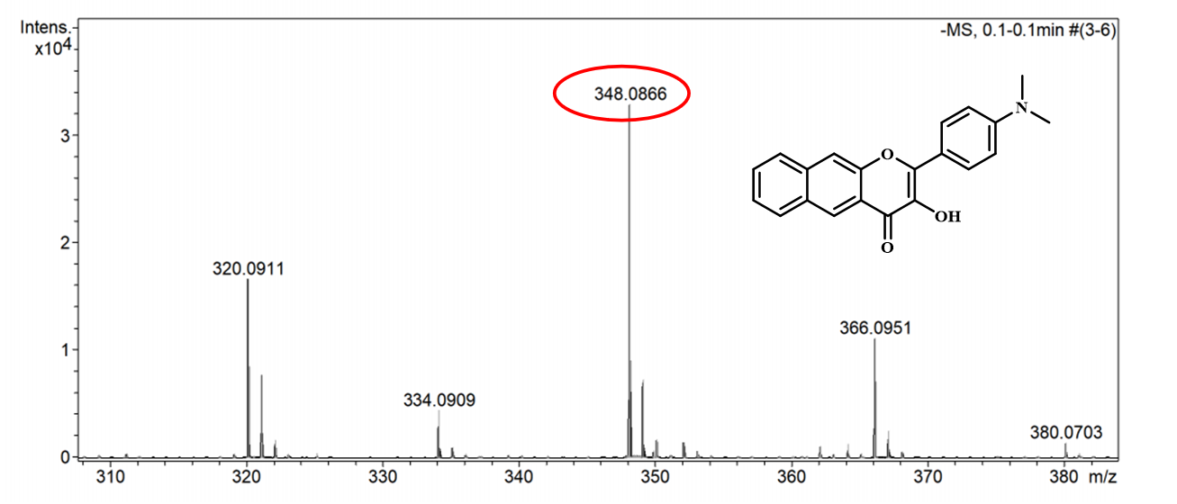
Figure S6. The HRMS spectrum of probe Fla-DNP +H₂S in acetonitrile. Calcd for Fla-DNP +H₂S [M+H₂O-H]⁻ : 348.1230.

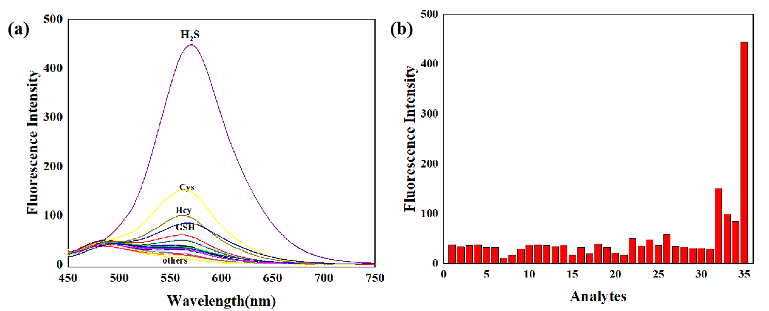

Figure S7. a) Fluorescence spectral changes and b) fluorescence intensity (566 nm) changes of 20 μM Fla-DNP upon addition of various analytes. Including: (1) Na⁺, (2) Ni²⁺, (3) Al³⁺, (4) Ca²⁺, (5) NH₄⁺, (6) Fe³⁺, (7) Zn²⁺, (8) K⁺, (9) Co²⁺ ,(10) Mn²⁺, (11) SO₃²⁻, (12) NO₃⁻, (13) SO₄²⁻, (14) Cl⁻, (15) Br⁻, (16) HCO₃⁻, (17) NO₂⁻, (18) CO₃²⁻, (19) SCN⁻, (20) F⁻, (21) I⁻, (22) Trp, (23) Leu, (24) Try, (25) Gly, (26) Phe, (27) Lys, (28) Arg, (29) Val, (30) Pro, (31) blank, (32) Cys, (33) Hcy, (34) GSH, (35) H₂S.
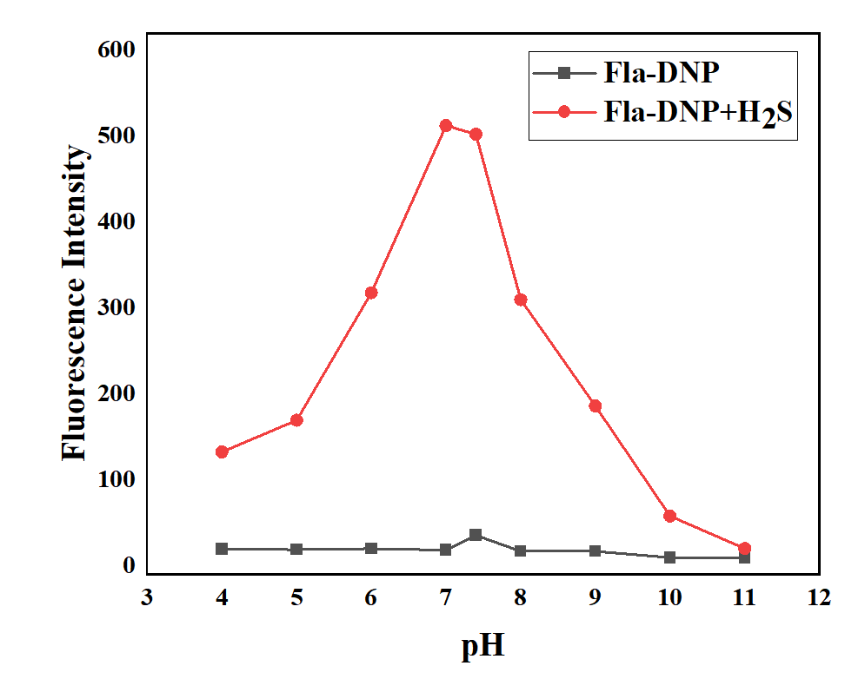
Figure S8. The effect of pH on the fluorescence intensity changes of Fla-DNP (20 μM) before and after adding H₂S (200 μM).

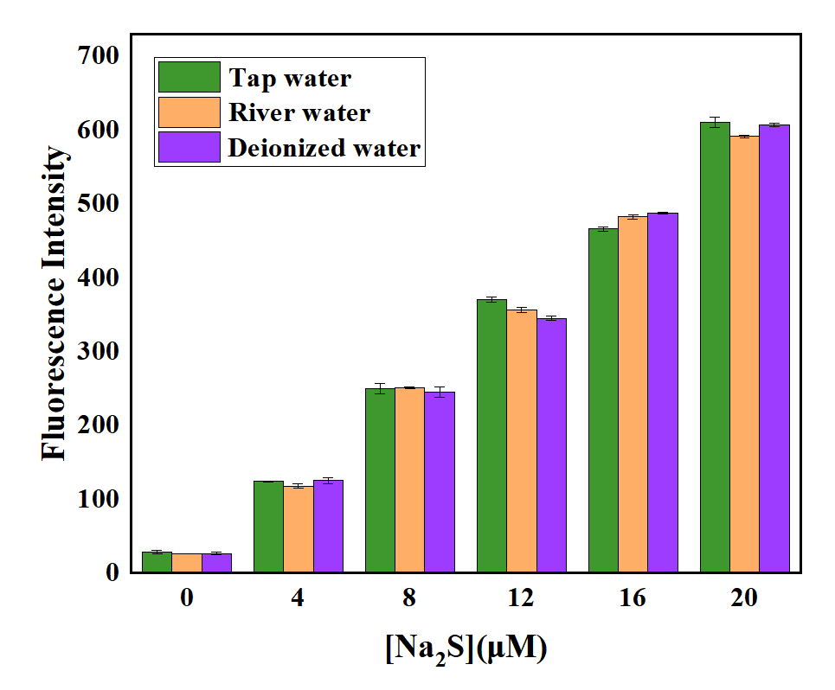
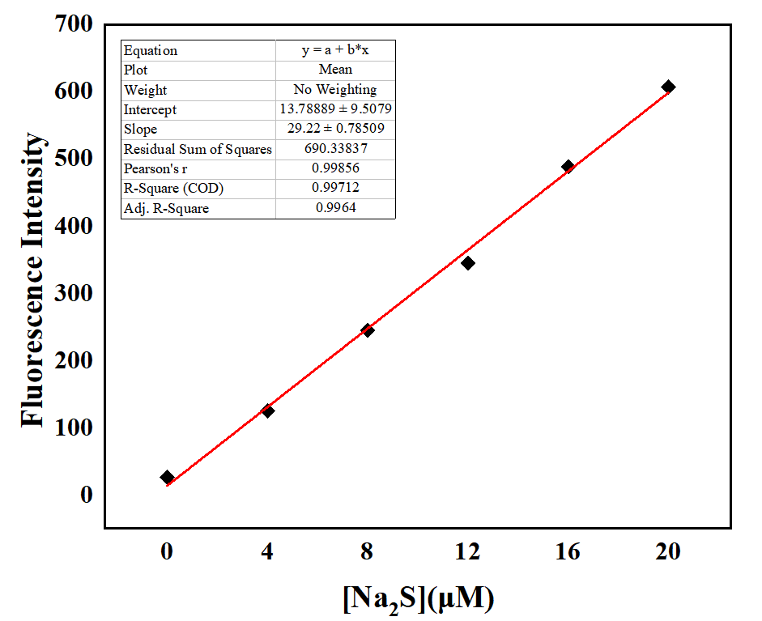
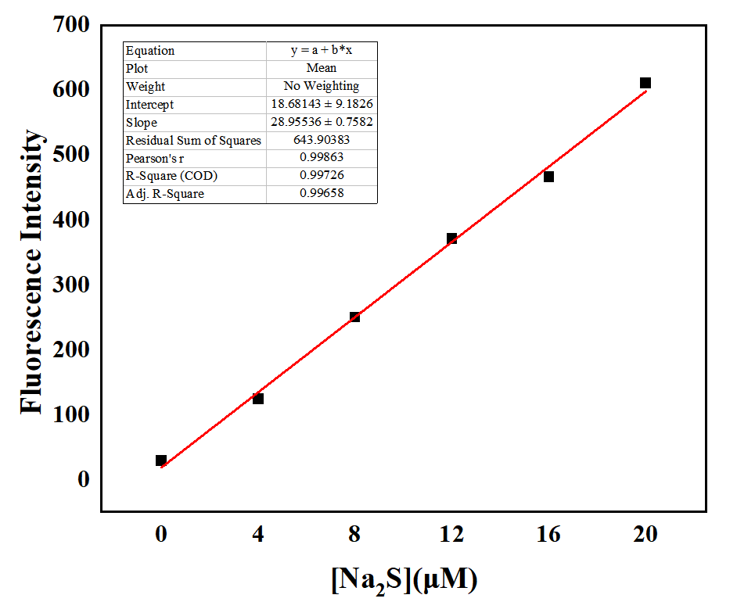
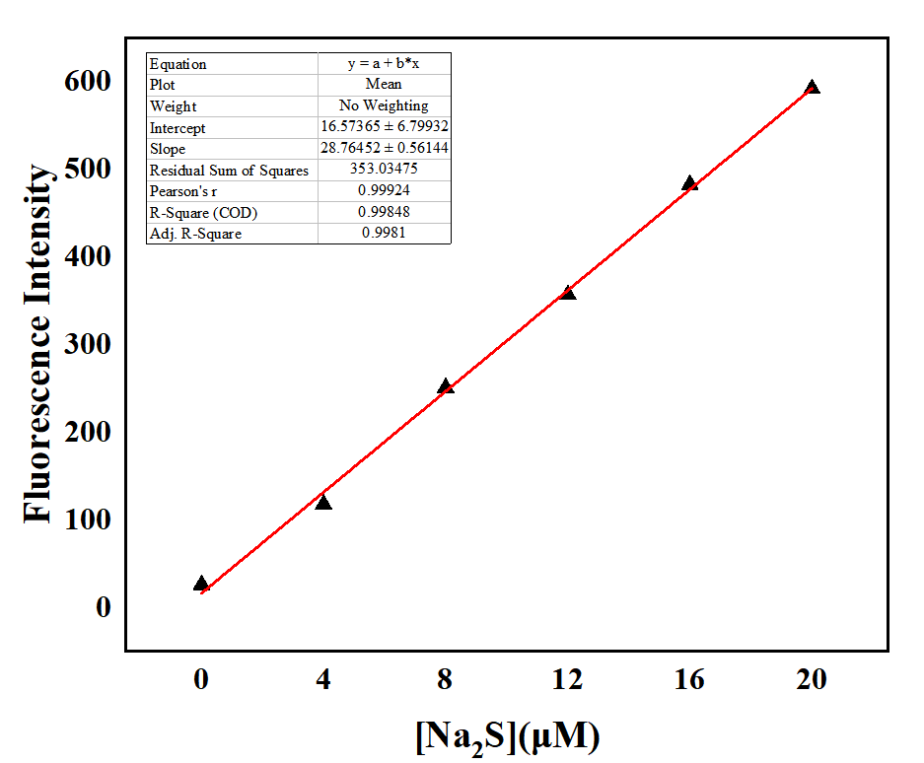
(a)
(b)
(c)
(d)

Figure S9. a) Fluorescence intensity at 566 nm of Fla-DNP (20 μM) after different concentrations Na₂S (0-20 μM) was added to three water samples. Linear relation of fluorescence intensity (566 nm) of Fla-DNP upon addition of Na₂S in b) Deionized, c) Tap and d) River water samples.

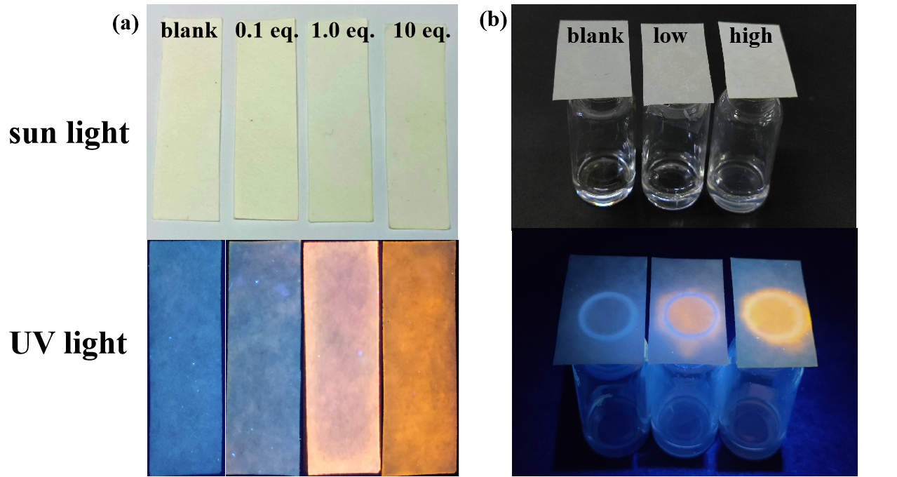

Figure S10. Fluorescent color changes of test strips loaded with Fla-DNP with differen concentrations of a) Na₂S and b) H₂S gas produced from Na₂S and HCl.

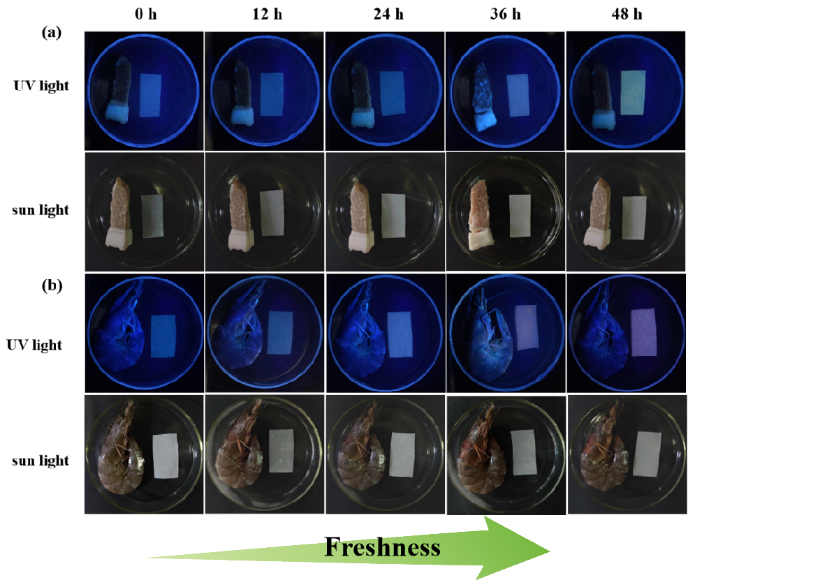Figure S11. Test strips of the Fla-DNP for detecting of H₂S generated during a) pork, b)shrimp spoilage at 4 ºC.

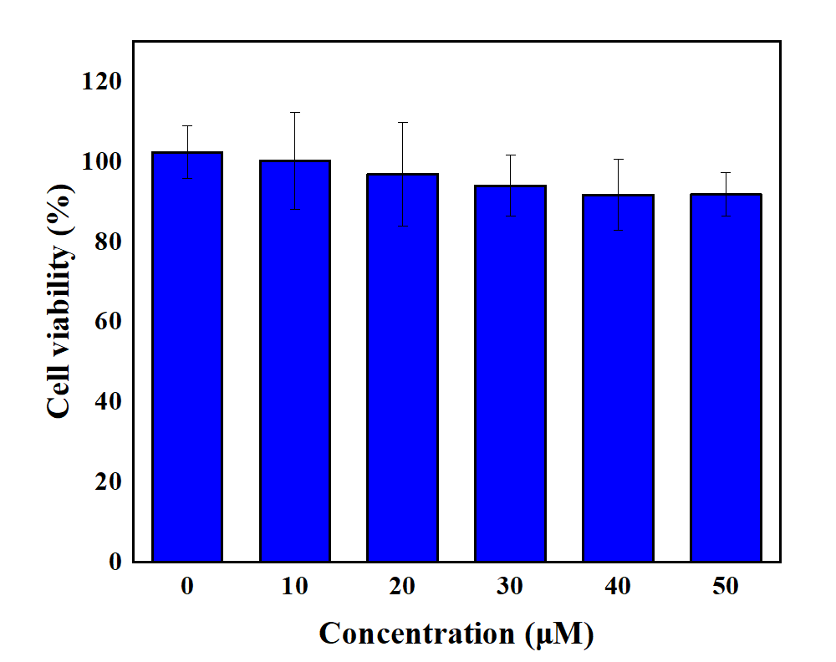
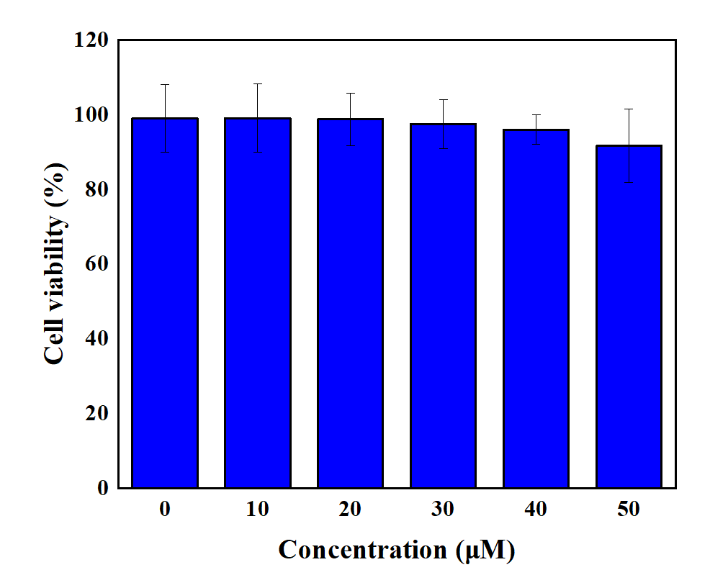
(a)
(b)

Figure S12. Effects of a) Fla-DNP and b) Fla at varied concentrations on the viability of 4T1 cells in vitro after incubation for 24 h.

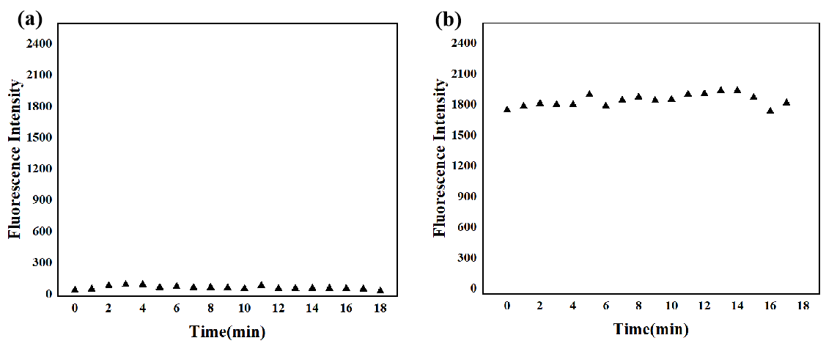
Figure S13. a) The fluorescent intensity changes (566 nm) of 60 μM Fla-DNP without H₂S under the visible light at 415 nm irradiation. b) The fluorescence intensity (566 nm) of 60 μM Fla-DNP upon addition of H₂S (200 μM) in dark conditions.
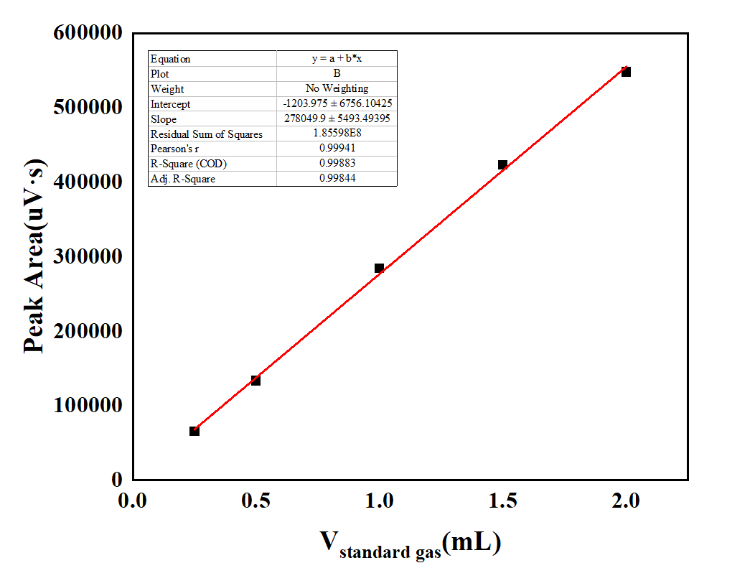
Figure S14. The CO standard curve established with a standard gas with a volume ratio of H₂/CO = 0.99004/0.00996.

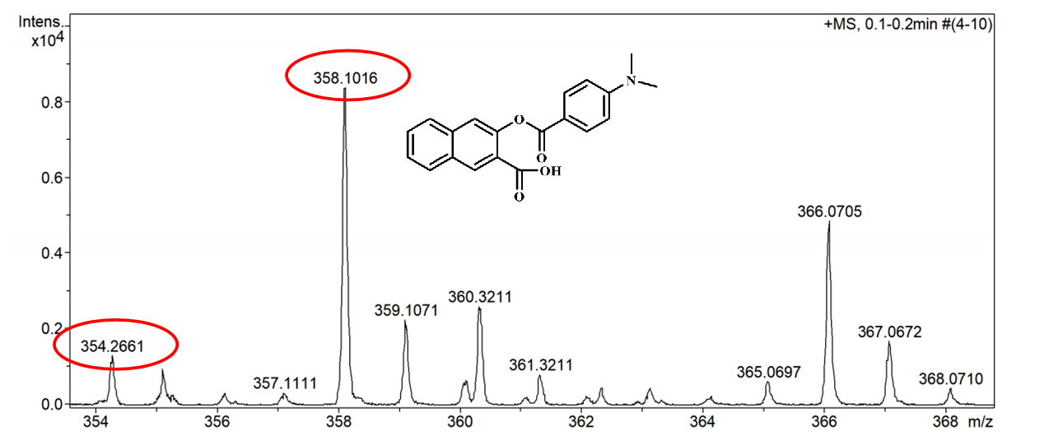
Figure S15. The HRMS spectrum of Fla’ and Fla in acetonitrile. Calcd for Fla’ [Fla’+Na]⁺ : 358.1049, Calcd for Fla [Fla+Na]⁺ : 354.1100.

