Supplementary 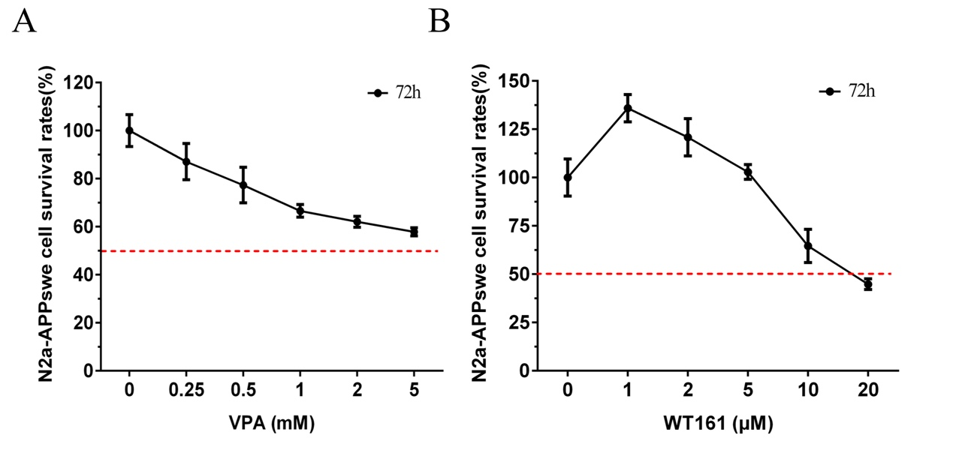Fig. S1 CCK-8 detects drug toxicity in N2a-APPswe. a Cytotoxic effect of VPA on N2a-APPswe. b Cytotoxic effects of WT161 on N2a-APPswe.
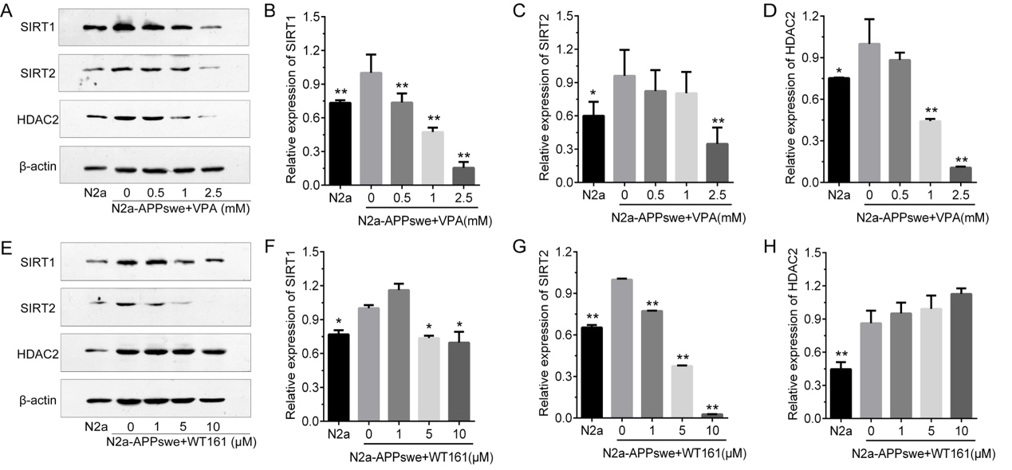
Fig. S2 Effect of VPA and WT161 on the expression of histone deacetylases. a Western blot detection of HDAC2, SIRT1, and SIRT2 expression in N2a-APPswe treated with different concentrations of VPA for 72 h. d Western blot detection of HDAC2, SIRT1, and SIRT2 expression in N2a-APPswe treated with different concentrations of WT161 for 72 h. b-c e-f The results of grayscale scan analysis ($\overline{x}$±s, n=3), in which N2a-APPswe treated with VPA and WT161 in group 0 were used as the baseline, and one-way ANOVA was used to compare the differences with other treatment groups, * P < 0.05, ** P < 0.01.
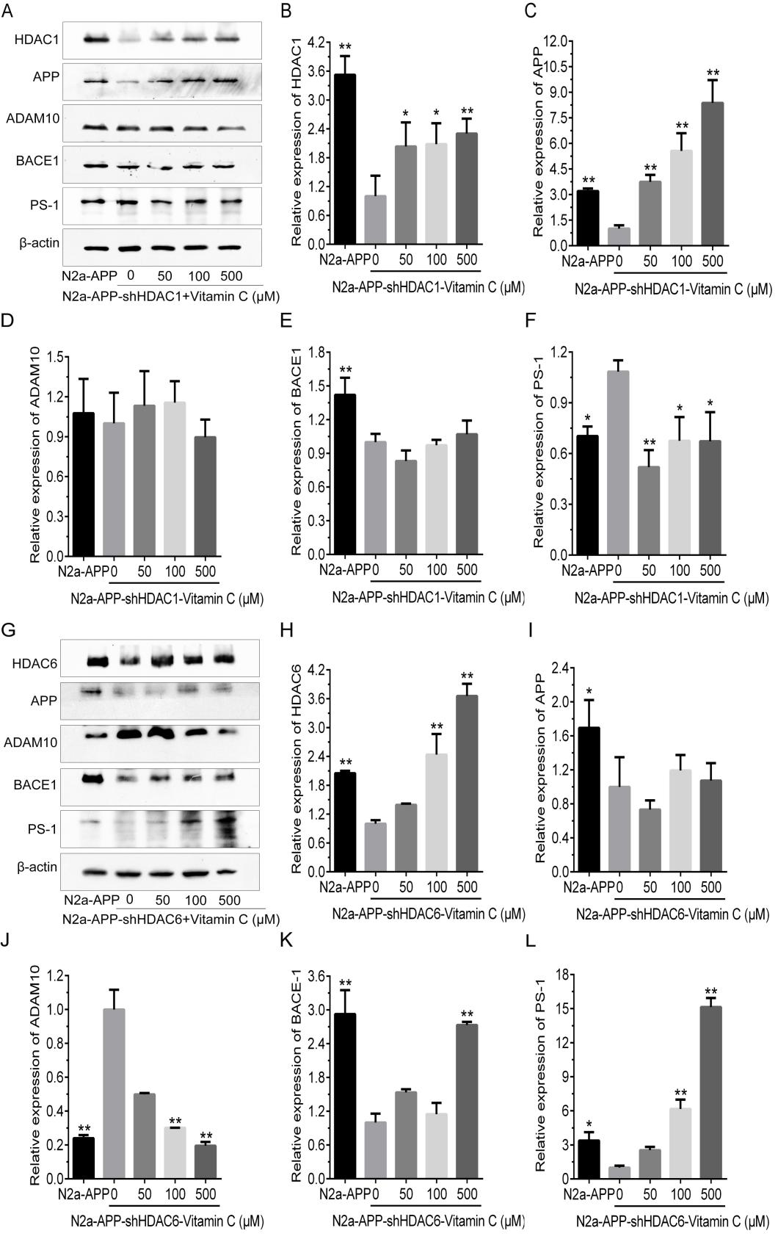
Fig. S3 Effect of vitamin C on the expression of HDACs and APP metabolism-related proteins. a Western blot detection of HDAC1, APP, ADAM10, BACE1 and PS-1 expression in N2a-APPswe-shHDAC1 cells after 48 h of treatment with different concentration gradients of vitamin C. b-f The results of grayscale scan analysis ($\overline{x}$±s, n=3) for N2a-APPswe-shHDAC1 vitamin C treatment group 0 were used as the baseline. g Western blot detection of HDAC1, APP, ADAM10, BACE1, and PS-1 expression in N2a-APPswe-shHDAC6 cells treated with different concentrations of vitamin C for 48 h. h-l The results of grayscale scan analysis ($\overline{x}$±s, n=3), in which N2a-APPswe-shHDAC6 vitamin C treatment group 0 was used as the baseline to compare the differences with other treatment groups using one-way ANOVA, *P < 0.05 and **P < 0.01.
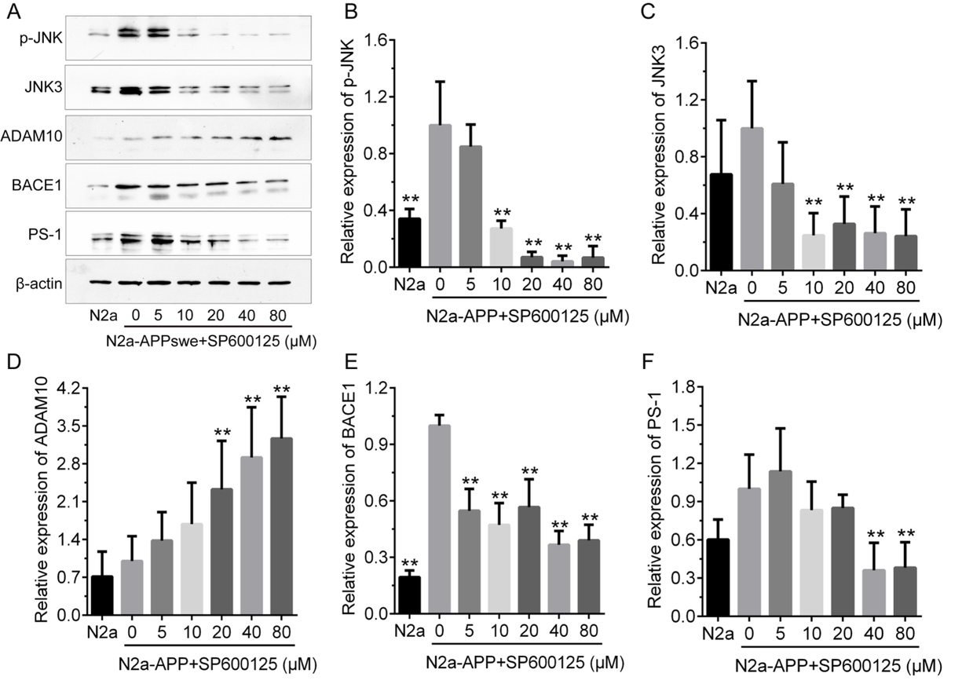
Fig. S4 Effect of the JNK pathway inhibitor SP600125 on APP-related protein expression
a Western blot detection of p-JNK, JNK3, ADAM10, BACE1, and PS-1 expression in N2a-APPswe after 24 h of treatment with SP600125 at concentrations of 5 μM, 10 μM, 20 μM, 40 μM, and 80 μM. b-f The results of grayscale scan analysis ($\overline{x}$±s, n=3), in which the N2a- APPswe cell group was the baseline, and the differences with other treatment groups were compared using one-way ANOVA, *P < 0.05 and **P < 0.01.
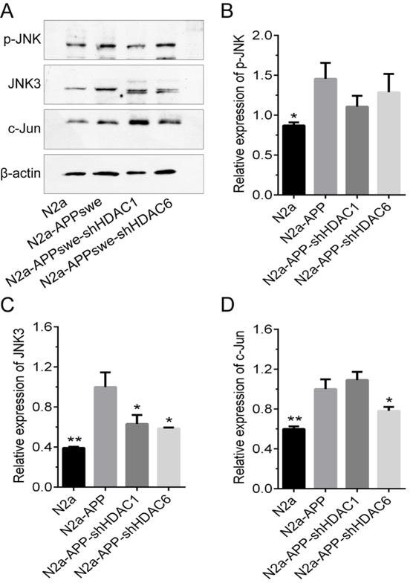
Fig. S5 Effect of knockdown of HDAC1 or HDAC6 on the JNK/c-Jun pathway. a Western blot detection of p-JNK, JNK3 and c-Jun expression in N2a-APPswe after stable transfection with shHDAC1 and shHDAC6. b-d The results of grayscale scan analysis ($\overline{x}$±s, n=3), in which the N2a-APPswe cell group was used as the baseline for comparison using one-way ANOVA differences with other treatment groups, *P < 0.05, **P < 0.01.
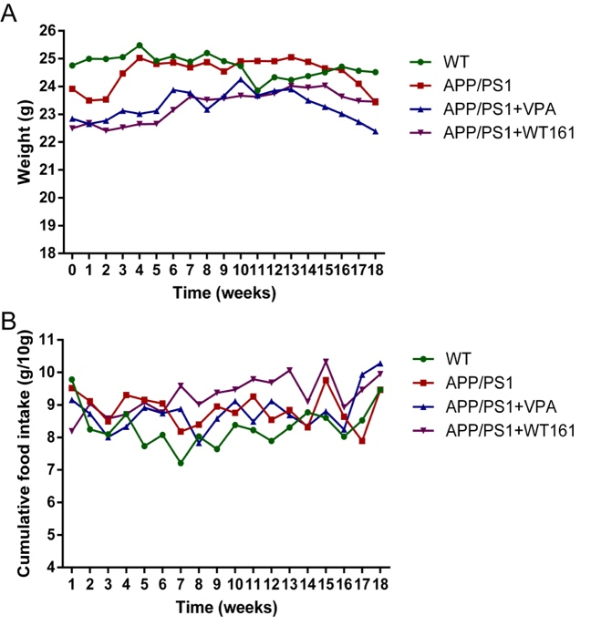
Fig. S6 Ingestion and weight changes in APP/PS1 mice after VPA and WT161 treatment. a APP/PS1 double transgenic AD mice were treated with VPA and WT161 (n=18). b Body weight changes in APP/PS1 double transgenic AD mice after VPA and WT161 treatment using two-way repeated-measures ANOVA to compare the effects of different treatments and times on the feeding and body weight of AD mice.
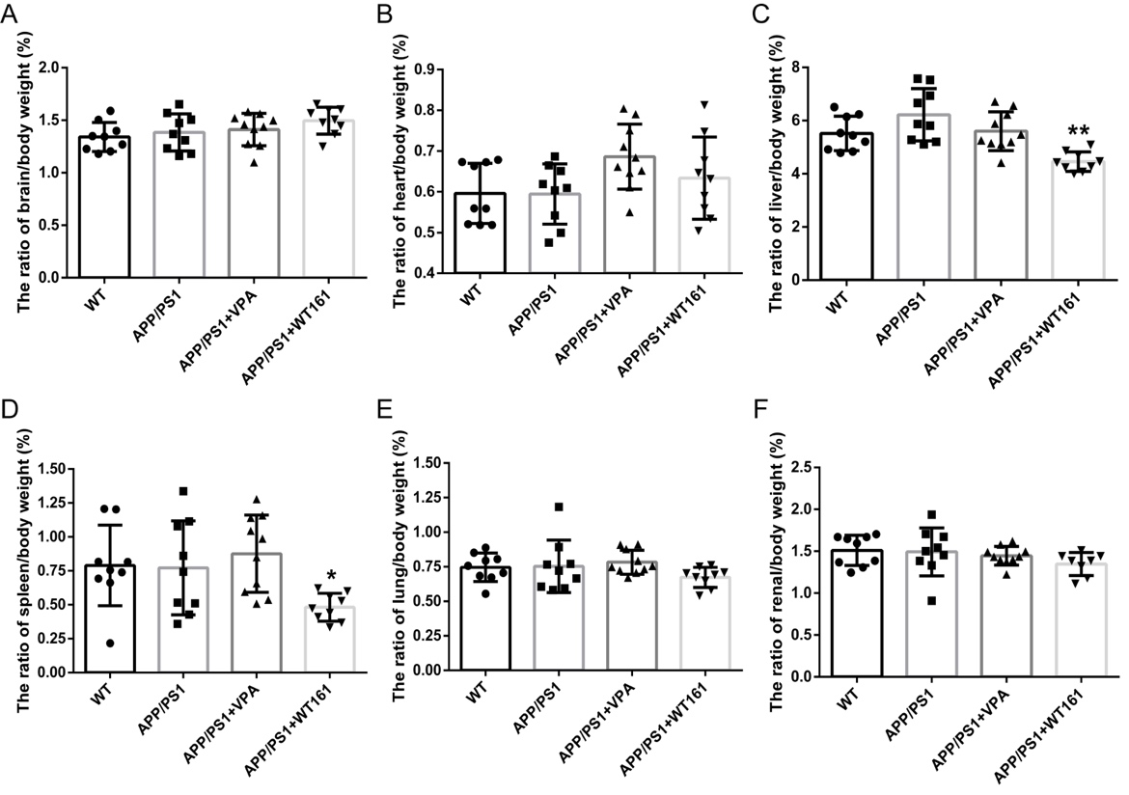
Fig. S7 Effect of VPA and WT161 treatment on the organ coefficients of APP/PS1 mice. a-f The organ coefficients of the brain, heart, liver, spleen, lung, and kidney in the WT group, APP/PS1 group, VPA group, and WT161 group mice (n=9). The APP/PS1 group was used as the baseline, and the differences with other treatment groups were compared using one-way ANOVA, *P < 0.05, **P < 0.01.
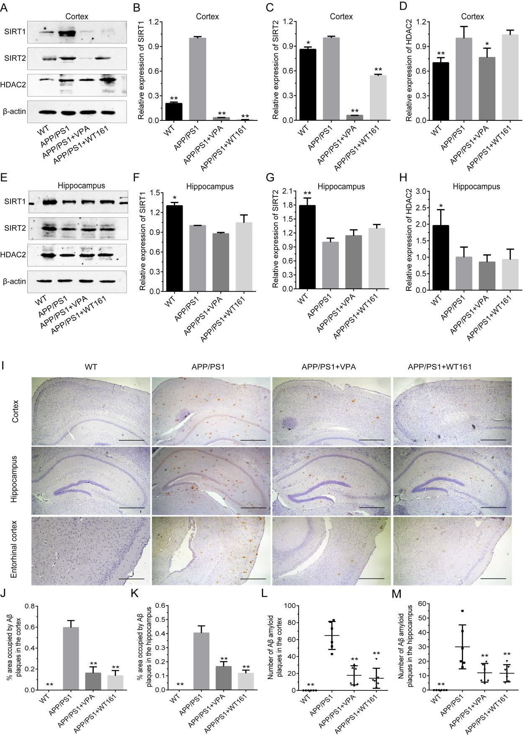
Fig. S8 Effects of treatments on the expression of HDACs in the hippocampus and cortex. a Western blot detection of SIRT1, SIRT2, and HDAC2 expression in the cortex of each group of mice. e Western blot detection of SIRT1, SIRT2 and HDAC2 expression in the hippocampus of each group of mice. b-d f-h The results of grayscale scan analysis ($\overline{x}$±s, n=3), in which the APP/PS1 group was used as the baseline and one-way ANOVA was used to compare the differences with other treatment groups, *P < 0.05, **P < 0.01. Immunohistochemical detection of VPA and WT161 on brain Aβ amyloid deposition in AD mice. i Immunohistochemistry was performed using mouse-derived 6E10 antibody (1:500) to detect Aβ amyloid deposition in the cortex, hippocampus and internal olfactory cortex of each group of mice (200×, coronal cut). j-k The area ratio of Aβ amyloid plaques in the cortex and hippocampus of each group of mice ($\overline{x}$±s, n=6). l-m The number of Aβ amyloid plaques in the cortex and hippocampus of each group of mice ($\overline{x}$±s, n=6), all of which were based on the APP/PS1 group. The differences with other treatment groups were compared using one-way ANOVA, *P < 0.05 and **P < 0.01.

Tab. S1 Serum biochemical indexes of VPA- and WT161-treated APP/PS1 double transgenic AD mice
Characteristics | WT | APP/PS1 | APP/PS1+VPA | APP/PS1+WT161 | F | P
glucose(mmol/L) | 2.12±1.08 | 2.31±0.56 | 1.48±0.48 | 1.40±0.44 | 1.716 | 0.217
Total cholesterol(mmol/L) | 2.27±0.91 | 1.87±0.03 | 1.66±0.26 | 1.87±0.22 | 1.071 | 0.398
Triglyceride(mmol/L) | 0.40±0.41 | 0.68±0.21 | 0.50±0.45 | 0.37±0.08 | 0.736 | 0.550
High-density lipoprotein cholesterol(mmol/L) | 2.44±0.55 | 1.67±0.27 | 1.55±0.44 | 1.73±0.46 | 3.193 | 0.063
Low-density lipoprotein cholesterol(mmol/L) | 0.16±0.07 | 0.16±0.02 | 0.17±0.03 | 0.10±0.03 | 1.951 | 0.175
Aspartate Transaminase(U/L) | 10.11±1.57** | 14.32±3.58 | 12.87±1.62 | 14.2±2.65 | 9.032 | 0.000
Alanine transaminase(U/L) | 8.02±3.66** | 9.09±3.35 | 9.23±2.34 | 10.29±8.06 | 4.896 | 0.007
Total bilirubin(μmol/L) | 15.17±1.16 | 19.73±2.64 | 17.45±2.99 | 22.01±3.65 | 0.324 | 0.808
Creatinine(μmol/L) | 76.48±7.56 | 80.47±12.96 | 81.9±14.22 | 78.12±12.69 | 0.158 | 0.922
Urea nitrogen(mmol/L) | 6.64±0.79 | 7.97±1.46 | 9.16±2.86 | 10.13±1.28 | 2.881 | 0.080
Using the APP/PS1 group as the baseline, one-way ANOVA was used to compare the differences with other treatment groups, *P< 0.05, **P < 0.01.

