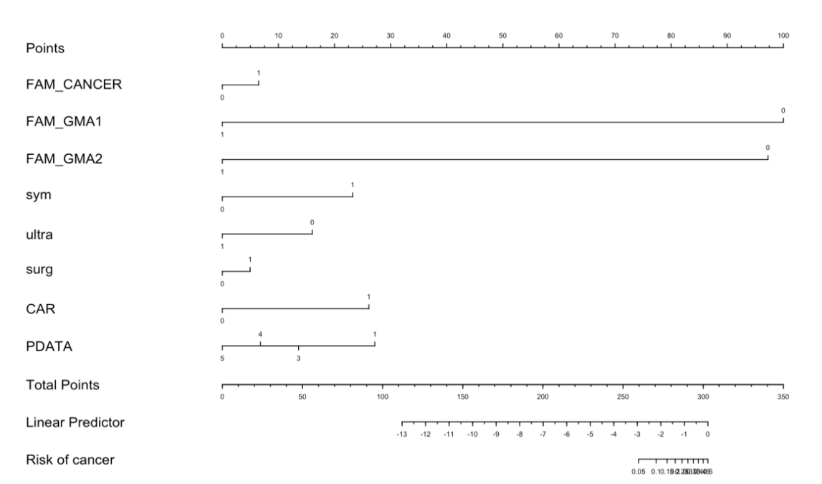
Supplementary Figure 1. Nomogram of breast cancer risk predictive model. Risk factors with neglectable impact (nearly unity odds ratio) were excluded for clarity.

Supplementary Table 1. Cox regression model with hazard ratio and 95% confidence interval.
Risk factor | HR | Lower bound of 95%CI | Upper bound of 95% CI | Standard error | P-value
fam_cancer1 | 1.539 | 1.478 | 1.602 | 0.0206 | <.0001
FAM_SIS | 1.036 | 1.007 | 1.065 | 0.01431 | 0.0142
FAM_GMA1 | 0.805 | 0.665 | 0.974 | 0.09735 | 0.0259
FAM_GMA2 | 0.869 | 0.728 | 1.039 | 0.09073 | 0.123
mc_end1 | 0.75 | 0.728 | 0.773 | 0.01545 | <.0001
FER_TIMES | 0.913 | 0.904 | 0.922 | 0.00488 | <.0001
fer_feeding1 | 0.904 | 0.884 | 0.924 | 0.01141 | <.0001
MED_HYEAR | 1.003 | 1.002 | 1.004 | 0.000717 | <.0001
sym | 4.223 | 4.118 | 4.33 | 0.01276 | <.0001
ultra | 1.006 | 0.941 | 1.076 | 0.03411 | 0.8586
o_two | 1.107 | 1.041 | 1.178 | 0.03149 | 0.0012
o_sur1 | 1.088 | 1.045 | 1.133 | 0.0206 | <.0001
edu1 | 1.053 | 1.042 | 1.064 | 0.00515 | <.0001
compare1 | 0.875 | 0.849 | 0.903 | 0.01564 | <.0001
pdata1 | 1.133 | 1.117 | 1.15 | 0.00731 | <.0001
age_m | 0.786 | 0.783 | 0.788 | 0.00183 | <.0001
m11 | 0.81 | 0.796 | 0.824 | 0.00886 | <.0001
car1 | 0.753 | 0.735 | 0.772 | 0.01271 | <.0001
(HR: hazard ratio, CI: confidence interval, fam_cancer1: family history of cancer, FAM_SIS: number of affected sisters, FAM_GMA1: grandmother breast cancer, FAM_GMA2: maternal grandmother breast cancer, mc_end1: menopausal status, FER_TIMES: fertility times, fer_feeding1: breast feeding, MED_HYEAR: years of hormone replacement, sym: breast symptom, ultra: sonography within two years, o_two: breast examinations within two years, o_sur1: previous breast surgery, edu1: educational level, compare1: compared to previous mammography, pdata1: breast density, age_m: age at mammography, m11: screening mammography times, car1: served with a mobile mammography unit)

Supplementary Table 2. (a) Pathological stage (pStage), (b) estrogen receptor (ER), (c) progesterone receptor (PR), (d) human epidermal growth factor receptor II (HER2), and (e) grade status of breast cancers with and without mammography screening.
- Pathological stage
pStage | Group
pStage | clinical | screening | Total
0 | 2065 | 3211 | 5276
0 | 7.70% | 13.36%
I | 9314 | 10487 | 19801
I | 34.75% | 43.65%
II | 11043 | 7725 | 18768
II | 41.20% | 32.15%
III | 4244 | 2537 | 6781
III | 15.83% | 10.56%
IV | 138 | 67 | 205
IV | 0.51% | 0.28%
Total | 26804 | 24027 | 50831

(b)
ER | Group
ER | clinical | screening | Total
0 | 5359 | 5004 | 10363
0 | 19.99% | 20.83%
1 | 21445 | 19023 | 40468
1 | 80.01% | 79.17%
Total | 26804 | 24027 | 50831

(c)
PR | Group
PR | clinical | screening | Total
0 | 7316 | 7111 | 14427
0 | 27.29% | 29.60%
1 | 19488 | 16916 | 36404
1 | 72.71% | 70.40%
Total | 26804 | 24027 | 50831

(d)
HER2 | Group
HER2 | clinical | screening | Total
0 | 19764 | 17431 | 37195
0 | 73.74% | 72.55%
1 | 7040 | 6596 | 13636
1 | 26.26% | 27.45%
Total | 26804 | 24027 | 50831

(e)
Grade | Group
Grade | clinical | screening | Total
I | 4471 | 4848 | 9319
I | 16.68% | 20.18%
II | 13655 | 12272 | 25927
II | 50.94% | 51.08%
III | 8678 | 6907 | 15585
III | 32.38% | 28.75%
Total | 26804 | 24027 | 50831

Supplementary Table 3. Risk factors for overall and relapse-free survival among 47,214 (overall survival) and 47,228 (relapse-free survival) Taiwanese breast cancer index cases. Grade I, ER/PR/HER2 negativity, and pStage 0 were the baseline for grade, immunohistochemistry staining, and pathological stage, respectively.
 | Survival
 |  | Overall |  |  | Relapse-free
Risk factor | HR | Standard error | P-value | HR | Standard error | P-value
pStage I | 1.515 | 0.14222 | 0.0035 | 2.229 | 0.12967 | <.0001
pStage II | 3.195 | 0.13664 | <.0001 | 4.116 | 0.12628 | <.0001
pstageIII | 9.434 | 0.13636 | <.0001 | 11.782 | 0.12621 | <.0001
pStageIV | 13.99 | 0.20331 | <.0001 | 16.668 | 0.18742 | <.0001
ER | 0.753 | 0.0655 | <.0001 | 0.79 | 0.05674 | <.0001
PR | 0.551 | 0.06277 | <.0001 | 0.63 | 0.05391 | <.0001
HER2 | 0.801 | 0.0493 | <.0001 | 0.932 | 0.04129 | 0.0883
Grade 2 | 1.404 | 0.08694 | <.0001 | 1.992 | 0.08178 | <.0001
Grade 3 | 1.785 | 0.09038 | <.0001 | 2.539 | 0.08469 | <.0001
Group | 1.666 | 0.04635 | <.0001 | 1.376 | 0.03861 | <.0001
(pStage: pathological stage, ER: estrogen receptor, PR: progesterone receptor, HER2: human epidermal growth factor receptor II, HR: hazard ratio)

