Supplementary Information

Supplemental Figure 1. Validation of Whole Blood Transcriptome Data using a Targeted Gene Array.

Supplemental Figure 2. Differential Gene Expression and Central Regulatory Features in SMA, excluding children presenting with sickle cell disease (SCD)

Supplemental Figure 1
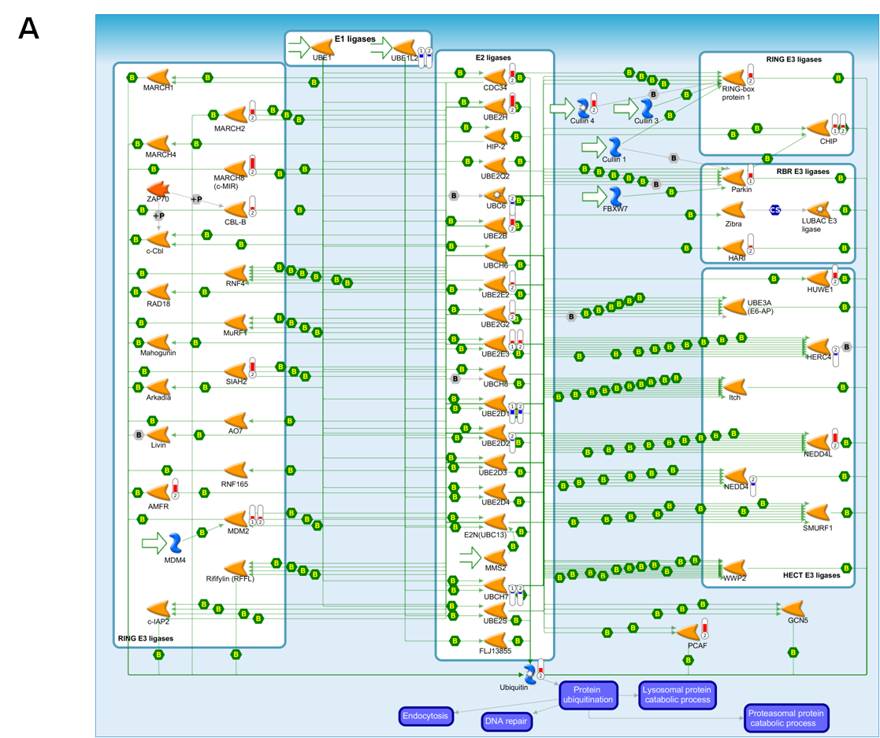

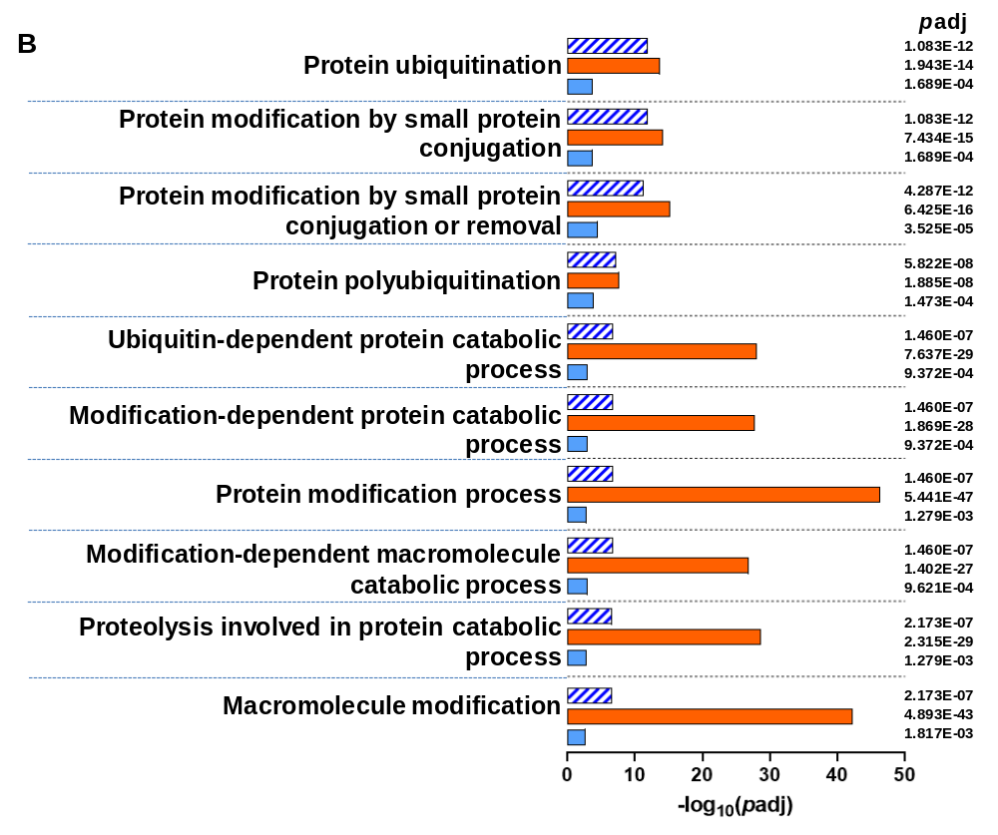

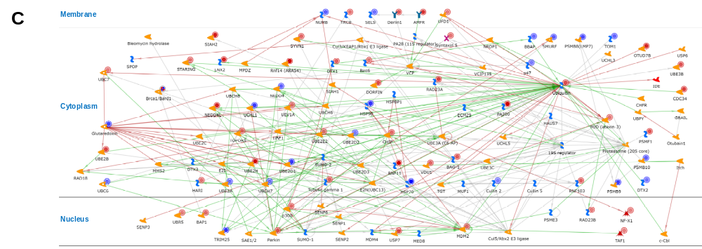
Supplemental Figure 1: Validation of Whole Blood Transcriptome Data using a Targeted Gene Array. To further compare findings from the two datasets, a workflow was generated in MetaCoreTM to identify common (shared) genes that mapped to pathways, GO processes, and process networks. The combined data objects (gene set) from the two a platforms revealed the following top-ranked features: (A) Proteolysis Ubiquitination was the top pathway map (padj=2.193E-11), and was characterized by shared genes that showed decreased expression of E1 ligase (UNE1L2), and E2 ligases (UBE2D1 and UBCH7), but elevated expression of E2 ligase (EBE2E3), as well as increased expression of RING E3 ligases (MDM2, and CHIP). In addition, objects from the transcriptome data showed increased expression of the E2 ligases (CDC34, UBE2H, UBE2B, UBE2G2 and UBE2E2) but a decrease in expression of UBC6 and UBE2D2. Similarly, there was higher expression of the RING E3 ligases (MARCH2, MARCH8, CBL-B, SIAH2, AMFR, RING-box protein 1, parkin, HARI, HUWE1, NEDD4L), and a lower expression of NEDD4. Children with SMA were also characterized by increased expression of, PCAF, Cullin 4 and ubiquitin, suggesting enhanced protein ubiquitination and subsequent downstream mechanisms. (B) Protein ubiquitination was the emerging GO process (padj=1.083E-12), in which the parent relation was the protein modification by small protein conjugation, and the children were actin ubiquitination, histone ubiquitination, protein autoubiquitination, protein monoubiquitination, protein polyubiquitination and isopeptide cross-linking via N6-glycyl-L-lysine. (C) Proteolysis Ubiquitin-proteasomal proteolysis emerged as the top process network (padj=2.250E-05), with the protease PSMA2 as the central divergence hub (44/41 edges) and ubiquitin protein as the central convergence hub (51/0 edges). The top GO process associated with this process network was the proteolysis involved in protein catabolic process (p=1.077E-152). The details of symbols used in these figures are available at: https://portal.genego.com/legends/MetaCoreQuickReferenceGuide.pdf.

Supplemental Figure 2

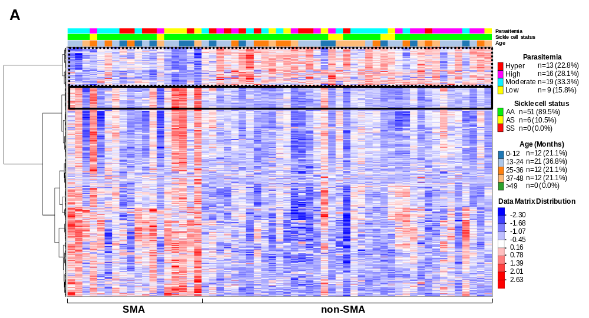

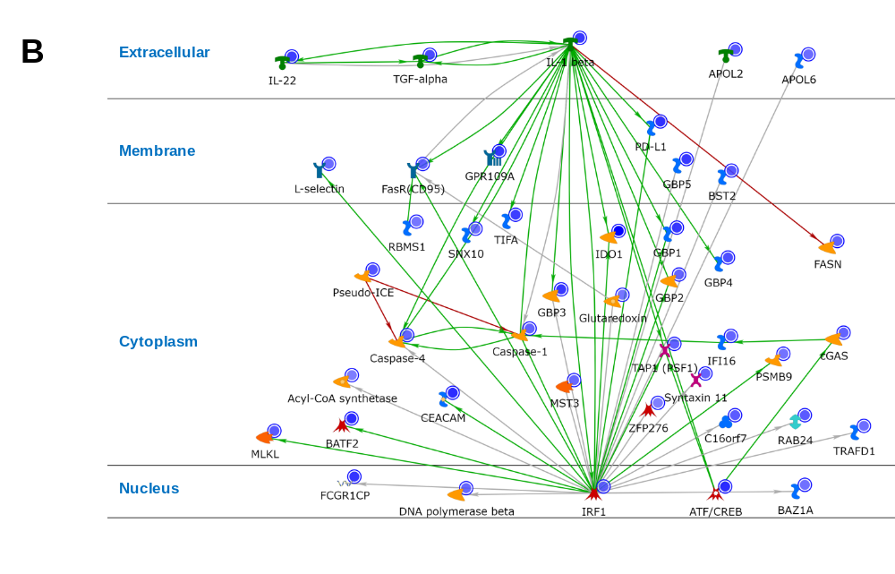

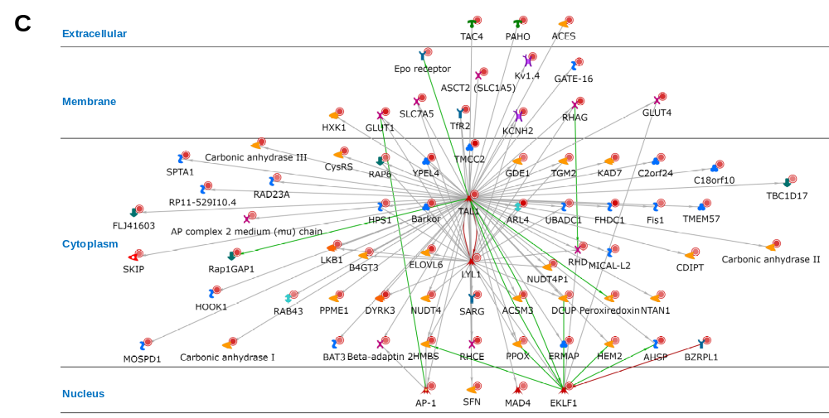
Supplemental Figure 2: Differential Gene Expression and Central Regulatory Features in SMA, excluding children presenting with sickle cell disease (SCD). Children presented with either non-SMA (Hb≥6.0g/dL, n=39) and SMA (Hb<6.0g/dL, n=18). (A). Hierarchical Clustering Heatmap. A non-supervised hierarchical cluster analysis of the top 1000 DEGs was performed, on log₂(FPKM+1) of union differential expression genes in children with SMA relative to those in the non-SMA group, excluding children with sickle cell disease (HbSS). Genes within the same cluster show the same trends in expression levels under different clinical groups. The white color implies the average magnitude of gene expression. The brightest blue represents the smallest value, and the brightest red represents the highest value. For the two major clusters that emerged, DEGs enrichment analysis using MetaCoreTM was performed and canonical pathway maps for direct functional interactions were generated. Cluster 1 shown in hatched black outline and cluster 2 shown with solid black outline. (B). Cluster 1 (n=156) genes represented the IRF1↔IL-1β↔Caspase-1↔Caspase-4↔FasR network, with IRF1, as the central divergence hub (36 direct interactions) and IL-1β as the central convergence hub (27 direct interactions). Top emerging process was the cellular response to IFN-β (p=4.126E-09). (C). The network that emerged for cluster 2 (n=100) genes was TAL1↔LYL1↔EKLF1↔HMBS↔RHD, with the transcription factor, TAL1, as the central divergence hub (74 direct interactions), and a secondary transcription factor LYL1, with a divergence hub (30 direct interactions), and HMBS as the central convergence hub (5 direct interactions). The top process associated with the functional interactions for cluster 2 was protoporphyrinogen IX biosynthetic process (p= 5.381E-08). The details of symbols used in these figures are available at: https://portal.genego.com/legends/MetaCoreQuickReferenceGuide.pdf.

