Supporting information

Turing cationic antimicrobial peptide KR-12 into Self-assembled nanobiotics with potent bacterial killing and LPS neutralizing activities

Ruyi Lei^{a#✉}, Yaqi Sun^{b#}, Tao Zhu^{c#}, Chujun Yang^{a#}, Zhiqiang Zhuª, Dejian Liª, Yunqing Yang^{d}, Liman Hao^{b}, Yang Li^{b}, Shuijing Wu^{b}, Hongwei Cui^{e}, Yumin Jiangª, Jiafeng Xieª, Hui Peiª, Jiye Liª, Yujing Maoª, Chao Lan^{a✉}, Changju Zhu^{a✉}, Xiangming Fang^{b✉}
ªDepartment of Emergency, the First Affiliated Hospital of Zhengzhou University, Zheng zhou 450052, China
^{b}Department of Anesthesiology, The First Affiliated Hospital, School of Medicine, Zhejiang University, Hangzhou 310003, China
^{c}Department of Critical Care Medicine, Sir Run Run Shaw Hospital, School of Medicine, Zhejiang University, Hangzhou, China.
^{d}Department of Breast Surgery, The First Affiliated Hospital of Zhengzhou University, Zhengzhou 450052, China.
^{e}Department of General ICU, The First Affiliated Hospital of Zhengzhou University, Zhengzhou 450052, China.
#Contributed equally.

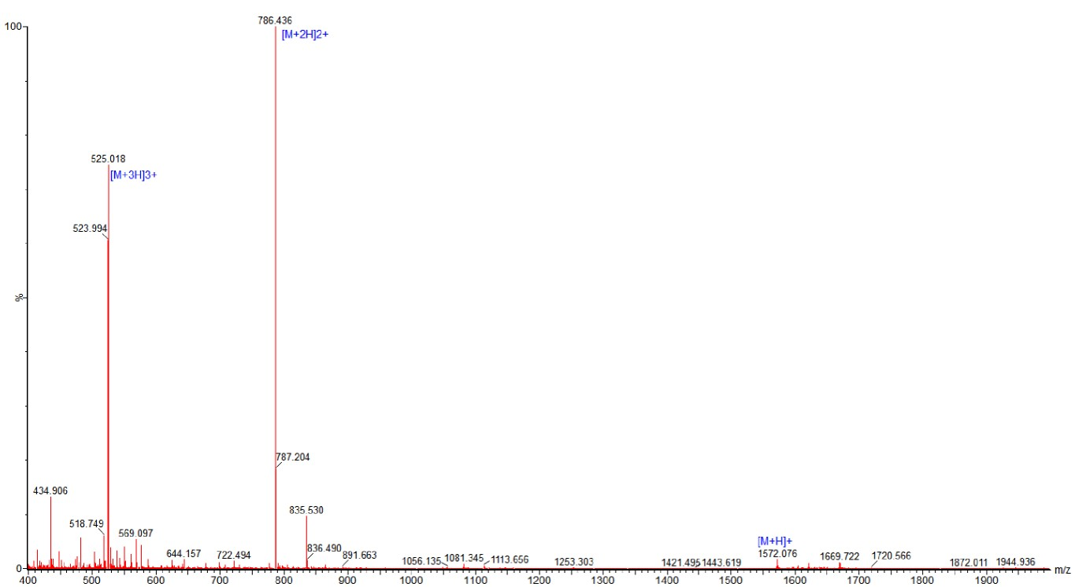
Figure S1. Electrospray ionization (ESI) mass (MS) spectrum of KR-12. The calculated molecular weight (Mw) is 1571.95, and the observed Mw is 1572.05.

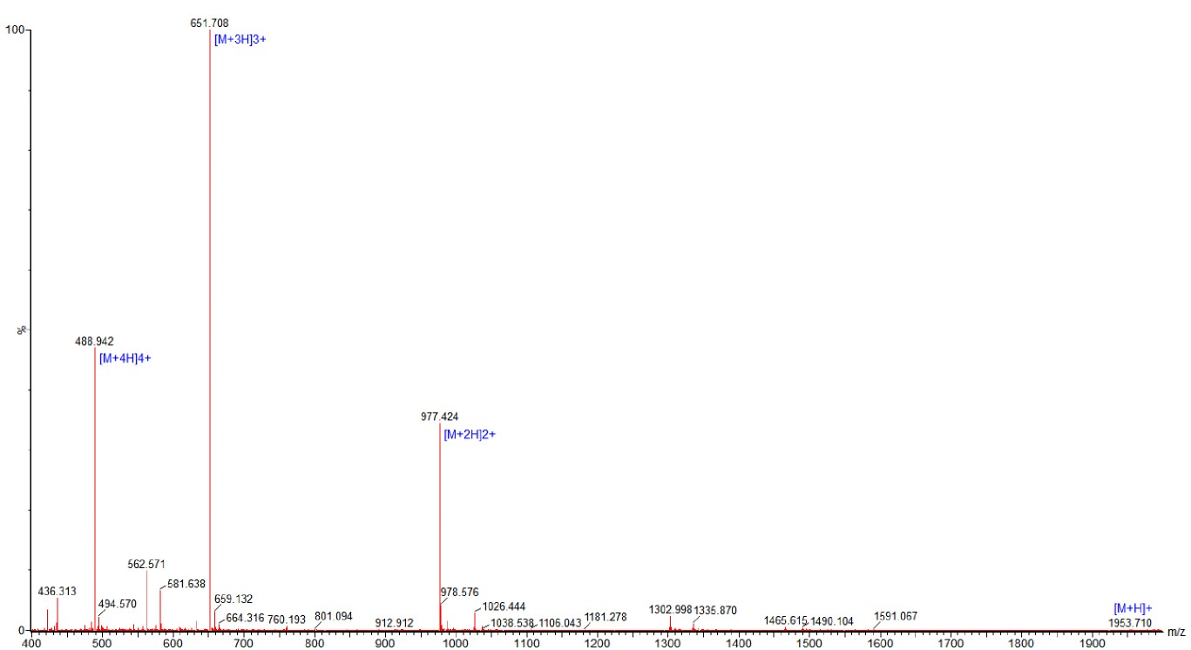
Figure S2. Electrospray ionization (ESI) mass (MS) spectrum of Myr-KR-12N. The calculated molecular weight (Mw) is 1952.48, and the observed Mw is 1952.12.

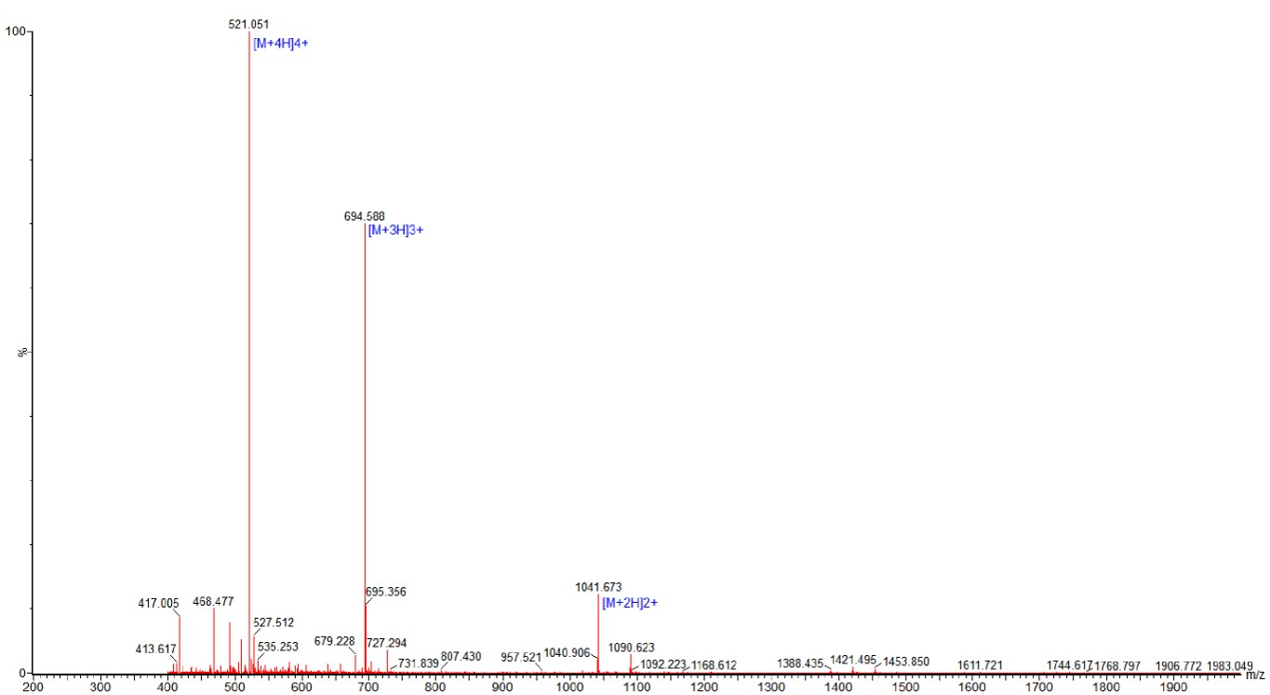
Figure S3. Electrospray ionization (ESI) mass (MS) spectrum of Myr-KR-12C. The calculated molecular weight (Mw) is 2081.65, and the observed Mw is 2081.76.

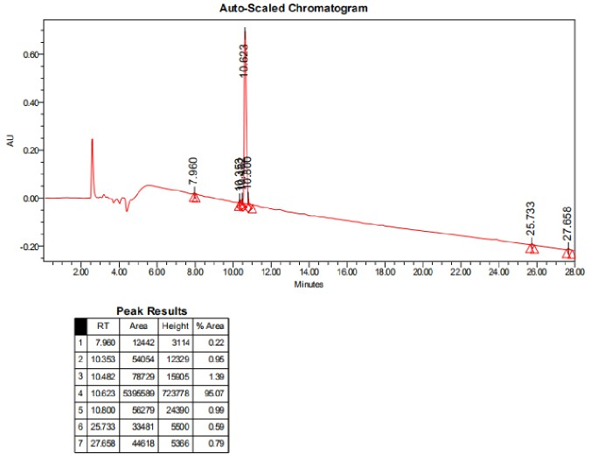
Figure S4. High-performance liquid chromatography (HPLC) analysis of KR-12. HPLC analysis of KR-12 were performed to confirm its purity of 95.07%.

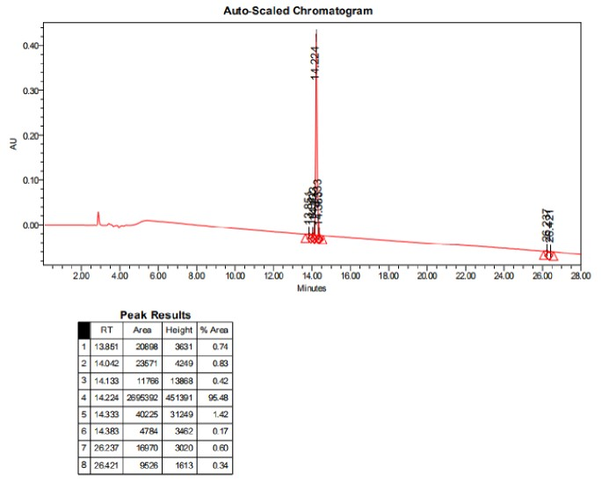
Figure S5. High-performance liquid chromatography (HPLC) analysis of Myr-KR-12N. HPLC analysis of Myr-KR-12N were performed to confirm its purity of 95.48%.

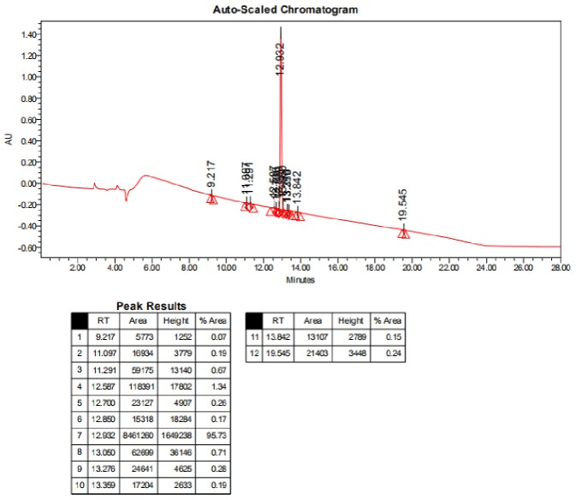
Figure S6. High-performance liquid chromatography (HPLC) analysis of Myr-KR-12C. HPLC analysis of Myr-KR-12C were performed to confirm its purity of 95.73%.

Table S1 Secondary structure of KR-12, Myr-KR-12N and Myr-KR-12C based on CD spectrum
 | Helix 1 | Helix2 | Strand 1 | Strand 2 | Turns | Unordered | Total
KR-12 | -0.001 | 0.028 | 0.295 | 0.196 | 0.229 | 0.253 | 0.999
Myr-KR-12N | -0.001 | 0.028 | 0.294 | 0.195 | 0.228 | 0.252 | 0.997
Myr-KR-12C | -0.001 | 0.028 | 0.295 | 0.196 | 0.229 | 0.252 | 0.998

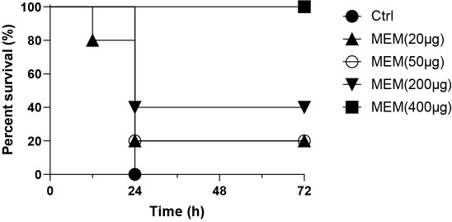
Figure S7. Therapeutic efficacy of MEM in bacterial sepsis. 5 mice per group were intraperitoneally challenged with 1 × 10⁷ CFU of E. coli, and different doses of MEM were then administered as single-dose treatments.

Figure S8. Toxicity of KR-12, Myr-KR-12N and Myr-KR-12C in vitro and in vivo. (A) The dose-dependent hemolytic activity of KR-12, Myr-KR-12N and Myr-KR-12C examined in mouse red blood cells. Percent hemolysis was calculated as described in the experimental section. The data are presented as mean ± SD from five independent experiments. (B) Toxicity of Myr-KR-12N in vivo. 5 mice per group were intraperitoneally injected with 100 μg of Myr-KR-12N per experimental animal or PBS as control. Body weight were monitored every day for 7 days. No difference was observed between the 2 groups.

Figure S9. Toxicity of KR-12, Myr-KR-12N and Myr-KR-12C in vivo. four groups of mice (6 mice per group) were subcutaneously injected with 240 μg of KR-12, Myr-KR-12N or Myr-KR-12C or PBS every 2 h for 6 times injection. At 20 h after the last injection of the drug, liver, kidney and blood were collected from the mice. Serum was taken for liver function (A-B) and kidney function (C-D) tests. No liver or kidney dysfunction was observed after treating with these nanobiotics.

Figure S10. Toxicity of KR-12, Myr-KR-12N and Myr-KR-12C in vivo. 4 groups of mice (6 mice per group) were subcutaneously injected with 240 μg of KR-12, Myr-KR-12N or Myr-KR-12C or PBS every 2 h for 6 times. At 20 h after the last injection of the drug, liver, kidney and blood were collected from the mice. The liver and kidney were fixed in formalin and then subjected to histopathological examination. No histopathological changes were observed after treating with these peptides.

