Supplementary Materials for

The dirty side of clean energy: Lithium ion batteries as a source of PFAS in the environment
Jennifer L. Guelfo, P. Lee Ferguson, Jonathan Beck, Melissa Chernick, Alonso Doria-Manzur, Patrick W. Faught, Thomas Flug, Evan P. Gray, Nishad Jayasundara, Detlef R. U. Knappe, Abigail S. Joyce, Pingping Meng, Marzieh Shojaei
Corresponding authors: jennifer.guelfo@ttu.edu; lee.ferguson@duke.edu

The PDF file includes:

Supplementary Text
Figs. S1 to S19
Tables S1 to S8
References

Other Supplementary Materials for this manuscript include the following:

Data S1 to S7 (single Excel file, Guelfo et al. Data)

Supplementary Text
Background
There is no universal definition of PFAS, but there are three commonly referenced definitions^{42,43}. The Organisation for Economic Co-operation and Development (OECD) defines a PFAS as, "fluorinated substances that contain at least one fully fluorinated methyl or methylene carbon atom⁴²." Additionally, a landmark paper by Buck et al. defined perfluoroalkyl PFAS as, "aliphatic substances for which all of the H atoms attached to C atoms... have been replaced by F atoms...⁴³." The USEPA recently added PFAS as a class to a list of unregulated contaminants that will be monitored in drinking water across the United States⁴⁴. For this purpose, PFAS are defined as chemicals that have at least one of R-(CF2)-CF(R')R", R-CF2OCF2-R', or CF3C(CF3)RR', and USEPA has provided a list of 10,239 PFAS that meet this definition on the USEPA Comptox dashboard⁴⁵.
Bis-perfluoroalkyl sulfonimide (bis-FASI) salts including bis-FMeSI and its longer-chain homologues (e.g., bis(pentafluoroethylsulfonyl)imide; bis-FEtSI) are produced internationally by companies including 3M and Solvay, accounting for over 57% and 13%, respectively, of global production^{5,7,24}. For example, 3M was issued a patent for bis-FASIs in 1999²², and advertises the Li⁺ salt of bis-FMeSI as lithium ion battery (LiB) electrolyte HQ-115⁶³, manufactured at facilities in Cottage Grove, MN, Cordova, IL, and Antwerp, Belgium³⁵. Solvay markets this same compound as LiTFSi⁶⁴ and production is centered in Salindres, France⁶⁵. In 2013, Solvay issued a press release reporting that they had doubled their production capacity of the Li salt of bis-FMeSI⁶⁶. Arkema markets a similar electrolyte, lithium bis(fluorosulfonyl)imide (i.e., LiFSi) that has only sulfur-fluorine bonds⁷, but also holds patents for battery electrolytes comprised of mixtures of Li salts that include both LiFSi and Li⁺ salts of bis-FMeSI⁶⁷. Further, Arkema manufactures Kynar PVDF for use in applications including LiBs⁶⁸. Of the bis-FASIs, bis-FMeSI is most well documented for use in LiB applications, but other perfluoroalkyl homologues including bis-FEtSI (CAS 132843-44-8) and bis(nonafluorobutylsulfonyl)imide; CAS 119229-99-1; bis-FBSI) are mentioned in LiB electrolyte patents³, and may be present as unintentionally-produced byproducts of bis-FASI salts⁴³.

Field blanks and duplicates
PFAS in all project field blanks were below detection with the exception of 1.06 ng/L GenX detected in January 2022 samples (Data S1). PFAS concentrations in aqueous field duplicates were generally within 25% (Data S1, S2, and S6), which indicates sampling protocol collected representative samples. There were limited exceptions when evaluating results of duplicate samples in the single digit ng/L levels where even minor concentration differences comprise percentages > 25% (e.g., PFOS concentrations of 7.63 and 4.90 ng/L in duplicate samples from EU 9, Data S6).

Minnesota results: Minneapolis-St. Paul region
In both January and June, there were unexpected detections of comparatively low concentrations ($≤$12 ng/L; Data S1-S2) of perfluoroalkyl ether acids (PFEAs) in samples proximal to 3M plant discharge (MN 4, MN 22), even though 3M is not a known producer of PFEAs. It is possible that 3M processes that use hexafluoropropylene oxide are at least partially responsible for unintentional production of PFEAs¹⁰. Regardless, these results demonstrate that environmental occurrence of PFEAs may result from manufacturers other than e.g. Chemours⁶⁹, albeit at much lower levels.
Minnesota results: Lake Elmo region
June sampling included locations north of Cottage Grove in Lake Elmo, MN, which has documented PFAS impacts resulting from historical disposal of 3M waste in the former Washington County Landfill (1969-1975). Concentrations in surface waters near Lake Elmo were <1 ng/L with the exception of 4.54 ng/L detected in Lake Elmo (MN 27). Due to relatively low concentrations, it is unclear if this results from legacy PFAS disposal or dispersed, atmospheric deposition. The oldest 3M patent that could be located for bis-FASIs was submitted in 1995, but presumably research and development pre-dated 1995. Lake Elmo is situated northeast of 3M Cottage Grove and crosswind of the primary wind directions (Fig. 1, main manuscript). Regardless of source and as noted in the main manuscript, these results demonstrate wide distribution of bis-FMeSI aqueous impacts in the Minneapolis-St. Paul region.

Minnesota results: Avian species
Multiple avian species were observed near the Mississippi River sampling sites including Haliaeetus leucocephalus (bald eagle), Cygnus buccinator (trumpeter swan), and Anas platyrhynchos (mallard) (Fig. S8). During January samples, birds were observed near unfrozen portions of the river such as warmer water in the vicinity of the 3M outfall (MN 4). While the toxicity of PFAS to these bird species is not well understood, a recent study proposed chronic reproductive toxicity thresholds for avian species (Colinus virginianus or bobwhite quail) of 100 ng/L via drinking water. These values decreased to <100 ng/L when mixtures were present, suggesting potential for synergistic effects⁷⁰. A recent study of PFAS in bald eagle nestlings from 3 industrialized areas found that PFAS were most elevated in the region of the 3M Cottage Grove facility⁷¹. Collectively results of this study and others raise significant questions regarding the impacts of aqueous releases of bis-FMeSI and other PFAS on terrestrial organisms in the region.

Europe results
Detections of bis-FASIs in the Antwerp region are discussed in the main manuscript. A total of 30 additional PFAS were detected at concentrations of 1.16 ng/L (PFO4DA) to 145,000 ng/L (PFOS; Data S6). PFBA (1.21-40,700 ng/L), PFPeA (5.74 - 36,700 ng/L), PFHxA (12.7 - 94,000 ng/L), PFHpA (3.81 - 40,800 ng/L), PFOA (5.18 - 68,200 ng/L), PFBS (5.38 - 20,900 ng/L), and PFOS (5.02 - 145,000 ng/L) were detected in all surface water samples. PFEA concentrations up to 178 ng/L (PFMOAA) were observed at EU 17, consistent with aqueous PFEA detections at MN 4 near the 3M, Cottage Grove facility. In Antwerp soils and sediments, 27 additional PFAS were detected at concentrations of 2.08 (EtFOSAA, EU 19 soil) - 23,040,288 (PFOS, EU 17 sediment) ng/kg. PFCAs (C6, C7, and C9-C14), PFSAs (C8 and C9), and EtFOSAA were detected in all soil and sediments along with more intermittent detections of FASAs (e.g., FHxSA and MeFOSAA) and 8Cl-PFOS, which are all consistent with 3M synthesis of PFAS using electrochemical fluorination^{43,72}. Fluorotelomer (FT) -based PFAS (e.g., 4:2 FTS and 6:2 FTS) were also detected, but at much lower levels (21.6 - 7,282 ng/kg).
In Salindres, bis-FMeSI was detected at concentrations of 4.36-6.55 ng/L in 2 samples (EU 24 and EU 25) collected in the L'Arias River proximal to and downstream of a Solvay facility (Data S6). A total of 18 additional PFAS (1.73 ng/L PFDA - 65.3 ng/L PFPeA) were detected in surface water samples from this region, and in the majority of PFAS, maximum concentrations were also detected at EU 24 and EU 25 (Data S6). Similarly, bis-FMeSI and/or homologues were also detected in all soils and sediment samples collected in the Salindres region at total bis-FASA concentrations of 42.1 (EU 21) - 253 (EU 20) ng/kg and 50.4 (EU 23) - 3,886 (EU 22) ng/kg, respectively, and bis-FBSI was the dominant homologue in 8 of 11 samples with bis-FASI detections (Fig. S13, Data S7). Despite similar bis-FASA distributions in the soils and sediments of the Antwerp and Salindres regions, signatures of other PFAS were reflective of different production chemistry. A total of 23 additional PFAS were detected at concentrations of 13.0 (PFHxS, EU 25 sediment) - 40,433 (PFOS, EU 22 sediment) ng/kg, so maximum concentrations were orders of magnitude lower than in Antwerp, and maximum FT-based PFAS concentrations (e.g., 13,952 ng/kg 6:2 FTS in EU 22 sediment and 11,431 ng/kg 8:2 FTS in EU 20 soil) were the same order of magnitude as PFOS.

Toxicity: D.magna
Unequal variance that changes with exposure dose is an underutilized but promising indicator of toxicity in exposed populations. Studies suggest it may be an earlier and more sensitive indicator of toxicological effects relative to parameters such as the mean^{32,73,74}. A Chi² test with a Bonferroni correction was used as an intercomparison metric to assess differences in velocity variance of control organisms vs. variance at each exposure concentration. Velocity variance at doses of 10, 1000, and 5000 ng/L bis-FMeSI were different from control variance.
As noted in the main manuscript, we did not identify prior studies that investigated sublethal impacts of PFAS on D. magna swimming behavior. Two prior studies concluded that PFBA, PFHxA, PFOA, PFNA, PFHxS, PFOS, and GenX lead to metabolic perturbations in D. magnia, which may be consistent with changes in swimming behavior observed herein; however exposure concentrations were $≥$1 mg/L^{75,76}. Prior studies with non PFAS toxicants have observed more significant impacts in endpoints evaluated here, but as with PFAS studies, dosing concentrations were higher⁷⁷. These results demonstrate the value of sublethal D. magna testing as a method of screening toxicity at the ng/L level, and support further exploration of variance as a novel toxicity endpoint.
The water quality parameters for D. magna toxicity test media are reported below in Table S6. All measured data are meet the required values or ranges described in EPA-821-R-02-012⁷⁸. The nominal concentrations of bis-FMeSI are also reported in Table S6, and increase from lowest highest exposure concentration.

Toxicity: zebrafish
The zebrafish assay for mitochondrial function included basal mitochondrial respiration, adenosine triphosphate (ATP) production, non-mitochondrial respiration, proton leak, spare capacity, and maximum mitochondrial respiration. Concentration dependent decreases were observed for all parameters except ATP production and non-mitochondrial basal respiration, with the highest concentration tested (i.e., 250,000 ng/L) statistically significant (Fig. S16). While not statistically significant, it should be noted that there were slight increases in maximal mitochondrial respiration and pare capacity for embryos exposed to the lowest concentration (i.e., 25 ng/L). This trend is consistent with the hyperactivity observed in the DanioVision assay (Fig. 3, main manuscript).

Treatment: oxidation
Oxidative conditions applied in this study are also used in a sample preparation technique known as the total oxidizable precursor (TOP) assay. The TOP assay is used to quantify the total concentration of unknown oxidizable precursors. It relies on oxidative conversion of unknown PFAS to terminal PFCAs that can be captured during targeted analysis⁵⁰. Increases in PFCAs that cannot be attribute to known oxidizable precursors are often used as a proxy for the total molar concentration of unknown PFAS in a sample.⁵⁰ TOP will not capture the concentrations of PFAS that are resistant to oxidation unless they are directly analyzed. Few, if any labs, routinely analyze bis-FASIs, which means their occurrence in samples would not be captured either by targeted or TOP-based analysis using standard methods

Fig. S1. Locations of samples collected in January and/or June 2022 near Cottage Grove, MN, US (left panel). The yellow box is the approximate extent of the map showing the southern sampling locations (right panel). The red square is the approximate location of 3M, Cottage Grove. MN 17 was collected from an office water bubbler not tied to a geographic location, so it is not depicted. Site location descriptions are in Table S2.

Fig. S2. Locations of samples collected in September, 2022 near Paducah, KY, US (upper panel). Note that locations KY1 and KY2 were collected while en route to the Paducah region in Knoxville and Nashville, TN respectively, and their locations are not shown. The yellow box is the approximate extent of the central sampling locations (bottom panel). The red box is the approximate location of Arkema, Calvert City. Site location descriptions are in Table S3.

Fig. S3. Locations of samples collected in September, 2022 near Louisville, KY, US. The red box is the approximate location of Arkema and Chemours in Louisville, KY. Site location descriptions are in Table S3.

Fig. S4. Locations of samples collected in October, 2022 near Antwerp, Belgium (top panel). The yellow box represents the approximate extent of the map showing the southern sampling locations (lower panel). The red square is the approximate location of 3M, Antwerp. Site location descriptions are in Table S4.
Fig. S5. Locations of samples collected in October, 2022 near Salindres, France. The red square is the approximate location of Solvay. Site location descriptions are in Table S4.

Fig. S6. A comparison of PFAS concentrations in June aqueous samples from the laboratories at Texas Tech University (x-axis) and Duke University (y-axis). Red points are bis-FMeSI results, and the red dashed line represents 1 to 1 agreement. Results show excellent agreement between the two labs with the expected increase in variability as results approach the limit of detection.

Fig. S7. USGS topographic map showing the location of the 3M Cottage Grove Center and associated disposal ponds. The creek which receives the 3M outfall before flowing into a holding pond and discharging into the Mississippi at sampling location MN 4 has been highlighted blue.

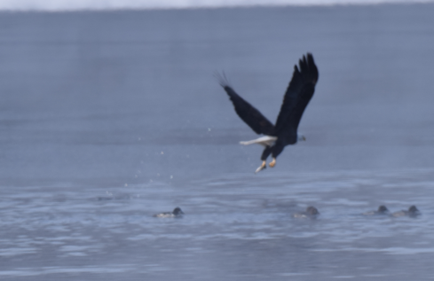

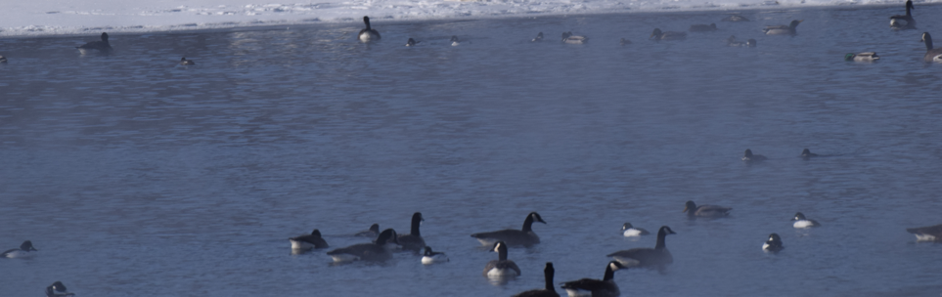

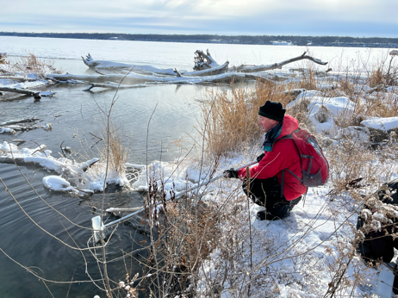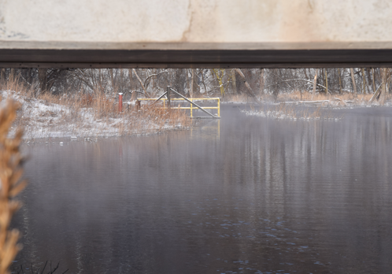

Fig. S8. Avian species observed in the Mississippi River during the January sampling including Cygnus buccinator (trumpeter swan; top left), Haliaeetus leucocephalus (bald eagle; top right), and other species including Branta canadensis (Canada Goose; center). Species were observed near unfrozen portions of the river including the 3M outfall creek (MN4) depicted facing towards the Mississippi River in the bottom left panel during sampling and facing towards 3M Cottage Grove in the bottom right panel.

Fig. S9. Field log K_{d} values calculated using sediment concentrations (C_{s}, ng/kg) and surface water concentrations (C_{w}, ng/L) from MN 4 for all PFAS that occurred in both media.

Fig. S10. Concentrations (ng/kg) of long chain PFCAs, bisFMeSI, and bis-FBSI in soils (black text) and sediment (brown text) collected in and near the Tennessee River in the Paducah, KY region, September 2022. The red box is the approximate location of Arkema facility outside of Paducah in Calvert City, KY.

Fig. S11. Concentrations of bis-FMeSI in surface water (ng/L) in the Antwerp sampling region in October 2022. The red marker denotes the location of 3M Antwerp

Fig. S12. Concentrations (ng/kg) of total bis-FASIs (sum of bis-FMeSI, bis-FEtSI, and bis-FBSI) in sediment (left panel) and soils (right panel) in the Antwerp region in October 2022 where pie charts denote the fraction of each homologue. The red marker denotes the location of 3M Antwerp.

Fig. S13. Concentrations (ng/kg) of total bis-FASIs (sum of bis-FMeSI, bis-FEtSI, and bis-FBSI) in sediment (left panel) and soils (right panel) in the Salindres region in October 2022 where pie charts denote the fraction of each homologue. The red marker denotes the location of Solvay, Salindres.

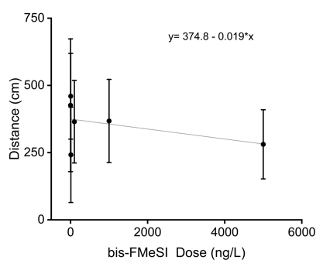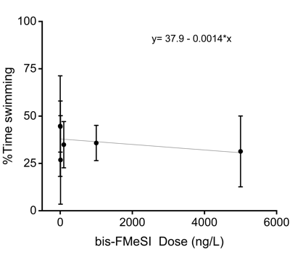
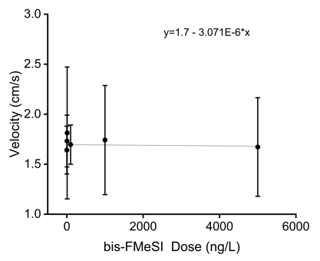
Fig. S14. Evaluation of individual swimming metrics vs. dose for D. magna. Pearson's correlations for distance, percent time swimming, and velocity were -0.45, -0.36, and -0.32, respectively, which indicates moderate to weak assocations. These weaker associations result from high variability observed in each endpoint, including controls

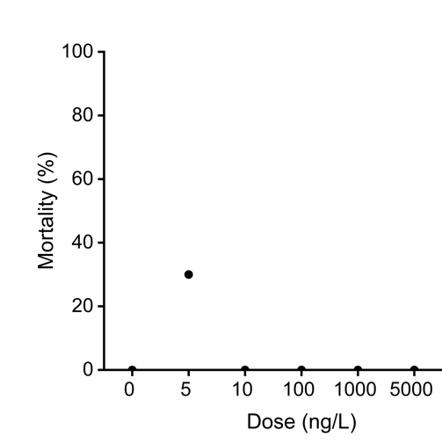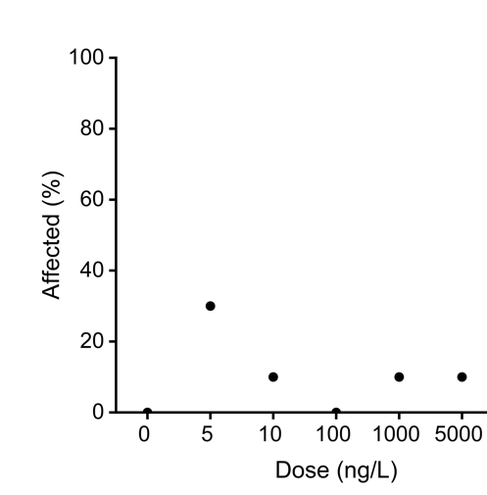
B
A
Fig. S15. Acute toxicity endpoints of (A) lethality and (B) lethality and immobilization. Ten total daphnia were exposed individually, therefore no standard deviation of either metric is reported. Test design was optimized for determination of swimming behavior.

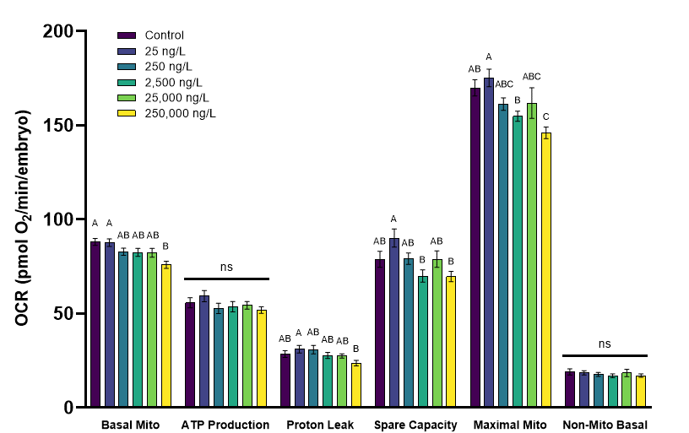
Fig. S16. Mitochondrial function of embryos (30 hpf) exposed to a range of concentrations of Li-HQ-115. Histogram is grouped by mitochondrial parameter. Bars represent mean ±SEM. Different letters represent statistical differences within each parameter (p<0.05; one-way ANOVA or Kruskal-Wallis; n=28 for basal mitochondrial respiration, ATP Production, and non-mitochondrial respiration; n=14 for proton leak, spare capacity, and maximum mitochondrial respiration).

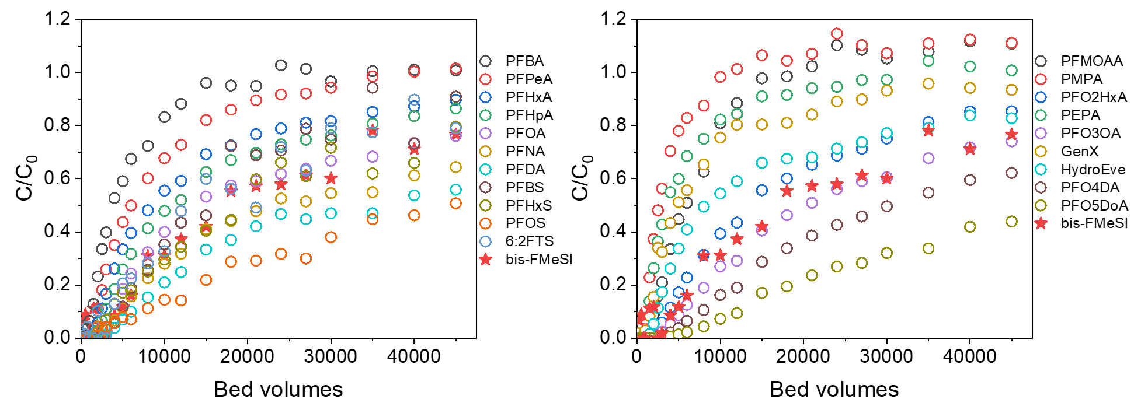Fig. S17. Normalized breakthrough (C/C₀) curves of 21 PFAS (left: bis-FMeSI compared to PFCAs and PFSAs; right: bis-FMeSI compared to PFEAs) in the GAC column in coagulated, settled surface water with a TOC level of 2.3 mg/L.

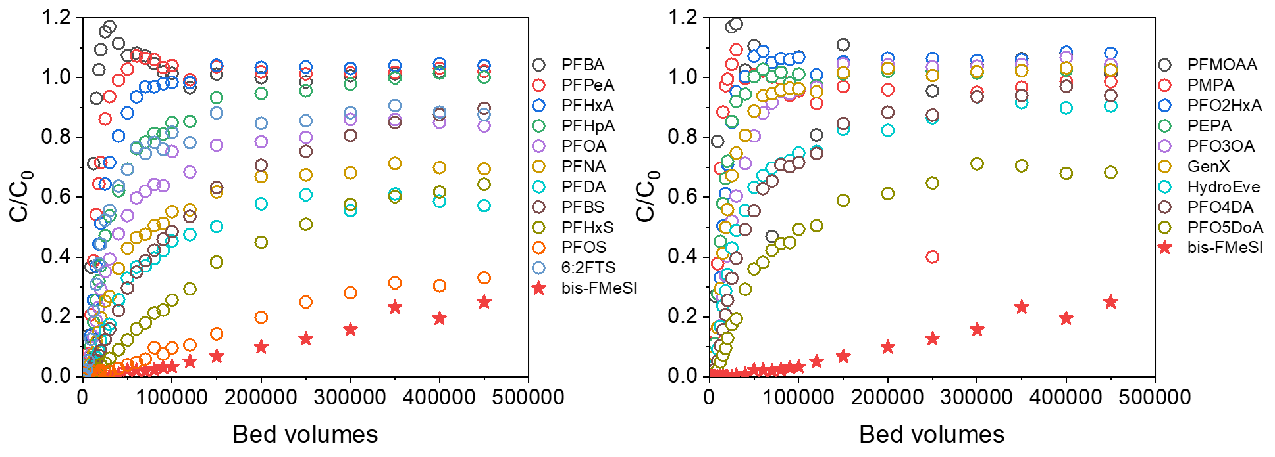
Fig. S18. Normalized breakthrough (C/C₀) curves of 21 PFAS (left: bis-FMeSI compared to PFCAs and PFSAs; right: bis-FMeSI compared to PFEAs) in the IX column in groundwater with a TOC level of 4.6 mg/L.

Fig. S19. Percent recovery of bis-FMeSI, bis-FEtSI, and bis-FBSI in spiked, deionized water following alkaline, heat activated persulfate activation.

Table S1. Target analytes and isotopically labeled standards used in this study.
Target analyte | Acronym | Isotopically labeled standards | CASRN
Perfluoroalkyl carboxylate (PFCA)¹
Perfluorobutanoic acid | PFBA | [ ¹³C₃] PFBA | 375-22-4
Perfluoropentanoic acid | PFPeA | [ ¹³C₄] PFPeA | 2706-90-3
Perfluorohexanoic acid | PFHxA | [ ¹³C₅] PFHxA | 307-24-4
Perfluoroheptanoic acid | PFHpA | [ ¹³C₄] PFHpA | 375-85-9
Perfluorooctanoic acid | PFOA | [ ¹³C₈] PFOA | 335-67-1
Perfluorononanoic acid | PFNA | [ ¹³C₈] PFNA | 375-95-1
Perfluorodecanoic acid | PFDA | [ ¹³C₆] PFDA | 335-76-2
Perfluoroundecanoic acid | PFUnA | [ ¹³C₇]PFUnA | 2058-94-8
Perfluorododecanoic acid | PFDoA | [ ¹³C₂] PFDoA | 307-55-1
Perfluorotridecanoic acid | PFTrDA | [ ¹³C₂] PFTeDA | 72629-94-8
Perfluorotetradecanoic acid | PFTeDA | [ ¹³C₂] PFTeDA | 376-06-7
Perfluoroalkyl sulfonate (PFSA)¹
Perfluorobutane sulfonic acid | PFBS | [ ¹³C₃] PFBS | 375-73-5
Perfluoropentane sulfonic acid | PFPeS | [ ¹³C₃] PFBS | 2706-91-4
Perfluorohexane sulfonic acid | PFHxS | [ ¹³C₃]PFHxS | 355-46-4
Perfluoroheptane sulfonic acid | PFHpS | [ ¹³C₈] PFOS | 375-92-8
Perfluorooctane sulfonic acid | PFOS | [ ¹³C₈] PFOS | 1763-23-1
Perfluorononane sulfonic acid | PFNS | [ ¹³C₈] PFOS | 68259-12-1
Perfluorodecane sulfonic acid | PFDS | [ ¹³C₈] PFOS | 335-77-3
Per- and polyfluoroalkylether carboxylate (PFECA)²
Perfluoro-2-propoxypropanoic acid | GenX  (HFPO-DA) | [¹³C₃]-HFPO-DA | 13252-13-6
4,8-dioxa-3H-perfluorononanoic acid | ADONA | [¹³C₈] PFOA | 919005-14-4
Perfluoro-2-methoxyacetic acid | PFMOAA | [¹³C₃] PFBA | 674-13-5
Perfluoro-3-methoxypropanoic acid (linear) | PFMPA³ | [¹³C₃] PFBA | 377-73-1
Perfluoro-2-(perfluoromethoxy)propanoic acid (branched) | PFMPA³ | [¹³C₃]-HFPO-DA | 13140-29-9
Perfluoro-4-methoxybutanoic acid (linear) | PFMBA⁴ | [¹³C₅] PFHxA | 863090-89-5
Perfluoro-2-ethoxypropanoic acid (branched) | PFMBA⁴ | [¹³C₃]-HFPO-DA | 267239-61-2
Perfluoro-3,5-dioxahexanoic acid | PFO2HxA | [¹³C₄] PFPeA | 39492-88-1
Perfluoro-3,6-dioxaheptanoic acid | PFO2HpA | [¹³C₄] PFHpA | 151772-58-6
Perfluoro-3,5,7-trioxaoctanoic acid | PFO3OA | [¹³C₅] PFHxA | 39492-89-2
Perfluoro-3,5,7,9-butaoxadecanoic acid | PFO4DA | [¹³C₄] PFHpA | 39492-90-5
Perfluoro-3,5,7,9,11-pentaoxadodecanoic acid | PFO5DoA | [¹³C₈] PFNA | 39492-91-6
Perfluoro-2-ethoxypropanoic acid | PEPA | [¹³C₄] PFPeA | 267239-61-2
HydroEve | HydroEve | [¹³C₄] PFHpA | 773804-62-9
Per- and polyfluoroalkylether sulfonate (PFESA)²
Perfluoro(2-((6-chlorohexyl)oxy) ethanesulfonic acid) | 9Cl-PF3ONS | [¹³C₈] PFOS | 756426-58-1
11-chloroeicosafluoro-3-oxaundecane-1-sulfonic acid | 11Cl-PF3OUdS | [¹³C₈] PFOS | 763051-92-9
Nafion Byproduct 2 | Nafion Byproduct 2 | [¹³C₃]PFHxS | 749836-20-2
1,1,2,2-tetrafluoro-2-(1,2,2,2-tetrafluoroethoxy) ethanesulfonate | NFHOS | [¹³C₃] PFBS | 1132933-86 -8
Chlorinated perfluoroalkyl sulfonate (Cl-PFSA)
Perfluoro-8-chloro-1-octanesulfonic acid | 8Cl-PFOS | [¹³C₈] PFOS | 777011-38-8
Fluorotelomer sulfonate (n:2 FtS)
4:2 fluorotelomer sulfonate | 4:2 FTS | [¹³C₂] 4:2FTS | 757124-72-4
6:2 fluorotelomer sulfonate | 6:2 FTS | [¹³C₂] 6:2FTS | 27619-97-2
8:2 fluorotelomer sulfonate | 8:2 FTS | [¹³C₂] 8:2FtS | 39108-34-4
Fluorotelomer carboxylate (n:x FTCA)
6:2 fluorotelomer carboxylic acid | 6:2 FTCA | [¹³C₂] 6:2FTCA | 53826-12-3
8:2 fluorotelomer carboxylic acid | 8:2 FTCA | [¹³C₂] 8:2FTCA | 27854-31-5
10:2 fluorotelomer carboxylic acid | 10:2 FTCA | [¹³C₂] 10:2FTCA | 53826-13-4
3:3 fluorotelomer carboxylic acid | 3:3 FTCA | [¹³C₂] 6:2FTCA | 356-02-5
5:3 fluorotelomer carboxylic acid | 5:3 FTCA | [¹³C₂] 6:2FTCA | 914637-49-3
7:3 fluorotelomer carboxylic acid | 7:3 FTCA | [¹³C₂] 6:2FTCA | 812-70-4
Perfluoroalkanesulfonamide (FASA)
Perflurobutanesulfonamide | FBSA | [¹³C₈] FOSA | 30334-69-1
Perfluorohexanesulfonamide | FHxSA | [¹³C₈] FOSA | 41997-13-1
Perfluorooctanesulfonamide | FOSA | [¹³C₈] FOSA | 754-91-6
Perfluorodecanesulfonamide | FDSA | [¹³C₈] FOSA | 4262-70-8
Bisperfluoroalkanesulfonimide (bisFASIs)
Bisperfluoromethane sulfonamide | bis-FMeSI | [¹³C₄] PFPeA | 82113-65-3
Bisperfluoroethanesulfonamide | bis-FEtSI | [¹³C₂] PFHxA | 152894-10-5
Bisperfluorobutanesulfonamide | bis-FBSI | [¹³C₄] PFHpA | 39847-39-7
Perfluoroalkane sulfonamido acetic acid
N-methylperfluorooctanesulfonamido acetic acid | N-MeFOSAA | [²H₃] N-MeFOSAA | 2355-31-9
N-ethylperfluorooctanesulfonamido acetic acid | N-EtFOSAA | [²H₅] N-EtFOSAA | 2991-50-6
^{1.}PFCAs and PFSAs referred to collectively as perfluoroalkyl acids (PFAAs). ^{2.}PFECAs and PFESAs are referred to collectively as per- and polyfluoroalkyl ether acids (PFEAs). ^{3.}PFMPA is used herein to refer to both the linear and branched isomer (sometimes referred to as PMPA). Use of the PMPA acronym was avoided because it can refer to multiple PFAS with different molecular weights and because the linear standard was used for analysis at TTU and the branched standard at Duke and NCSU. ^{4.}Consistent with PFMPA, PFMBA is used herein to refer to both linear and branched isomer (sometimes referred to as PEPA). The linear standard was used for analysis at TTU and the branched standard at Duke and NCSU.
Table S2. Sample locations, dates, and types collected near Cottage Grove, MN.
Definitions: Surface water (SW); sediment (sed); tap water (TW); ground water (GW); Samples in red represent drinking water sources
Table S3. Sample locations, dates, and types collected near Paducah and Louisville, KY.
Definitions: Surface water (SW); sediment (sed)

Table S4. Sample locations, dates, and types collected near Antwerp, Belgium and Salindres, France
Definitions: Surface water (SW); sediment (sed)
Table S5. Parameters of GAC and IX columns used in this study.

Parameters | GAC | IX
Particle size (mm) | 0.069 | 0.070
GAC/IX mass (g) | 0.042 | 0.011
Empty bed contact time (min) | 0.056 | 0.0151
Bed depth (cm) | 0.99 | 0.425
Bed diameter (cm) | 0.318 | 0.318
Flow rate (mL/min) | 1.4 | 2.23
Hydraulic loading rate (m/h) | 10.6 | 16.9
Total organic carbon concentration in the influent water (mg/L) | 2.3 | 4.6
Total bed volume treated | 50,000 | 500,000

Table S6. Experimental water quality and bis-FMeSI dose confirmation data for all D. magna exposure testing. Water quality and parameters for EPA moderately hard water and measured values in dilution water for all 48-hr acute D. magna exposures.

Water Quality Parameter Validation
Parameter | Method Requirements | Measured values
pH | 7.4 - 7.8 | 7.5
Hardness (mg/L) | 80 - 100 | 91
Alkalinity (mg/L) | 57 - 64 | 62
DO (mg/L) | > 6 mg/L | 7.68
Conductivity (μS/cm) |  | 241
bis-FMeSI exposure dose validation
Nominal (ng/L) |  | Measured ± SD (ng/L)
0 |  | BQL (value?)
5 |  | 13.6 ±3.7
10 |  | 16.4 ±2.4
100 |  | 151 ±15.2
1000 |  | 1292 ±65.2
5000 |  | 6590 ±53.4

Table S7. Analysis of bis-FASIs in LiBs, battery binding agents, and landfill leachates
 |  | bis(perfluoroalkyl)sulfonimides
 |  | bis-FMeSI | bis-FESI | bis-FBSI
Batteries |  | Total mass in battery (± SD), ng |  |  | Battery type & size
Batteries | iPad Air battery A1484, 8827 mAh, 3.73 V | n.d. | n.d. | n.d. | LiPo, 133 mm (w) x 189 mm (h) 209 g
Batteries | iPhone 13 battery A2655, 3227 mAh, 3.84 V | n.d. | n.d. | n.d. | LiPo, 45 mm (w) x 88 mm (h) 80 g
Batteries | Liter Energy 102050 LiPo, 1000 mAh, 3.7 V | 54.8 (6.3) | 6.9 (0.1) | 5.4 (0.3) | LiPo, 20 mm (w) x 50 mm (h), 19 g
Batteries | UltraFire, 1800 mAh, 3.7 V | 21,800 (5,400) | n.d. | n.d. | 14500, 14.2 mm (d) x 48.5 mm (h), 21 g
Batteries | Tesla battery, 3500 mAh, 3.7 V | n.d | 13.3 (6.4) | n.d | 18650, 18 mm (d) x 65 mm (h), 47 g
Batteries | Panasonic NCR-18650-B, 3400 mAh, 3.6 V | n.d. | 5.4 (0.1) | n.d | 18650, 18 mm (d) x 65 mm (h), 47 g
Batteries | Panasonic NCR-18650-GA, 3450 mAh, 3.6 V | 19.3 (0.7) | n.d. | n.d. | 18650, 18 mm (d) x 65 mm (h), 47 g
Batteries | Samsung ICR18650-30B, 2950 mAh, 3.7 V | 35,600,000 (1,000,000) | n.d. | n.d. | 18650, 18 mm (d) x 65 mm (h), 47 g
Batteries | Samsung INR-18650-30Q, 3000 mAh, 3.6 V | 7.2 (1.6) | n.d. | n.d. | 18650, 18 mm (d) x 65 mm (h), 47 g
Batteries | Samsung INR-18650-25R, 2500 mAh, 3.6 V | n.d | n.d. | n.d. | 18650, 18 mm (d) x 65 mm (h), 47 g
Batteries | LithiumWerks APR-18650-M1B, 1200 mAh, 3.3 V | 228.2 (1.2) | n.d. | n.d. | 18650, 18 mm (d) x 65 mm (h), 47 g
Batteries | FST 18650, 2200 mAh, 3.6 V | 8,290 (47) | n.d. | n.d. | 18650, 18 mm (d) x 65 mm (h), 47 g
Batteries | Molicel INR-21700-P42, 4200 mAh, 3.6 V | n.d. | n.d. | n.d. | 21700, 21.7 mm (d) x 70.2 mm (h), 70 g
Batteries | Samsung INR-21700-40T, 4000 mAh, 3.6 V | n.d. | n.d. | n.d. | 21700, 21.7 mm (d) x 70.2 mm (h), 70 g
Batteries | Samsung INR-21700-50E, 5000 mAh, 3.6 V | 29.1 (0.7) | n.d. | n.d. | 21700, 21.7 mm (d) x 70.2 mm (h), 70 g
Batteries | Epoch INR-21700, 5000 mAh, 3.7 V | 8.6 (0.2) | n.d. | n.d. | 21700, 21.7 mm (d) x 70.2 mm (h), 70 g
Batteries | LG INR-21700-M50LT, 5000 mAh, 3.6 V | n.d. | n.d. | n.d. | 21700, 21.7 mm (d) x 70.2 mm (h), 70 g
 |  | Concentration in bulk material (± SD), ng/g |  |  | Description
 | PVDF Binder | 385 (2) | n.d. | n.d. | CAS 24937-79-9, avg. MW ~1,000,000
Landfill leachate
Landfill leachate |  | Dissolved concentration, ng/L |  |  | Sample collection date
Landfill leachate | Leachate A | 195 | n.d | n.d. | 1/10/22
Landfill leachate | Leachate A | 518 | n.d | n.d. | 3/25/22
Landfill leachate | Leachate A | 342 | n.d | n.d. | 4/7/22
Landfill leachate | Leachate A | 374 | n.d | n.d. | 5/24/22
Landfill leachate | Leachate B | 881 | n.d | n.d. | 1/10/22
Landfill leachate | Leachate B | 510 | n.d | n.d. | 3/25/22
Landfill leachate | Leachate B | 598 | n.d | n.d. | 4/7/22
Landfill leachate | Leachate B | 825 | n.d | 5.3 | 5/24/22

Table S8. Concentrations of bis-FASIs in spiked, deionized water before and after alkaline, heat-activated persulfate oxidation.

Compound | Pre- oxidation (ng/L) | $$±$$ | Post-oxidation (ng/L) | $$±$$ | Recovery (%)
bis-FMeSI | 862 | 13.9 | 993.966667 | 6.67 | 115
bis-FEtSI | 969 | 8.33 | 1076.31333 | 13.2 | 111
bis-FBSI | 652 | 36.7 | 676.307143 | 31.3 | 104

Data S1 (separate file). Concentrations of PFAS measured in surface water and snow (MN6) samples during the January 2022 sampling event in the Cottage Grove, MN region. PFAS from Table S1 that are not shown here were not detected in any project field sample.

Data S2 (separate file). Concentrations of PFAS measured in surface water samples during the June 2022 sampling event in the Cottage Grove, MN region. PFAS from Table S1 that are not shown here were not detected in any project field sample.

Data S3 (separate file). Concentrations of PFAS measured in soil (MN 28-MN 31) and sediment (MN1, MN4, MN24, MN 27) samples during the June 2022 sampling event in the Cottage Grove, MN region. PFAS from Table S1 that are not shown here were not detected in any project field sample.

Data S4 (separate file). Concentrations of PFAS measured in surface water samples collected while traveling to and from KY (KY 1-2, KY 31-32) near Paducah, KY (KY 2-KY1 6) and near Louisville, KY (KY 17-22) during the September 2022 sampling event. PFAS from Table S1 that are not shown here were not detected in any project field sample.

Data S5 (separate file). Concentrations of PFAS measured in sediment (KY 12-13, KY20, KY30) and soil (KY 27-29) near Paducah, KY and Louisville, KY (KY 20 only) during the September 2022 sampling event. PFAS from Table S1 that are not shown here were not detected in any project field sample.

Data S6 (separate file). Concentrations of PFAS measured in surface water samples near Antwerp (EU 1 -17) and Salindres (EU 24 - 26) during the September 2022 sampling event.PFAS from Table S1 that are not shown here were not detected in any project field sample.

Data S7 (separate file). Concentrations of PFAS measured in sediment (denoted "sed") in Antwerp, Belgium (EU 1 - EU 19) and Salindres, France (EU 20 - EU 25) during the October 2022 sampling event. PFAS from Table S1 that are not shown here were not detected in any project field sample.

References
50. Shojaei, M., Kumar, N. & Guelfo, J. L. An Integrated Approach for Determination of Total Per- and Polyfluoroalkyl Substances (PFAS). Environ. Sci. Technol. 56, 14517–14527 (2022).
51. Shojaei, M. et al. Enhanced Recovery of Per- and Polyfluoroalkyl Substances (PFASs) from Impacted Soils Using Heat Activated Persulfate. Environ. Sci. Technol. acs.est.0c08069 (2021) doi:10.1021/acs.est.0c08069.
52. Pétré, M.-A. et al. Per- and Polyfluoroalkyl Substance (PFAS) Transport from Groundwater to Streams near a PFAS Manufacturing Facility in North Carolina, USA. Environ. Sci. Technol. 55, 5848–5856 (2021).
53. USEPA. Methods for Measuring the Toxicity and Bioaccumulation of Sediment-associated Contaminants with Freshwater Invertebrates. internal-pdf://USEPA 2000-0707894272/USEPA 2000.pdf (2000).
54. Bradski, G. The OpenCV Library. Dr. Dobb’s Joural of Software Tools (2000).
55. Bownik, A. Daphnia swimming behaviour as a biomarker in toxicity assessment: A review. Science of The Total Environment 601–602, 194–205 (2017).
56. Bownik, A., Sokołowska, N. & Ślaska, B. Effects of apomorphine, a dopamine agonist, on Daphnia magna: Imaging of swimming track density as a novel tool in the assessment of swimming activity. Science of The Total Environment 635, 249–258 (2018).
57. Motulsky, H. J. & Brown, R. E. Detecting outliers when fitting data with nonlinear regression – a new method based on robust nonlinear regression and the false discovery rate. BMC Bioinformatics 7, 123 (2006).
58. Satterthwaite, F. E. Synthesis of variance. Psychometrika 6, 309–316 (1941).
59. Kimmel, C. B., Ballard, W. W., Kimmel, S. R., Ullmann, B. & Schilling, T. F. Stages of embryonic development of the zebrafish. Dev. Dyn. 203, 253–310 (1995).
60. Babich, R. et al. Defining drinking water metal contaminant mixture risk by coupling zebrafish behavioral analysis with citizen science. Sci Rep 11, 17303 (2021).
61. Houtz, E. F. & Sedlak, D. L. Oxidative Conversion as a Means of Detecting Precursors to Perfluoroalkyl Acids in Urban Runoff. Environmental Science & Technology 46, 9342–9349 (2012).
62. Houtz, E. F., Higgins, C. P., Field, J. A. & Sedlak, D. L. Persistence of Perfluoroalkyl Acid Precursors in AFFF-Impacted Groundwater and Soil. Environmental Science & Technology 47, 8187–8195 (2013).
63. 3M. Product Information: FluoradTM Lithium (Bis) Trifluoromethanesulfonimide Battery Electrolyte HQ-115. (2002).
64. Solvay. LiTFSi: Lithium Salt for Safe and Performing Batteries. https://www.google.com/url?sa=t&rct=j&q=&esrc=s&source=web&cd=&ved=2ahUKEwjLisbPppH9AhWIfDABHWgSCtIQFnoECBMQAQ&url=https%3A%2F%2Fwww.solvay.com%2Fen%2FdownloadDocument%3FfileId%3DT5Yk9C04xcifrk18Yo%26fileName%3D24998%2520LiTFSI%2520for%2520Safe%2520and%2520Performing%2520Batteries%2520v2%26base%3DFAST&usg=AOvVaw1FZa-96nMjQ8KDJ3tSgkWa (NA).
65. Solvay. Manufactured products: Solvay Salindres Plant. https://www.solvay.fr/implantations/salindres/produits-fabriques (2023).
66. Solvay. Solvay accelerates its growth in specialty fluoroaliphatic derivatives for electronics and pharmaceuticals markets. https://www.solvay.com/en/press-release/solvay-accelerates-its-growth-specialty-fluoroaliphatic-derivatives-electronics-and (2013).
67. Schmidt, G. Use of lithium salt mixtures as li-ion battery electrolytes. (2015).
68. Arkema. Kynar PVDF Provides High Purity, Chenically Resistant Solutions for the Semiconductor Industry. https://hpp.arkema.com/en/markets-and-applications/chemical-industry-and-general-industry/chemical-process-industry-overview/semiconductor-industry/ (2022).
69. Sun, M. et al. Legacy and Emerging Perfluoroalkyl Substances Are Important Drinking Water Contaminants in the Cape Fear River Watershed of North Carolina. Environmental Science & Technology Letters 3, 415–419 (2016).
70. Dennis, N. M. et al. Chronic Reproductive Toxicity Thresholds for Northern Bobwhite Quail ( Colinus virginianus ) Exposed to Perfluorohexanoic Acid (PFHxA) and a Mixture of Perfluorooctane Sulfonic Acid (PFOS) and PFHxA. Enviro Toxic and Chemistry 40, 2601–2614 (2021).
71. Dykstra, C. R., Route, W. T. & Williams, K. A. Trends and Patterns of Perfluoroalkyl Substances in Blood Plasma Samples of Bald Eagle Nestlings in Wisconsin and Minnesota, USA. Environ Toxicol Chem 40, 754–766 (2021).
72. Barzen-Hanson, K. A. et al. Discovery of 40 Classes of Per- and Polyfluoroalkyl Substances in Historical Aqueous Film-Forming Foams (AFFFs) and AFFF-Impacted Groundwater. Environmental Science & Technology 51, 2047–2057 (2017).
73. Nikinmaa, M., Suominen, E. & Anttila, K. Water-soluble fraction of crude oil affects variability and has transgenerational effects in Daphnia magna. Aquatic Toxicology 211, 137–140 (2019).
74. Szabó, B., Lang, Z., Kövér, S. & Bakonyi, G. The inter-individual variance can provide additional information for the ecotoxicologists beside the mean. Ecotoxicology and Environmental Safety 217, 112260 (2021).
75. Labine, L. M. et al. Sublethal Exposure of Per‐ and Polyfluoroalkyl Substances of Varying Chain Length and Polar Functionality Results in Distinct Metabolic Responses in Daphnia magna. Enviro Toxic and Chemistry 42, 242–256 (2023).
76. Labine, L. M. et al. Comparison of sub-lethal metabolic perturbations of select legacy and novel perfluorinated alkyl substances (PFAS) in Daphnia magna. Environmental Research 212, 113582 (2022).
77. Tkaczyk, A., Bownik, A., Dudka, J., Kowal, K. & Ślaska, B. Daphnia magna model in the toxicity assessment of pharmaceuticals: A review. Science of The Total Environment 763, 143038 (2021).
78. USEPA. Methods for Measuring the Acute Toxicity of Effluents and Receivng Waters to Freshwater and Marine Organisms, Fifth edition. https://www.epa.gov/sites/default/files/2015-08/documents/acute-freshwater-and-marine-wet-manual_2002.pdf (2002).

