Appendix A: Additional EEG analysis
We examined the topographical maps of each group at 225, 350, 475, and 600 ms, corresponding to each of the later peaks, i.e. several instantiations of pattern-reversal VEPs. Except for the peak at 225 ms, children in the HL group (middle column) exhibited a slightly stronger activity of their visual cortex than children in the LL group (left column).

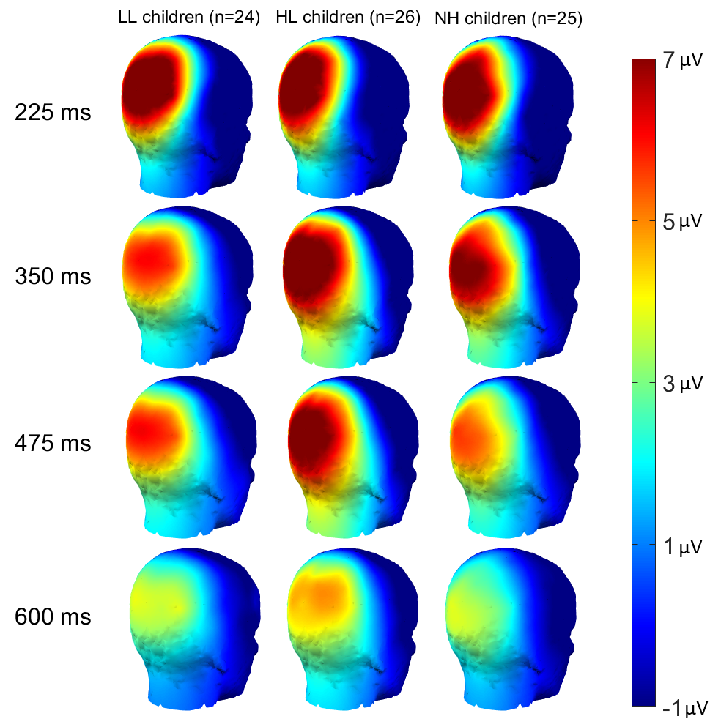
Figure A1: Topographical maps of each group at times corresponding to subsequent occipital peaks in response to each reversal of the checkerboard.

Second peak (225 ms): For P2 amplitude, there was no main effect of group [χ²(2)<0.1, p=0.982], and the main effect of chronological age missed significance [χ²(1)=3.0, p=0.083], without interaction [χ²(2)=2.3, p=0.310]. The non-significant trend with age suggested a decrease in amplitude in older children. For P2 latency, there was no main effect of group [χ²(2)=5.0, p=0.083], no main effect of chronological age [χ²(1)=1.5, p=0.221], without interaction [χ²(2)=1.7, p=0.428]. Age at implantation did not matter for either amplitude or latency [p>0.307].
Third peak (350 ms): For P3 amplitude, there was no main effect of group [χ²(2)=2.1, p=0.356], but a main effect of chronological age [χ²(1)=9.7, p=0.002], without interaction [χ²(2)=2.3, p=0.311]. P3 amplitude decreased in older children. For P3 latency, there was no group effect [χ²(2)=3.0, p=0.224], no age effect [χ²(1)=0.2, p=0.642], and no interaction [χ²(2)=2.2, p=0.332]. P3 amplitude decreased (slightly) with age at implantation [p=0.030] but not P3 latency [p=0.754].
Fourth peak (475 ms): For P4 amplitude, there was no main effect of group [χ²(2)=2.8, p=0.248], but a main effect of chronological age [χ²(1)=9.8, p=0.002], without interaction [χ²(2)=0.9, p=0.645]. P4 amplitude decreased in older children. For P4 latency, there was no group effect [χ²(2)=1.0, p=0.608], no age effect [χ²(1)=1.8, p=0.184], and no interaction [χ²(2)=0.4, p=0.824]. Age at implantation did not matter for either amplitude or latency [p>0.090].
Fifth peak (600 ms): For P5 amplitude, there was no main effect of group [χ²(2)=2.0, p=0.369], and the main effect of chronological age missed significance [χ²(1)=3.2, p=0.075], without interaction [χ²(2)=4.4, p=0.113]. The non-significant trend suggested a decrease in P5 amplitude in older children. For P5 latency, surprisingly, there was a main effect of group [χ²(2)=6.9, p=0.032], no main effect of chronological age [χ²(1)=0.6, p=0.443], without interaction [χ²(2)=1.0, p=0.602]. The group difference was driven by larger amplitude in the HL group compared to the LL or NH groups, but none of the pairwise comparisons actually reached significance, so we ignored it. P5 amplitude decreased (slightly) with age at implantation [p=0.032] but not P5 latency [p=0.146].
Averaged pattern-reversal VEP: Given the good consistency across these peaks, we can average their amplitude and express their latency relative to a given reversal of the checkerboard. The LME analysis confirmed the consistent pattern aforementioned, i.e. no main effect of group [χ²(2) = 1.0, p = 0.601], but a main effect of chronological age [χ²(1) = 6.3, p = 0.012] without interaction [χ²(2) = 2.4, p = 0.303]. The pattern-reversal VEPs were reduced by about 5.1 µV per decade, and the average peak was 6.3 µV within our age range (left, Figure A2). For latency, there was neither a main effect of group [χ²(2) = 2.1, p = 0.341], nor a main effect of chronological age [χ²(1)<0.1, p = 0.753], without interaction [χ²(2) = 2.8, p = 0.242]. On average, the latency of pattern-reversal VEPs was 97.6 ms (right, Figure A2). Neither amplitude nor latency reached a significant correlation with age at first implantation [p = 0.097 and p = 0.166, respectively]. The amplitude of the later peaks did not correlate with the CELF score [p = 0.256], but their latency did to some degree [r² = 0.07, p = 0.018]: children with shorter latencies tended to obtain better language outcomes. Nevertheless, given the lack of group differences on these pattern-reversal measures, this latter relationship was not emphasized in the main article (which focused on the pattern-onset VEP instead).
Summary: The amplitude of each of these pattern-reversal peaks decreased in older children, presumably for physiological reasons such as skull growth and myelination (Appendix C). Age, however, had no effect on their respective latency. Group differences were largely absent in either amplitude or latency. We conclude that, for some reason (perhaps because it reflects V1 activity more exclusively), the pattern-reversal VEPs do not offer ample opportunity to differentiate between children with CIs, and thus would have limited audiological application, contrary to the pattern-onset VEP discussed in the main article.

Figure A2: Average amplitude (left) and latency (right) of peak 2 to 5 corresponding to a pattern-reversal VEP, plotted as a function of the child’s chronological age. Note that the peaks occurred roughly 100 ms after a given rotation of the checkerboard (every 125 ms), so they were realigned here at each reversal onset, before averaging.

Appendix B: Additional fNIRS analysis
Here, we delved more closely into several regions of the occipital lobe, from its centre (V1) to more peripheral areas. As illustrated in Figure B1 from left to right, we noticed that the group LL showed the most activation on V1 but it faded quickly in peripheral areas. In contrast, for children in the group HL and even more for NH children, the occipital response appeared to be less focussed on V1 and maintained over peripheral regions.
One single channel at V1 (S22-D16): There was no main effect of group [F(2,72)=2.6, p=0.083 for HbO; F(2,72)=0.7, p=0.506 for HbR].
Six channels directly around V1: There was no main effect of group [F(2,72)=0.1, p=0.895 for HbO; F(2,72)=0.3, p=0.762 for HbR].
Three channels below Oz: There was no main effect of group [F(2,72)=1.7, p=0.198 for HbO; F(2,72)=2.4, p=0.102 for HbR].
Six channels towards inferotemporal regions
There was no main effect of group [F(2,72)=1.9, p=0.151 for HbO; F(2,72)=2.0, p=0.146 for HbR].
Four channels towards parietal regions: There was no main effect of group [F(2,72)=0.2, p=0.803 for HbO; F(2,72)<0.1, p=0.976 for HbR].
Summary: Although, there seems to be a differential spread of activity in the LL group compared to the HL and NH groups, there is too much heterogeneity to highlight group differences. This is why our analysis combined these 20 channels (completely non-redundant) which were all identified by the Tailarach atlas as partially overlapping with V1/V2.

Figure B1: Group-averaged event-related changes in oxygenated (red) and deoxygenated (blue) hemoglobin occurring in slightly different parts of the visual cortex, going from its centre (most-left) to more peripheral areas (towards right panels).

Appendix C: the role of chronological age
Although not directly related to our hypothesis, a consistent observation made throughout our EEG data was the progressive reduction in amplitude measures for older children, consistent with previous findings (Mitchell and Neville, 2004). The morphology of pattern-reversal VEP is supposed to be adult-like in the first couple years of life (Moskowitz and Sokol, 1983; Doucet et al., 2005). In contrast, the morphology of pattern-onset VEP takes on a longer developmental course extending into adolescence and even adulthood (Ossenblok et al., 1992; Thompson et al., 2017; Fritsch et al., 2018). For this reason, effects of chronological age were expected for the pattern-onset VEPs, but we observed them as well in pattern-reversal VEPs. Perhaps, one explanation is head growth. With increase in head size, skull density and thickness, the electrodes at the scalp naturally become further away from the neural generators. As a result, VEPs recorded on older children are more likely to be reduced (Huiskamp et al., 1999). Note that these considerations extend to sex differences (Dion et al., 2015; Sharma et al., 2015). In this study, male and female children did not differ by age [p = 0.641] and this did not interact with group [p = 0.092], but we still controlled for it with random intercepts. Factors such as myelination and dendritic branching complicate the issue by occurring at a different pace in different brain regions, often coinciding with functional development (Long et al., 2017). As cortical areas become more fully myelinated, larger potentials might be facilitated in older children, thereby counteracting the effect of head size. The plasticity of myelination (see for example Smith et al., 2011 for a lack of myelination in the context of auditory deprivation in infants) also might have impacted the amplitude and latency of different components of a VEP, differentially for young versus older children, and perhaps differentially for NH versus CI children.
In fNIRS methodology, age effects are less systematic because different factors counteract each other. The “banana shaped photon path” of NIRS should theoretically go deeper on a smaller head (Pinti et al., 2020; Harrison et al., 2021). On this basis, it should be easier to measure oxygen demands caused by neural activity in younger children. On the other hand, the cerebral blood flow and the oxygen metabolism exhibit developmental changes (Takahashi et al., 1999) such that oxygen demands elicited by a given task may not be as obvious in young children. Problematically, these developmental changes are once again not homogeneous across brain regions. Here, responses were reduced in older children over STG but this did not happen in the visual cortex. Maybe the deactivation of auditory regions is genuinely facilitated in younger children, but this point should be taken with great caution until we understand the root cause of these age effects.

Appendix D: methodological choices and limitations
A number of methodological choices made in this study deserve further justification, along with acknowledgment of the limitations of the two techniques.

Task: Chen et al. (2017) noticed that studies that engaged participants in an active task (e.g. visual discrimination) tended to reveal stronger visual cortex response by deaf individuals or CI users relative to NH controls (Bavelier et al., 2001; Fine et al., 2005; Stropahl et al., 2015). In contrast, studies that presented visual stimuli repeatedly (eliciting visual adaptation) tended to report the opposite (Sandmann et al., 2012; Bottari et al., 2014; Hauthal et al., 2014). Considering that 7 year-old children would generally not pay as much attention as 18 year-old children, and given the low-level nature of a flickering checkerboard, we thought it was simpler to take attention out of the equation in this cohort and use a passive task.

Sample size: Many CI studies which included neuroimaging have ranged from 10 to 30 participants. Furthermore, studies often targeted adult CI users, sometimes with very different onset and duration of deafness or CI experience, whose heterogeneity likely induced inconsistencies in cortical activations. This prompted us to target a more homogeneous population with 1) a relatively larger sample, 2) younger ages with limited auditory deprivation (max 4 years), and 3) controlled educational outcomes. In a previous study, we showed that standard clinical tests (speech perception measures) corroborated the children’s global ease or difficulty with language, and we confirmed that age at implantation was (on a group level) a relevant factor but it did not account for individual variability (Wolfe et al., 2021). Here, we found group differences and correlations with individual outcomes, so we strongly suspect some of this variability to originate from cross-modal reorganization. Recent explorations of auditory cortex response to an oddball paradigm (Deroche et al., 2023) and resting-state networks (Koirala et al., 2023) in the same sample of children also revealed striking group differences and links to language and literacy outcomes, reinforcing the notion that this neuroimaging approach to CI outcomes is promising and has clinical relevance.

Limitation of EEG: In the EEG data, there is potential for misinterpreting the activity recorded over the STG (right panel, Figure 1). At the scalp, activity from auditory cortex is generally best captured around the vertex (Cz or FCz) due to the orientation of the respective dipole (Opitz et al., 1999). The presence of a dominant potential at Oz (here 15 μV) could result in negative potentials at the vertex, simply because each electrode was referenced to the average of all 128 electrodes. The same argument held for temporal electrodes, casting a doubt as to whether the STG waveforms were genuinely initiated from auditory regions or a pale inverted version of the visual cortex response. This is why it was critical to conduct a source localization analysis (Michel et al., 2001; Murray et al., 2008) that demonstrated an independent STG/MTG origin in this visual task. Other studies (Sharma et al., 2015; Campbell and Sharma, 2016) also recorded cross-modal VEPs and their source analysis corroborated the idea of STG/MTG generators. Furthermore, the recruitment has been consistently stronger on the right side (Buckley and Tobey, 2011; Sandmann et al., 2012; Kim et al., 2016). Here, we also found a strong asymmetry pointing to the right auditory cortex being coupled with the visual cortex (Figure 2, right panels). But bear in mind that this power reflected an inhibition of the temporal regions. So, recruitment of the right STG/MTG (e.g. by the LL group) was revealed by a reduced inhibition (a slightly tangential reasoning than the idea of truly activating auditory resources for a visual purpose). Finally, we should emphasize once more that it is generally not the primary auditory cortex that tends to be recruited during visual tasks but rather auditory association areas (as observed from other techniques such as PET, MEG, and fMRI). These areas are closer to the scalp; they have more varied dipole orientations; and this is perhaps why they may be captured by temporal electrodes.
Thus, we believe these cross-modal changes to the auditory cortex to be genuine and a promising indicator of the interplay between visual and auditory functions in children with CIs, extending to language outcomes. In this regard, we aim to further explore this population with audio-visual speech materials to get a more comprehensive picture of the quality of multi-sensory communication in ecological settings. Especially if these plastic changes affect parietal regions (Hauthal et al., 2014), enhancement in multi-sensory integration would be extremely valuable to study (see review by Strelnikov et al., 2015 in the PET literature). Unfortunately, these cortical regions are often the ones contaminated by CI artifacts in EEG recording. Here, it is worth reminding that all devices were switched off since there was no sound, and this successfully limited the prevalence of such artifacts. But for more complex materials and tasks, this issue remains a challenge and it is highly variable from one device to another (Gilley et al., 2006; Martin, 2007; Debener et al., 2008; McLaughlin et al., 2013), posing serious complications for enterprises such as EEG source analysis.

Limitation of fNIRS: Even though fNIRS appears as a promising alternative, devoid of the CI artifacts aforementioned, this imaging technique has limitations of its own. First, it cannot capture activity from structures deep in the brain, so it might be hard for example to isolate activity from A1. This may not be an issue if the areas recruited are auditory association areas, closer to the scalp. But it certainly constrains the type of research questions that can be answered in CI users (Saliba et al., 2016; Harrison and Hartley, 2019). Furthermore, it is a pity that the technique simply fails in some subjects. Improving test/retest reliability (including for simple tasks such as a checkerboard, Plichta et al., 2006) and reducing the impact of skin pigmentation (Wassenaar and van den Brand, 2005; Couch et al., 2015) would be highly desirable for this technique to reach higher standards of neuroimaging. Currently, although our activation metrics were related between EEG and fNIRS (Figure D1), the shared variance remained modest. Similar attempts at comparing fNIRS and EEG (Wallois et al., 2012; Ludyga et al., 2019; Steinmetzger et al., 2020) or fNIRS and fMRI (e.g. Arun et al., 2018) have also provided only modest agreement.

Figure D1: Comparison of EEG and fNIRS metrics in visual and auditory cortices. Activation of the visual cortex (top-left) and deactivation of the auditory cortex (bottom-right) was consistent between the two techniques, and inversely related to each other (top-right and bottom-left).

