Appendices

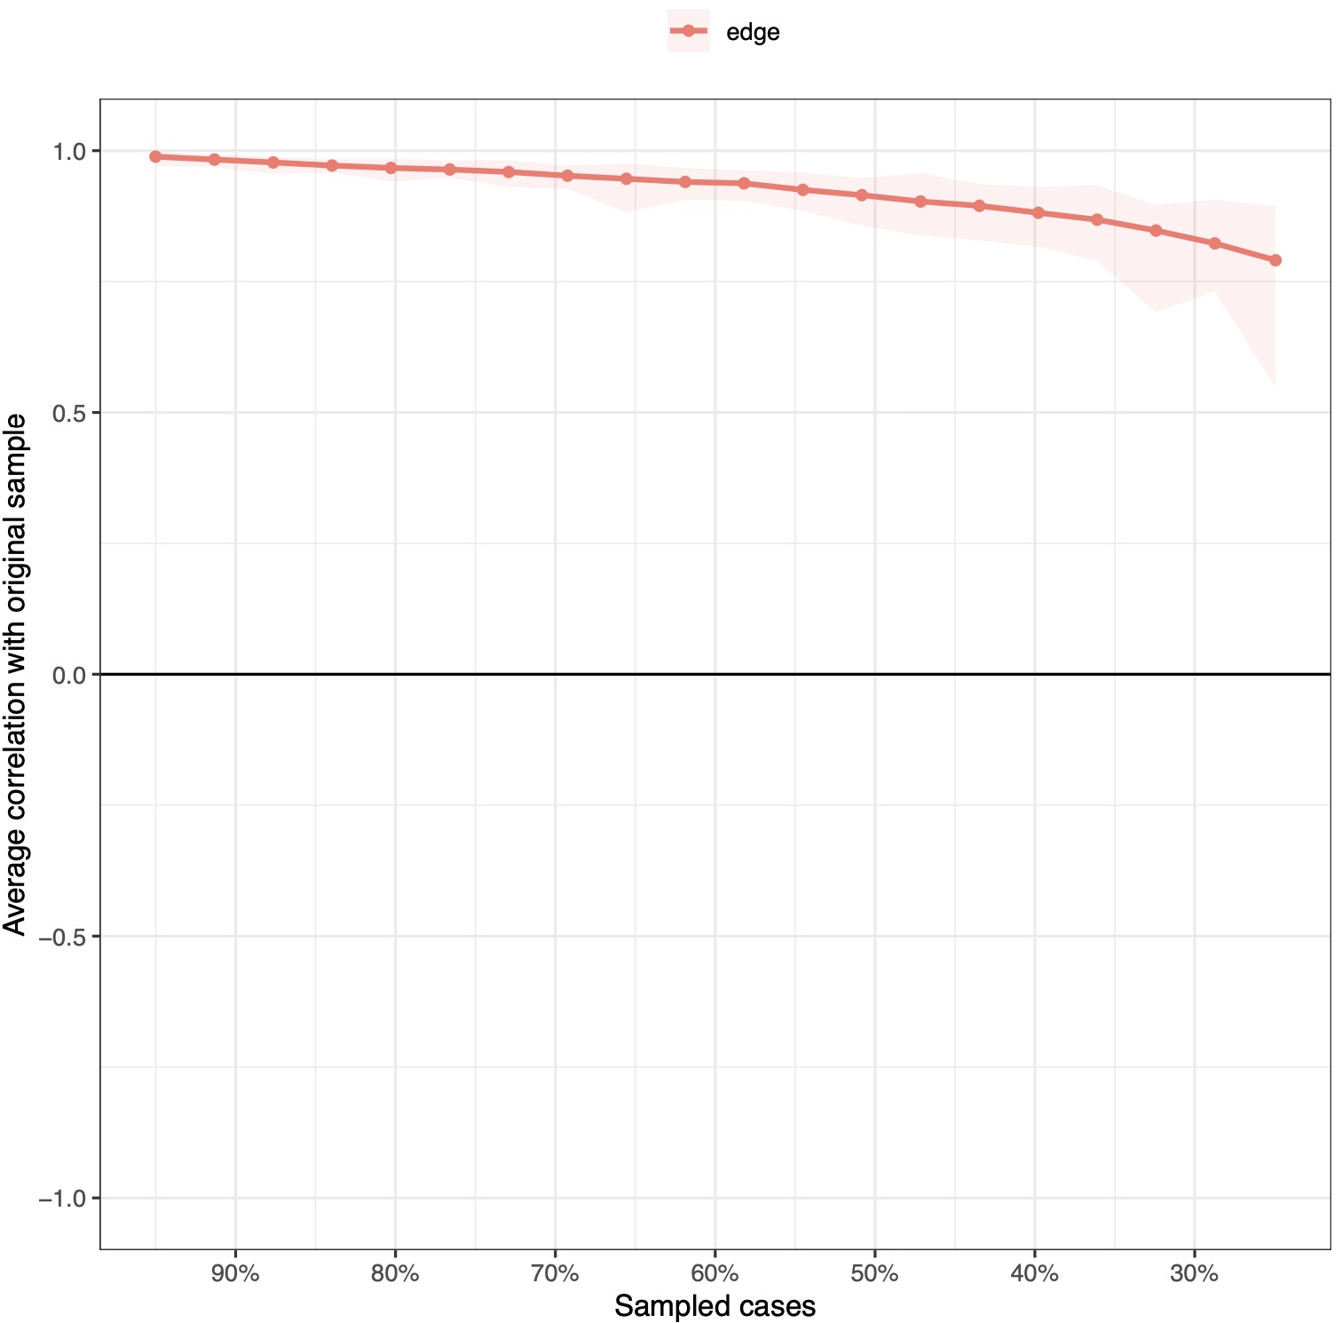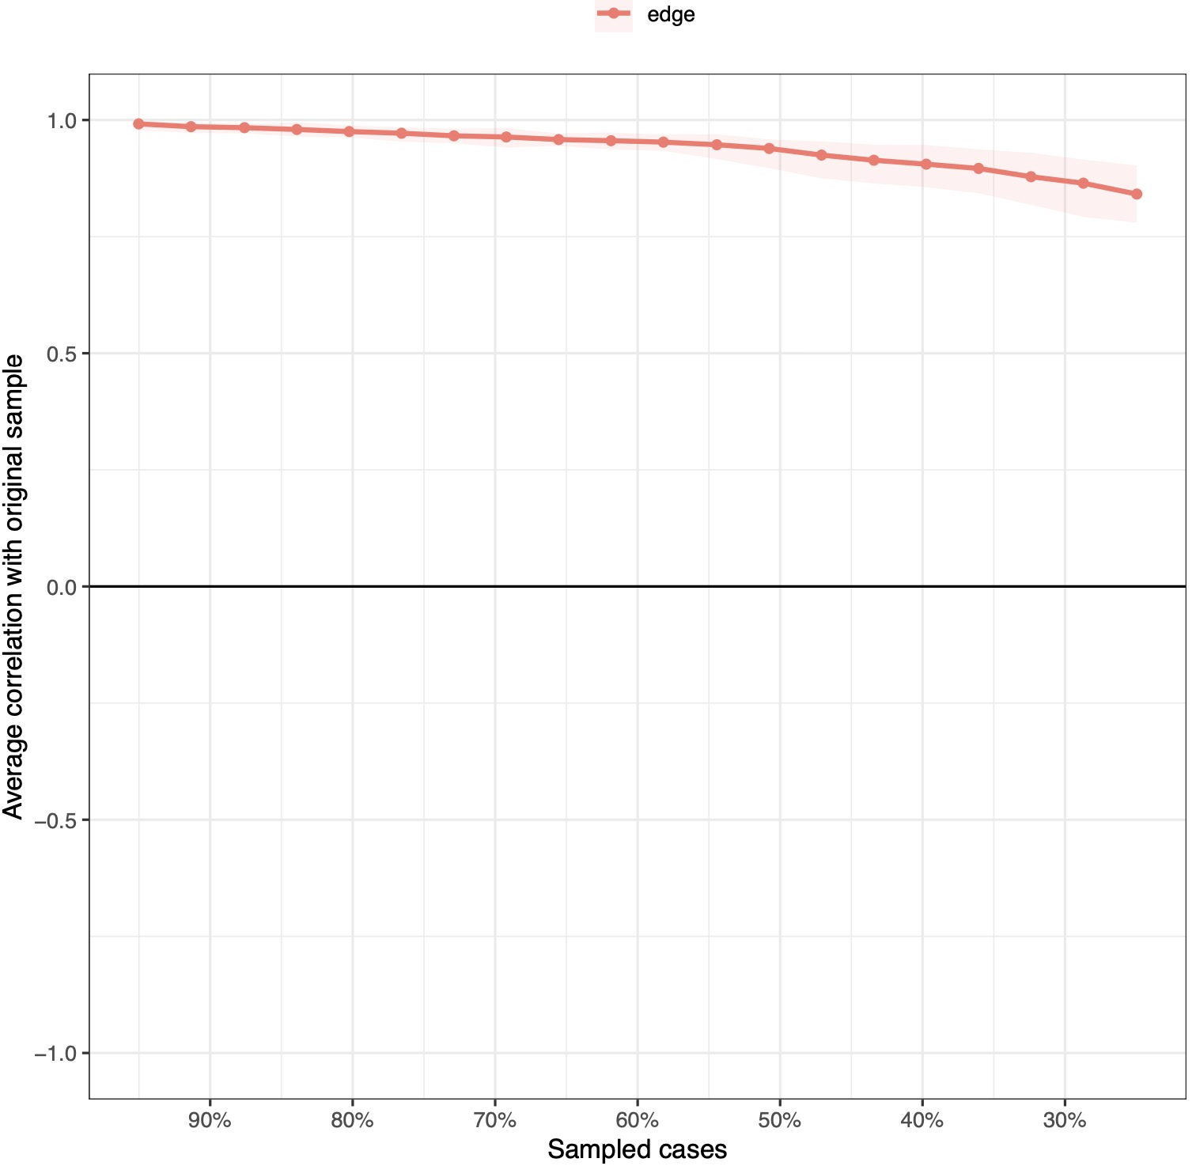
Figure 1: Stability estimations of edges using the case-drop bootstrapping method of low-risk group (left, n = 842) and high-risk group (right, n = 1306)

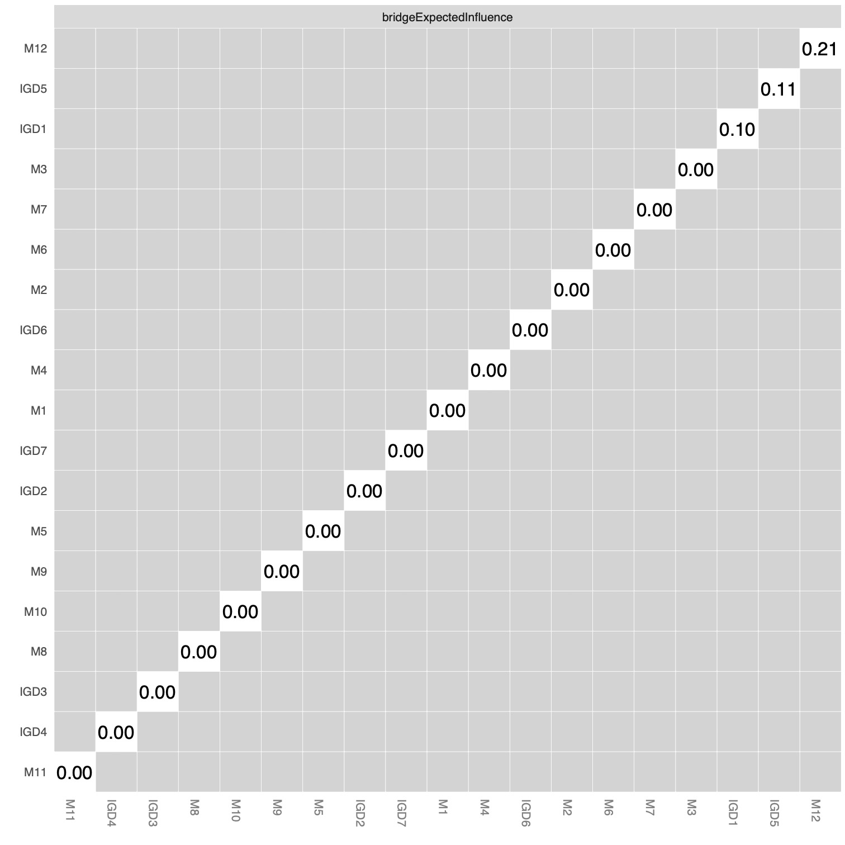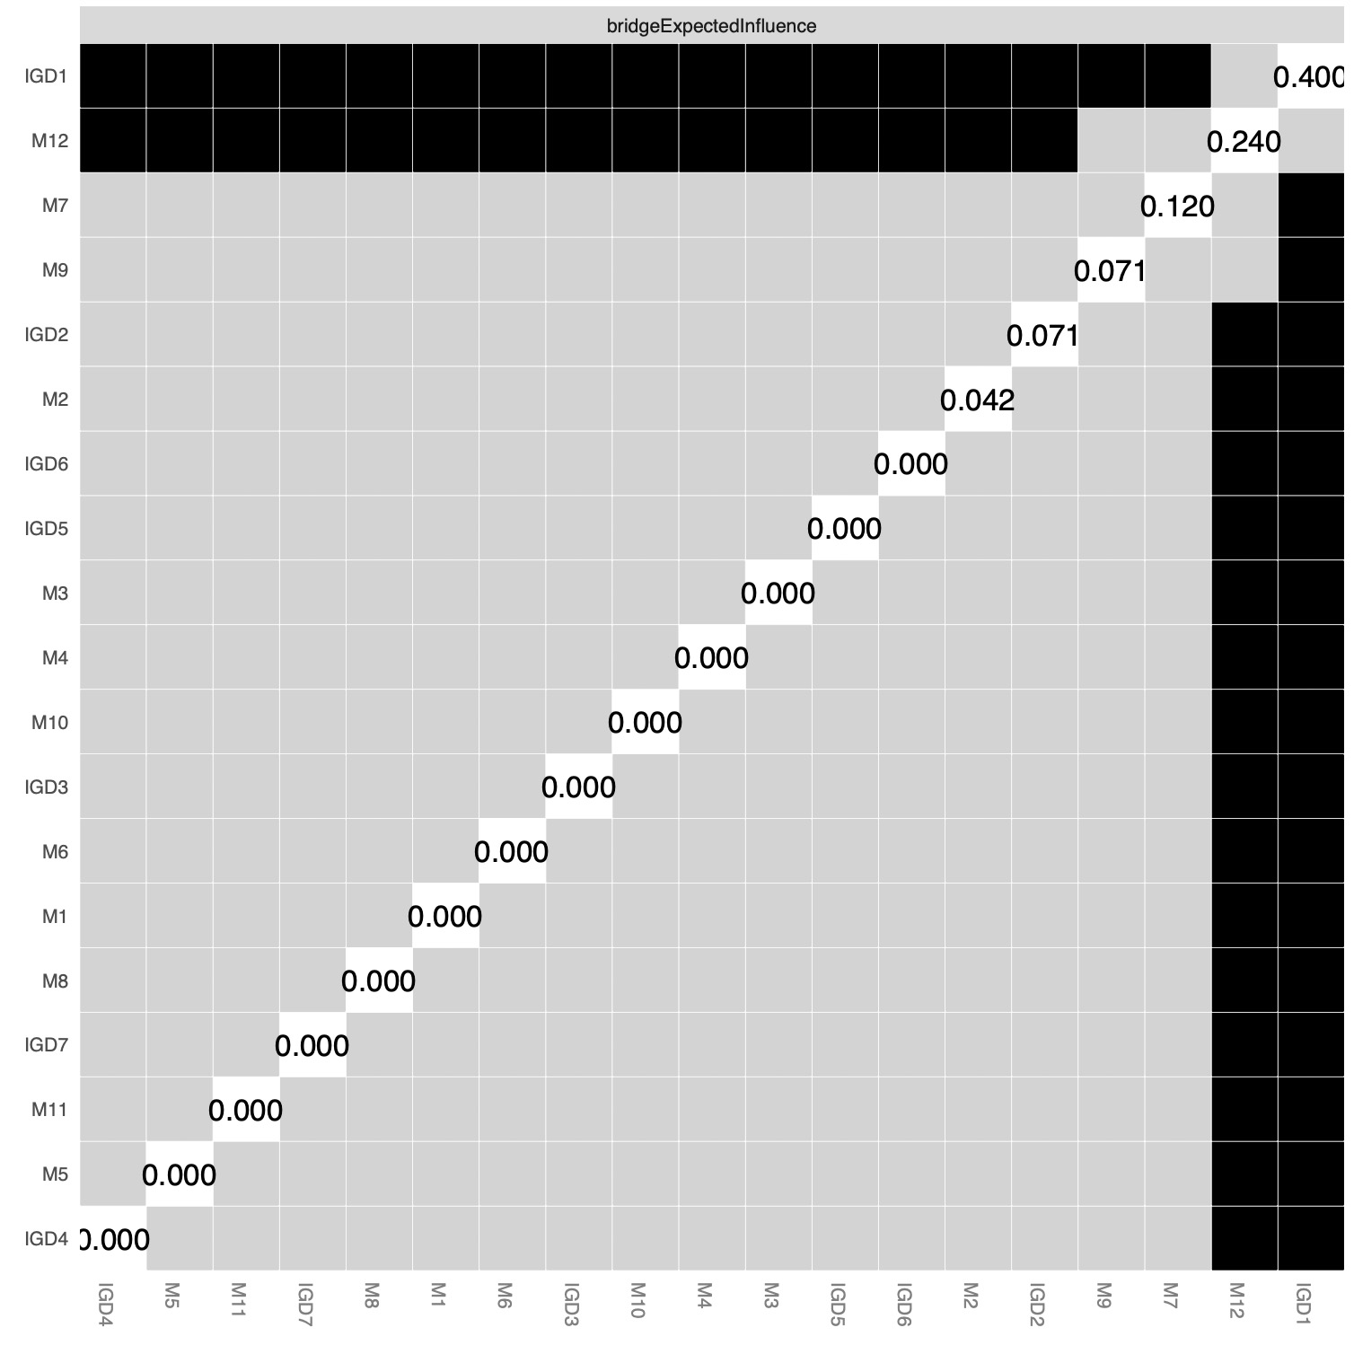
Figure 2: The difference test results of bridge expected influence using the non-parametric bootstrapping method in the low-risk group (n = 842, Left) and the high-risk group (n = 1306, Right)

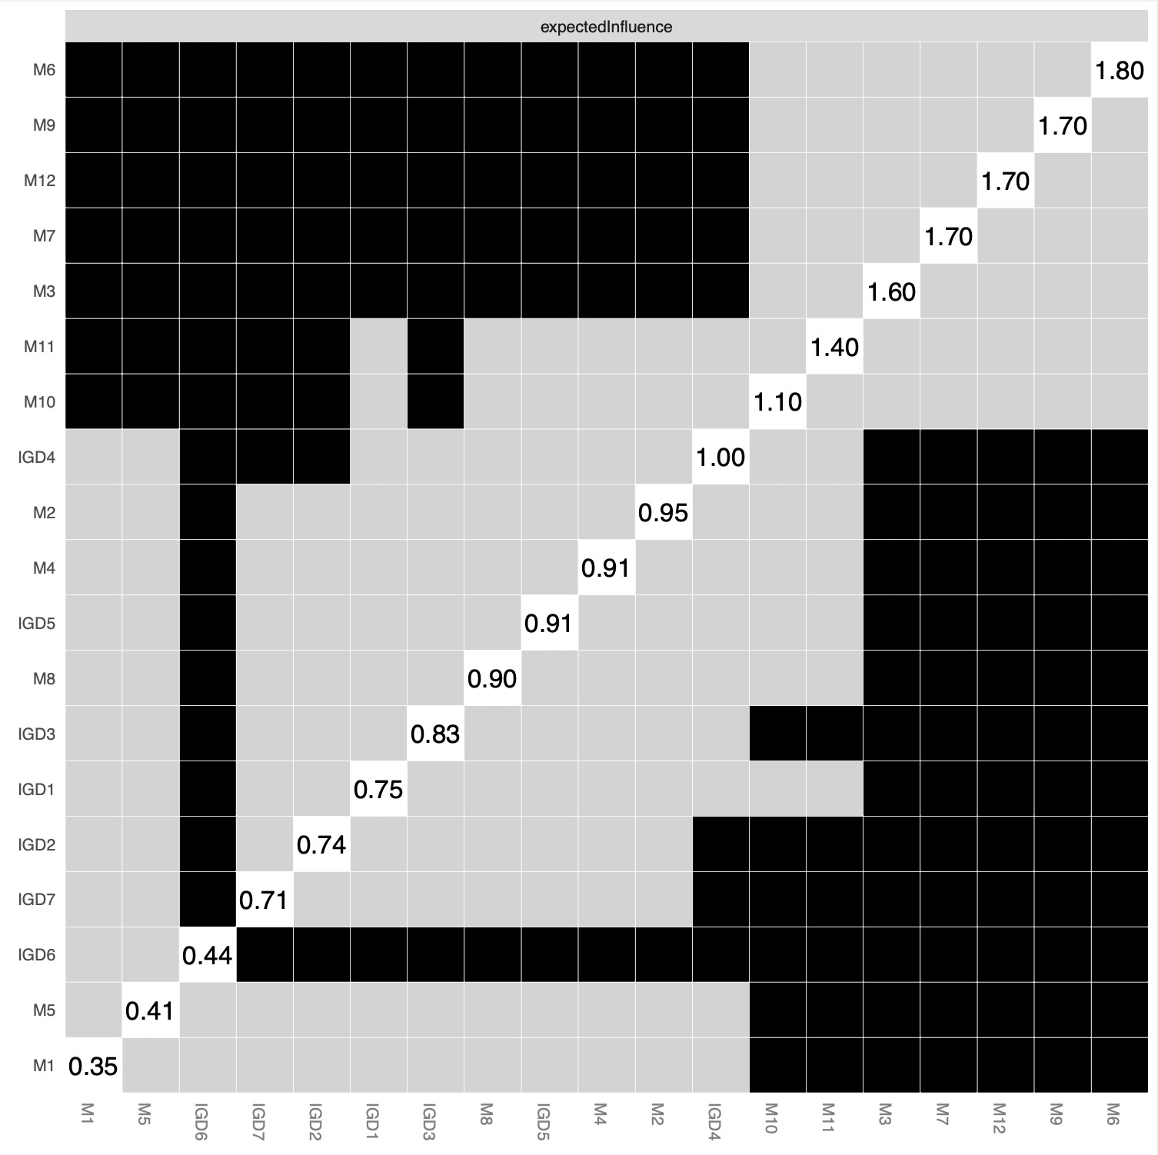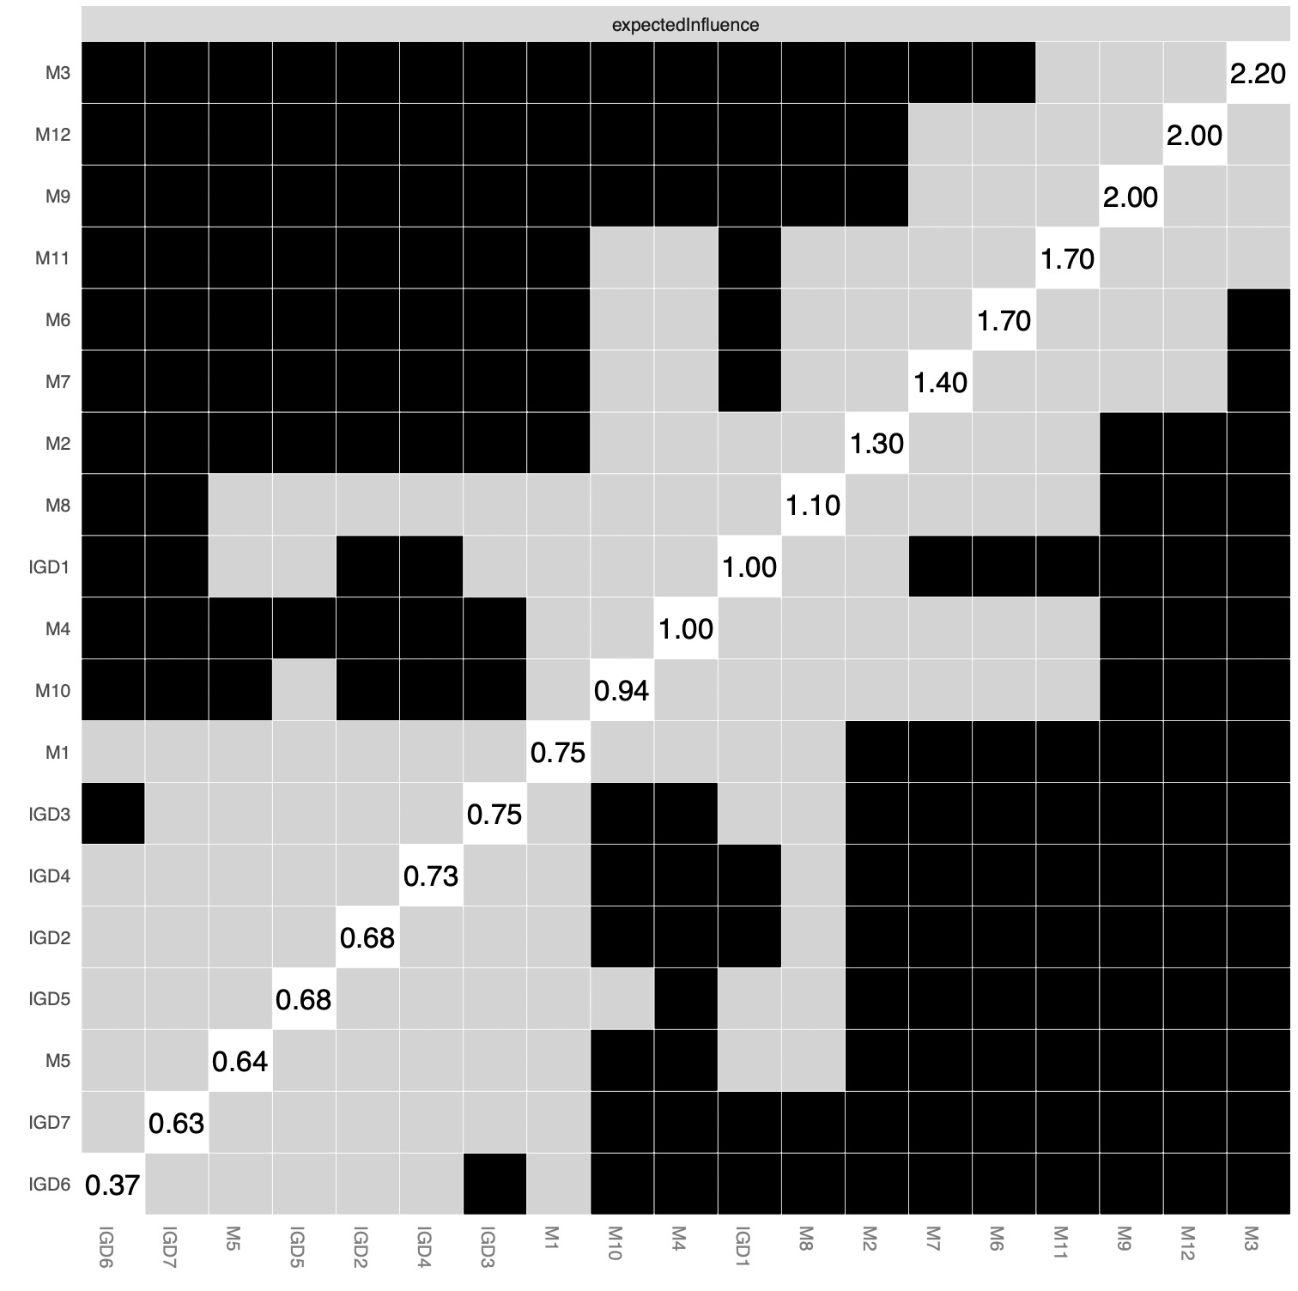
Figure 3: The difference test results of expected influence using the non-parametric bootstrapping method in the low-risk group (n = 842, Left) and the high-risk group (n = 1306, Right)

