Title: An ADAM10 exosite inhibitor is efficacious in an in vivo collagen-induced arthritis model

Authors: Juan Diez¹, Michael E. Selsted², Thomas D. Bannister³, Dmitriy Minond^{1,4*}
Affiliations:
¹ College of Pharmacy, Department of Pharmaceutical Sciences, Nova Southeastern University, 3321 College Avenue, Fort Lauderdale, FL, USA 33314
² Department of Pathology and Laboratory Medicine, Keck School of Medicine of the University of Southern California, 2011 Zonal Ave., Los Angeles, CA 90089
³ Department of Molecular Medicine, The Herbert Wertheim UF Scripps Institute for Biomedical Innovation & Technology, 120 Scripps Way, Jupiter, FL, USA 33458
⁴ Rumbaugh-Goodwin Institute for Cancer Research, Nova Southeastern University, 3301 College Avenue, CCR r.605, Fort Lauderdale, FL, USA 33314.
* Corresponding author. Email: dminond@nova.edu
One Sentence Summary: An exosite-binding inhibitor of ADAM10 is efficacious in the CIA model.

Supplemental Figures:
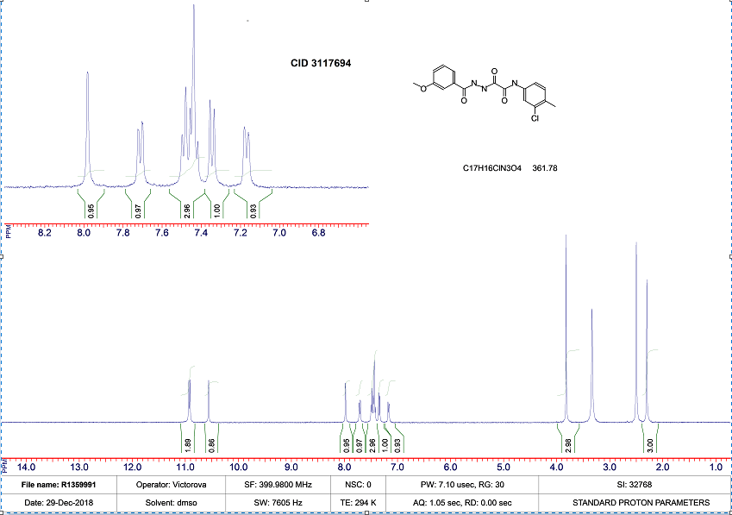
Supplemental Fig. 1. Structural characterization of batch of CID 3117694 synthesized for this study by H1 NMR confirms the identity of the compound.

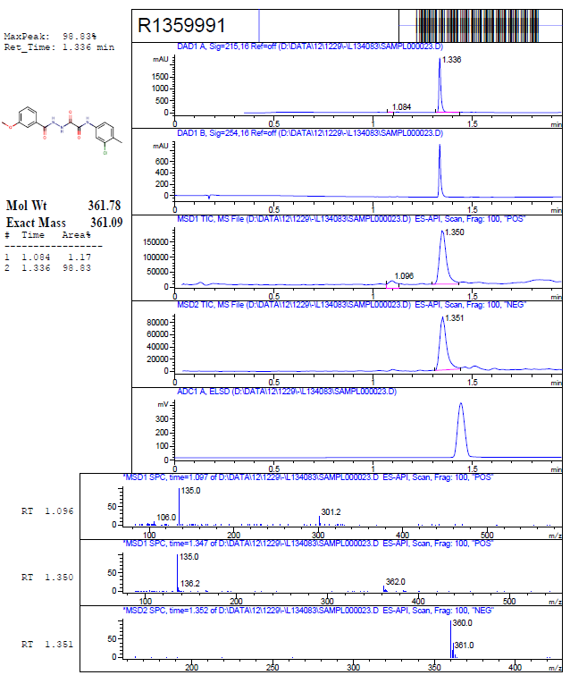
Supplemental Fig. 2. LC/MS/MS characterization of batch of CID 3117694 synthesized for this study confirms its purity and correct molecular weight.

