Supplementary Information: Systematic review of the actual emissions reductions of carbon offset projects across all major sectors

Benedict Probst¹², Malte Toetzke¹, Andreas Kontoleon², Laura Diaz Anadon²³, Volker H. Hoffmann¹

¹ Group for Sustainability and Technology, ETH Zurich, Switzerland
² Centre for Energy, Environment and Natural Resource Governance, Department of Land Economy, University of Cambridge, United Kingdom
³ Harvard Kennedy School, Harvard University, United States

Supplementary Figures

Supplementary Figure 1: ROSES flow diagram for systematic reviews.
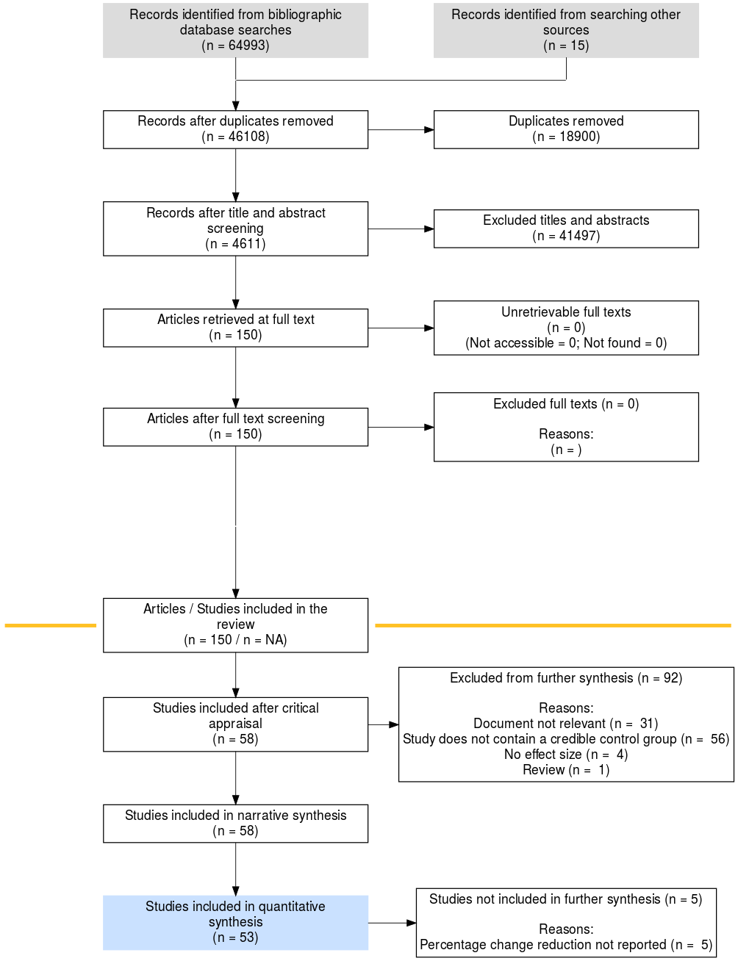

Supplementary Figure 2: Flow of study selection.

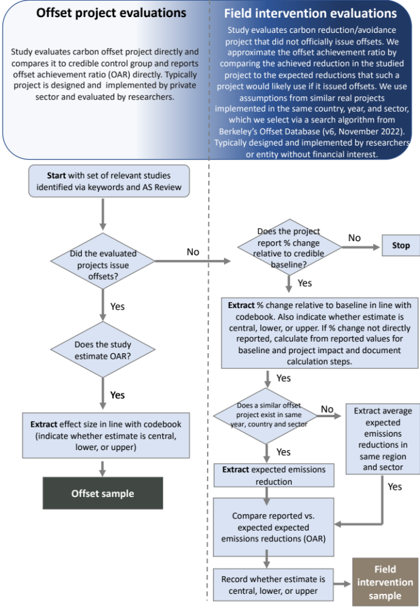

Supplementary Figure 3: Types of additionality and stringency.
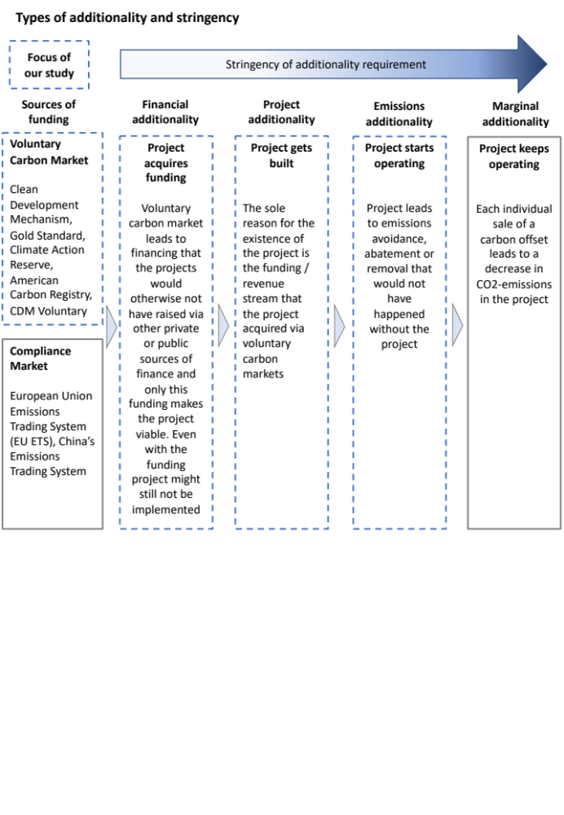

Supplementary Figure 4: Ex-ante vs. ex-post project baseline and project emissions.
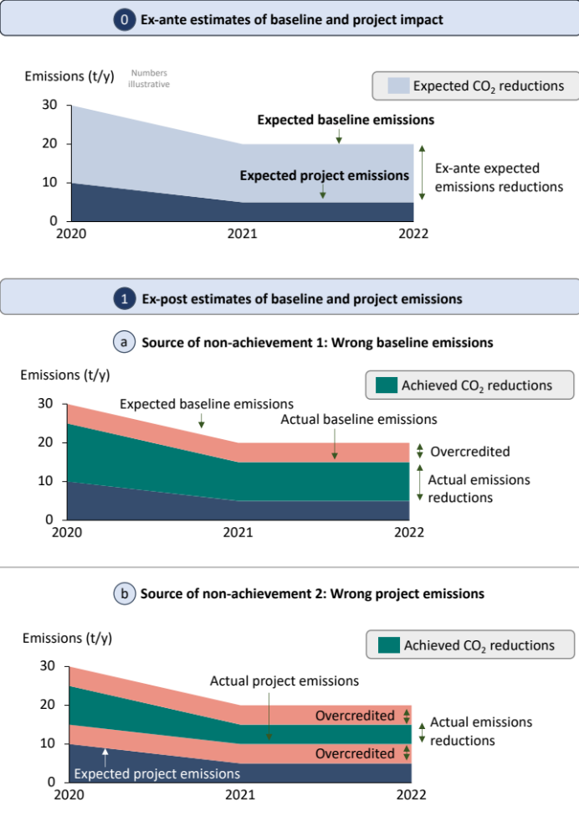

Supplementary Figure 5: Small sample bias plot.
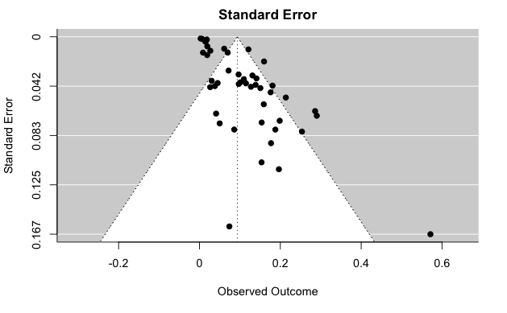

Supplementary Tables

Supplementary Table 1: Keywords used for search in SCOPUS. All articles downloaded: 26. Aug. 2022.
 | Search Keywords in SCOPUS
1. Population | -
2. Intervention
Generic | “project-based mechanism*” OR “tradable emission* reduc* credit*” OR “carbon market*” OR “voluntary project*” OR “carbon W/5 offset*“ OR “condition* payment*” OR “condition* cash transfer*” OR “economic* incentiv*” OR “clean development mechanism” OR “joint implementation mechanism” OR “kyoto protocol*”
Forestry and Land Use
REDD+ | "reduc* emission* from deforestation and forest degradation" OR "reduc* emission* from deforestat* and degradat*" OR "deforestat* reduc*" OR "payment* for ecosystem service*" OR "payment* for environmental services" OR "cash payment" OR “condition* pay*” OR "REDD+" OR "REDD"
Improved Forest Management | "forest*" W/5 ("manag*")
Afforestation / Reforestation | (payment* OR subsid*) W/5 (forest* OR plantat*) OR “afforest*” OR “reforest*”
Renewable Energy
Wind | (wind) W/5 (farm* OR project* OR power OR energy)
Solar | (solar) W/5 (farm* OR project* OR power OR energy)
Hydro | (hydro*) W/5 (project OR power OR energy)
Biomass | (biomass) W/5 (project OR power OR energy)
Waste management
Landfill / wastewater methane | “landfill” W/5 (“gas” OR “methane”) OR “wastewater” W/5 (“gas” OR “methane”)
Chemical processes
Ozone depleting substances | “HFC-23” OR “SF6” OR “ozone” W/5 “deplet*” OR “regfrig*”
N2O destruction in nitric acid production | “N2O” AND “nitric*”
Household and community
Cookstoves | *stove*
Industrial manufacturing
Mine methane capture | “mine" AND "methane" AND "captur*
Natural gas electricity production | “natural” AND “gas” W/5 (project OR power OR energy)
Carbon capture and storage
Carbon capture and enhanced oil recovery | “carbon” W/5 “captur*”
3. Comparator
Generic | "control group*" OR "randomized trial" OR "evaluat*" OR "before-after-control-intervention" OR assess* OR impact* OR causal* OR "synthetic* control*" OR mechanism OR "quasi-experiment*" OR "Random* Control* Trial" OR "Random* trial*" OR "ex post" OR "ex post" OR baseline OR "difference*-in-difference*" OR "identification strategy" OR compliance OR "synthetic* match*" OR “confound* factors”
4. Outcome
 | “environment* integrity” OR (CO2 OR carbon OR SF6 OR HFC-23 OR “waste gas*” OR deforest* OR “forest*” OR “tree cover” OR “land cover” OR conservation OR “fuel” OR “greenhouse gas*” OR “wood*” OR “*coal”) W/5 (abat* OR “produc*” OR generat* OR lower* OR “conserv*” OR “impact*” OR “increas*” OR loss OR protect* OR “additional” OR “change” OR “decline*” OR “consum*” OR curb OR sav*)

Supplementary Table 2: Keywords used for search in Web of Science. All articles downloaded: 26. Aug. 2022
 | Search Keywords in WOS
1. Population | -
2. Intervention
Generic | “project-based mechanism*” OR “tradable emission* reduc* credit*” OR “carbon market*” OR “voluntary project*” OR “carbon NEAR/5 offset*“ OR “condition* payment*” OR “condition* cash transfer*” OR “economic* incentiv*” OR “clean development mechanism” OR “joint implementation mechanism” OR “kyoto protocol*”
Forestry and Land Use
REDD+ | "reduc* emission* from deforestation and forest degradation" OR "reduc* emission* from deforestat* and degradat*" OR "deforestat* reduc*" OR "payment* for ecosystem service*" OR "payment* for environmental services" OR "cash payment" OR “condition* pay*” OR "REDD+" OR "REDD"
Improved Forest Management | "forest*" NEAR/5 ("manag*") W/5 “improv*”
Afforestation / Reforestation | (payment* OR subsid*) NEAR/5 (forest* OR plantat*) OR “afforest*” OR “reforest*”
Renewable Energy
Wind | (wind) NEAR/5 (farm* OR project* OR power OR energy)
Solar | (solar) NEAR/5 (farm* OR project* OR power OR energy)
Hydro | (hydro*) NEAR/5 (project OR power OR energy)
Biomass | (biomass) NEAR/5 (project OR power OR energy)
Waste management
Landfill / wastewater methane | “landfill” NEAR/5 (“gas” OR “methane”) OR “wastewater” NEAR/10 (“gas” OR “methane”)
Chemical processes
Ozone depleting substances | “HFC-23” OR “SF6” OR “ozone” NEAR/5 “deplet*” OR “regfrig*”
N2O destruction in nitric acid production | “N2O” AND “nitric*”
Household and community
Cookstoves | *stove*
Industrial manufacturing
Mine methane capture | “mine" AND "methane" AND "captur*”
Natural gas electricity production | “gas” NEAR/5 (project OR power OR energy)
Carbon capture and storage
Carbon capture and enhanced oil recovery | “carbon” NEAR/5 “captur*”
3. Comparator
Generic | "control group*" OR "randomized trial" OR "evaluat*" OR "before-after-control-intervention" OR assess* OR impact* OR causal* OR "synthetic* control*" OR mechanism OR "quasi-experiment*" OR "Random* Control* Trial" OR "Random* trial*" OR "ex post" OR "ex post" OR baseline OR "difference*-in-difference*" OR "identification strategy" OR compliance OR "synthetic* match*" OR “confound* factors”
4. Outcome
 | “environment* integrity” OR (CO2 OR carbon OR SF6 OR HFC-23 OR “waste gas*” OR deforest* OR “forest*” OR “tree cover” OR “land cover” OR conservation OR “fuel” OR “greenhouse gas*” OR “wood*” OR “*coal”) W/5 (abat* OR “produc*” OR generat* OR lower* OR “conserv*” OR “impact*” OR “increas*” OR loss OR protect* OR “additional” OR “change” OR “decline*” OR “consum*” OR curb OR sav*)

Supplementary Table 3: Inclusion and exclusion criteria for studies.
 | Population | Intervention | Comparator | Outcome | Study type
Inclusion | - | Conditional payments for CO2e-emissions reduction | Projects, plots of land, or people that were not subject to the intervention | CO2e-emissions reduction (or comparable metric, such as deforestation) | Empirical quantitative studies that include a control group
Exclusion | - | Interventions that do not adhere to principle of conditionality | Without comparator | Without quantified impact of intervention | Simulation or modelling-based studies

Supplementary Table 4: Previous-meta-analyses.
Name of study | Literature search strategy | Years covered | Databases used | Studies covered
Cames et al (2016) | No specific literature search strategy, but qualitative analysis of project design documents of 300 of projects in the Clean Development Mechanism | 2006-2015 | CDM project database, but no standardised literature search | NA

Supplementary Table 5: Descriptive overview of sample. Please also see Figure 5 in the main manuscript for other co-variates not reported here and the Extended Data 1 for the raw data.
No | Variable | Stats / Values | Frequency
1 | Publication year | Mean (sd): 2017.7 (3.5)  Min < median < max: 2007 < 2018 < 2022 | 13 distinct values
2 | Sector | - Forestry  - Household  - Renewable Energy  - Chemical processes | - 45  - 11  - 3  - 2  4 distinct sectors
3 | Sub-Sector | - REDD+  - IFM  - Afforestation/Reforestation  - Cookstoves  - Wind  - Ozone depleting substances | - 42  - 2  - 1  - 11  - 3  - 2  6 distinct sub-sectors
4 | Region | - Latin America  - Asia  - Africa  - Multiple  - Northern America  - Europe | - 34  - 13  - 6  - 4  - 3  - 1  5 distinct regions (+ multiple)
5 | Country | - Mexico  - Brazil  - Ecuador  - India  - Peru  - Multiple  - Costa Rica  - Senegal  - United States of America  - Cambodia  - China  - Indonesia  - Chile  - Colombia  - Ethiopia  - Guatemala  - Guyana  - Inner Mongolia  - Nepal  - Russia  - Uganda | - 10  - 8  - 5  - 5  - 4  - 4  - 3  - 3  - 3  - 2  - 2  - 2  - 1  - 1  - 1  - 1  - 1  - 1  - 1  - 1  - 1  21 distinct countries (+ multiple)
6 | Intervention Start Year | Mean (sd): 2006.2 (5.5)  Min < median < max: 1992 < 2007 < 2019 | 20 distinct values
7 | Intervention Duration in Years | Mean (sd): 6.5 (4.3)  Min < median < max: 0.33 < 6 < 21 | 19 distinct values
8 | Total sample | Mean (sd): 20906.7 (77774.09)  Min < median < max: 1 < 522 < 473,282 | 53 distinct values
9 | Generic study design | - Difference-in-difference + matching  - Linear regressions + matching  - RCT  - Synthetic Control Method  - Fixed effects  - Before-after comparison  - Difference in-means + matching  - Difference-in-difference  - Fixed effects + matched  - Financial modelling  - Multiple  - Blatantly inframarginal projects methodology developed in the paper  - Comparison coarse baseline vs. ecologically-grounded baseline  - Heckman two stage model  - IV  - Logistic regression + matching  - Randomised Controlled Trial  - t-test + matching | - 11  - 10  - 8  - 5  - 4  - 3  - 3  - 3  - 3  - 2  - 2  - 1  - 1  - 1  - 1  - 1  - 1  - 1
10 | Percentage change | Mean (sd): -49.9% (146.1%)  Min < median < max: -995.6% < -20% < 25.2% | 41 distinct values
11 | Estimate type (across all studies) | - Point estimate  - Lower bound  - Upper bound  - No point estimate | - 52  - 3  - 3  - 3
12 | Uncertainty quantification | - Point estimate with uncertainty  - Only point estimate without uncertainty  - No point estimate / no uncertainty | - 49  - 9  - 3
13 | Offsets issued (only offset studies) | - Yes  - No | - 10  - 51
14 | Reported additionality (only offset studies) | Mean (sd): 25.0% (28.6%)  Min < median < max: -1% < -16.6% < 70.1%

Supplementary Table 6: Studies included in the review
Number | Authors | Title | DOI | Publ_year | Region | Country | Sector | Sub_sector
1 | Chan and Huenteler | Financing Wind Energy Deployment in China through the Clean Development Mechanism | NA | 2015 | Asia | China | Renewable Energy | Wind
2 | Calel et al | Do Carbon Offsets Offset Carbon? | NA | 2021 | Asia | India | Renewable Energy | Wind
3 | Gillenwater et al | Additionality of wind energy investments in the U.S. voluntary green power market | 10.1016/j.renene.2013.10.003 | 2013 | North America | United States of America | Renewable Energy | Wind
4 | Ludwinski D., Moriarty K., Wydick B. | Environmental and health impacts from the introduction of improved wood stoves: evidence from a field experiment in guatemala | 10.1007/s10668-011-9282-z | 2011 | Latin America | Guatemala | Household | Cookstoves
5 | Jeuland M.A., Pattanayak S.K., Samaddar S., Shah R., Vora M. | Adoption and impacts of improved biomass cookstoves in rural rajasthan | 10.1016/j.esd.2020.06.006 | 2020 | Asia | India | Household | Cookstoves
6 | Brooks N., Bhojvaid V., Jeuland M.A., Lewis J.J., Patange O., Pattanayak S.K. | How much do alternative cookstoves reduce biomass fuel use? evidence from north india | 10.1016/j.reseneeco.2015.12.001 | 2016 | Asia | India | Household | Cookstoves
7 | Adrianzen, A. | Improved cooking stoves and firewood consumption: quasi-experimental evidence from the northern peruvian andes | 10.1016/j.ecolecon.2013.02.010 | 2013 | Latin America | Peru | Household | Cookstoves
8 | Mekonen, A., Beyene, A., Bluffstone, R., Gebreegziabher, Z., Martinsson, P., Toman, M., Vieder, F. | Do improved biomass cookstoves reduce fuelwood consumption and carbon  emissions? Evidence from a field experiment in rural Ethiopia | 10.1016/j.ecolecon.2022.107467 | 2022 | Africa | Ethiopia | Household | Cookstoves
9 | Hanna R., Duflo E., Greenstone M. | Up in smoke: the influence of household behavior on the long-run impact of improved cooking stoves | 10.1257/pol.20140008 | 2016 | Asia | India | Household | Cookstoves
10 | Beltramo T., Levine D.I. | The effect of solar ovens on fuel use, emissions and health: results from a randomised controlled trial | 10.1080/19439342.2013.775175 | 2013 | Africa | Senegal | Household | Cookstoves
11 | Bensch G., Peters J. | The intensive margin of technology adoption – Experimental evidence on improved cooking stoves in rural Senegal | 10.1016/j.jhealeco.2015.03.006 | 2015 | Africa | Senegal | Household | Cookstoves
12 | Aung T.W., Jain G., Sethuraman K., Baumgartner J., Reynolds C., Grieshop A.P., Marshall J.D., Brauer M. | Health and climate-relevant pollutant concentrations from a carbon-finance approved cookstove intervention in rural india | 10.1021/acs.est.5b06208 | 2016 | Asia | India | Household | Cookstoves
13 | Bensch and Peters | Alleviating Deforestation Pressures? Impacts of Improved Stove Dissemination on Charcoal Consumption in Urban Senegal | 10.3368/le.89.4.676 | 2013 | Africa | Senegal | Household | Cookstoves
14 | Berkouwer, S., Dean, J. | Credit and attention in the adoption of profitable energy efficient technologies in Kenya | 10.1257/aer.20210766 | 2022 | Africa | Kenya | Household | Cookstoves
15 | Carrilho C.D., Demarchi G., Duchelle A.E., Wunder S., Morsello C. | Permanence of avoided deforestation in a transamazon redd+ project (pará, brazil) | 10.1016/j.ecolecon.2022.107568 | 2022 | Latin America | Brazil | Forestry | REDD+
16 | Simonet G., Subervie J., Ezzine-De-Blas D., Cromberg M., Duchelle A.E. | Effectiveness of a redd project in reducing deforestation in the brazilian amazon | 10.1093/ajae/aay028 | 2018 | Latin America | Brazil | Forestry | REDD+
17 | Von Thaden J., Manson R.H., Congalton R.G., L√≥pez-Barrera F., Salcone J. | A regional evaluation of the effectiveness of mexico’s payments for hydrological services | 10.1007/s10113-019-01518-3 | 2019 | Latin America | Mexico | Forestry | REDD+
18 | Jayachandran S., De Laat J., Lambin E.F., Stanton C.Y., Audy R., Thomas N.E. | Cash for carbon: a randomized trial of payments for ecosystem services to reduce deforestation | 10.1126/science.aan0568 | 2017 | Africa | Uganda | Forestry | REDD+
19 | Montoya-Zumaeta J., Rojas E., Wunder S. | Adding rewards to regulation: the impacts of watershed conservation on land cover and household wellbeing in moyobamba, peru | 10.1371/journal.pone.0225367 | 2019 | Latin America | Peru | Forestry | REDD+
20 | Le Velly, G; Sauquet, A; Cortina-Villar, S | PES impact and leakages over several cohorts: the case of the psa-h in yucatan, mexico | 10.3368/le.93.2.230 | 2017 | Latin America | Mexico | Forestry | REDD+
21 | Mohebalian P.M., Aguilar F.X. | Design of tropical forest conservation contracts considering risk of deforestation | 10.1016/j.landusepol.2017.11.008 | 2018 | Latin America | Ecuador | Forestry | REDD+
22 | Jones K.W., Holland M.B., Naughton-Treves L., Morales M., Suarez L., Keenan K. | Forest conservation incentives and deforestation in the ecuadorian amazon | 10.1017/s0376892916000308 | 2017 | Latin America | Ecuador | Forestry | REDD+
23 | Costedoat S., Corbera E., Ezzine-de-Blas D., Honey-Ros√©s J., Baylis K., Castillo-Santiago M.A. | How effective are biodiversity Conservation payments in mexico? | 10.1371/journal.pone.0119881 | 2015 | Latin America | Mexico | Forestry | REDD+
24 | Clements T., Milner-Gulland E.J. | Impact of payments for environmental services and protected areas on local livelihoods and forest conservation in northern cambodia | 10.1111/cobi.12423 | 2014 | Asia | Cambodia | Forestry | REDD+
25 | Ramirez-Reyes C., Sims K.R.E., Potapov P., Radeloff V.C. | Payments for ecosystem services in mexico reduce forest fragmentation | 10.1002/eap.1753 | 2018 | Latin America | Mexico | Forestry | REDD+
26 | Honey-Roses J., Baylis K., Ramirez M.I. | A spatially explicit estimate of avoided forest loss | 10.1111/j.1523-1739.2011.01729.x | 2018 | Latin America | Mexico | Forestry | REDD+
27 | Arriagada R.A., Ferraro P.J., Sills E.O., Pattanayak S.K., Cordero-Sancho S. | Do payments for environmental services affect forest cover? a farm-level evaluation from costa rica | 10.3368/le.88.2.382 | 2012 | Latin America | Costa Rica | Forestry | REDD+
28 | Ruggiero P.G.C., Metzger J.P., Reverberi Tambosi L., Nichols E. | Payment for ecosystem services programs in the brazilian atlantic forest: effective but not enough | 10.1016/j.landusepol.2018.11.054 | 2019 | Latin America | Brazil | Forestry | REDD+
29 | Robalino, J; Pfaff, A; Sandoval, C; Sanchez-Azofeifa, GA | Can we increase the impacts from payments for ecosystem services? impact rose over time in costa rica, yet spatial variation indicates more potential | 10.1016/j.forpol.2021.102577 | 2021 | Latin America | Costa Rica | Forestry | REDD+
30 | Robalino et al | Evaluating Interactions of Forest Conservation Policies on Avoided Deforestation | doi.org/10.1371/journal.pone.0124910 | 2015 | Latin America | Costa Rica | Forestry | REDD+
31 | Bos A.B., Duchelle A.E., Angelsen A., Avitabile V., De Sy V., Herold M., Joseph S., De Sassi C., Sills E.O., Sunderlin W.D., Wunder S. | Comparing methods for assessing the effectiveness of subnational redd+ initiatives | 10.1088/1748-9326/aa7032 | 2017 | Multiple | Multiple | Forestry | REDD+
32 | Correa J., Cisneros E., B√∂rner J., Pfaff A., Costa M., Raj√£o R. | Evaluating redd+ at subnational level: amazon fund impacts in alta floresta, brazil | 10.1016/j.forpol.2020.102178 | 2020 | Latin America | Brazil | Forestry | REDD+
33 | Ellis E.A., Sierra-Huelsz J.A., Ceballos G.C.O., Binnq√ºist C.L., Cerd√°n C.R. | Mixed effectiveness of redd+ subnational initiatives after 10 years of interventions on the yucatan peninsula, mexico | 10.3390/f11091005 | 2020 | Latin America | Mexico | Forestry | REDD+
34 | Roopsind A., Sohngen B., Brandt J. | Evidence that a national redd program reduces tree cover loss and carbon emissions in a high forest cover, low deforestation country | 10.1073/pnas.1904027116 | 2019 | Latin America | Guyana | Forestry | REDD+
35 | Sims K.R.E., Alix-Garcia J.M. | Parks versus pes: evaluating direct and incentive-based land conservation in mexico | 10.1016/j.jeem.2016.11.010 | 2016 | Latin America | Mexico | Forestry | REDD+
36 | Alix-Garcia J.M., Sims K.R.E., Yañez-Pagans P. | Only one tree from each seed? environmental effectiveness and poverty alleviation in mexico's payments for ecosystem services program | 10.1257/pol.20130139 | 2015 | Latin America | Mexico | Forestry | REDD+
37 | Alix-Garcia J.M., Shapiro E.N., Sims K.R.E. | Forest conservation and slippage: evidence from mexico's national payments for ecosystem services program | 10.3368/le.88.4.613 | 2012 | Latin America | Mexico | Forestry | REDD+
38 | Chervier C., Costedoat S. | Heterogeneous impact of a collective payment for environmental services scheme on reducing deforestation in cambodia | 10.1016/j.worlddev.2017.04.014 | 2017 | Asia | Cambodia | Forestry | REDD+
39 | Jones K.W., Mayer A., Von Thaden J., Berry Z.C., López-Ramírez S., Salcone J., Manson R.H., Asbjornsen H. | Measuring the net benefits of payments for hydrological services programs in mexico | 10.1016/j.ecolecon.2020.106666 | 2020 | Latin America | Mexico | Forestry | REDD+
40 | Giudice R., Börner J., Wunder S., Cisneros E. | Selection biases and spillovers from collective conservation incentives in the peruvian amazon | 10.1088/1748-9326/aafc83 | 2019 | Latin America | Peru | Forestry | REDD+
41 | Jones K.W., Lewis D.J. | Estimating the counterfactual impact of conservation programs on land cover outcomes: the role of matching and panel regression techniques | 10.1371/journal.pone.0141380 | 2015 | Latin America | Ecuador | Forestry | REDD+
42 | Cisneros E., Börner J., Pagiola S., Wunder S. | Impacts of conservation incentives in protected areas: the case of bolsa floresta, brazil | 10.1016/j.jeem.2021.102572 | 2022 | Latin America | Brazil | Forestry | REDD+
43 | Etchart N., Freire J.L., Holland M.B., Jones K.W., Naughton-Treves L. | What happens when the money runs out? forest outcomes and equity concerns following ecuador's suspension of conservation payments | 10.1016/j.worlddev.2020.105124 | 2020 | Latin America | Brazil | Forestry | REDD+
44 | Pagiola S., Honey-Rosés J., Freire-González J. | Evaluation of the permanence of land use change induced by payments for environmental services in quindío, colombia | 10.1371/journal.pone.0147829 | 2016 | Latin America | Colombia | Forestry | REDD+
45 | Fiorini A.C., Mullally C., Swisher M., Putz F.E. | Forest cover effects of payments for ecosystem services: evidence from an impact evaluation in brazil | 10.1016/j.ecolecon.2019.106522 | 2020 | Latin America | Brazil | Forestry | REDD+
46 | Montoya-Zumaeta J.G., Wunder S., Rojas E., Duchelle A.E. | Does redd+ complement law enforcement? evaluating impacts of an incipient initiative in madre de dios, peru | 10.3389/ffgc.2022.870450 | 2022 | Latin America | Peru | Forestry | REDD+
47 | Sharma B.P., Karky B.S., Nepal M., Pattanayak S.K., Sills E.O., Shyamsundar P. | Making incremental progress: impacts of a redd+ pilot initiative in nepal | 10.1088/1748-9326/aba924 | 2020 | Asia | Nepal | Forestry | REDD+
48 | Zhou T., Shen W., Qiu X., Chang H., Yang H., Yang W. | Impact evaluation of a payments for ecosystem services program on vegetation quantity and quality restoration in inner mongolia | 10.1016/j.jenvman.2021.114113 | 2022 | Asia | Inner Mongolia | Forestry | REDD+
49 | España F., Arriagada R., Melo O., Foster W. | Forest plantation subsidies: impact evaluation of the chilean case | 10.1016/j.forpol.2022.102696 | 2022 | Latin America | Chile | Forestry | Afforestation/Reforestation
50 | Fu G., Uchida E., Shah M., Deng X. | Impact of the grain for green program on forest cover in china | 10.1080/21606544.2018.1552626 | 2019 | Asia | China | Forestry | REDD+
51 | Hayes T., Murtinho F., Wolff H., López-Sandoval M.F., Salazar J. | Effectiveness of payment for ecosystem services After loss and uncertainty of compensation | 10.1038/s41893-021-00804-5 | 2022 | Latin America | Ecuador | Forestry | REDD+
52 | Linkie M., Smith, R., Zhu Y., Martyr, D., et al | Evaluating Biodiversity Conservation around a Large  Sumatran Protected Area | 10.1111/j.1523-1739.2008.00906.x | 2007 | Asia | Indonesia | Forestry | REDD+
53 | Erbaugh J.T. | Impermanence and failure: the legacy of conservation-based payments in sumatra, indonesia | 10.1088/1748-9326/ac6437 | 2022 | Asia | Indonesia | Forestry | REDD+
54 | Cuenca P., Robalino J., Arriagada R., Echeverría C. | Are government incentives effective for avoided deforestation in the tropical andean forest? | 10.1371/journal.pone.0203545 | 2018 | Latin America | Ecuador | Forestry | REDD+
55 | Badgley G., Freeman J., Hamman J.J., Haya B., Trugman A.T., Anderegg W.R.L., Cullenward D. | Systematic over-crediting in california's forest carbon offsets program | 10.1111/gcb.15943 | 2021 | Northern America | United States of America | Forestry | IFM
56 | West et al. | ﻿Action needed to make carbon offsets from forest conservation work for climate change mitigation | NA | 2023 | Multiple | Multiple | Forestry | REDD+
57 | Guizar-Coutiño A. et al | A global evaluation of the effectiveness of voluntary REDD+ projects at reducing deforestation and degradation in the moist tropics | 10.1111/cobi.13970 | 2022 | Multiple | Multiple | Forestry | REDD+
58 | Coffield et al | Using remote sensing to quantify the additional climate  benefits of California forest carbon offset projects | 10.1111/gcb.16380 | 2022 | Northern America | United States of America | Forestry | IFM
59 | West T.A.P., B√∂rner J., Sills E.O., Kontoleon A. | Overstated carbon emission reductions from voluntary redd+ projects in the brazilian amazon | 10.1073/pnas.2004334117 | 2020 | Latin America | Brazil | Forestry | REDD+
60 | Schneider, L; Kollmuss, A | Perverse effects of carbon markets on hfc-23 and sf6 abatement projects in russia | 10.1038/nclimate2772 | 2015 | Europe | Russia | Chemical processes | Ozone depleting substances
61 | Schneider, LR | Perverse incentives under the cdm: an evaluation of hfc-23 destruction projects | 10.3763/cpol.2010.0096 | 2011 | Multiple | Multiple | Chemical processes | Ozone depleting substances

Supplementary Note 1: Small sample bias.

We standardised the effect sizes (Cohen’s d) to test for the presence of publication bias. The funnel plot in Supplementary Figure 5 shows the individual effect size estimates and their respective standard error. If there was no bias, then the individual effect sizes (or dots in the plot), would be spread symmetrically around the mean estimate (dotted line). Studies that contain precise estimates should be found near the average, whereas studies with lower precision should be spread symmetrically around the average in a funnel. In our case, smaller studies tend to report stronger effects, which suggests a small sample bias. We also conducted the Standard Egger’s test, which supports the presence of a small-sample bias (t = 8.11, p<0.001).

Supplementary Note 2: Divergence in results between offset projects and field interventions

The divergence in findings between offset projects and field interventions could be explained by a few different factors. We can only speculate about the reasons but hypothesise that one fundamental difference might drive the difference in observed outcomes. Field interventions (in contrast to offset projects) are often designed by researchers or non-governmental organisations – especially for RCTs – that want to test the effectiveness of a particular intervention instead of maximising financial gains as for private firms developing offset projects. For instance, Delacotte et al.³⁸ show that NGOs tend to locate forest protection projects in higher risk areas than private firms that only aim to sell carbon credits. These differences in motivation could in turn affect a range of factors that lead to higher observed offset achievement ratios across projects.
First, careful targeting of ecosystems, regions, or households as subjects for offset interventions is crucial to ensure potential for additional emissions reductions. Some forests may be more at risk to deforestation than others and, therefore, more in need of protection via offset projects. For instance, Wunder et al¹³ report that only 9% of REDD+ projects used spatial targeting based on threats to the forest. Likewise, the provision of efficient cookstoves to households with particularly high financial needs, fuelwood consumption, and emissions increases the emissions reduction potential.⁷
Second, adapting to local contexts in project design and implementation is important to ensure that an offset intervention, which has proven effectiveness in other ecosystems, regions, or during laboratory experiments, also works in the project-specific setting. This includes, for example, selecting cookstoves appropriate to local cooking habits and meals; planting trees that fit into the natural ecosystem; or incorporating the economic value of natural ecosystems for local communities. Adapting to local contexts may also entail laying the educational groundwork for later interventions. For instance, Mobarak et al⁴⁸ document low interest in the health impacts of improved cookstoves among women, and especially men. If participants do not perceive the benefits of the stoves and do not easily accustom themselves, they may not fully switch to the new stove or proceed in using it.³⁴
Third, through continuous monitoring, interaction, and sanctioning for non-compliance divergences from projected project outcomes can be identified and addressed. This includes malfunction of technologies (e.g., broken stoves)⁴⁹, external shocks (e.g., wildfires, extreme weather)³⁷, or lack of compliance with offset protocols (e.g., continued business as usual)⁷. For example, in field interventions for cookstove studies NGOs visited the intervention villages on daily bases to fix broken stoves or adjust cookstove heights to the needs of the cooks. In forestry studies, 63% of field interventions monitored compliance regularly, though only one quarter of projects sectioned participants for non-compliance.¹³
These insights from the literature suggests that there are no one-size-fits-all solutions. While the cornerstones of increasing the offset achievement ratio may be specific targeting, local context adaptation, and continuous, dynamic monitoring, considering these factors in project design and implementation will also make it more difficult to scale these interventions. Hence, there is likely a trade-off between environmental integrity and transaction cost.³ These trade-offs are likely particularly high for cookstove projects as the targeting of households and monitoring of compliance is more costly and less scalable as in the case of forestry where larger areas can be approximated, and monitoring can be informed via new tools based on satellite images and other technology.

For forestry projects, a value below -100% indicates that deforestation was fully offset and – in addition – new forest cover gained (e.g., -130% means that deforestation 100% reduced and 30% additional forest cover gained (relative to area that was deforested in counterfactual). A value above 0% indicates that the project led to increases in emissions relative to the baseline (i.e., did not offset any emissions, but actually increased them).
Please not that these numbers deviate from the results reported in the main text as estimates in the main text only include central estimates (and here we also include upper bound estimates)

