Modeling the population dynamics of Rift Valley fever virus mosquito vectors in the western Mediterranean Basin
Alex Drouin, Thomas Balenghien, Benoit Durand, Carles Aranda, Amal Bennouna, Ali Bouattour, Said C Boubidi, Annamaria Conte, Sarah Delacour, Maria Goffredo, Oumnia Himmi, Grégory L’Ambert, Francis Schaffner, Véronique Chevalier

Entomological data
The entomological datasets we used to calibrate and assess our model are the following:
- Spain:
  - SP1 (unpublished data): Data provided by the national surveillance, control and eradication of BTV (bluetongue virus) program, funded by the Spanish Ministry of Agriculture, Fishery and Food (MAPA) since 2000 and coordinated by the University of Zaragoza (Zaragoza, Spain). Captures were performed using UV CDC (Center for Disease Control and Prevention) traps, deployed in almost all autonomous communities of Spain (551 locations in the used data). The duration of the capture sessions was one night. Mosquitoes were caught by these traps even if they were not targeted.
  - SP2 (unpublished data): Data collected between 2012 and 2021 using EVS (Encephalitis-Virus-Surveillance, Bioquip, USA) CO₂-baited traps, set in 25 different sites in the Barcelona region, all at about 1.5 m from ground level. The trapping sessions lasted approximately 24 hours, encompassing the nighttime hours, every two weeks from May to November.
- France (Camargue wetland region):
  - FR1: Data collected from May to October 2004 using horse- and bird-baited traps and human landing catch collections, in two different sites. Capture sessions were 24h long and occurred once a week [41].
  - FR2: Data collected from March to October 2005, in eight different sites located in two zones, using CO₂-baited traps. Capture session occurred two consecutive night per week, every two weeks [42].
  - FR3: Data collected between 2004 and 2005 using CO₂-baited traps in two different sites. Capture session occurred one night a week, from April to October [15].
  - FR4: Data collected from February to December 2006 using CO₂-baited traps and bird-baited traps, both trap types placed at ground level (referred to ‘low’) and at canopy level (referred to as ‘high’), in four different locations. Capture session occurred two consecutive nights per week, every two weeks [43].
- Italy (Abruzzo and Molise regions):
  - IT1: Data collected between 2019 and 2021 in 59 locations, using CO₂-baited light traps. Capture session occurred once a week during different time periods according to the location [44].
- Morocco (Rabat region):
  - MO1: Larvae collected every 8 to 12 days between 1994 and 1996 using the aquatic net method. We used the data from 10 different larval developmental sites [45].
  - MO2: Adults collected in 2016 using CO₂-baited traps. Capture sessions occurred one night a week, 10 times per month [46].
  - MO3: Adults collected in 2017 using BG Sentinel traps and chemical lure [47], data obtained from ECDC VectorNet data-base. Capture sessions occurred twice a month, from April to November, and the data we used were from four different locations.
Fig. S1 shows the locations of the data used, and Table S1 details the data available for each mosquito species.

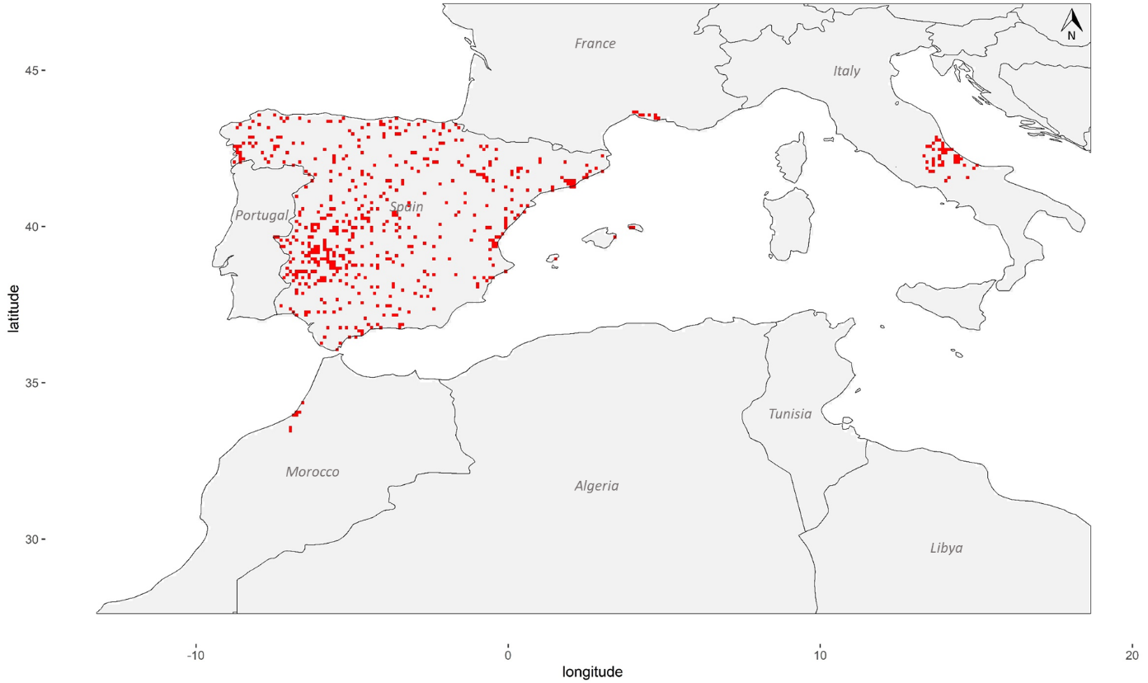Figure S1. Map of the study area and location of mosquito trapping data. Each red dot represents a pixel in which at least one entomological time series (longitudinal data for one trap) was available.

Table S1. Entomological data description.
Species |  | Ae. caspius | Ae. detritus | Ae. vexans | Cx. pipiens | Cx. theileri
Number of sources  Number of datasets |  | 7 | 6 | 5 | 8 | 7
 |  | 15 | 14 | 13 | 16 | 15
Number of time series* |  | 9900 (45*) | 9226 (18*) | 8528 (22*) | 9504 (170*) | 8835 (7*)
Number of different pixels with trapping data |  | 562 | 561 | 560 | 505 | 506
Trap types | - Bird-baited traps (‘high’) | X | X | X | X | X
Trap types | - Bird-baited traps (‘low’) | X | X | X | X | X
Trap types | - Chemical lure |  |  |  | X
Trap types | - CO₂-baited traps (‘high’) | X | X | X | X | X
Trap types | - CO₂-baited traps (‘low’) | X | X | X | X | X
Trap types | - CO₂-baited traps and light | X | X | X | X | X
Trap types | - Horse-baited traps | X | X | X | X | X
Trap types | - Human landing catches | X | X | X | X | X
Trap types | - Light traps | X | X | X | X | X
Trap types | - Aquatic net (larvae) | X | X |  | X | X
‘Low’ refers to traps deployed at ground level and ‘high’ at canopy level.*The number in brackets represents the number of daily time series with at least 10 trapping results that include at least five non-null value.

Model parametrization

Constant parameters and meteorological-dependent functions
Table S2 summarizes the constant parameters and meteorological-dependent functions used in the model.
Table S2. Constant parameters and meteorological-dependent functions of the model, for each of the five species of interest.
Parameter | Definition | Ae. caspius | Ae. detritus | Ae. vexans | Cx. pipiens | Cx. theileri | Reference
$$β_{1}$$ | Number of eggs laid/ovipositing nulliparous female | $$160$$ | $$120$$ | $$160$$ | $$141$$ | $$92$$ | [3–7]
$$β_{2}$$ | Number of eggs laid/ovipositing parous female | $$80$$ | $$60*$$ | $$80*$$ | $$80$$ | $$78$$ | [3–5,7]
$f_{E}$  (day⁻¹) | Transition rate from eggs to larvae | Boolean  $$\left\{\begin{matrix}1 if θ>15 \& R>15 \\ 0 otherwise\end{matrix}\right.$$ | Boolean  $$\left\{\begin{matrix}1 if R>15 \\ 0 otherwise\end{matrix}\right.$$ | Boolean  $$\left\{\begin{matrix}1 if θ>10 \& R>15 \\ 0 otherwise\end{matrix}\right.$$ | Logan model with  $$A=0.16 \\ B=0.11 \\ C=5.01 \\ θ_{min}=10$$  $$θ_{max}=35$$ | Logan model with  $$A=0.06 \\ B=0.17 \\ C=3.62 \\ θ_{min}=12 \\ θ_{max}=39$$ | [4,8–10]
$$f_{L}$$  (day⁻¹) | Transition rate from larvae to pupae | $$\frac{f_{P}}{1.65}$$ | $$\frac{f_{P}}{1.65}*$$ | Logan model with  $$A=0.02 \\ B=0.15 \\ C=3.56 \\ θ_{min}=10 \\ θ_{max}=35$$ | Logan model with  $$A=0.017 \\ B=0.13 \\ C=3.98 \\ θ_{min}=7 \\ θ_{max}=35$$ | Logan model with  $$A=0.02 \\ B=0.12 \\ C=3.28 \\ θ_{min}=12 \\ θ_{max}=36$$ | [4,11–13]
$$f_{P}$$  (day⁻¹) | Transition rate from pupae to emerging adults | Logan model with  $$A=0.14 \\ B=0.16 \\ C=5.01 \\ θ_{min}=10 \\ θ_{max}=35$$ | Logan model with *  $$A=0.14 \\ B=0.16 \\ C=5.01 \\ θ_{min}=10 \\ θ_{max}=35$$ | Logan model with  $$A=0.21 \\ B=0.11 \\ C=3.41 \\ θ_{min}=15 \\ θ_{max}=35$$ | Logan model with  $$A=0.13 \\ B=0.23 \\ C=4.09 \\ θ_{min}=10 \\ θ_{max}=35$$ | Logan model with  $$A=0.15 \\ B=0.14 \\ C=4.67 \\ θ_{min}=12 \\ θ_{max}=36$$ | [4,8,11–13]
$$σ_{em}$$ | Sex ratio at emergence | $$0.5$$ | $$0.5$$ | $$0.5$$ | $$0.5$$ | $$0.5$$ | [4,5,8,14,15]
$$γ_{A_{em}}$$  (day⁻¹) | Development rate of emerging adults | $$0.4$$ | $$0.4*$$ | $$0.5$$ | $$1.143$$ | $$1.143*$$ | [4,8,16–18]
$$γ_{A_{h}}$$  (day⁻¹) | Transition rate from host-seeking to engorged adults | $$0.222$$ | $$0.222*$$ | $$0.33$$ | $$0.885$$ | $$0.885*$$ | [4,5,14,19]
$$f_{A_{g}}$$  (day⁻¹) | Transition rate from engorged to ovipositing adults | $$\frac{θ-T_{Ag}}{TDD_{Ag}} \\ T_{Ag}=10 \\ TDD_{Ag}=78 \\ f_{Ag}>0$$ | $$\frac{θ-T_{Ag}}{TDD_{Ag}}* \\ T_{Ag}=10 \\ TDD_{Ag}=78 \\ f_{Ag}>0$$ | $$\frac{θ-T_{Ag}}{TDD_{Ag}}* \\ T_{Ag}=10 \\ TDD_{Ag}=78 \\ f_{Ag}>0$$ | $$\frac{θ-T_{Ag}}{TDD_{Ag}} \\ T_{Ag}=9.8 \\ TDD_{Ag}=64.4 \\ f_{Ag}>0$$ | $$\frac{θ-T_{Ag}}{TDD_{Ag}} \\ T_{Ag}=9.8 \\ TDD_{Ag}=73.09769 \\ f_{Ag}>0$$ | [4,18,20]
$$γ_{A_{o}}$$  (day⁻¹) | Transition rate from ovipositing to host-seeking adults | $$0.222$$ | $$0.222*$$ | $$0.33$$ | $$2$$ | $$2*$$ | [3,4,14,21]
$$μ_{E}$$  (day⁻¹) | Egg mortality rate | $$0.001*$$ | $$0.001*$$ | $$0.001$$ | $$0.262$$ | $$0.0290$$ | [4,5,10,14]
$$m_{L}$$  (day⁻¹) | Larval mortality rate | $$e^{-\frac{θ}{2}}+μ_{L}$$ | $$e^{-\frac{θ}{2}}+μ_{L}$$ | $$e^{-\frac{θ}{2}}+μ_{L}$$ | $$e^{-\frac{θ}{2}}+μ_{L}$$ | $$e^{-\frac{θ}{2}}+μ_{L}$$ | [4,5,14]
$$μ_{L}$$  (day⁻¹) | Minimum larval mortality rate | $$0.0367$$ | $$0.003113426$$ | $$0.04671658$$ | $$0.0304$$ | $$0.05392209$$ | [4,13,22,23]
$$m_{P}$$  (day⁻¹) | Pupal mortality rate | $$e^{-\frac{θ}{2}}+μ_{P}$$ | $$e^{-\frac{θ}{2}}+μ_{P}$$ | $$e^{-\frac{θ}{2}}+μ_{P}$$ | $$e^{-\frac{θ}{2}}+μ_{P}$$ | $$e^{-\frac{θ}{2}}+μ_{P}$$ | [4,5,14]
$$μ_{P}$$  (day⁻¹) | Minimum pupal mortality rate | $$0.12$$ | $$0.001137951$$ | $$0.02200325$$ | $$0.0146$$ | $$0.06593466$$ | [4,13,22,23]
$$m_{A}$$  (day⁻¹) | Adult mortality rate | $$-0.005941 + 0.002965×θ \\ for m_{A}>μ_{A}$$ | $$-0.005941 + 0.002965×θ* \\ for m_{A}>μ_{A}$$ | $$0.02320402+0.002075247×θ \\ for m_{A}>μ_{A}$$ | $$-0.06578724+0.004460362×θ \\ for m_{A}>μ_{A}$$ | $$0.01841533+0.002431452×θ \\ for m_{A}>μ_{A}$$ | [4,24–26]
$$μ_{A}$$  (day⁻¹) | Minimum adult mortality rate | $$0.03773585$$ | $$0.03773585*$$ | $$0.02673797$$ | $$0.01083424$$ | $$0.01083424*$$ | [24,25,27,28]
$$m_{A}^{dia}$$  (day⁻¹) | Adult mortality rate during diapause stage | $$m_{A}$$ | $$m_{A}*$$ | $$m_{A}*$$ | $$μ_{A}$$ | $$μ_{A}*$$ | [4]
$$μ_{em}$$  (day⁻¹) | Mortality rate during emergence | $$0.1$$ | $$0.1$$ | $$0.1$$ | $$0.1$$ | $$0.1$$ | [4,14]
$$μ_{r}$$  (day⁻¹) | Mortality rate related to seeking behavior | $$0.08$$ | $$0.08$$ | $$0.08$$ | $$0.08$$ | $$0.08$$ | [4,14]
Table S2. (Continued)
Parameter | Definition | Ae. caspius | Ae. detritus | Ae. vexans | Cx. pipiens | Cx. theileri | Reference
$${κ_{L}}_{max}$$  (larvae.ha⁻¹) | Maximum environment carrying capacity for larvae | $${10}^{10}$$ | $${10}^{10}$$ | $${10}^{10}$$ | $${8×10}^{8}$$ | $${8×10}^{8}$$ | [4]
$${κ_{P}}_{max}$$  (pupae.ha⁻¹) | Maximum environment carrying capacity for pupae | $${10}^{8}$$ | $${10}^{8}$$ | $${10}^{8}$$ | $${10}^{7}$$ | $${10}^{7}$$ | [4]
$$α$$ | Shape parameter | $$\exp\left(1.5\right)$$ | $$\exp\left(1.5\right)$$ | $$\exp\left(1.5\right)$$ | $$\exp\left(-0.5\right)$$ | $$\exp\left(-0.5\right)$$ | Calibrated from data
$$Φ$$ | Boolean value to account for differences in resistance stage | 0 | 0 | 0 | 1 | 1 | [4,14]
$$Start$$ | First day of the favorable season | 74 (March 15th) | No diapause | 74 (March 15th) | 74 (March 15th) | 74 (March 15th) | [4,8]
$$End$$ | Last day of the favorable season | 287 (October 14th) | No diapause | 287 (October 14th) | 264 (September 21st) | 264 (September 21st) | [4,8]
Greek letters refers to constant parameters and Latin to meteorological-dependent functions.$θ$ refers to the temperature (Celsius degrees) and $R$ to the precipitations (in millimeters). *Parameter extrapolated from another species of the same genus, in absence of specific data for the species considered.

Parametrization of the carrying capacities

Materials and methods
For M₃, we calibrated $α$ with the entomological data by minimizing the squares of distances between the observed and predicted data for the same dates and locations. Because the predicted values represented a total mosquito population size and the observed data were numbers of individuals trapped during a capture session, the ranges of observed and predicted values were not directly comparable. To compute the squared distance for each dataset, we first rescaled the corresponding predicted values between zero and the maximum observed value. We then summed the squared distances between observed and rescaled predicted data for each dataset and computed a final score. We assessed values of $\log\left(α\right)$ between - 9 and 3, corresponding to extreme shapes of the relationship between the carrying capacities $κ_{L_{x,y}}$and $κ_{P_{x,y}}$ and the associated probability of presence $p_{x,y}$ (Fig. S2). We also computed the percentage of observed time series with the maximum value being higher than the maximum value of the corresponding predicted data. Considering the observed data is a fraction of the total mosquito population that we are aiming to simulate, we expected the observed values to be lower than the predicted values. Therefore, this percentage was an indicator of the $α$ value being too high, preventing the carrying capacities from reaching a value high enough for an important mosquito population to be simulated in pixels where mosquitoes have been effectively observed in the field. We selected the best $α$ value as the one with a $\log\left(α\right)$value minimizing the squared distance between observed and rescaled predicted data, and with a low percentage of putatively underestimated predicted populations.
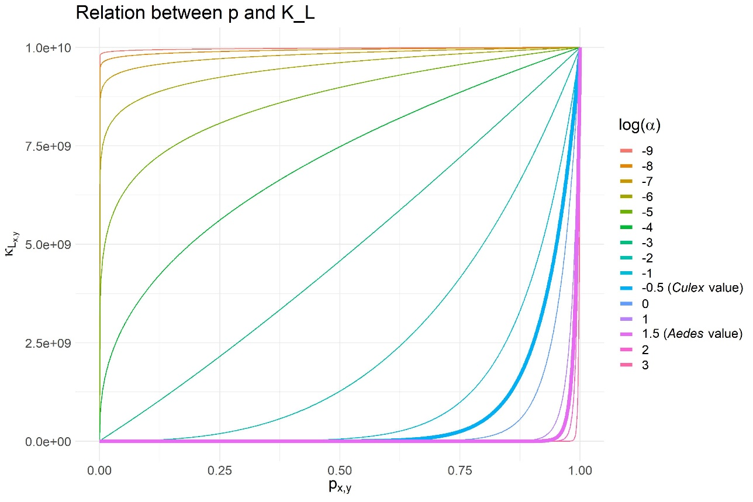
Figure S2. Shape of the relationship between the carrying capacity $κ_{x,y}$ and the probability of presence$p_{x,y}$, according to the values of $α$, and taking the example of $κ_{L_{x,y},}$, with $κ_{L_{max}}={10}^{10}$, the Aedes value.

Results
The squared difference between the rescaled predicted data and the observed data was generally decreased with increasing $log(α)$ values, showing one local minimum value for Aedes mosquitoes and two for Culex mosquitoes (Fig. S2). The percentage of time series with the maximum predicted value being lower than the maximum observed value increased with the$log(α)$ value. This relationship is explained by the fact that, as $α$ increases, the carrying capacity decreases, especially for pixels with a low probability of presence. For Aedes mosquitoes, we chose the local minimum value ($log⁡(α)=1.5)$ as the best value. Choosing a higher $α$ value would have led to an increase of the percentage of observed time series with the maximum value being higher than the maximum value of the corresponding predicted time series. For Culex we chose the first local minimum value ($\log\left(α\right)=-0.5)$ for the same reason.
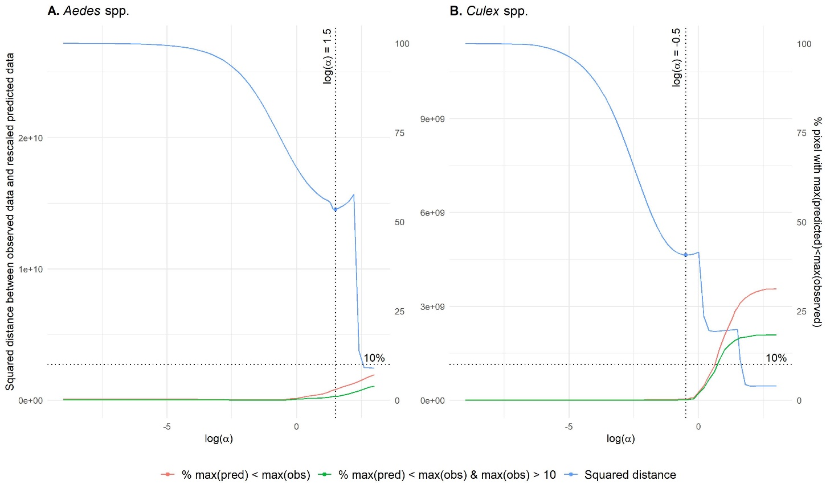
Figure S3. Squared distance between observed data and rescaled predicted data for Aedes and Culex ‘%max(pred) < max(obs)’ refers to the percentage of observed time series with the maximal value being higher than the maximum value of the corresponding predicted time series among all datasets. ‘%max(pred) < max(obs) & max(obs) > 10’ refers to the same percentage, but for time series with a maximum value greater than 10 mosquitoes.
The distribution of the differences between rescaled predicted data and observed data for SP1 and IT1 according to the method of parametrization of the carrying capacities are provided in Figs. S4 to S12.

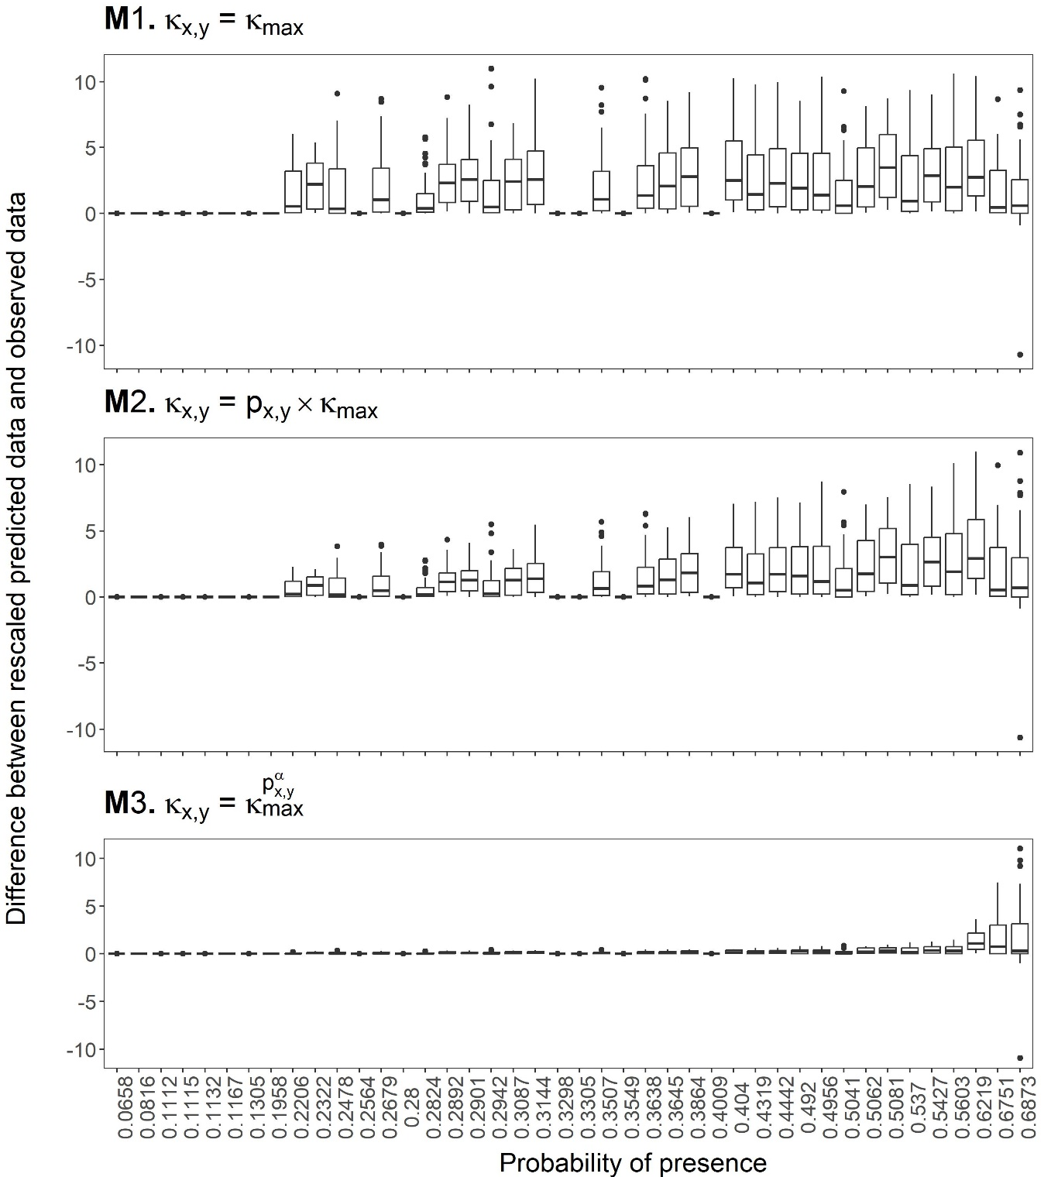
Figure S4. Distribution of the differences between rescaled predicted data and observed data, according to the probability of presence in the pixel – Ae. detritus, IT1 data. There were 42 different values of probability of presence, ranging from 0.07 to 0.69. Maximum observed number of mosquitoes in a pixel: 11 mosquitoes.
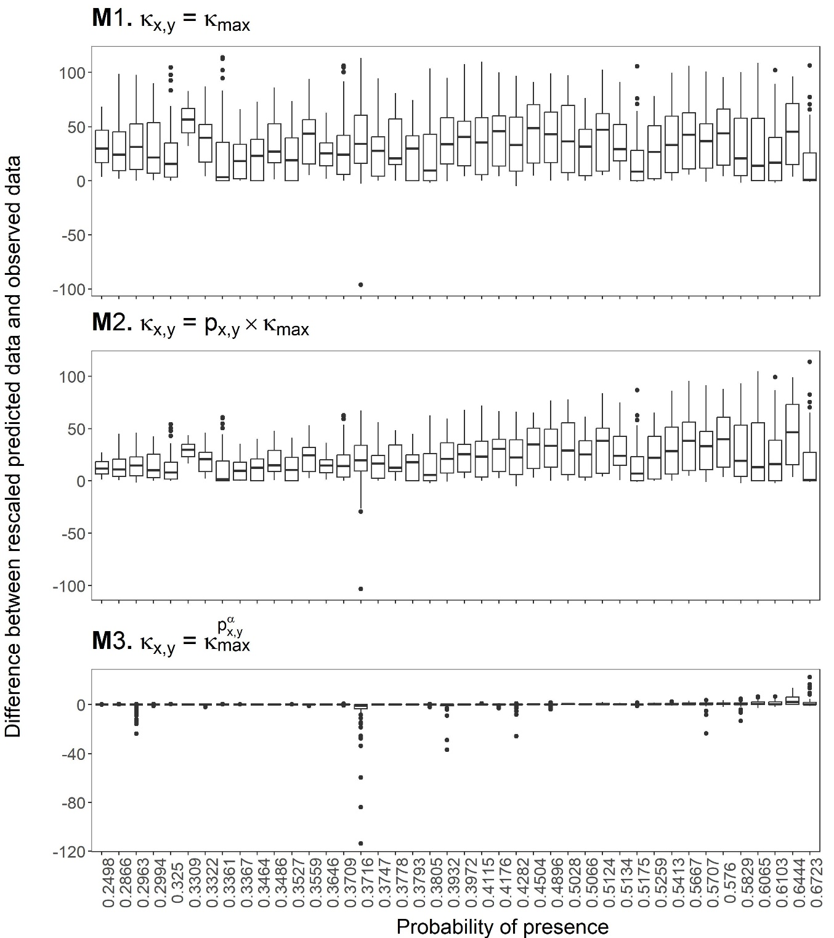
Figure S5. Distribution of the differences between rescaled predicted data and observed data, according to the probability of presence in the pixel – Ae. vexans, IT1 data. There were 42 different values of probability of presence, ranging from 0.25 to 0.67. Maximum observed number of mosquitoes in a pixel: 114 mosquitoes.

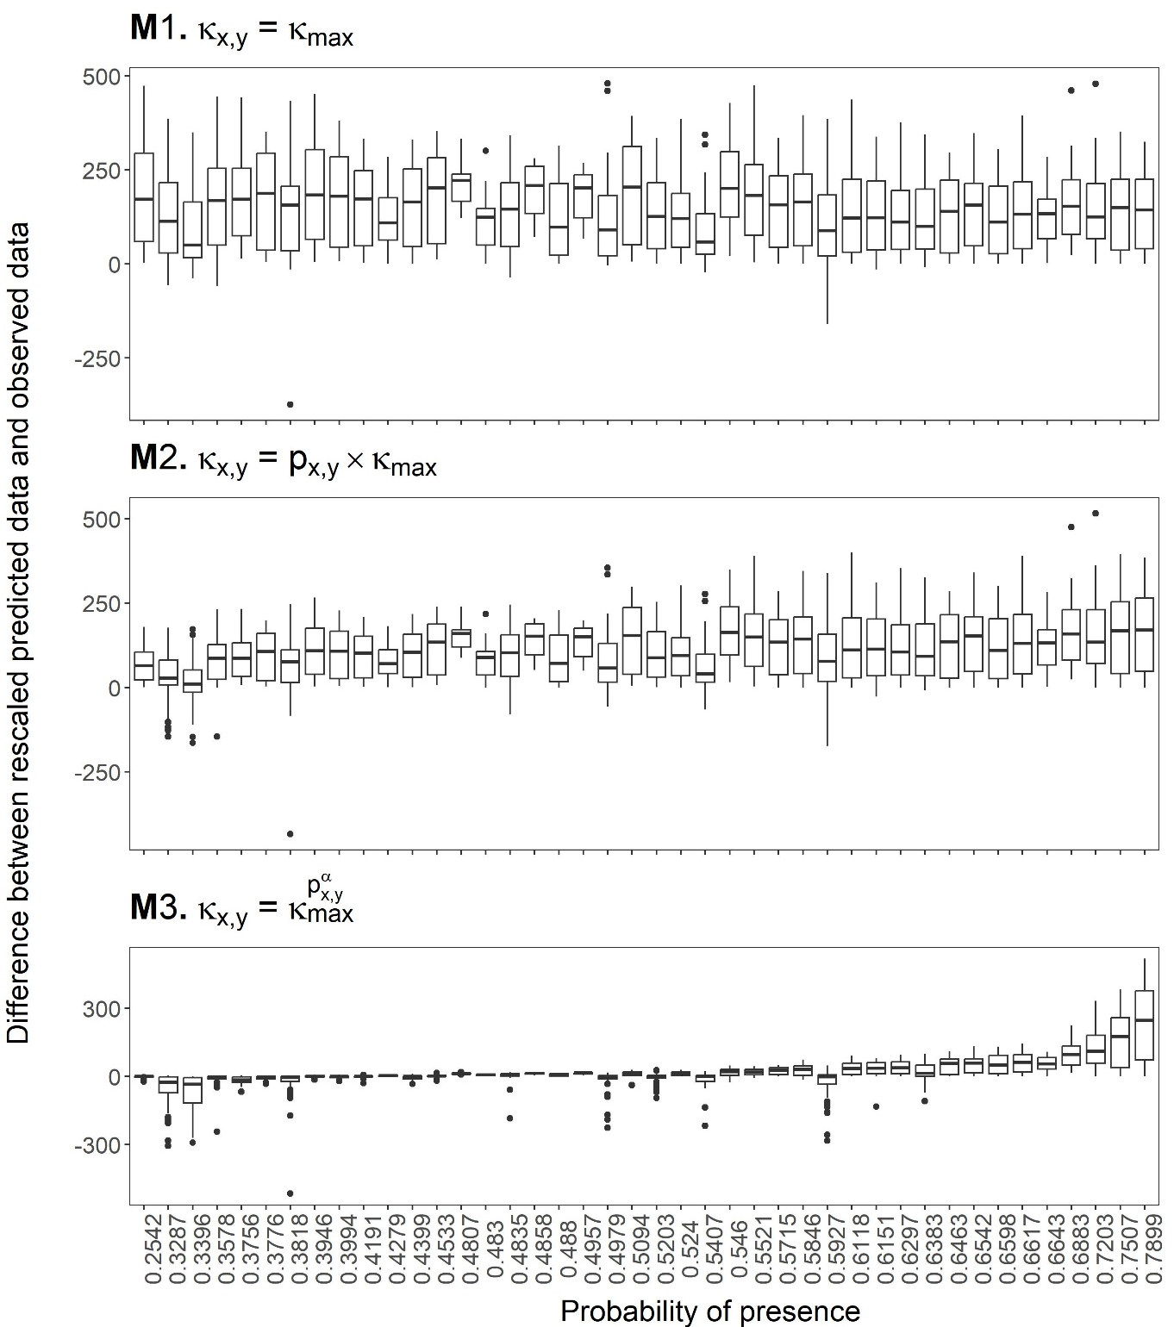
Figure S6. Distribution of the differences between rescaled predicted data and observed data, according to the probability of presence in the pixel – Cx. pipiens, IT1 data. There were 42 different values of probability of presence, ranging from 0.25 to 0.79. Maximum observed number of mosquitoes in a pixel: 517 mosquitoes.

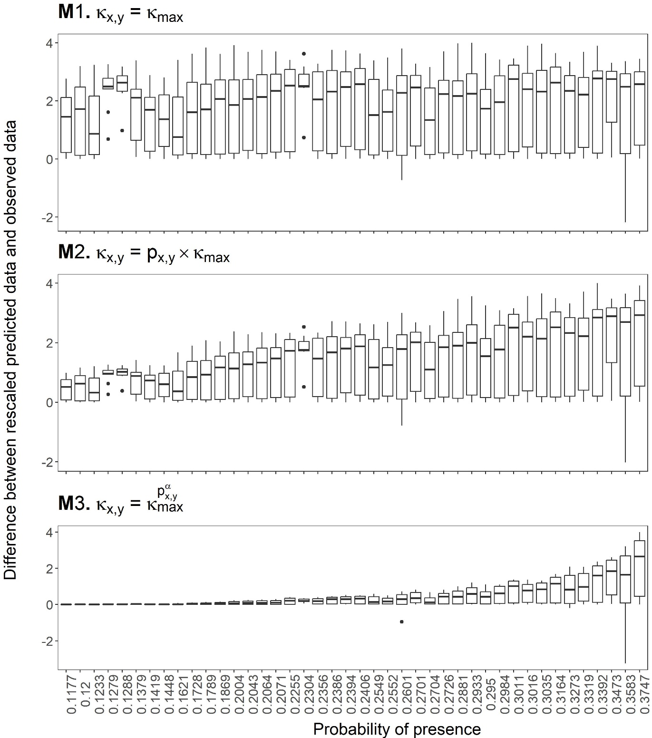
Figure S7. Distribution of the differences between rescaled predicted data and observed data, according to the probability of presence in the pixel – Cx. theileri, IT1 data. There were 42 different values of probability of presence, ranging from 0.12 to 0.37. Maximum observed number of mosquitoes in a pixel: 4 mosquitoes.

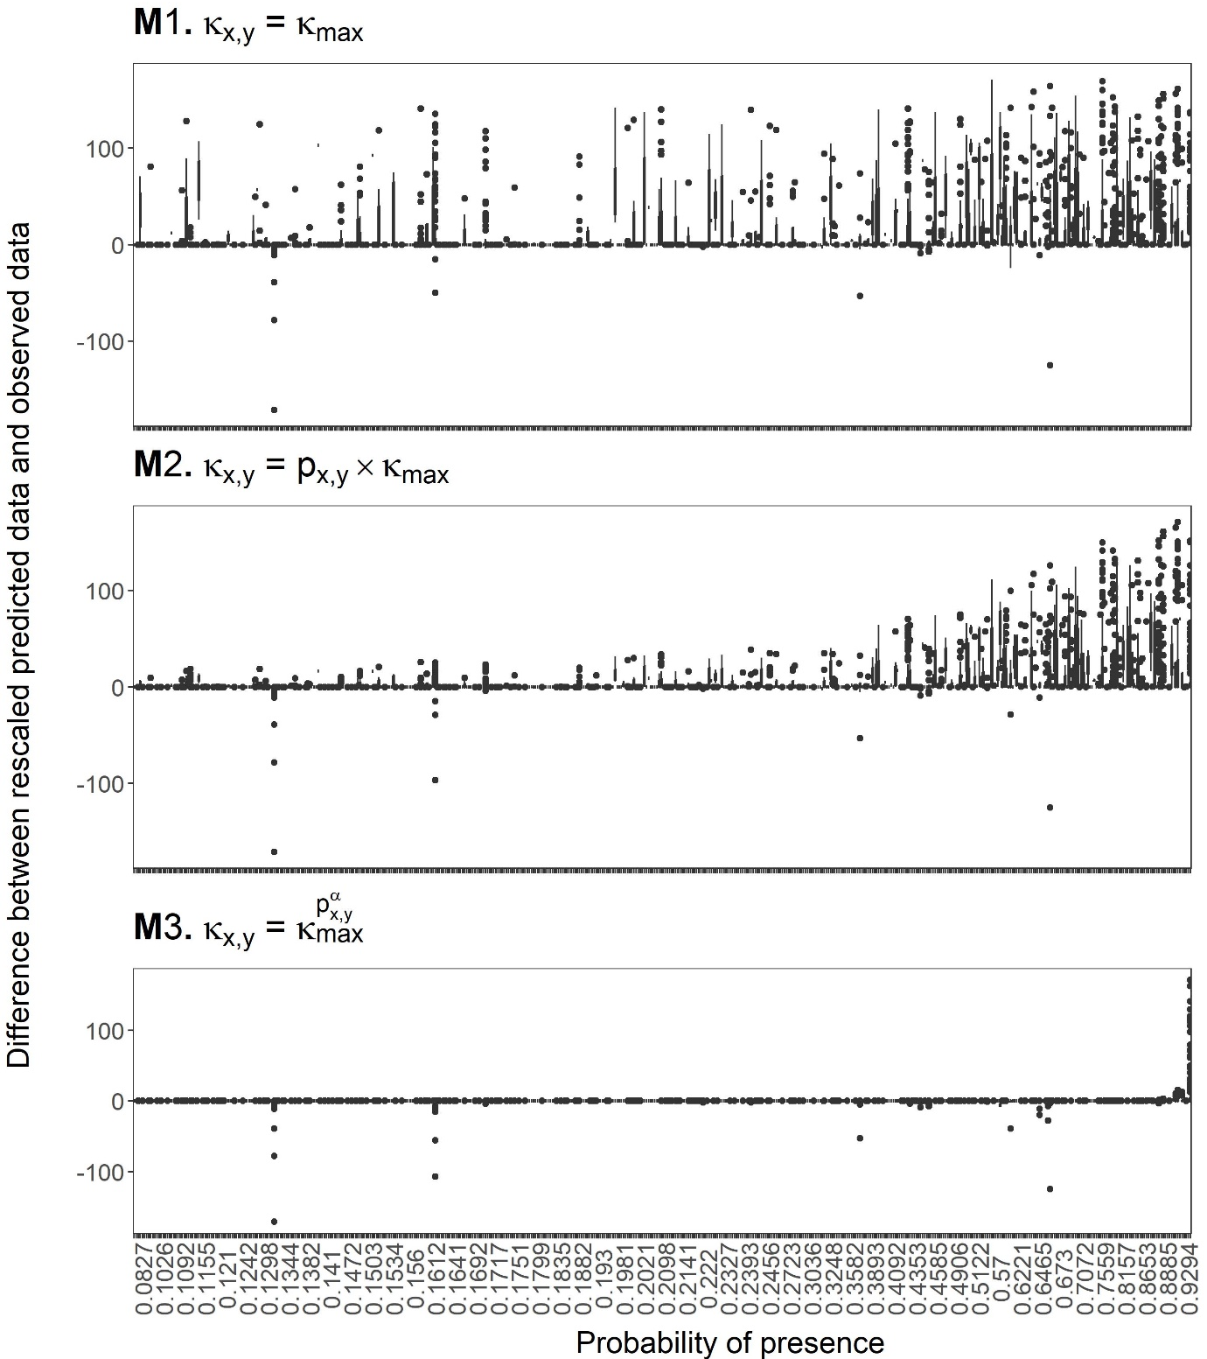
Figure S8. Distribution of the differences between rescaled predicted data and observed data, according to the probability of presence in the pixel – Ae. caspius, SP1 data. There were 506 different values of probability of presence, ranging from 0.08 to 0.97. Maximum observed number of mosquitoes in a pixel: 171 mosquitoes.

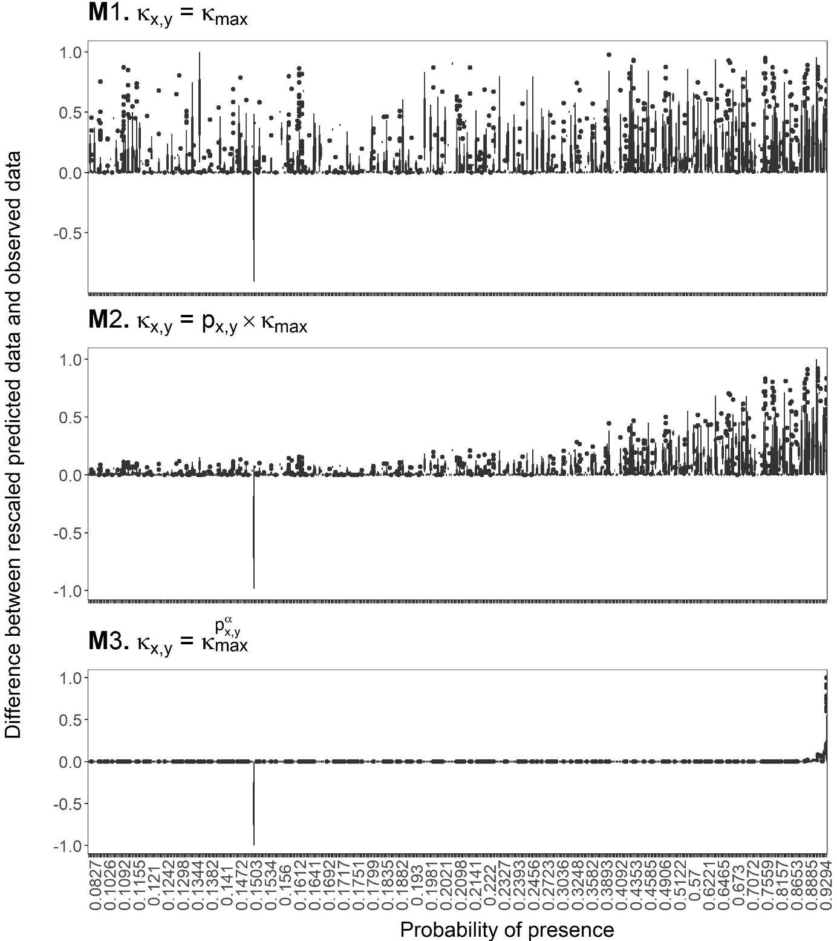
Figure S9. Distribution of the differences between rescaled predicted data and observed data, according to the probability of presence in the pixel – Ae. detritus, SP1 data. There were 506 different values of probability of presence, ranging from 0.08 to 0.97. Maximum observed number of mosquitoes in a pixel: 1 mosquito.

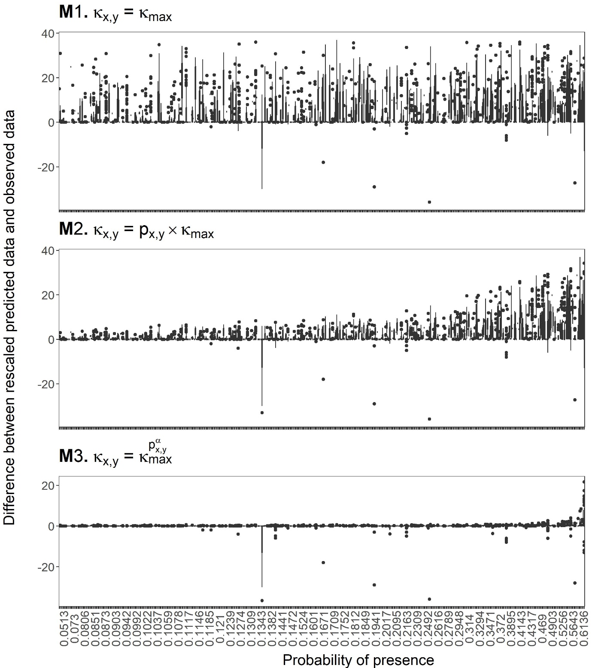
Figure S10. Distribution of the differences between rescaled predicted data and observed data, according to the probability of presence in the pixel – Ae. vexans, SP1 data. There were 506 different values of probability of presence, ranging from 0.05 to 0.69. Maximum observed number of mosquitoes in a pixel: 37 mosquitoes.

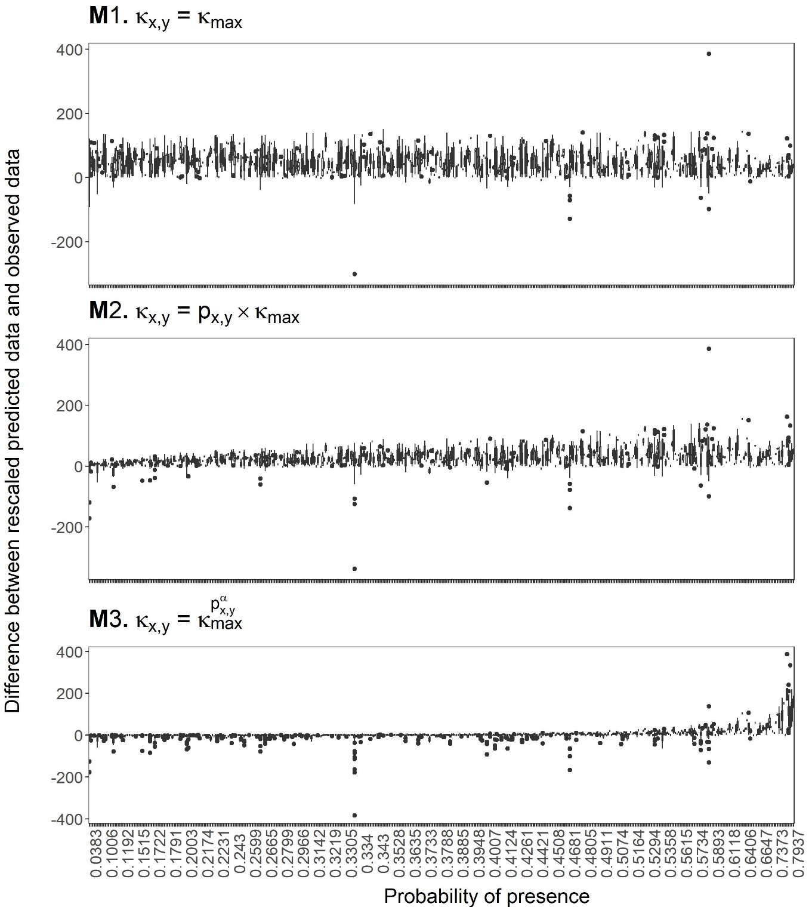
Figure S11. Distribution of the differences between rescaled predicted data and observed data, according to the probability of presence in the pixel – Cx. pipiens, SP1 data. There were 442 different values of probability of presence, ranging from 0.04 to 0.80. Maximum observed number of mosquitoes in a pixel: 386 mosquitoes.

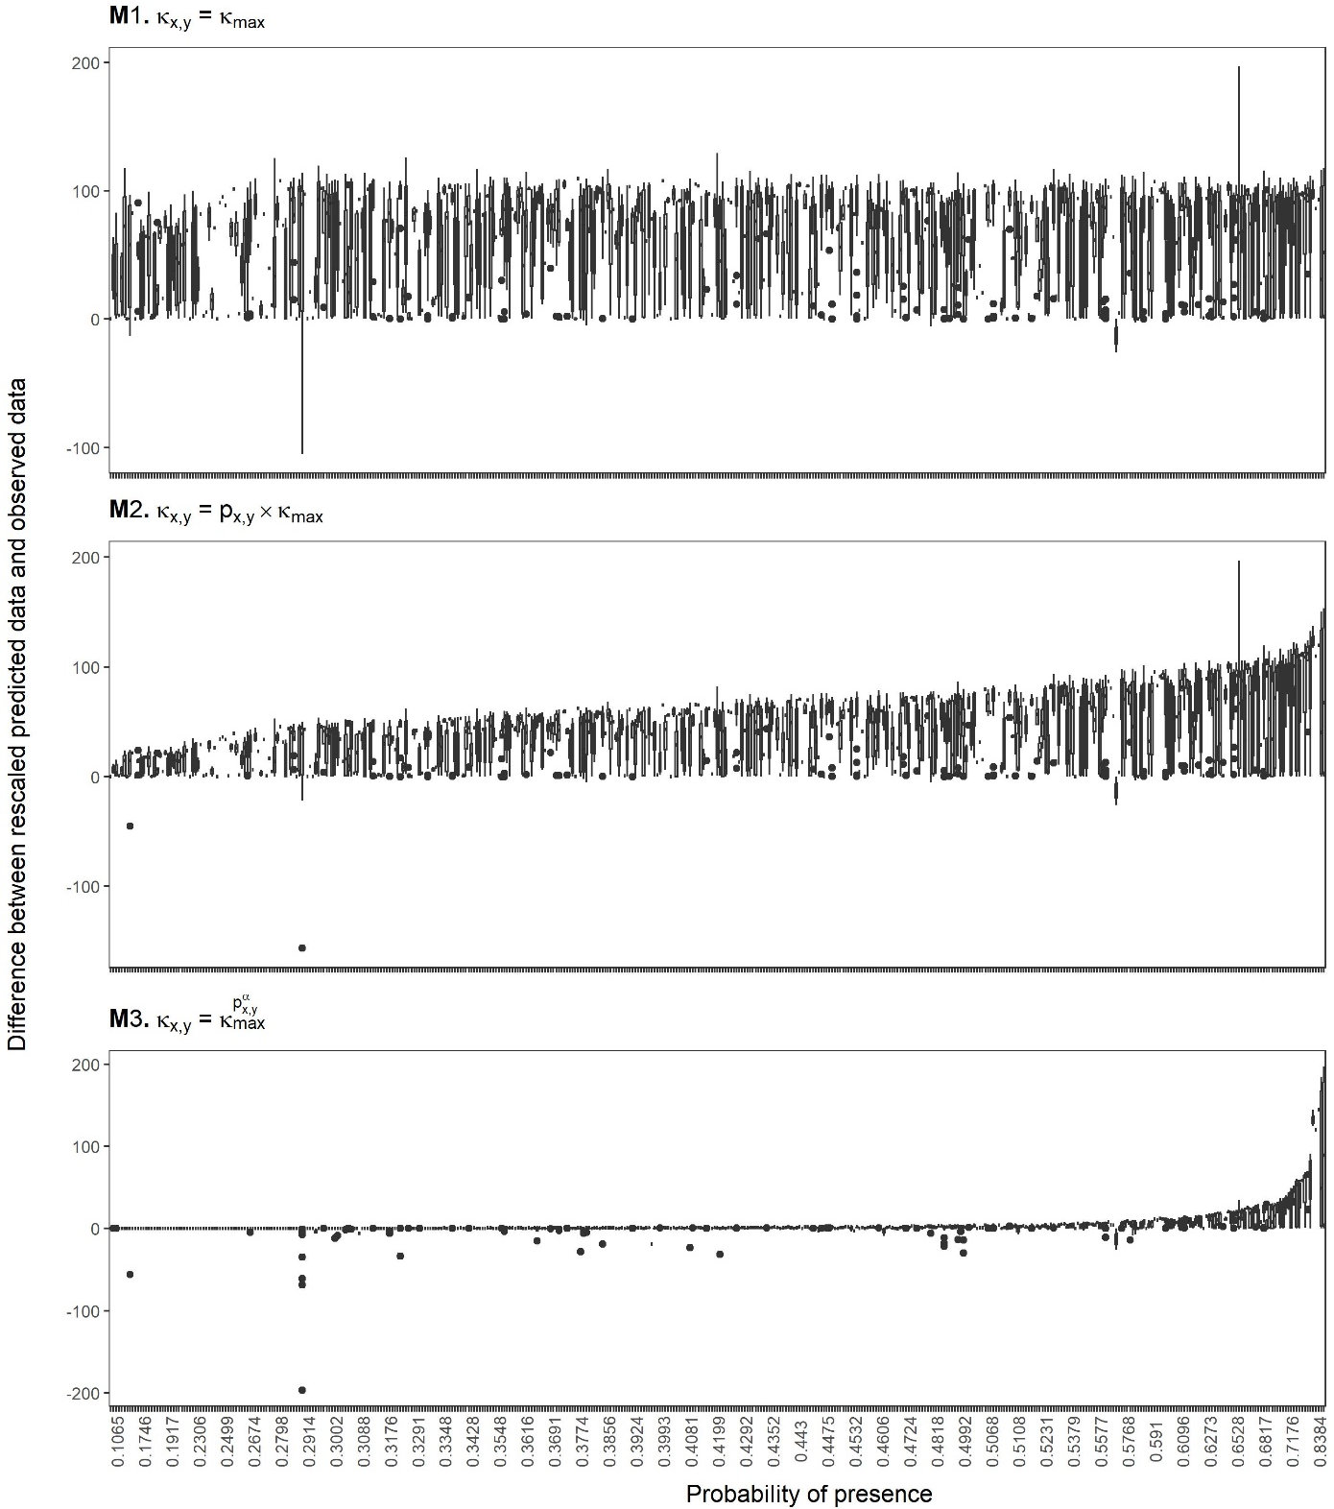
Figure S12. Distribution of the differences between rescaled predicted data and observed data, according to the probability of presence in the pixel – Cx. theileri, SP1 data. There were 445 different values of probability of presence, ranging from 0.11 to 0.86. Maximum observed number of mosquitoes in a pixel: 197 mosquitoes.

Model initialization
For each run of the model, and to avoid outputs being dependent on the initial situation, we ran the model through an annual biological cycle using the meteorological data from the first year of the period of interest, i.e., 1990, until the yearly dynamic was stable. More precisely, in each pixel, we first introduced ${10}^{4}$ individuals of the resistant stage (i.e., eggs for Aedes species or emerging adults for Culex species). Then, we ran the model for a whole year using the meteorological data of 1990. We saved the values from 31 December, and ran the model again for a whole year using the same meteorological data. We repeated this process until the mean difference between two successive runs was less than 0.1%, for all stages, and saved the values from 31 December of the last run as the initial situation for the simulation of the whole period of interest.

Model predictions
Videos showing the model predictions for the five mosquito species between 2020 and 2021 are available on the following GitHub repository: https://github.com/drouinalex/spatial_modelling_rvf_vectors

Model fit assessment
The results of the assessment of model fit from the computation of the temporal correlation between observed and predicted data, for daily, weekly, biweekly and monthly time steps are given in Table S3. The density plots of correlation coefficients for daily, biweekly and monthly time steps are provided in Figs. S13 to S15.
Table S3. Median of temporal correlation coefficients between observed and predicted data.
Species | Ae. caspius | Ae. detritus | Ae. vexans | Cx. pipiens | Cx. theileri
Daily time step | 0.13 (38%)  N = 45 | 0.30 (0.83%)  N = 18 | 0.13 (36%)  N = 22 | 0.32 (65%)  N = 170 | 0.07 (29%)  N = 7
Weekly time step | 0.15 (42%)  N = 45 | 0.32 (78%)  N = 18 | 0.13 (26%)  N = 19 | 0.31 (69%)  N = 166 | 0.05 (29%)  N = 7
Biweekly time step | 0.15 (31%)  N =45 | 0.30 (78%)  N = 18 | 0.22 (53%)  N = 19 | 0.34 (71%)  N = 162 | 0.05 (29%)  N = 7
Monthly time step | 0.20 (50%)  N = 20 | 0.34 (100%)  N = 5 | 0.24 (55%)  N = 11 | 0.31 (68%)  N = 100 | -0.07 (0%)  N = 4
The number in parentheses represents the percentage of coefficients higher than 0.2. N is the number of time series included in the computation.
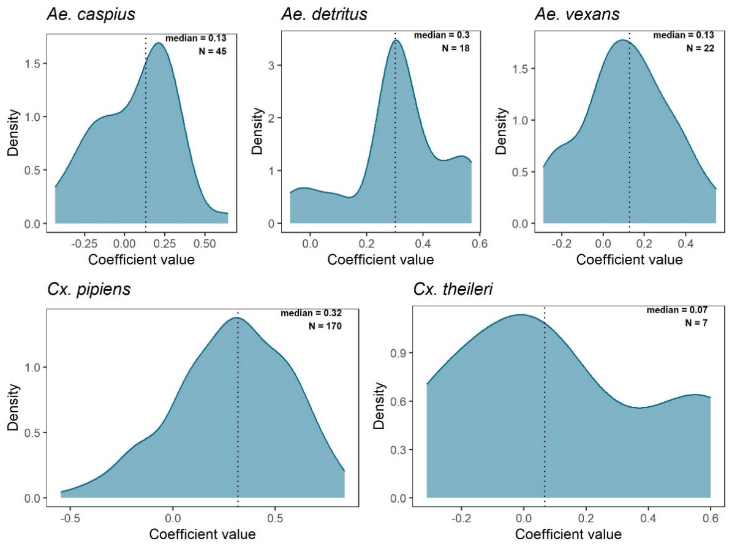
Figure S13. Distribution of the Spearman correlation coefficients between observed and predicted data (temporal correlation – daily time step). Only time series with at least 10 observations and one value greater than zero were included. The dotted lines indicate the median values.
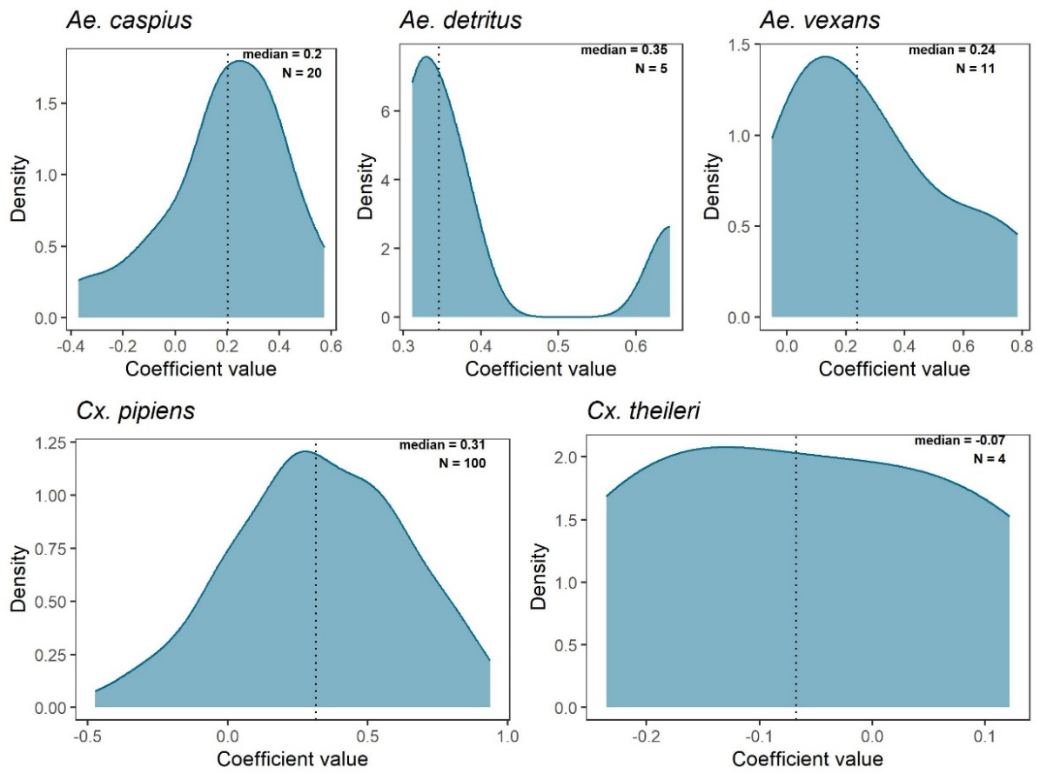
Figure S14. Distribution of the Spearman correlation coefficients between observed and predicted data (temporal correlation – biweekly time step). Only time series with at least 10 observations and one value greater than zero were included. The dotted lines indicate the median values.
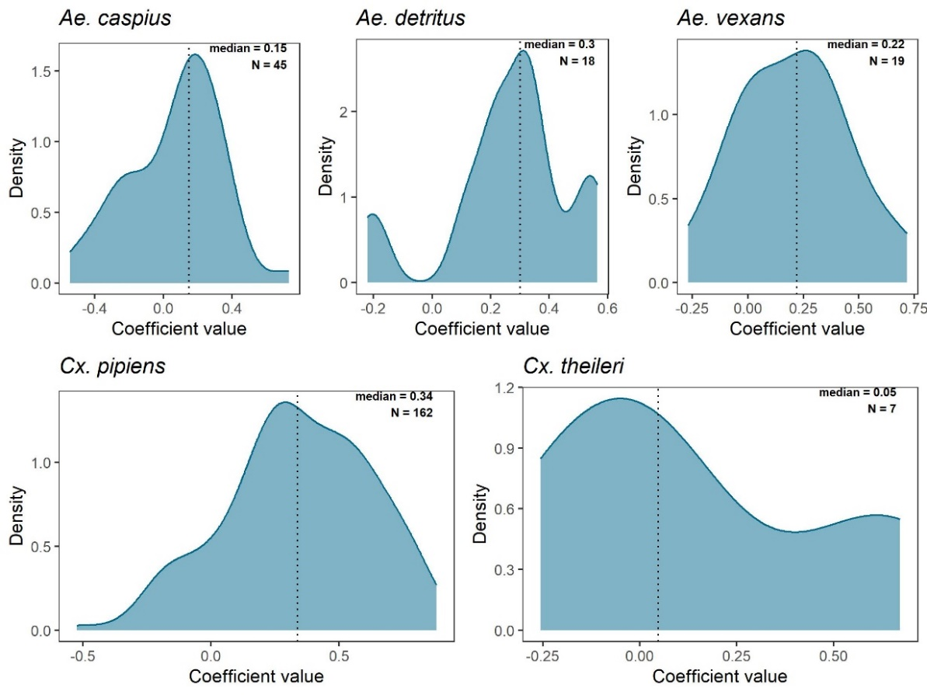
Figure S15. Distribution of the Spearman correlation coefficients between observed and predicted data (temporal correlation – monthly time step). Only time series with at least 10 observations and one value greater than zero were included. The dotted lines indicate the median values.
Sensitivity analysis
Heatmaps of the results of the sensitivity analysis ($μ^{*}$and $σ$) are shown in Figs. S16 to S23
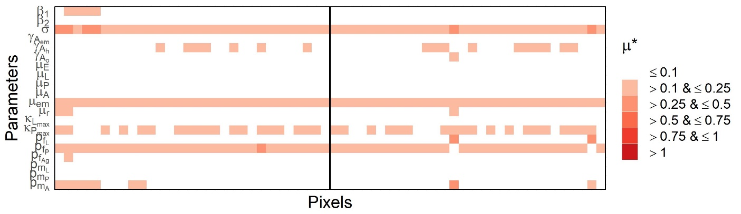
Figure S16. Heatmap of the results of the sensitivity analysis for Ae. detritus. The left panel of the heatmap shows the $μ^{*}$values for the European pixels, and the right panel, the African pixels.

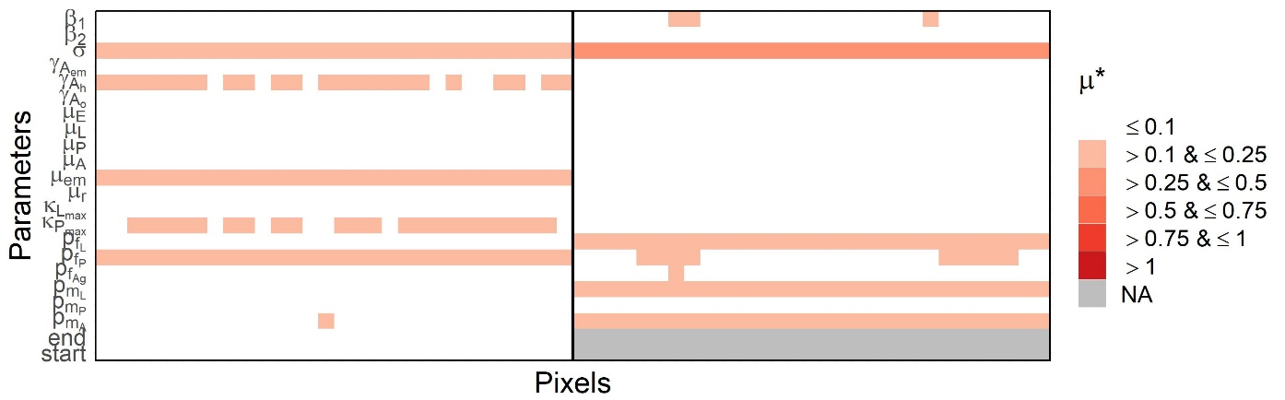
Figure S17. Heatmap of the results of the sensitivity analysis for Ae. vexans. The left panel of the heatmap shows the $μ^{*}$values for the European pixels, and the right panel, the African pixels.

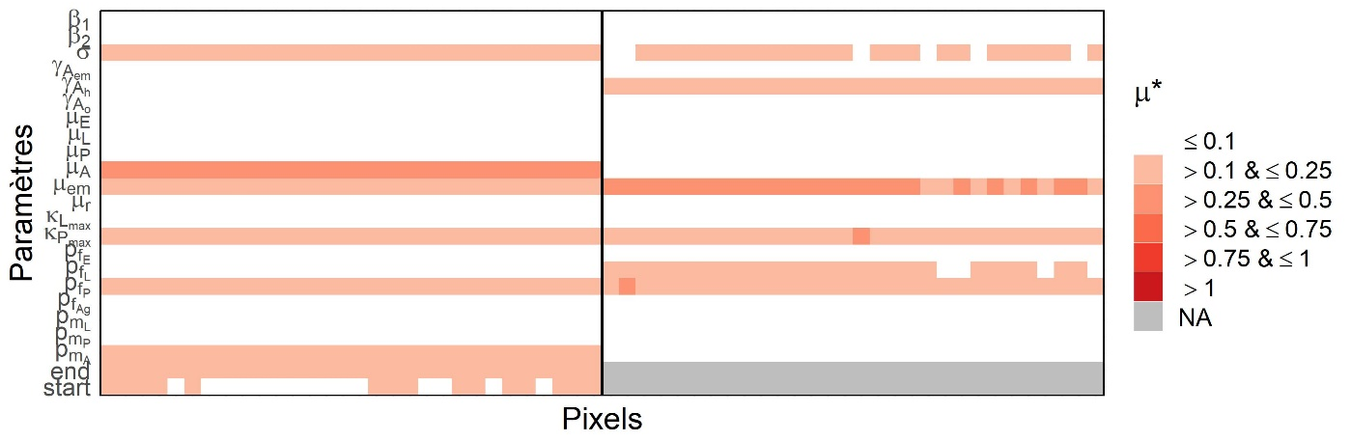
Figure S18. Heatmap of the results of the sensitivity analysis for Cx. theileri. The left panel of the heatmap shows the $μ^{*}$values for the European pixels, and the right panel, the African pixels.

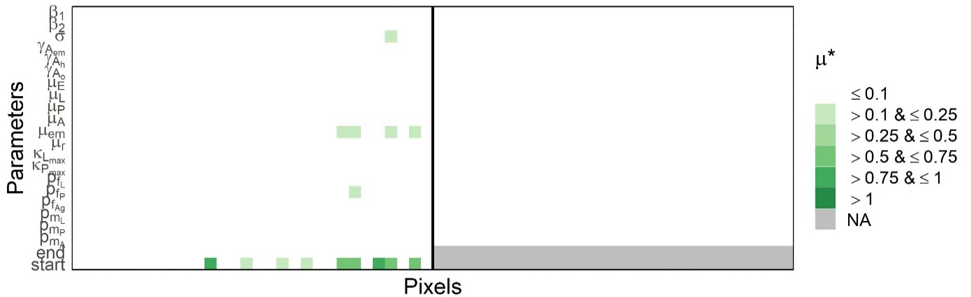
Figure S19. Heatmap of the results of the sensitivity analysis for Ae. caspius. The left panel of the heatmap shows the $σ$ values for the European pixels, and the right panel, the African pixels.

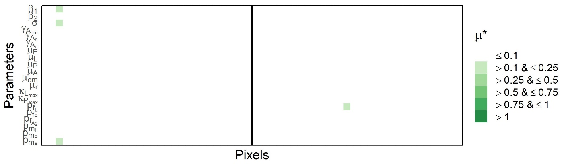
Figure S20. Heatmap of the results of the sensitivity analysis for Ae. detritus. Left part of the heatmaps represents $σ$ values for the European pixels, and right part for the African pixels.

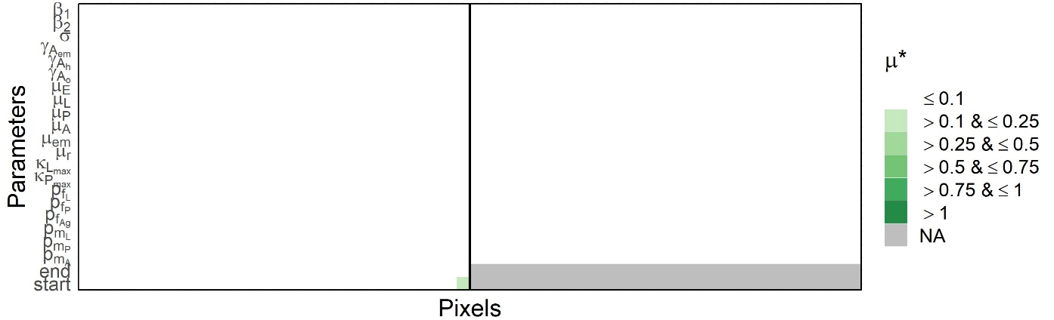
Figure S21. Heatmap of the results of the sensitivity analysis for Ae. vexans. Left part of the heatmaps represents $σ$ values for the European pixels, and right part for the African pixels.

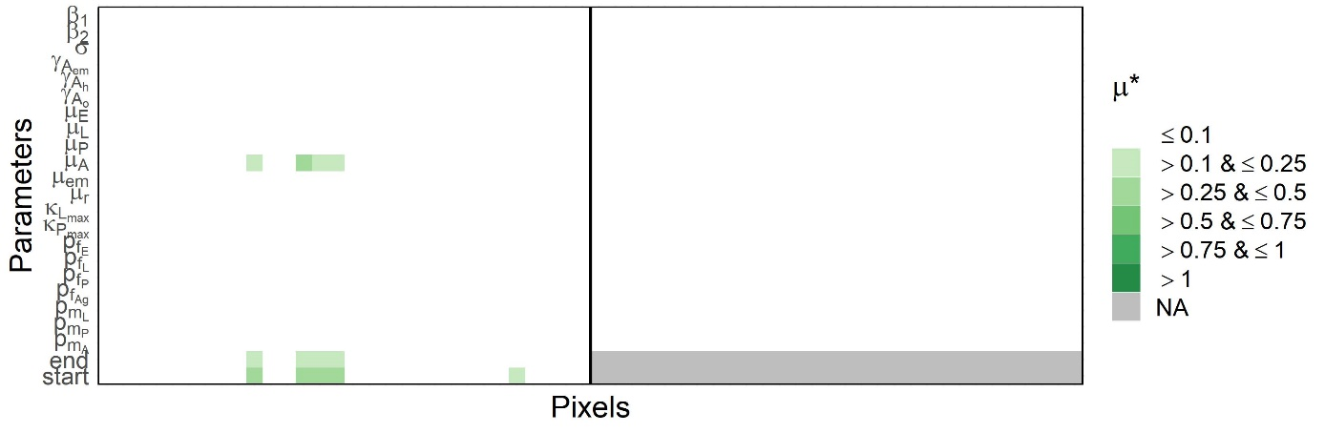
Figure S22. Heatmap of the results of the sensitivity analysis for Culex pipiens. Left part of the heatmap represents $σ$ values for the European pixels, and right part for the African pixels.
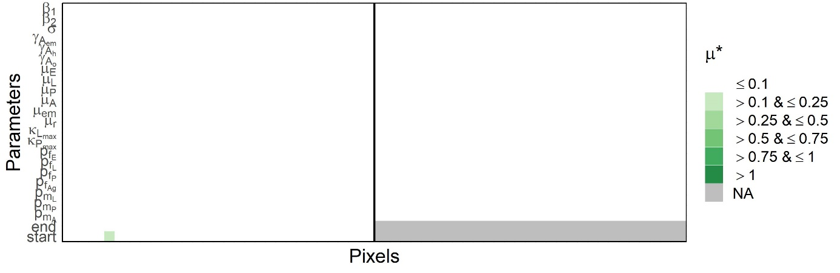
Figure S23. Heatmap of the results of the sensitivity analysis for Cx. theileri. Left part of the heatmap represents $σ$ values for the European pixels, and right part for the African pixels.

