Interactions between C-steel and blended-cement in concrete under radwaste repository conditions at 80 °C

Margit Fabian¹*, Otto Czompoly¹, Istvan Tolnai¹, Laurent De Windt²
¹Centre for Energy Research, Konkoly Thege st 29-33, 1121 Budapest, Hungary, fabian.margit@ek-cer.hu
²Mines Paris, PSL University, Centre for geosciences and geoengineering, 77300 Fontainebleau, France

Supplementary information

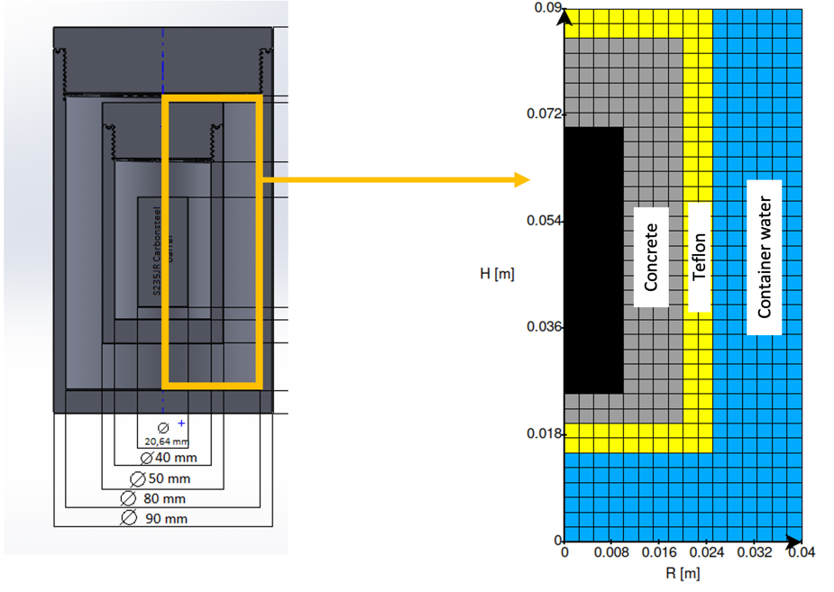
Fig. SI-1 Modeling grid of the experimental cell in cylindrical symmetry.

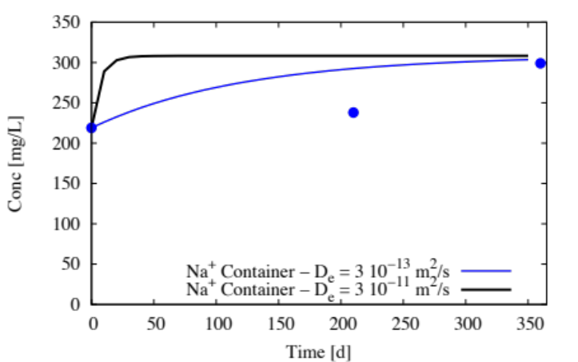
Fig. SI-2 Effect of the diffusion coefficient on the time evolution of the non-reactive Na⁺ concentration; the experimental data of the reservoir are added (blue circles) for the sake of comparison.

Table SI-1. Oxide composition of the clinker and slag considered in the modeling
Composition [wt. %] | Clinker | Slag
SiO₂ | 21.3 | 37.4
Al₂O₃ | 5.0 | 7.3
Fe₂O₃ | 3.4 | 1.2
CaO | 64.8 | 43.9
MgO | 2.1 | 5.7
K₂O | 1.0 | 0.56
Na₂O | 0.11 | 0.55
Cl | 0.03 | 0.03
CaSO₄ | 2.50 | -

