Suppl. 1 Identification of D-Gluconic acid (Cas 526-95-4, C₆H₁₂O₇, M.W.196)

Standard
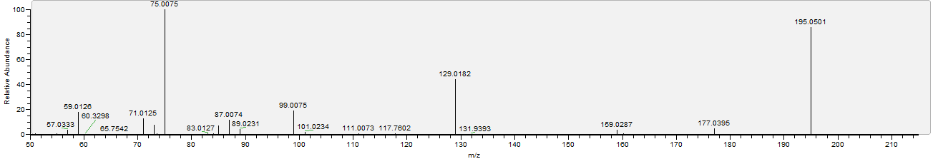

Sample
