Suppl. 52 Identification of (+)-4-Cholesten-3-one (Cas 601-57-0, C₂₇H₄₄O, M.W. 384.65)

Standard 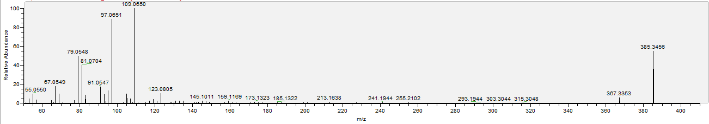

Sample 