Suppl. 8 Identification of puerarin (Cas 3681-99-0, C₂₁H₂₀O₉, M.W. 416.38)

Standard
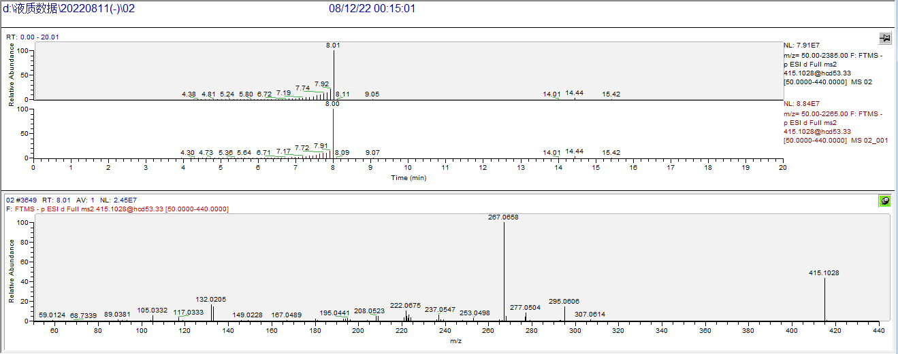

Sample
