Suppl. 23 Identification of Hesperidin (Cas 520-26-3, C₂₈H₃₄O₁₅, M.W.610.565 )

Standard
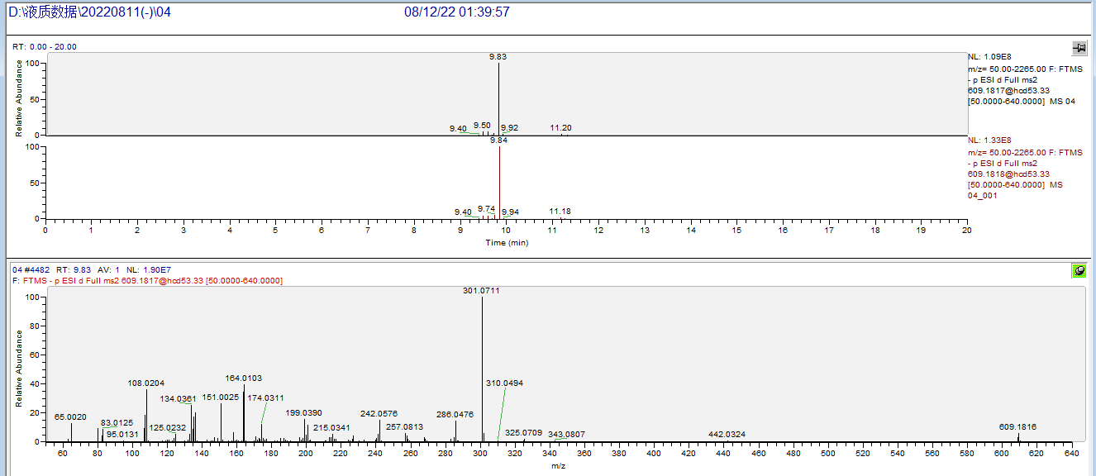

Sample
