Suppl. 27 Identification of Isorhamnetin-3-o-β-d-glucoside (Cas 5041-82-7 , C₂₂H₂₂O₁₂, M.W. 478.4)
Standard
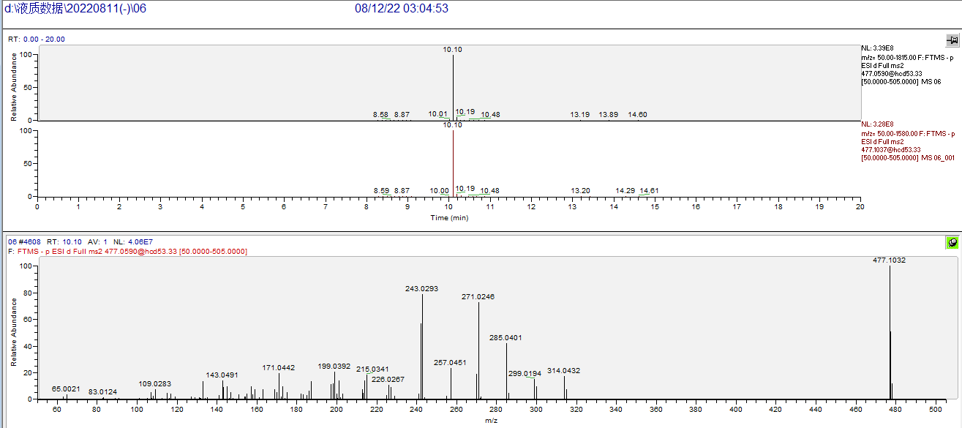

Sample
