Suppl. 16 Identification of (-)-Pinoresinol (Cas 81446-29-9, C₂₀H₂₂O₆, M.W.358.39 )
Standard
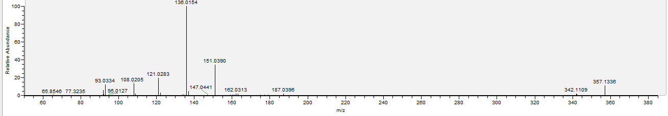

Sample
