Suppl. 31 Identification of 7,4'-dihydroxyflavone (Cas 2196-14-7, C₁₅H₁₀O₄, M.W. 254)

Standard
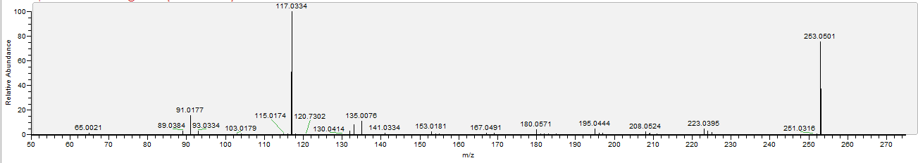

Sample
