Suppl. 32 Identification of S-Naringenin (Cas 480-41-1, C₁₅H₁₂O₅, M.W.272.25)

Standard
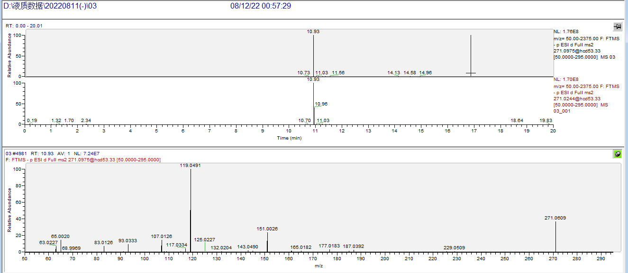

Sample
