Suppl. 40 Identification of Senkyunolide A (Cas 63038-10-8, C₁₂H₁₆O₂, M.W. 192.25)

Standard
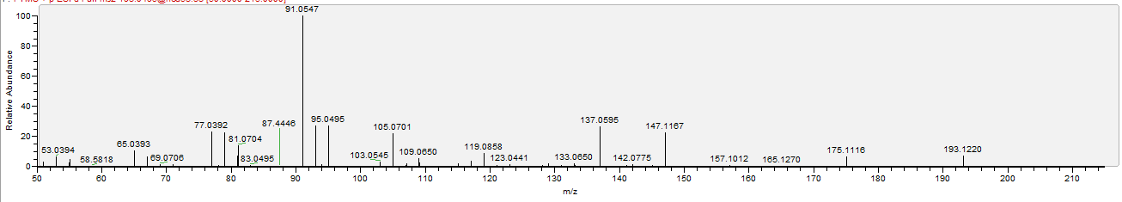

Sample
