Suppl. 18 Identification of Liquiritin (Cas 551-15-5, C₂₁H₂₂O₉, M.W. 418.4)

Standard
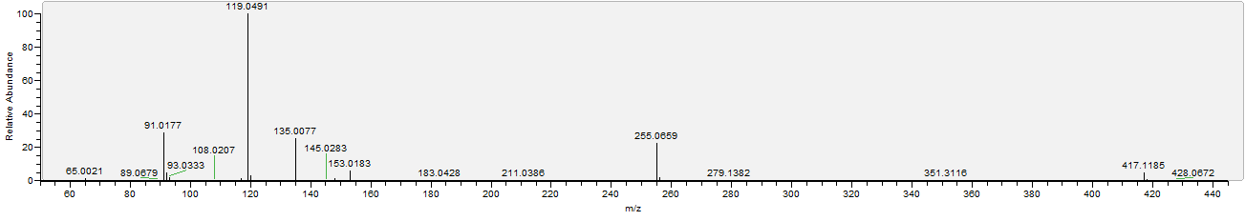

Sample
